NAME: | Shubham Vishwakarma
UID No. | 2021700071
BRANCH: | S.Y CSE-DS
BATCH: | D
SUBJECT | Design and Analysis of Algorithms
EXPERIMENT No. | 10
Date of Performance | 16/04/2023
Date of Submission | 20/04/2023

AIM: | String Matching algorithms (To implement Robin Karp algorithm)
Program 1
PROBLEM STATEMENT : | Implement the Robin Karp algorithm to the given sequence.
ALGORITHM/  THEORY: | Start  pat_len := pattern Length  str_len := string Length  patHash := 0 and strHash := 0, h := 1  maxChar := total number of characters in character set  for index i of all character in the pattern, do  h := (h*maxChar) mod prime  for all character index i of pattern, do  patHash := (maxChar*patHash + pattern[i]) mod prime  strHash := (maxChar*strHash + text[i]) mod prime  for i := 0 to (str_len - pat_len), do  if patHash = strHash, then  for charIndex := 0 to pat_len -1, do  if text[i+charIndex] ≠ pattern[charIndex], then  break  if charIndex = pat_len, then  print the location i as pattern found at i position.  if i < (str_len - pat_len), then  strHash := (maxChar*(strHash – text[i]*h)+text[i+patLen]) mod prime, then  if strHash < 0, then  strHash := strHash + primeEnd
PROGRAM: | #include <stdio.h>  int main()  {  int q, ns, np, p=0, s=0;  int i=0, index=0, sp_hit=0;  char ch;  printf("\nEnter length of sequence: ");  scanf("%d", &ns);  int seq[ns], hit[ns];  printf("Enter sequence: ");  scanf("%c", &ch);  for(i=0; i<ns; i++)  {  scanf("%c", &ch);  seq[i] = ch;  hit[i] = ns+100;  }  printf("Enter length of pattern: ");  scanf("%d", &np);  int pat[np];  printf("Enter pattern: ");  scanf("%c", &ch);  for(i=0; i<np; i++)  {  scanf("%c", &ch);  pat[i] = ch;  p = p*10 + pat[i];  }  printf("Enter hash key value: ");  scanf("%d", &q);  int hashT[ns-1], hashP;  hashP = p%q;  printf("\nShift | Sequence | Hash\t |\n");  printf("----------------------------------------------------------\n");  for(i=0; i<ns; i++)  {  printf("%d\t|\t%c\t|\t", i, (char)seq[i]);  s=0;  for(int k=i; k<i+np; k++)  {  s = s*10 + seq[k];  }  hashT[i] = s%q;  if(i!=ns-1)  printf("%d\t | ",hashT[i]);  if(hashT[i] == hashP)  {  printf("Hit\t");  for(int j=0; j<np; j++)  {  if(seq[i+j] != pat[j])  {  printf("(Spurious)");  sp_hit++;  goto next;  }  }  printf("(Valid)");  hit[index] = i;  index++;  }  next:  printf("\n");  }  for(i=0; hit[i]<ns; i++)  {  printf("\nString found at shift %d", hit[i]);  }  printf("\nNo. of valid hits: %d", i);  printf("\nNo. of spurious hits: %d\n\n", sp_hit);  }  //3141592653589793  //cxyzghxyzvjkxyz
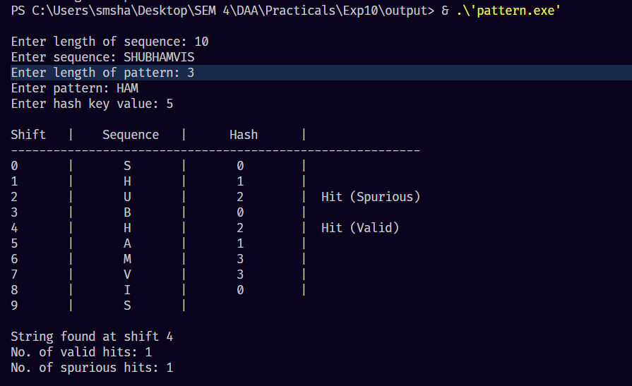
RESULT:

CONCLUSION : |  | Rabin-Karp algorithm can be used to check image similarity based on hash value calculation. The way the calculation works is the same as that done to string matching. Hence we achieved the aim of the experiment.

