NAME: | Shubham Vishwakarma
UID No. | 2021700071
BRANCH: | S.Y CSE-DS
BATCH: | D
SUBJECT | Design and Analysis of Algorithms
EXPERIMENT No. | 1A
Date of Performance | 25/01/2023
Date of Submission | 30/01/2023

AIM: | To implement the various functions e.g. linear, non-linear, quadratic, exponential etc.
Program 1
PROBLEM STATEMENT : | For this experiment, you have to implement at least 10 functions from the  list.  The input (i.e. n) to all the above functions varies from 0 to 100 with increment of 1. Then add the function n! in the  list and execute the same for n from 0 to 20
ALGORITHM/  THEORY: | Theory:  Algorithm is a step-by-step procedure, which defines a set of instructions to be executed in a certain order to get the desired output. Algorithms are generally created independent of underlying languages, i.e. an algorithm can be implemented in more than one programming language.  From the data structure point of view, following are some important categories of algorithms −  - Search − Algorithm to search an item in a data structure.  - Sort − Algorithm to sort items in a certain order.  - Insert − Algorithm to insert item in a data structure.  - Update − Algorithm to update an existing item in a data structure.  - Delete − Algorithm to delete an existing item from a data structure.  Algorithm:  Step 1: Create 10 function from the given list of functions.  Step 2: Run for values from 0 to 100 in the gap of 10 numbers.  Step 3: Note the corresponding value of the function  Step 4: Implement the 11th function of factorial from 0 to 20 in the gap 2 numbers.  Step 3: Plot the graph of x values to the f(x) values.
PROGRAM: | #include <stdio.h>  #include <math.h>  double fun1(double n)  {  return log(n);  }  double fun2(double n)  {  return n * log2(n);  }  double fun3(double n)  {  return n;  }  double fun4(double n)  {  return log2(log2(n));  }  double fun5(double n)  {  return pow(sqrt(2), log2(n));  }  double fun6(double n)  {  return pow(2, log2(n));  }  double fun7(double n)  {  return pow(2, sqrt(2 * log2(n)));  }  double fun8(double n)  {  return sqrt(log2(n));  }  double fun9(double n)  {  return log2(n);  }  double fun10(double n)  {  return pow(n, 1 / log2(n));  }  double fun11(double n)  {  double fac = 1;  for (int i = 1; i <= n; i++)  {  fac = fac * i;  }  return fac;  }  void main()  {  int A[] = {0, 10, 20, 30, 40, 50, 60, 70, 80, 90, 100};  printf("\nX\tFun_1\tFun_2\tFun_3\tFun_4\tFun_5\tFun_6\tFun_7\tFun_8\tFun_9\tFun_10\n\n");  for (int i = 0; i <= 10; i++)  {  printf("%d ", A[i]);  printf("\t");  printf("%0.2f", fun1(A[i]));  printf("\t");  printf("%0.2f", fun2(A[i]));  printf("\t");  printf("%0.2f", fun3(A[i]));  printf("\t");  printf("%0.2f", fun4(A[i]));  printf("\t");  printf("%0.2f", fun5(A[i]));  printf("\t");  printf("%0.2f", fun6(A[i]));  printf("\t");  printf("%0.2f", fun7(A[i]));  printf("\t");  printf("%0.2f", fun8(A[i]));  printf("\t");  printf("%0.2f", fun9(A[i]));  printf("\t");  printf("%0.2f\n", fun10(A[i]));  }  printf("\nX\tFun_11\n");  for (int i = 0; i <= 20; i += 2)  {  printf("%d ", i);  printf("\t");  printf("%0.2f\n", fun11(i));  }  }
RESULT:
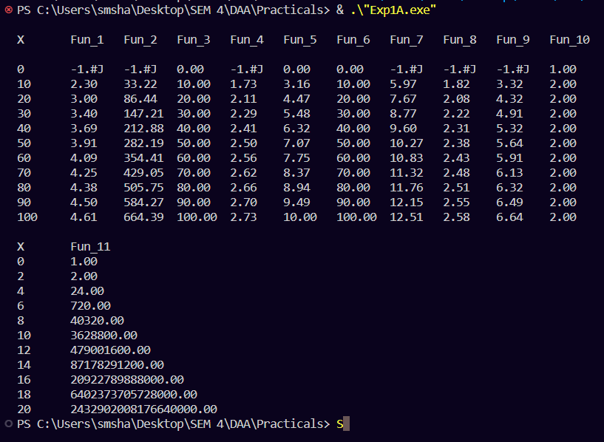

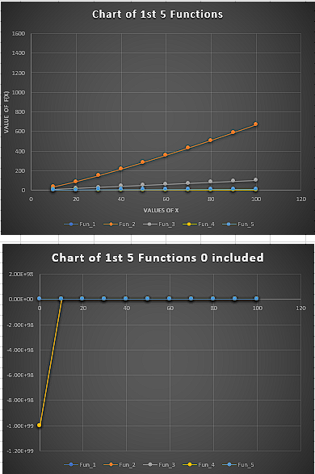

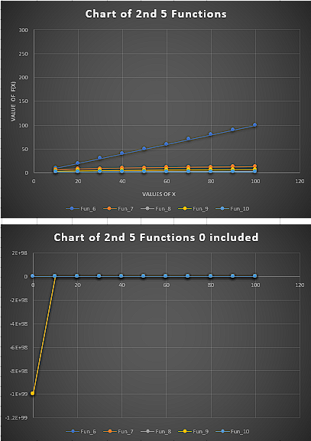

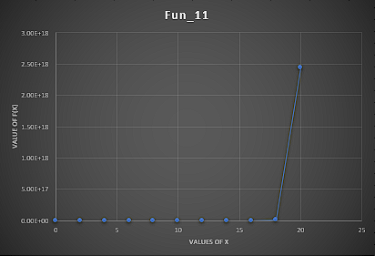

Graph of factorial function

CONCLUSION : |  | By studying the behaviour graph of different functions we can conclude that the straight line passing through origin have functions directly proportional to n elements values. The curves below the straight line have less values of f(x) corresponding to x values, hence the lower curve function are less complex and efficient to execute. The curves above the straight have more value of f(x) corresponding to x values, thus are very complex and takes more time to execute.

