NAME: | Shubham Vishwakarma
UID No. | 2021700071
BRANCH: | S.Y CSE-DS
BATCH: | D
SUBJECT | Design and Analysis of Algorithms
EXPERIMENT No. | 9
Date of Performance | 18/04/2023
Date of Submission | 23/04/2023

AIM: | Approximation algorithms (Travelling Salesman Problem)
Program 1
PROBLEM STATEMENT : | Implement the Travelling Salesman algorithm for the given scenario.
ALGORITHM/  THEORY: | 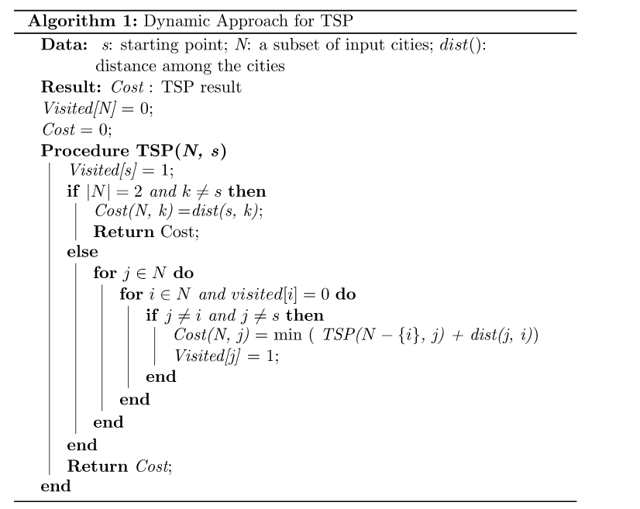
PROGRAM: | #include<stdio.h>  int ary[10][10],completed[10],n,cost=0;  void takeInput()  {  int i,j;  printf("Enter the number of villages: ");  scanf("%d",&n);  printf("\nEnter the Cost Matrix\n");  for(i=0;i < n;i++)  {  printf("\nEnter Elements of Row: %d\n",i+1);  for( j=0;j < n;j++)  scanf("%d",&ary[i][j]);  completed[i]=0;  }  printf("\n\nThe cost list is:");  for( i=0;i < n;i++)  {  printf("\n");  for(j=0;j < n;j++)  printf("\t%d",ary[i][j]);  }  }  void mincost(int city)  {  int i,ncity;  completed[city]=1;  printf("%d--->",city+1);  ncity=least(city);  if(ncity==999)  {  ncity=0;  printf("%d",ncity+1);  cost+=ary[city][ncity];  return;  }  mincost(ncity);  }  int least(int c)  {  int i,nc=999;  int min=999,kmin;  for(i=0;i < n;i++)  {  if((ary[c][i]!=0)&&(completed[i]==0))  if(ary[c][i]+ary[i][c] < min)  {  min=ary[i][0]+ary[c][i];  kmin=ary[c][i];  nc=i;  }  }  if(min!=999)  cost+=kmin;  return nc;  }  int main()  {  takeInput();  printf("\n\nThe Path is:\n");  mincost(0); //passing 0 because starting vertex  printf("\n\nMinimum cost is %d\n ",cost);  return 0;  }
RESULT:
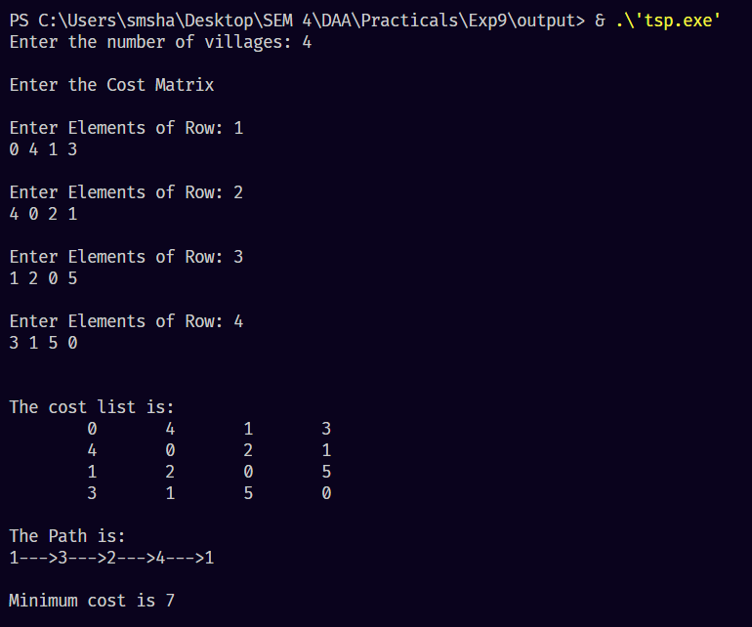

CONCLUSION : |  | The traveling salesman problem is a permutation problem in which the goal is to find the shortest path between N different cities that the salesman takes is called the TOUR. In other words, the problem deals with finding a route covering all cities so that the total distance traveled is minimal.

