NAME: | Shubham Vishwakarma
UID No. | 2021700071
BRANCH: | S.Y CSE-DS
BATCH: | D
SUBJECT | Design and Analysis of Algorithms
EXPERIMENT No. | 1A
DATE: | 25/01/2023
AIM: | To implement the various functions e.g. linear, non-linear, quadratic, exponential etc.
PROGRAM: | #include <stdio.h>  #include <math.h>  double fun1(double n)  {  return log(n);  }  double fun2(double n)  {  return n * log2(n);  }  double fun3(double n)  {  return n;  }  double fun4(double n)  {  return log2(log2(n));  }  double fun5(double n)  {  return pow(sqrt(2), log2(n));  }  double fun6(double n)  {  return pow(2, log2(n));  }  double fun7(double n)  {  return pow(2, sqrt(2 * log2(n)));  }  double fun8(double n)  {  return sqrt(log2(n));  }  double fun9(double n)  {  return log2(n);  }  double fun10(double n)  {  return pow(n, 1 / log2(n));  }  double fun11(double n)  {  double fac = 1;  for (int i = 1; i <= n; i++)  {  fac = fac * i;  }  return fac;  }  void main()  {  int A[] = {0, 10, 20, 30, 40, 50, 60, 70, 80, 90, 100};  printf("\nX\tFun_1\tFun_2\tFun_3\tFun_4\tFun_5\tFun_6\tFun_7\tFun_8\tFun_9\tFun_10\n\n");  for (int i = 0; i <= 10; i++)  {  printf("%d ", A[i]);  printf("\t");  printf("%0.2f", fun1(A[i]));  printf("\t");  printf("%0.2f", fun2(A[i]));  printf("\t");  printf("%0.2f", fun3(A[i]));  printf("\t");  printf("%0.2f", fun4(A[i]));  printf("\t");  printf("%0.2f", fun5(A[i]));  printf("\t");  printf("%0.2f", fun6(A[i]));  printf("\t");  printf("%0.2f", fun7(A[i]));  printf("\t");  printf("%0.2f", fun8(A[i]));  printf("\t");  printf("%0.2f", fun9(A[i]));  printf("\t");  printf("%0.2f\n", fun10(A[i]));  }  printf("\nX\tFun_11\n");  for (int i = 0; i <= 20; i += 2)  {  printf("%d ", i);  printf("\t");  printf("%0.2f\n", fun11(i));  }  }
RESULT: | 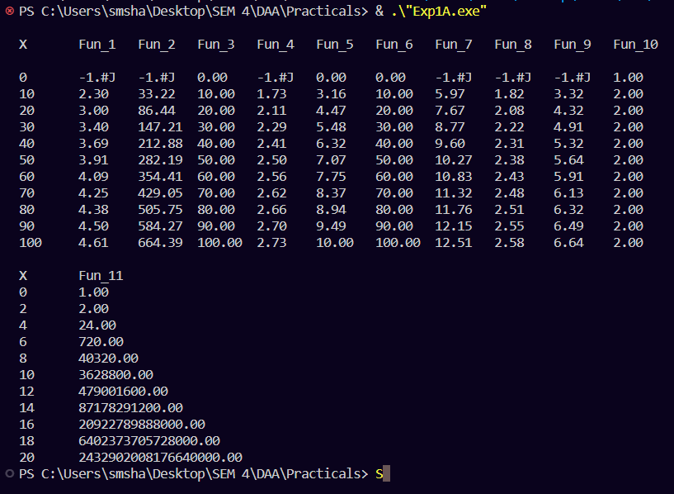  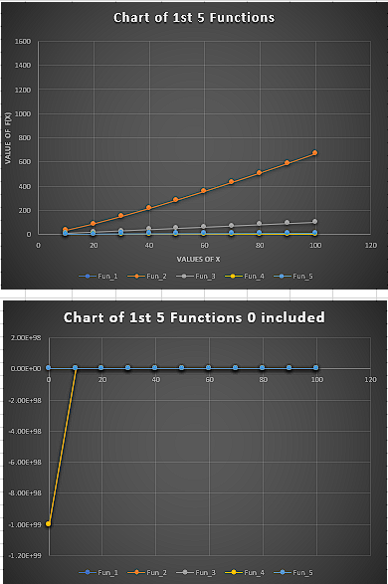  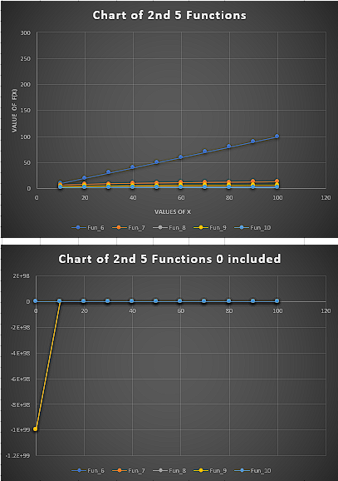  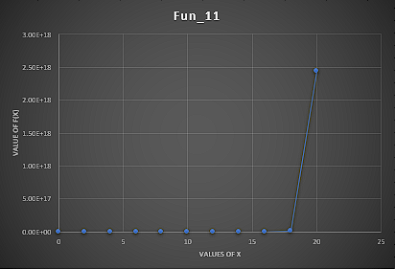
CONCLUSION: | By studying the behaviour graph of different functions we can conclude that the straight line passing through origin have time complexity of O(n), proportional to n elements. The curves below the straight line have time complexiy less than O(n), hence the lower curve function are less complex and efficient to execute. The curves above the straight have time complexity greater than O(n), thus are very complex and takes more time to execute.

