NAME: | Shubham Vishwakarma
UID No. | 2021700071
BRANCH: | S.Y CSE-DS
BATCH: | D
SUBJECT | Design and Analysis of Algorithms
EXPERIMENT No. | 7
Date of Performance | 10/04/2023
Date of Submission | 14/04/2023

AIM: | Backtracking (To implement N Queens problem using backtracking.)
Program 1
PROBLEM STATEMENT : | Implement the N queen problem for 4x4 chess board.
ALGORITHM/  THEORY: | Step 1 - Place the queen row-wise, starting from the left-most cell.  Step 2 - If all queens are placed then return true and print the solution matrix.  Step 3 - Else try all columns in the current row.  - Condition 1 - Check if the queen can be placed safely in this column then mark the current cell [Row, Column] in the solution matrix as 1 and try to check the rest of the problem recursively by placing the queen here leads to a solution or not.  - Condition 2 - If placing the queen [Row, Column] can lead to the solution return true and print the solution for each queen's position.  - Condition 3 - If placing the queen cannot lead to the solution then unmark this [row, column] in the solution matrix as 0, BACKTRACK, and go back to condition 1 to try other rows.  Step 4 - If all the rows have been tried and nothing worked, return false to trigger backtracking.
PROGRAM: | #include<stdio.h>  int board[100][100];  int safe(int r,int c,int n){  for(int i=0;i<r;i++){  if(board[i][c] == 1)  return 0;  }  for(int i=r,j=c;i>=0 && j>=0;i--,j--){  if(board[i][j] == 1)  return 0;  }  for(int i=r,j=c;i>=0 && j<n;i--,j++){  if(board[i][j] == 1)  return 0;  }  return 1;  }  void printsol(int n){  for(int i=0;i<n;i++){  for(int j=0;j<n;j++){  if(board[i][j]==1){  printf("Q ");  }  else  printf("_ ");  }  printf("\n");  }  printf("\n");  }  void position(int n,int r){  if(r>=n){  printsol(n);  return;  }  for(int i=0;i<n;i++){  if(safe(r,i,n)){  board[r][i] = 1;  position(n,r+1);  board[r][i] = 0;  }  }  }  int main(){  int n;  printf("\nEnter the size of the board: ");  scanf("%d",&n);  printf("\nThe possible outputs are: \n");  position(n,0);  }
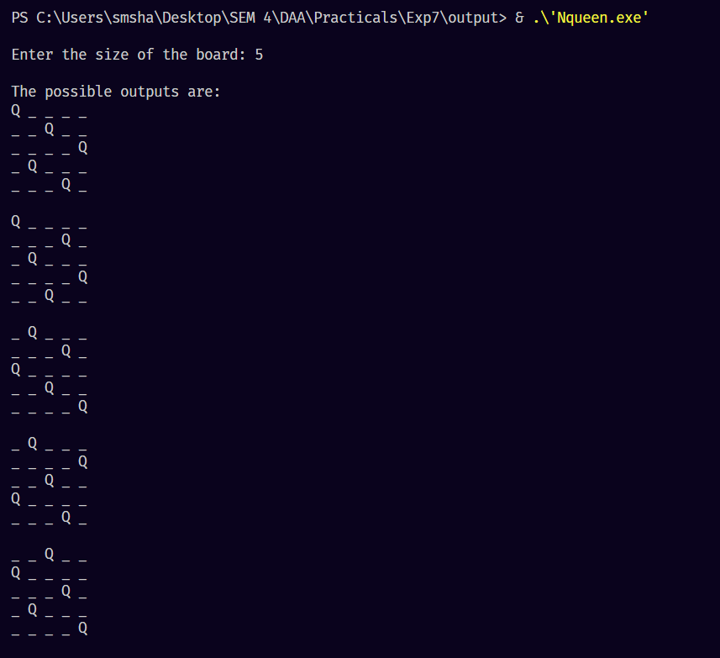
RESULT:

CONCLUSION : |  | - N Queen problem is a classical puzzle that beautifully develops the concept of Backtracking.  - The time complexity of the brute force backtracking algorithm is O(N×N!)O(N×N!). However, using bitmasking the time complexity can be optimized to O(N!)O(N!).  - The space complexity irrespective of the approach is O(N2)O(N2) because we need to print a 2-dimensional array as the answer.

