NAME: | Shubham Vishwakarma
UID No. | 2021700071
BRANCH: | S.Y CSE-DS
BATCH: | D
SUBJECT | Design and Analysis of Algorithms
EXPERIMENT No. | 6
Date of Performance | 28/03/2023
Date of Submission | 30/03/2023

AIM: | Prim’s Algorithm Implementation
Program 1
PROBLEM STATEMENT : | Implement the prim’s algorithm for the given graph.
ALGORITHM/  THEORY: | Step 1: Determine an arbitrary vertex as the starting vertex of the MST.  Step 2: Follow steps 3 to 5 till there are vertices that are not included in the MST (known as fringe vertex).  Step 3: Find edges connecting any tree vertex with the fringe vertices.  Step 4: Find the minimum among these edges.  Step 5: Add the chosen edge to the MST if it does not form any cycle.  Step 6: Return the MST and exit
PROGRAM: | #include <limits.h>  #include <stdbool.h>  #include <stdio.h>  #define V 5  int minKey(int key[], bool mstSet[])  {  int min = INT_MAX, min_index;  for (int v = 0; v < V; v++)  if (mstSet[v] == false && key[v] < min)  min = key[v], min_index = v;  return min_index;  }  int printMST(int parent[], int graph[V][V])  {  printf("Edge \tWeight\n");  for (int i = 1; i < V; i++){  printf("%d - %d \t%d \n", parent[i], i,graph[i][parent[i]]);  }  }  void primMST(int graph[V][V])  {  int parent[V];  int key[V];  bool mstSet[V];  for (int i = 0; i < V; i++)  key[i] = INT_MAX, mstSet[i] = false;  key[0] = 0;  parent[0] = -1;  for (int count = 0; count < V - 1; count++)  {  int u = minKey(key, mstSet);  mstSet[u] = true;  for (int v = 0; v < V; v++)  if (graph[u][v] && mstSet[v] == false  && graph[u][v] < key[v])  parent[v] = u, key[v] = graph[u][v];  }  // print the constructed MST  printMST(parent, graph);  }  int main()  {  int graph[V][V] = { { 0, 2, 0, 6, 0 },  { 2, 0, 3, 8, 5 },  { 0, 3, 0, 0, 7 },  { 6, 8, 0, 0, 9 },  { 0, 5, 7, 9, 0 } };  // Print the solution  primMST(graph);  return 0;  }
RESULT:

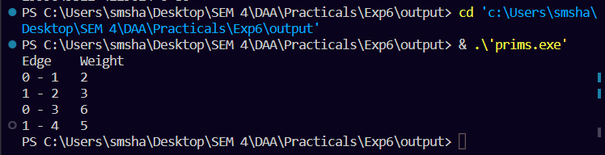

CONCLUSION : |  | It does this by using a greedy approach of selecting the minimum cost edge for every vertex. The time complexity for the algorithm depends on the data structure used to implement it. Prims Algorithm is favored over Krushkal's to find MST when the graph is dense.

