NAME: | Shubham Vishwakarma
UID No. | 2021700071
BRANCH: | S.Y CSE-DS
BATCH: | D
SUBJECT | Design and Analysis of Algorithms
EXPERIMENT No. | 3
Date of Performance | 28/02/2023
Date of Submission | 02/03/2023

AIM: | Experiment based on divide and conquer approach.
Program 1
PROBLEM STATEMENT : | Implement Strassen’s Matrix Multiplication algorithm and compare it with  standard matrix multiplication.
ALGORITHM/  THEORY: | Let us consider two matrices X and Y. We want to calculate the resultant matrix Z by multiplying X and Y.  Naïve Method  First, we will discuss naïve method and its complexity. Here, we are calculating Z = X × Y. Using Naïve method, two matrices (X and Y) can be multiplied if the order of these matrices are p × q and q × r. Following is the algorithm.  Algorithm: Matrix-Multiplication (X, Y, Z)  for i = 1 to p do  for j = 1 to r do  Z[i,j] := 0  for k = 1 to q do  Z[i,j] := Z[i,j] + X[i,k] × Y[k,j]  Complexity  Here, we assume that integer operations take O(1) time. There are three for loops in this algorithm and one is nested in other. Hence, the algorithm takes O(n³) time to execute.  Strassen’s Matrix Multiplication Algorithm  In this context, using Strassen’s Matrix multiplication algorithm, the time consumption can be improved a little bit.  Strassen’s Matrix multiplication can be performed only on square matrices where n is a power of 2. Order of both of the matrices are n × n.  Divide X, Y and Z into four (n/2)×(n/2) matrices as represented below −  Z=[IKJL]  X=[ACBD] and Y=[EGFH]  Using Strassen’s Algorithm compute the following −  M1:=(A+C)×(E+F)  M2:=(B+D)×(G+H)  M3:=(A−D)×(E+H)  M4:=A×(F−H)  M5:=(C+D)×(E)  M6:=(A+B)×(H)  M7:=D×(G−E)  Then,  I:=M2+M3−M6−M7  J:=M4+M6  K:=M5+M7  L:=M1−M3−M4−M5  Analysis  T(n)={c7xT(n2)+dxn2ifn=1otherwise  where c and d are constants  Using this recurrence relation, we get T(n)=O(nlog7)  Hence, the complexity of Strassen’s matrix multiplication algorithm is O(nlog7)
PROGRAM: | #include<stdio.h>  int main(){  int a[2][2], b[2][2], c[2][2], i, j;  int m1, m2, m3, m4 , m5, m6, m7;  printf("\nEnter the elements of first matrix 2x2\n\n");  for(i = 0;i < 2; i++)  {  for(j = 0;j < 2; j++)  {  printf("Enter the element %d%d: ",i,j);  scanf("%d", &a[i][j]);  }  }  printf("\nEnter the elements of second matrix 2x2\n\n");  for(i = 0;i < 2; i++)  {  for(j = 0;j < 2; j++)  {  printf("Enter the element %d%d: ",i,j);  scanf("%d", &b[i][j]);  }  }  printf("\nThe first matrix is\n\n");  for(i = 0; i < 2; i++)  {  printf("|");  printf("\t");  for(j = 0; j < 2; j++)  {  printf("%d\t", a[i][j]);  }  printf("| ");  printf("\n");  }  printf("\nThe second matrix is\n\n");  for(i = 0; i < 2; i++)  {  printf("|");  printf("\t");  for(j = 0; j < 2; j++)  {  printf("%d\t", b[i][j]);  }  printf("| ");  printf("\n");  }  m1= (a[0][0] + a[1][1]) * (b[0][0] + b[1][1]);  m2= (a[1][0] + a[1][1]) * b[0][0];  m3= a[0][0] * (b[0][1] - b[1][1]);  m4= a[1][1] * (b[1][0] - b[0][0]);  m5= (a[0][0] + a[0][1]) * b[1][1];  m6= (a[1][0] - a[0][0]) * (b[0][0]+b[0][1]);  m7= (a[0][1] - a[1][1]) * (b[1][0]+b[1][1]);  c[0][0] = m1 + m4- m5 + m7;  c[0][1] = m3 + m5;  c[1][0] = m2 + m4;  c[1][1] = m1 - m2 + m3 + m6;  printf("\nAfter multiplication using Strassen's algorithm \n\n");  for(i = 0; i < 2; i++)  {  printf("|");  printf("\t");  for(j = 0; j < 2; j++)  {  printf("%d\t", c[i][j]);  }  printf("| ");  printf("\n");  }  return 0;  }
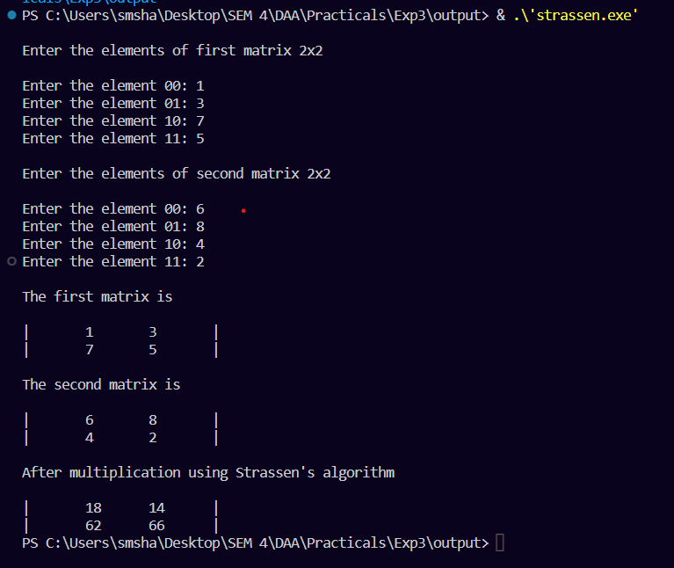
RESULT:

Self-analysis:

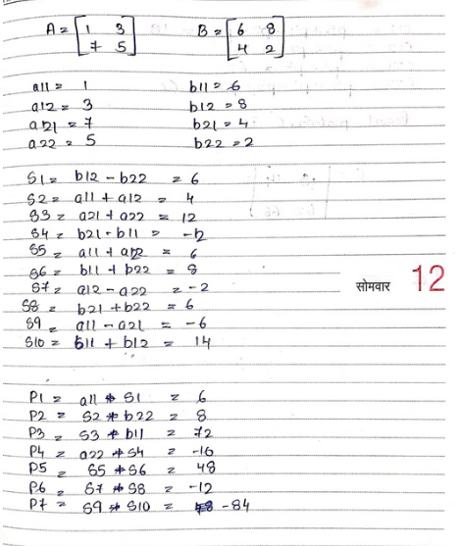

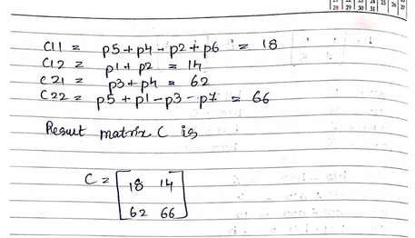

CONCLUSION : |  | Strassen's Matrix Multiplication, SMM, is used to multiply two matrices, and it is better than Native matrix multiplication. due to the fact that SMM's has a complexity of around whereas usual multiplication's complexity is .  The reason for this is because the number of operations required in SMM is less than in usual multiplication.  While usual multiplication requires 8 multiplications and 4 additions SMM requires 7 multiplications and 18 additions.

