NAME: | Shubham Vishwakarma
UID No. | 2021700071
BRANCH: | S.Y CSE-DS
BATCH: | D
SUBJECT | Design and Analysis of Algorithms
EXPERIMENT No. | 5
Date of Performance | 13/03/2023
Date of Submission | 19/03/2023

AIM: | Dynamic Programming -Matrix Chain Multiplication
Program 1
PROBLEM STATEMENT : | Implement the matrix chain multiplication algorithm for the given problem statement.
ALGORITHM/  THEORY: | Matrix chain multiplication (or Matrix Chain Ordering Problem, MCOP) is an optimization problem that to find the most efficient way to multiply a given sequence of matrices. The problem is not actually to perform the multiplications but merely to decide the sequence of the matrix multiplications involved.  The matrix multiplication is associative as no matter how the product is parenthesized, the result obtained will remain the same. For example, for four matrices A, B, C, and D, we would have:  ((AB)C)D = ((A(BC))D) = (AB)(CD) = A((BC)D) = A(B(CD))  However, the order in which the product is parenthesized affects the number of simple arithmetic operations needed to compute the product. For example, if A is a 10 × 30 matrix, B is a 30 × 5 matrix, and C is a 5 × 60 matrix, then computing (AB)C needs (10×30×5) + (10×5×60) = 1500 + 3000 = 4500 operations while computing A(BC) needs (30×5×60) + (10×30×60) = 9000 + 18000 = 27000 operations. Clearly, the first method is more efficient.  MATRIX-CHAIN-ORDER (p)  1. n length[p]-1  2. for i ← 1 to n  3. do m [i, i] ← 0  4. for l ← 2 to n // l is the chain length  5. do for i ← 1 to n-l + 1  6. do j ← i+ l -1  7. m[i,j] ← ∞  8. for k ← i to j-1  9. do q ← m [i, k] + m [k + 1, j] + p_{i-1} p_{k} p_{j}  10. If q < m [i,j]  11. then m [i,j] ← q  12. s [i,j] ← k  13. return m and s.
PROGRAM: | Recursive Approach:  #include <stdio.h>  #include <limits.h>  #include <stdio.h>  int MatrixChainOrder(int p[], int i, int j)  {  if (i == j)  return 0;  int k;  int min = INT_MAX;  int count;  for (k = i; k < j; k++) {  count = MatrixChainOrder(p, i, k) +  MatrixChainOrder(p, k + 1, j) +  p[i - 1] * p[k] * p[j];  if (count < min)  min = count;  }  return min;  }  int main()  {  int arr[] = { 2, 4, 6, 8, 6 };  int n = sizeof(arr) / sizeof(arr[0]);  printf("\nUsing recursion and optimal subtree solution");  printf("\nMinimum number of multiplications is %d\n ",MatrixChainOrder(arr, 1, n - 1));  return 0;  }  Dynamic Programming Approach:  #include <stdio.h>  #include <limits.h>  #include <stdio.h>  int m[10][10];  int MatrixChainOrder(int p[], int n)  {  //int m[n][n];  int i, j, k, L, q;  // cost is zero when multiplying one matrix.  for (i = 1; i < n; i++)  m[i][i] = 0;  // L is chain length.  for (L = 2; L < n; L++) {  for (i = 1; i < n - L + 1; i++) {  j = i + L - 1;  m[i][j] = INT_MAX;  for (k = i; k <= j - 1; k++) {  // q = cost/scalar multiplications  q = m[i][k] + m[k + 1][j] + p[i - 1] * p[k] * p[j];  if (q < m[i][j])  m[i][j] = q;  }  }  }  printf("\n");  for (int i = 1; i < n; i++)  {  for (int j = 1; j < n; j++)  {  if (i<=j)  {  printf("\t\t%d",m[i][j]);  }  else  printf("\t\t0");  }  printf("\n");  }  return m[1][n - 1];  }  int main()  {  int arr[] = { 2 ,4 ,6 ,8 ,6 };  int size = sizeof(arr) / sizeof(arr[0]);  printf("\nUsing dynamic programming approach");  printf("\nMinimum number of multiplications is %d\n ",MatrixChainOrder(arr, size));  return 0;  }
RESULT:

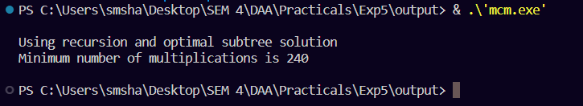

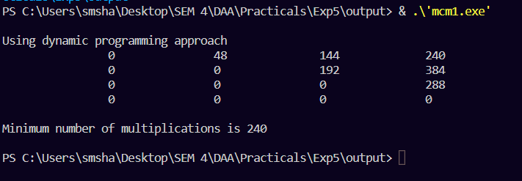

Self-analysis:

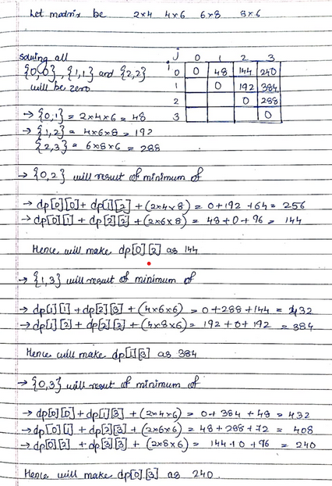

CONCLUSION : |  | In the matrix chain multiplication problem, the minimum number of multiplication steps required to multiply a chain of matrices has been calculated.  Determining the minimum number of steps required can highly speed up the multiplication process.  It takes O(n3) time and O(n2) auxiliary space to calculate the minimum number of steps required to multiply a chain of matrices using the dynamic programming method.

