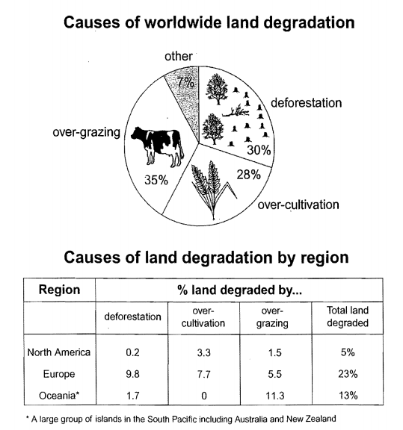

The graph given illustrates the reasons for gobal land degradation and distribution of various factors contributing to the land degradation in specefic three areas.

Obviously,the over-grazing stood out to be the dominant reason accounting for the world land degradation,at 30 percent,followed by the deforestation and the over-cultivation which almost shared the same percentage of that,with 30 percent and 28 percent,respectively.Additionally, they were 5 percent and 7 percent less than that of over-graving.What came to the least were some other reasons lead to worldwide land degardation,only took up 7 percent,which was one fifth of over-grazing.

When it came to the concrete areas which was undergoing land degradation, the predominant counterpart was the Europe, with 25 percent of the land degrated in total,consituted with 9.8 percent destoryed by deforestation, 7.7 percent by over-cultivation and 5.5 percent by over-grazing.Alough the Oceania took the second place, at 13 percent,but the palce which was threaten by the over-grazing reached the highest percentage of 11.3,meanwhile, the factor of over-cultivation was even zero.Besides, the remainder was the deforestation, which took up 1.7 percent.The last but not the least, the North America was the least polluted area, owning only 5 percentage of land facing the degradation.The reasons were ranging from 0.2 percent to 3.3 percent.

Above all, the Europe faced with the largest land pollution,while the North America was the least polluted area.When it came to gobal land degradation,the over-grazing accounted for most,while the remainder took the least.