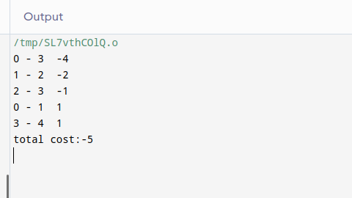
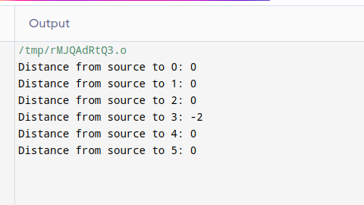

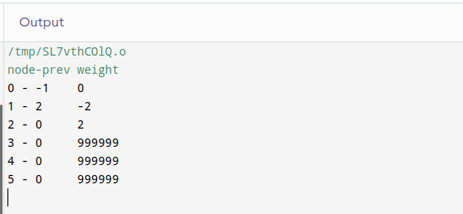

What I inferred from the outputs of the three uploaded codes is, none of the three algorithms work for the given directed negative weighted graph.

As I have learnt data structures in C, I found it easy to use the same for the given problems too.

Vikas
21011102118
IOT-B

