­­ADM – Homework4

*Giacomo Parmendola(1462237)*

*Vigèr Durand Azimedem Tsafack(1792126)*

*Mattia Podio()*

* **First Step**: Graph creation

1. Here we process the JSON file and create a graph with all the authors as nodes. Two nodes are connected if they share, at least, one publication and the weight of an edge is computed in this way: $w(a1, a2) = 1 - J(p1, p2)$.

Find the python code in the file *graph_creation.py.*

*output:*



* **Second Step**: Some statistics

1. Given a conference in input, return the subgraph induced by the set of authors who published at the input conference at least once: Find the python code in the file *graph_creation.py*

First, we ask the user to insert some conference ID:



*Output graph:*

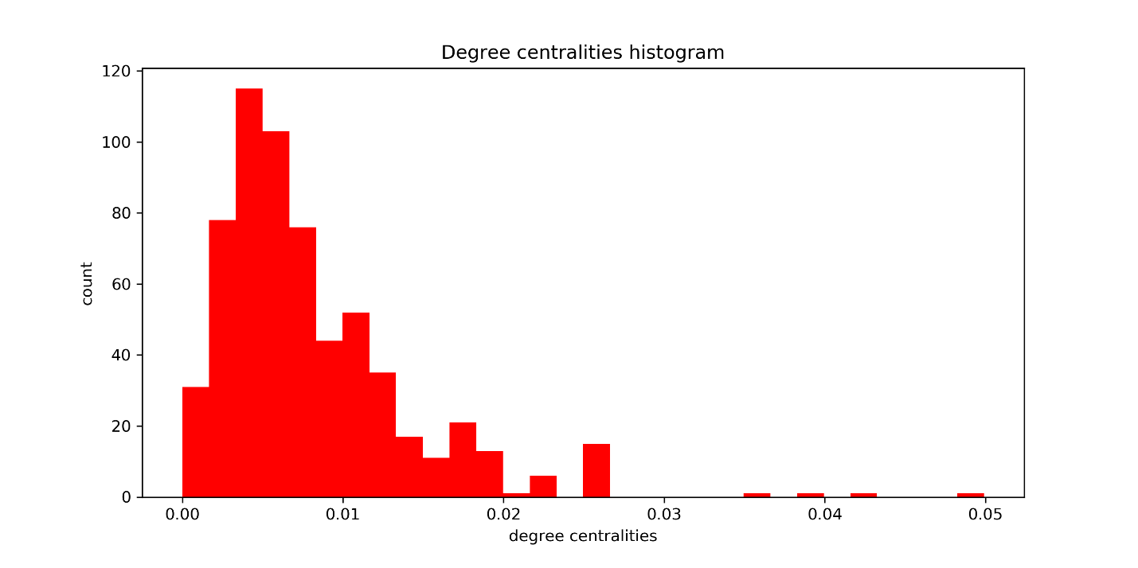

Degree is a simple centrality measure that counts how many neighbors a node has. Thus, A node is important if it has many neighbors. From this histogram, we can state that the probability for a node to be important is quite low while the probability for a node to be less important is pretty height.

degree centrality = 0.005 count = 115 low importance, height probability

degree centrality = 0.05 count = 1 height importance, low probability

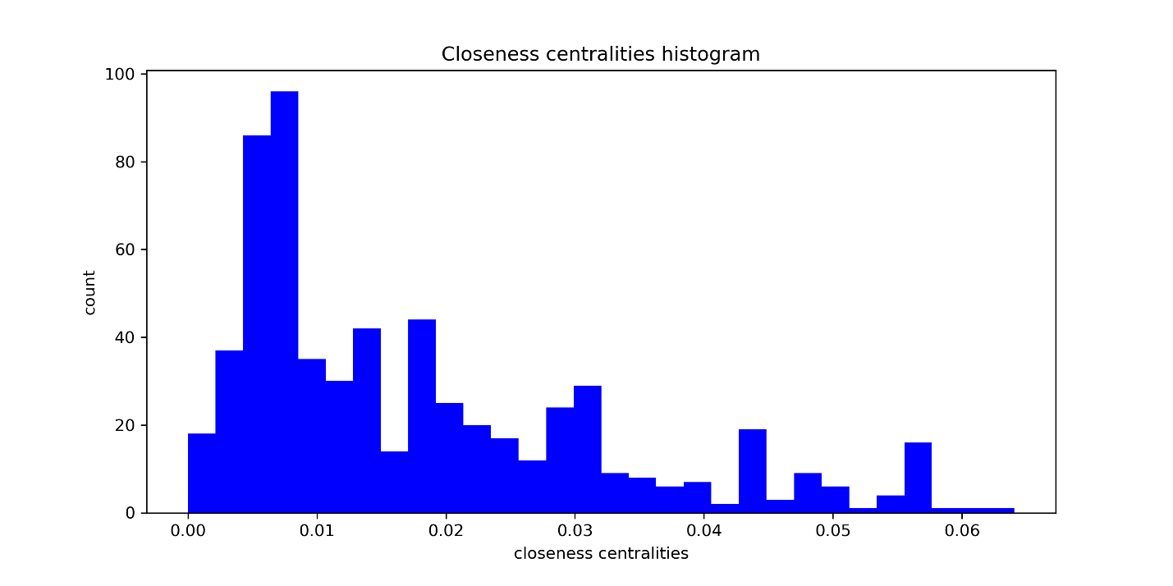

Closeness centrality measures the mean distance from a vertex to other vertices. it gives low values to more central nodes and high values to less central ones, which is the opposite of other centrality measures. Here the histogram shows that the probability for a node to be important according to the closeness centrality is height while the probability to be less important is low.

closeness centrality = 0.008 count = 95 height importance, height probability

closeness centrality = 0.06 count = 1 low importance, low probability

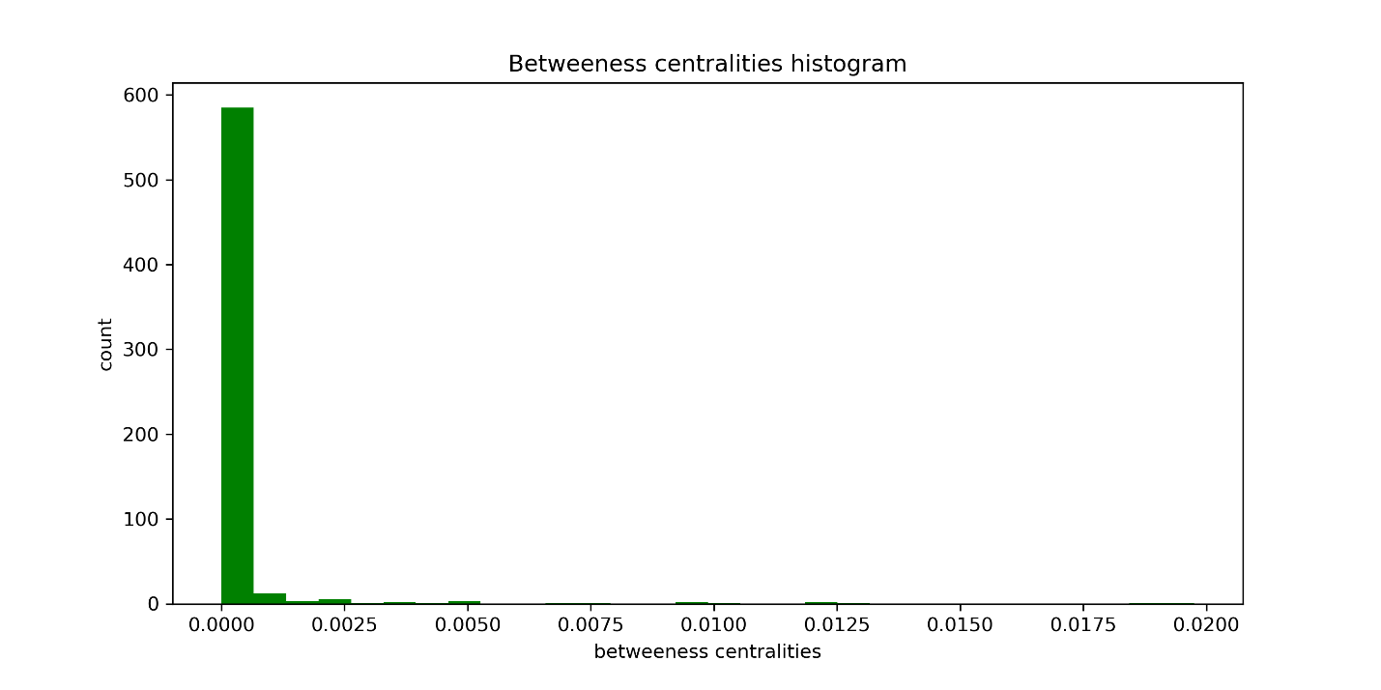

Betweenness centrality measures the extent to which a vertex lies on paths between other vertices. Vertices with high betweenness may have considerable influence within a network by virtue of their control over information passing between others. They are also the ones whose removal from the network will most disrupt communications between other vertices. Here looking at the histogram we can say that we are again in a case were the probability for a node to be important is quite low while the probability for a node to be less important is pretty height.

betweenness centrality = 0.001 count = 580 low importance, height probability

betweenness centrality = 0.0050 count = 1 height importance, low probability

We can generally say that two over three centrality measures (Degree and betweenness) follow the power law (Pareto principle also known as the 80/20 rule or the law of the vital few) which state that for many events, roughly 80% of the effects come from 20% of the causes. For example, 80% of Italy's land is owned by 20% of the population.

*Computation time:*



1. given in input an author and an integer d, get the subgraph induced by the nodes that have hop distance at most equal to *d* with the input author: find the python code in the file *graph_creation.py*.

First, we ask the user to insert some author ID:



And then we also ask the user for an integer *d* which is going to the max for the hop-distance:



*Output graph:*

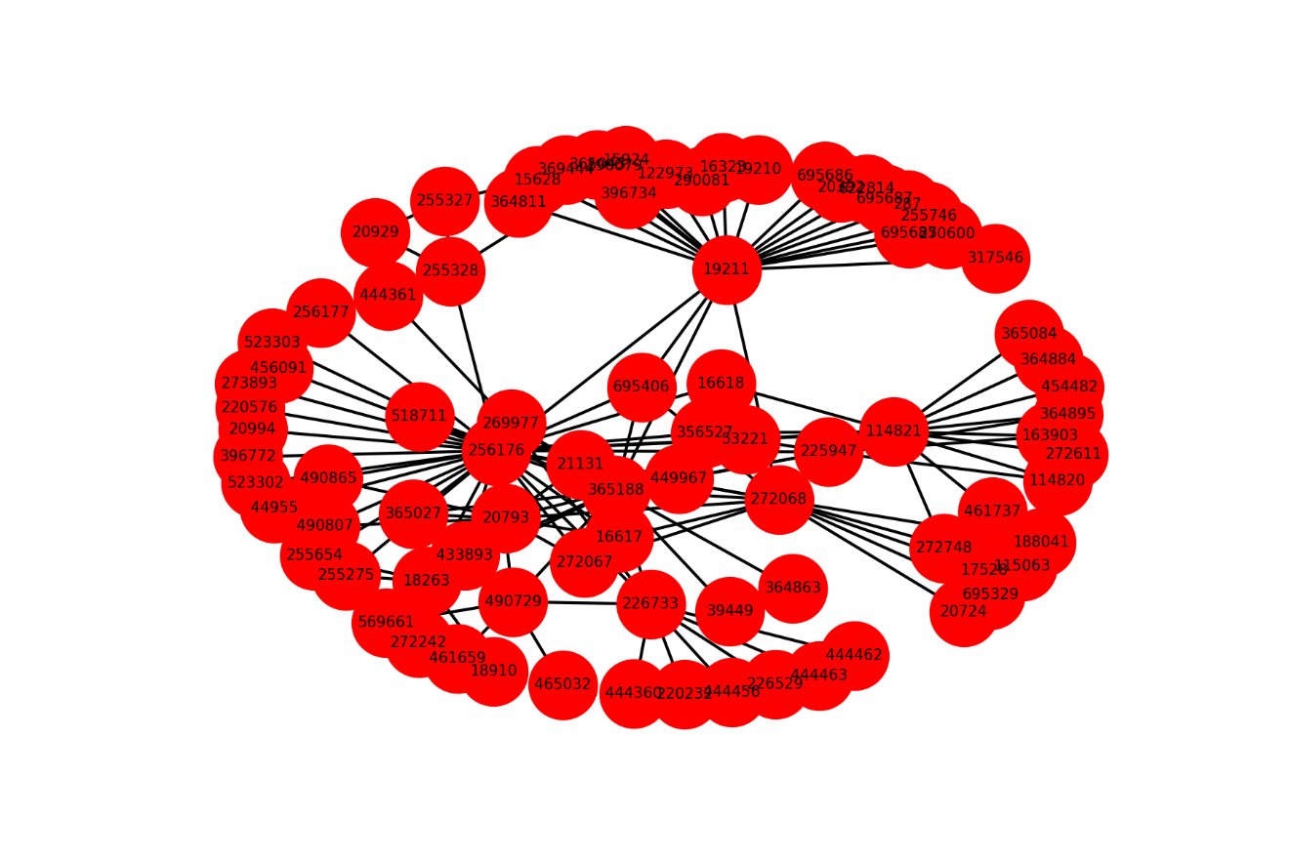



* **Third Step**: Erdős number

1. Here we compute the weight of the shortest path that connects some input author with Aris. We use as measure of distance the weight of the edges. Find the python code in the file *graph_creation.py* and the shortest_path function in the file *Libhw4.py*

First, we ask the user to insert some author ID:



And we call our shortest_path function which returns:



After that, we call the *nx.dijkstra_path_length* function which returns the same result with a little difference in the computation time.

Computation time of our function:



Computation time of the nx function:



1. Here we compute for each node of the graph, its GroupNumber, defined as follow: *GroupNumber(v) = minu∈I{ShortestPath(v,u)}.*

First, we ask the user to insert some author ID: