10/17/25
Start with LED light
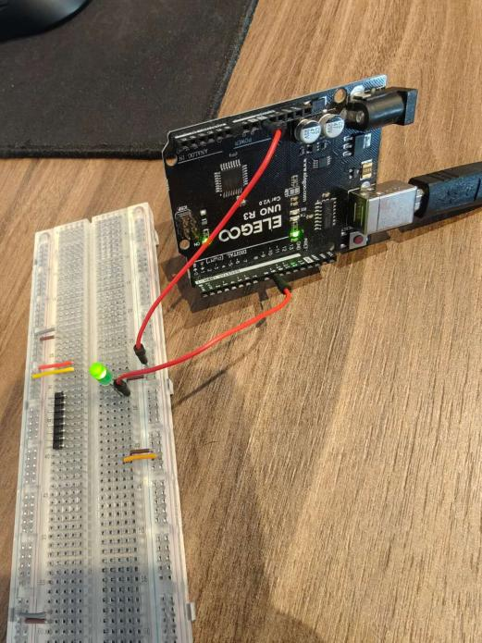

Install mpu6050libary
Start reading mpu6050 using mpu6050_tockn.h
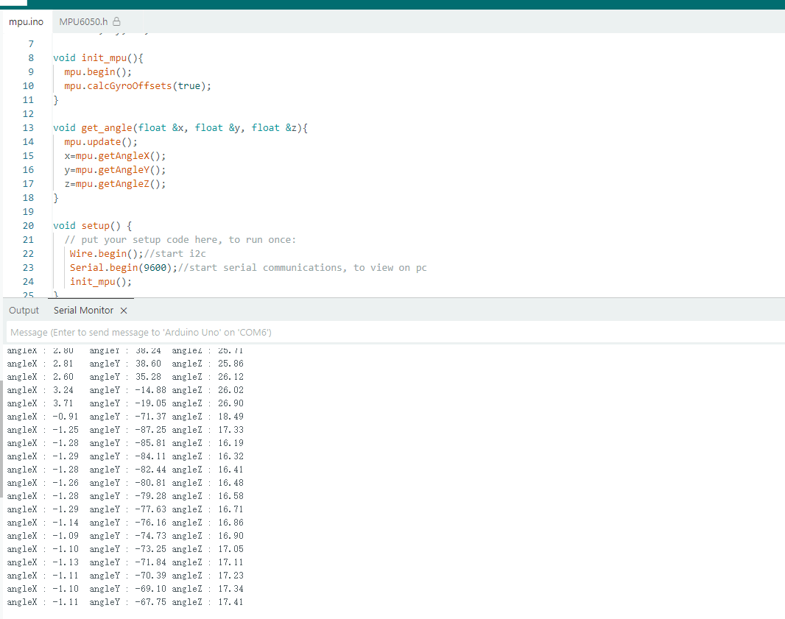

10/21
Draw the schemetic
Finish Gantt chart(from now to 2025/12/09)
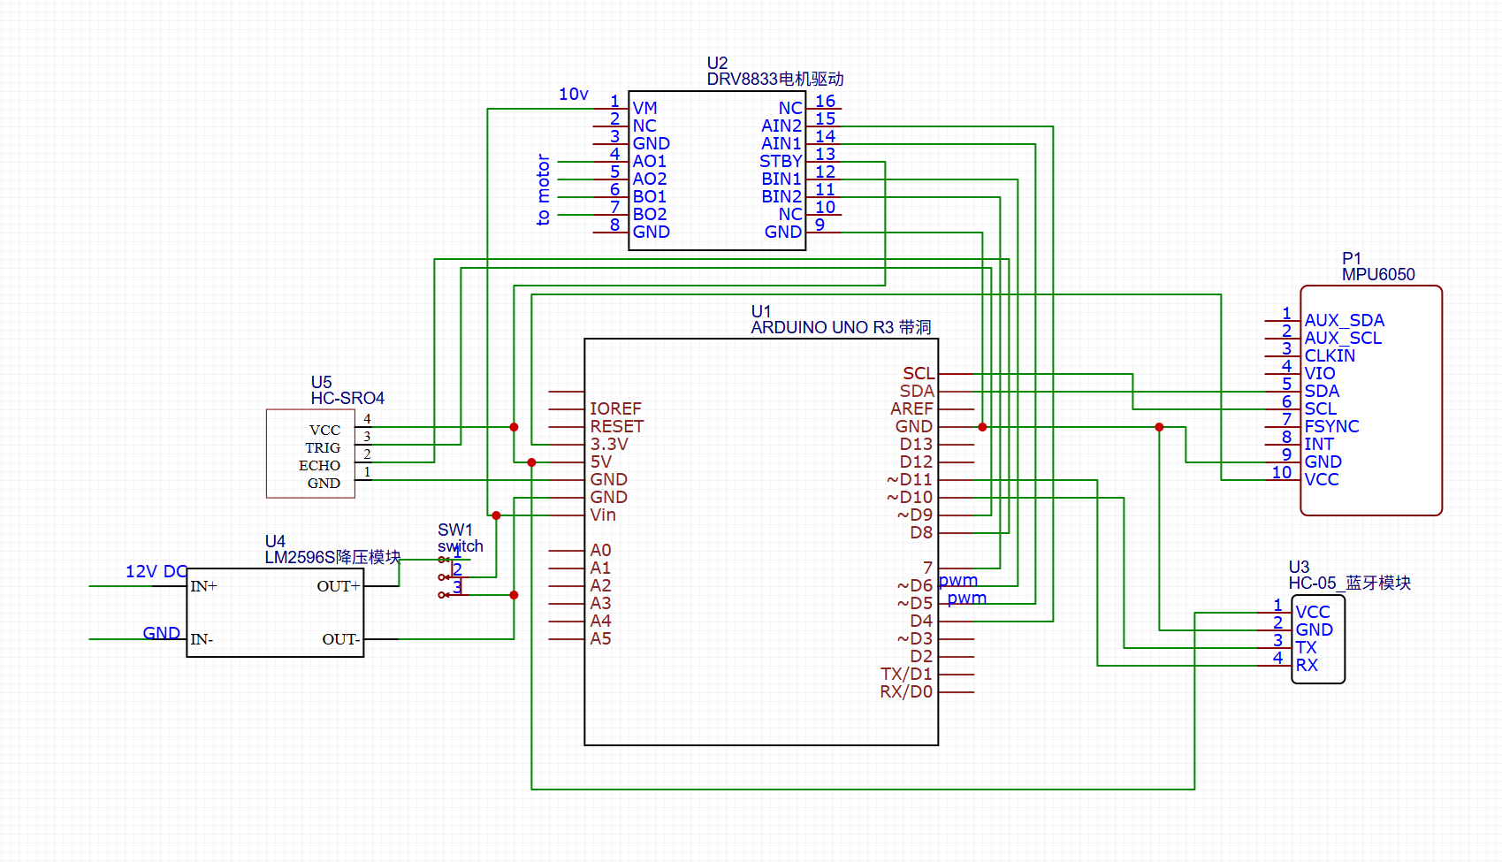

10/22/25
Meeting: update the progress,
Tutor said that give a mark scheme such as hold a cup of wine, and whatever the car move, the wine keeps no spil out.

10/24/25
- 实现了超声波HC-SRO4模块代码：可读取数据。
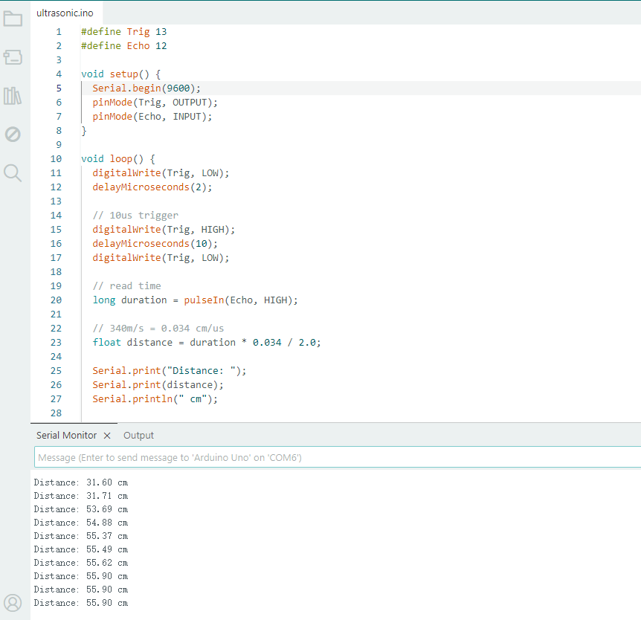

- 修改Mpu6050模块代码：
问题：当陀螺仪倾斜一定角度后再回到水平时，角度angle会缓慢回正，无法实时响应，判断是在主循环中调用mpu.update() 函数导致更新率太慢（因为加了delay（200）防止打印过快）
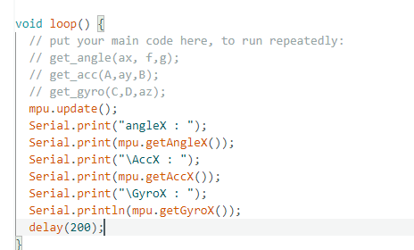
解决方法：使用计时器将update和打印隔开。millis() 返回自上电以来的毫秒数，判断now - lastPrint >= 50，50ms打印一次。但update的频率不受影响。

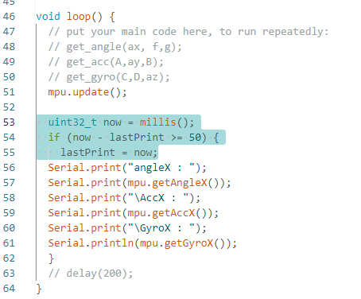

10/28/25
修改电机驱动型号，原来是DRV8833, 现采用TB6612电机驱动模块。
修改原理图，修改引脚连接。
完成电机驱动模块代码：
#define AIN1 12
#define AIN2 13
#define BIN1 7
#define BIN2 6
#define PWMA 11
#define PWMB 10
#define Start_PWMA 9//start compensation value A
#define Start_PWMB 10//start compensation value B

int PWM = 0;
int SCA = Start_PWMA;
int SCB = Start_PWMB;

void Motor_Init(){
pinMode(AIN1, OUTPUT);
pinMode(AIN2, OUTPUT);
pinMode(BIN1, OUTPUT);
pinMode(BIN2, OUTPUT);
pinMode(PWMA, OUTPUT);
pinMode(PWMB, OUTPUT);

}

void serial_Debug(){
while(Serial.available()){
char Receive_Char = Serial.read();//use keyboard to test
switch(Receive_Char){
case '1' : PWM++; break;
case '2' : PWM--; break;
case '0' : PWM = 0; break;

}
}
Serial.print("PWM:"); Serial.println(PWM);
}

void MOTOR_logic(int P1, int P2, int PWM_pin, int pwmx, int SC){
pwmx = constrain(pwmx, (-255+SC), (255-SC)); //set limit

if (pwmx == 0){
digitalWrite(P1, HIGH);
digitalWrite(P2, HIGH);
analogWrite(PWM_pin, 0);
}

if (pwmx > 0){ //forward rotation
digitalWrite(P1, HIGH);
digitalWrite(P2, LOW);
analogWrite(PWM_pin, pwmx+SC);
}

if (pwmx < 0){ //backward rotation
digitalWrite(P1, LOW);
digitalWrite(P2, HIGH);
analogWrite(PWM_pin, -(pwmx-SC));
}
}

void Wheel_drive(int pwm, int SCA, int SCB){
MOTOR_logic(AIN1, AIN2, PWMA, pwm, SCA);
// MOTOR_logic(BIN1, BIN2, PWMB, -pwm);//two wheels are opposite, use negative value here
MOTOR_logic(BIN1, BIN2, PWMB, pwm, SCB);
}

void setup() {
Serial.begin(9600);
Motor_Init();
}

void loop() {
// put your main code here, to run repeatedly:
serial_Debug();
Wheel_drive(PWM, SCA, SCB);
}

测试后可正常驱动电机，电机型号为JGA25-370编码减速电机，12V280RPM，
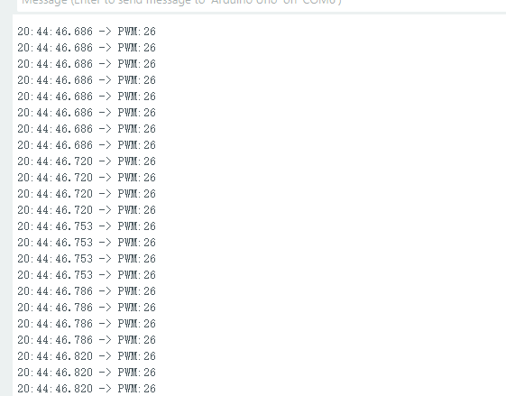

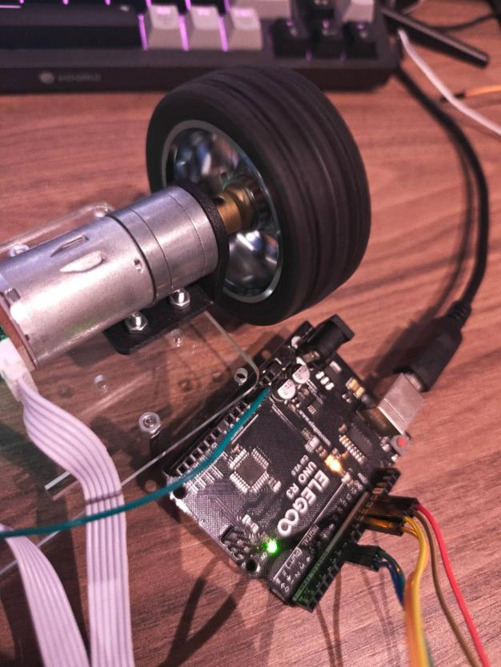

10/29/25
完成蓝牙硬件代码，待测试。Arduino uno 串口通信高电平输出电压为5V，HC-05高电平为3.3v，续接分压电阻使用。
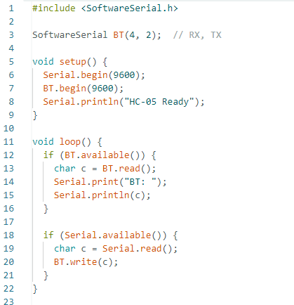

11/2/25
- 测试蓝牙模块驱动和硬件连接是否正常，能够接收手机发送数据：
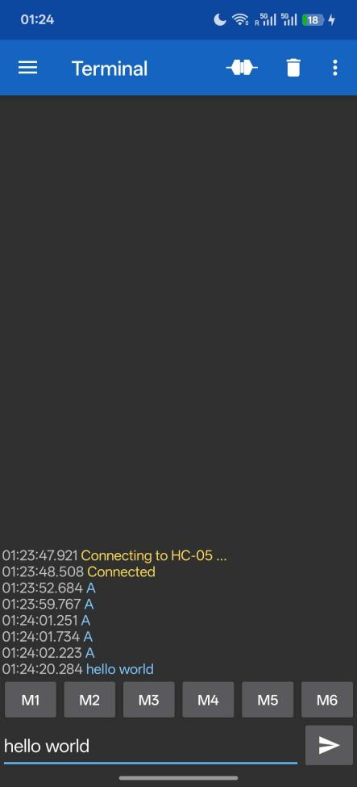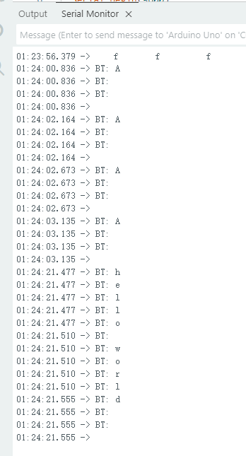

- 开发蓝牙手机app（Android），测试蓝牙通信，正常。

- 测试手机app是否工作正常，扫描可用蓝牙设备，能够成功连接HC-05蓝牙模块并控制小车移动。

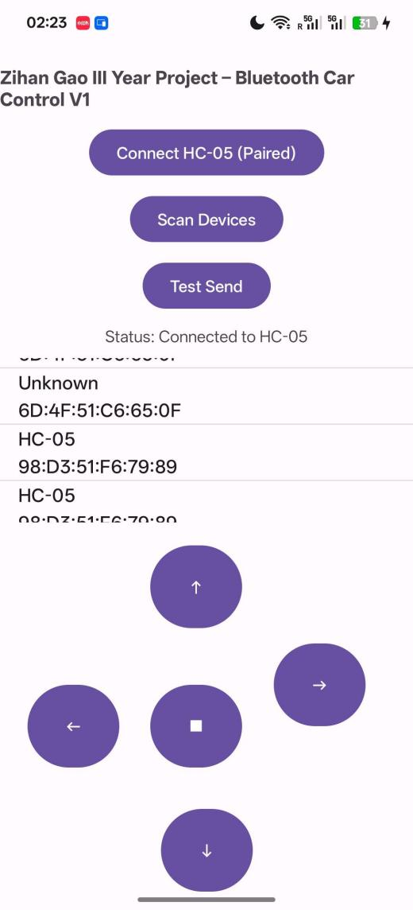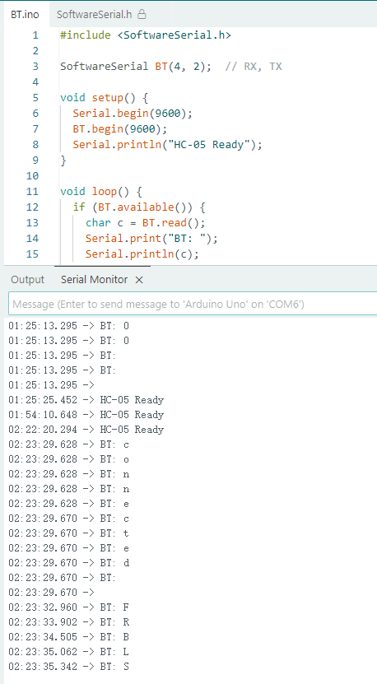

APP有待优化，界面和功能性：
界面可更加美观，
功能性：可以添加数据可视化，在app上浏览小车状态，方便后续调整pid参数。

11/4/25
完成编码器测速：
代码：
#define ENCA 2 // Phase A for motor A
#define ENCB 3 // Phase B for motor B
#define PMA
#define PMB
volatile long pulse_count = 0;

int lastEncoded = 0;
float rpm = 0;
unsigned long lastTime = 0;

const int pulses_per_rev = 11;
const float gear_ratio = 179.2;

void setup() {
pinMode(ENCA, INPUT);
pinMode(ENCB, INPUT);
attachInterrupt(digitalPinToInterrupt(ENCA), readEncoder, CHANGE);
Serial.begin(9600);
}

void loop() {
if (millis() - lastTime >= 1000) {
noInterrupts();
long count = pulse_count;
pulse_count = 0;
interrupts();

rpm = ((float)count / (pulses_per_rev * gear_ratio)) * 280;
Serial.print("Speed: ");
Serial.print(rpm);
Serial.println(" RPM");

// Serial.println(" pulse:");
Serial.print(count);
lastTime = millis();
}
}

void readEncoder() {
int a = digitalRead(ENCA);
int b = digitalRead(ENCB);
if (a == b) pulse_count++; // forward
else pulse_count--; //backward
}

效果：
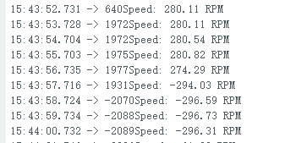
问题1：当输出最大PWM值时，正转和反转测得转速有差距。正转时为+280左右，反转转速为 -296左右。可能是在测电机输出轴和编码器旋转轴减速比时使用的是用正转最大值来估算减速比，所以正转测速是对的，反转测速有误差。
解决方法：待定。

问题2：数字引脚不够用了
当前PIN arrangement：
Digital PIN | Connection | Function
0 | NO Connection | TX/serial communication/upload
1 | NO Connection | RX/serial communication/upload
2 | Motor A PIN1 | INT[1], encoder interrupt trigger pin
3 | Motor B PIN1 | INT[0], encoder interrupt trigger pin
4 | HC-05 RX | Blue tooth RX pin
5 | HC-05TX | Blue tooth TX pin
6 | TB6612 BIN2 | Motor B direction control
7 | TB6612 BIN1 | Motor B direction control
8 | HC-SRO4 ECHO | ultrasonic echo
9 | HC-SRO4 TRIG | ultrasonic trigger
10 | TB6612 PWMB | PWM output, Motor B speed control
11 | TB6612 PWMA | PWM output, Motor A speed control
12 | TB6612 AIN1 | Motor A direction control
13 | TB6612 AIN2 | Motor A direction control

解决方法：用Analogue PIN 代替数字引脚：
Analogue PIN
0 | Motor A PIN2 | Use as a digital pin, working with Digital PIN 2
1 | Motor B PIN2 | Use as a digital pin, working with Digital PIN 3
2 | NO Connection
3 | NO Connection
4 | NO Connection
5 | NO Connection

修改编码器代码：
添加了motorB 的编码器，并且将中断的电平变化触发CHANGE替换为RISING上升沿触发。
#define ENCA 2 // Phase A for motor A
#define ENCB 3 // Phase B for motor B
#define PMA A0 //Phase B for motor A
#define PMB A1 //Phase B for motor B
volatile long pulse_countA = 0;
volatile long pulse_countB = 0;

int lastEncoded = 0;
float rpmA = 0;
float rpmB = 0;
unsigned long lastTime = 0;

const int pulses_per_rev = 11;
const float gear_ratio = 89.6;

void setup() {
pinMode(ENCA, INPUT);
pinMode(ENCB, INPUT);
pinMode(PMA, INPUT);
pinMode(PMB, INPUT);
attachInterrupt(digitalPinToInterrupt(ENCA), readEncoderA, RISING);
attachInterrupt(digitalPinToInterrupt(ENCB), readEncoderB, RISING);
Serial.begin(9600);
}

void Encoder_get(){
if (millis() - lastTime >= 1000) {
noInterrupts();
long countA = pulse_countA;
long countB = pulse_countB;
pulse_countA = 0;
pulse_countB = 0;
interrupts();

rpmA = ((float)countA / (pulses_per_rev * gear_ratio)) * 280;
rpmB = ((float)countB / (pulses_per_rev * gear_ratio)) * 280;
Serial.print("SpeedA: ");
Serial.print(rpmA);
Serial.println(" RPM");
lastTime = millis();
}
}

void loop() {
Encoder_get();
}

void readEncoderA() {
int a = digitalRead(ENCA);
int b = digitalRead(PMA);
if (a == b) pulse_countA++; // forward
else pulse_countA--; //backward
}

void readEncoderB() {
int a = digitalRead(ENCB);
int b = digitalRead(PMB);
if (a == b) pulse_countB++; // forward
else pulse_countB--; //backward
}

2025/11/8
重画原理图，用网络标签导线，更加直观和清晰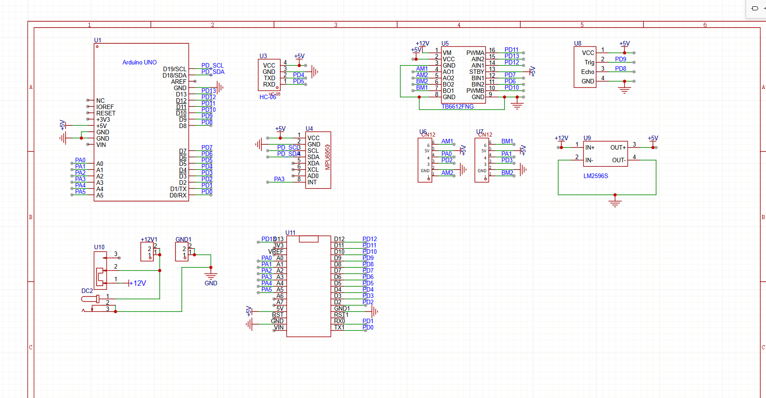
根据原理图设计pcb：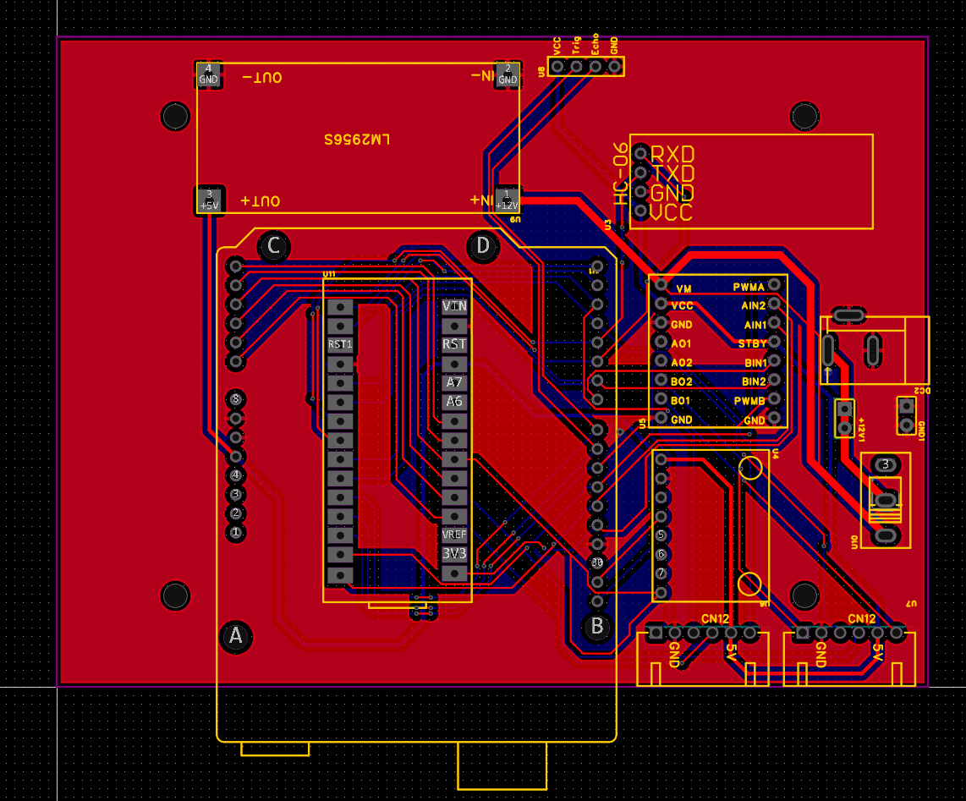
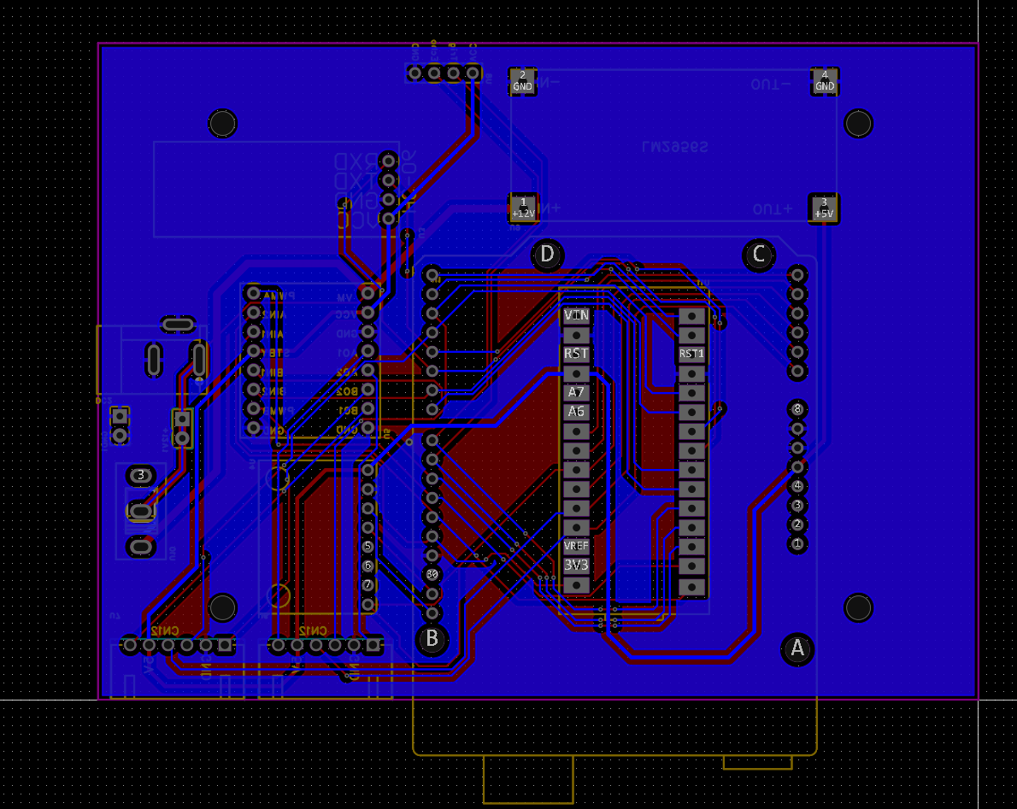

11/10/25
- 对pcb进行了修改，优化了布线，添加丝印，删除Uno对应的打孔，检查并优化了DFM：
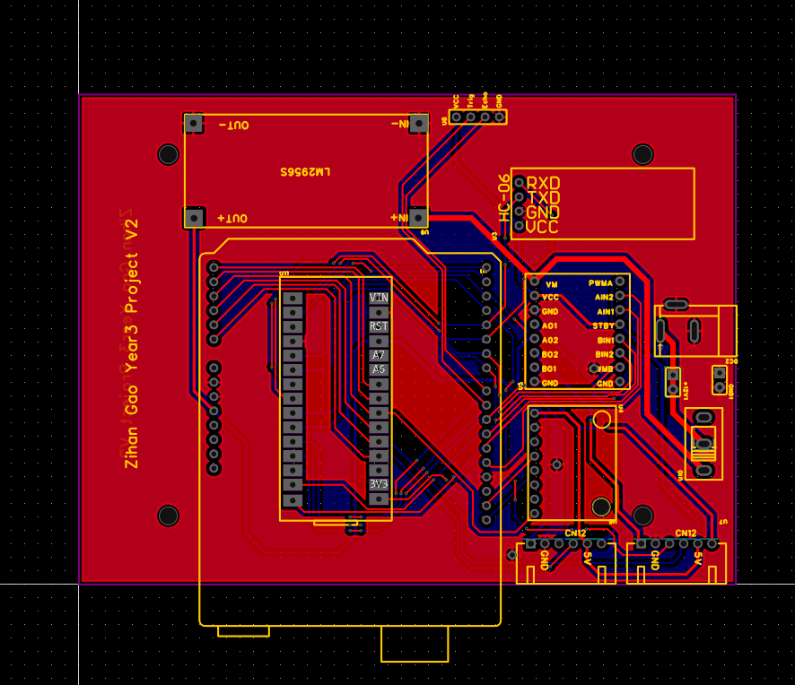
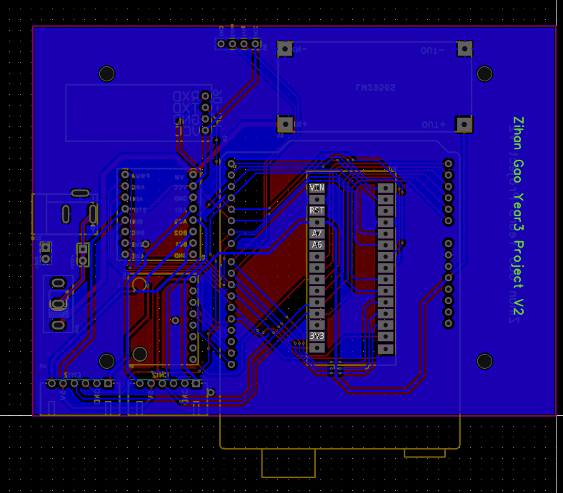
- 整合代码，使只有一个main，其他作为模块化.h和.cpp在main中include
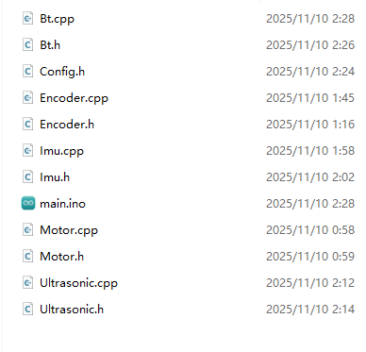

main.ino:
#include "Config.h"
#include "Motor.h"
#include "Encoder.h"
#include "Imu.h"
#include "Bt.h"
#include "Ultrasonic.h"
#include "PID.h"

// ===== definitions for extern =====
int PWM = 0;
int SCA = Start_PWMA;
int SCB = Start_PWMB;

void setup() {
// put your setup code here, to run once:
Serial.begin(9600);
Encoder_init();
Motor_Init();
init_mpu();
ultra_init();
btBegin();
}

void loop() {
//keyboard control speed
serial_Debug();
Wheel_drive(PWM, SCA, SCB);

//get and print speed value
float rpmA, rpmB;
if (encoderSampleRPM(rpmA, rpmB)) {
Serial.print("SpeedA: "); Serial.print(rpmA); Serial.print(" RPM, ");
Serial.print("SpeedB: "); Serial.print(rpmB); Serial.println(" RPM");
}

//print mpu6050 value
imuPollAndPrint();
float AngleX, AccX, GyX;
get_dataX(AngleX, AccX, GyX);

//print ultrasonic value
float dist = GetDistance();
if (dist > 0) {
Serial.print("Distance: ");
Serial.print(dist);
Serial.println(" cm");
} else {
Serial.println("No echo");
}
//PID
PWM = PID_PWMcount();
Bluetooth_Debug();
}

将引脚定义编进Config.h:
#pragma once
#include <Arduino.h>

// ===== Pins =====
#define AIN1 12
#define AIN2 13
#define BIN1 7
#define BIN2 6
#define PWMA 11
#define PWMB 10
#define ENCA 2 // encoder A channel
#define ENCB 3 // encoder B channel
#define PMA A0 // phase B for motor A
#define PMB A1 // phase B for motor B
// #define SDA_Pin
// #define SCL_Pin
#define Trig 9
#define Echo 8
#define BT_RX 4 // HC-05 TX --> Arduino pin 4
#define BT_TX 5 // HC-05 RX --> Arduino pin 5

// ===== Values =====
#define Start_PWMA 9 // start compensation A
#define Start_PWMB 10 // start compensation B

// ===== Encoder constants =====
const int pulses_per_rev = 11; // per motor shaft
const float gear_ratio = 89.6/4.667; // gearbox

// ===== Shared variables (defined in MyBot.ino) =====
extern int PWM;
extern int SCA;
extern int SCB;

写PID平衡算法：
#include "PID.h"
#include "Imu.h"
#include "Bt.h"
#include <math.h> // fabsf

// static float Balance_Angle = 0;
static float Kp = 0, Ki = 0, Kd = 0;
static float AngleX, AccX, GyX;
static float Balance_Angle = 0.0, ANG_intg = 0.0;
int16_t ANG_PWM;

int16_t PID_PWMcount(){
get_dataX(AngleX, AccX, GyX);

float erro = AngleX - Balance_Angle; //count error

ANG_intg += erro; //accumulate error
ANG_intg = constrain(ANG_intg, -800, 800);

ANG_PWM = Kp*erro + Ki*ANG_intg + Kd*GyX;

if (fabsf(AngleX) > 45){
ANG_PWM = 0;
erro = 0.0;
return ANG_PWM;
}
if (ANG_PWM > 255){
ANG_PWM = 255;
}
if (ANG_PWM<-255){
ANG_PWM = -255;
}
return ANG_PWM;
}

void Bluetooth_Debug(){
while (btAvailable()){
char Receive = btRead();

switch (Receive){
case '1': Balance_Angle += 0.1;
case '2': Balance_Angle -= 0.1;

// case '3': Balance_Angle += 0.1;
// case '4': Balance_Angle += 0.1;
// case '5': Balance_Angle += 0.1;
// case '6': Balance_Angle += 0.1;
}
}
}

11/18/25
验证pcb功能
降压模块，电机驱动，mpu6050都正常，
发现问题：
- 超声波引脚正反问题
- 蓝牙模块需添加贴片电阻
- 电机接口尺寸不对
- 板子尺寸稍大。需优化
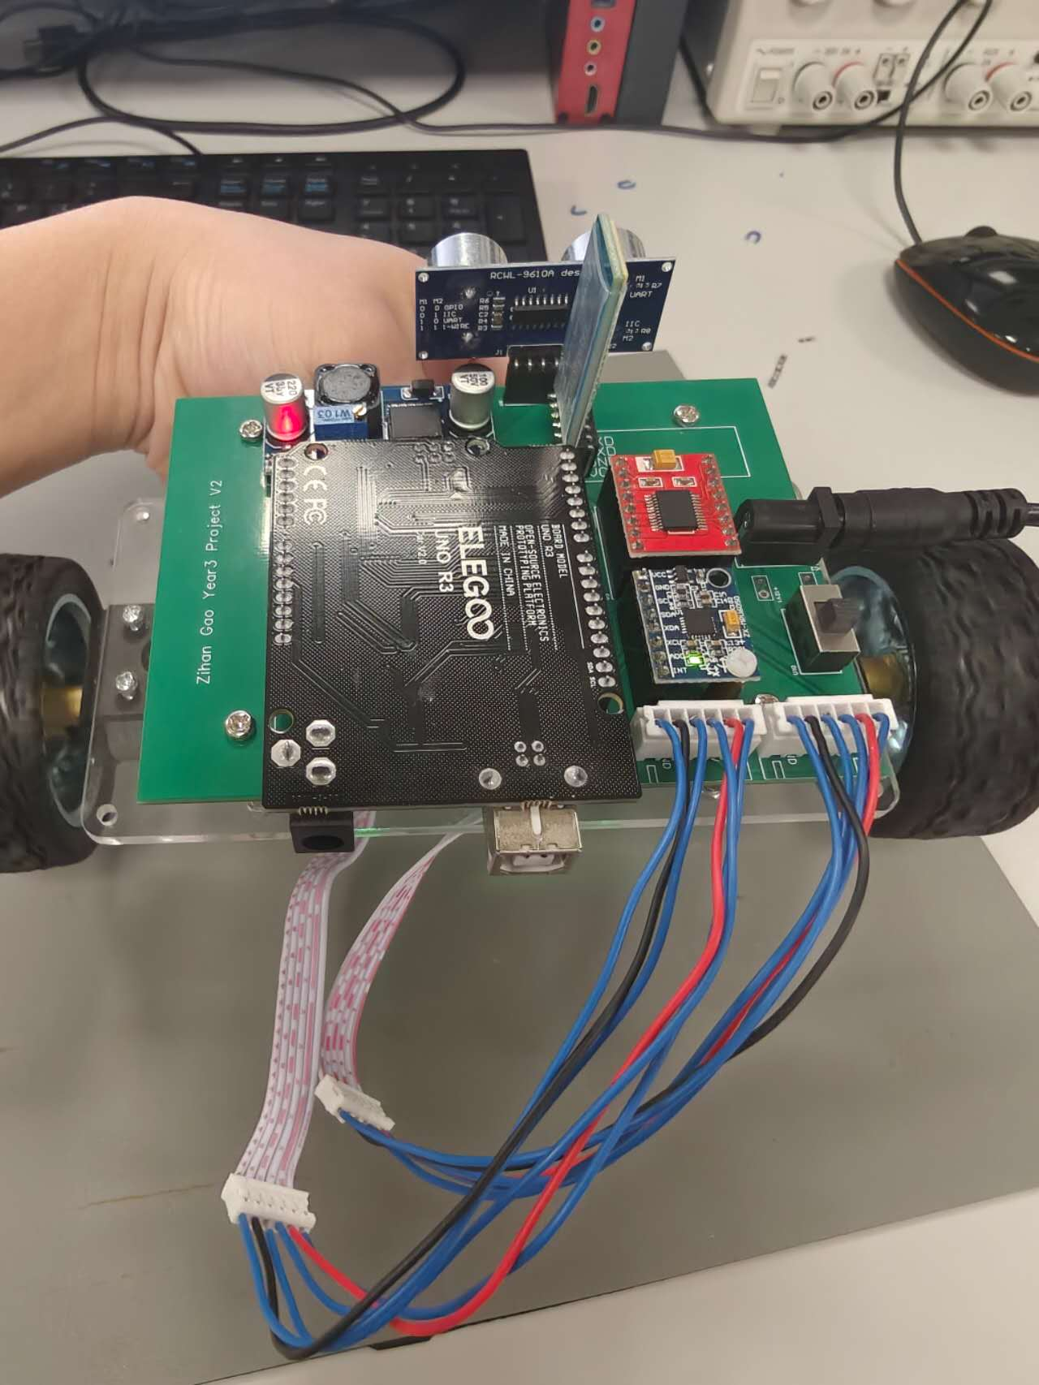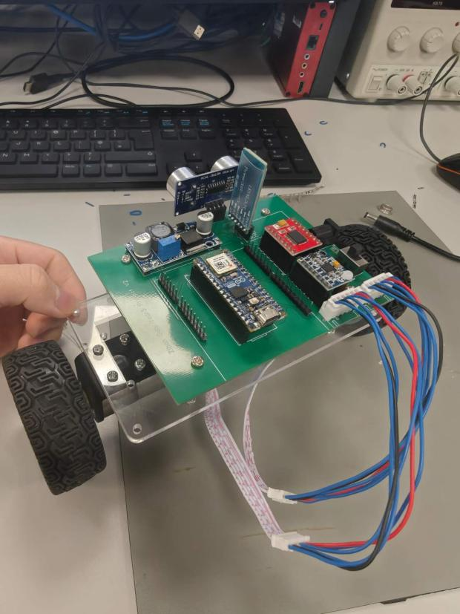
画完之后第三版电路板：
