医疗App

MUI 框架

项目简介：医疗App是苏州园区公积金系统的一部分，面向苏州园区参保人员。参保人员可以在医院使用该App缴费，查明具体报销情况，查看补助政策等。

前端使用MUI框架，后端使用Java。我主要负责新增页面，部分页面的调整以及向后台传输数据，MUI框架的底层是JQuery，js中大多使用的传输数据的方式也是ajax.

饿了么App

Vue 框架

项目简介：饿了么App是我学习Vue的练习作品，我使用了手脚架Vue-cli搭建项目，webpack作为打包工具。后台是mock的json数据，使用webpack中的devServer模拟返回数据。

前端使用Vue框架，布局使用原生div+css,未使用其他布局框架。

模拟数据

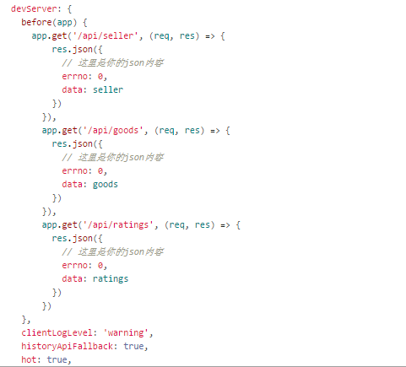

页面示例

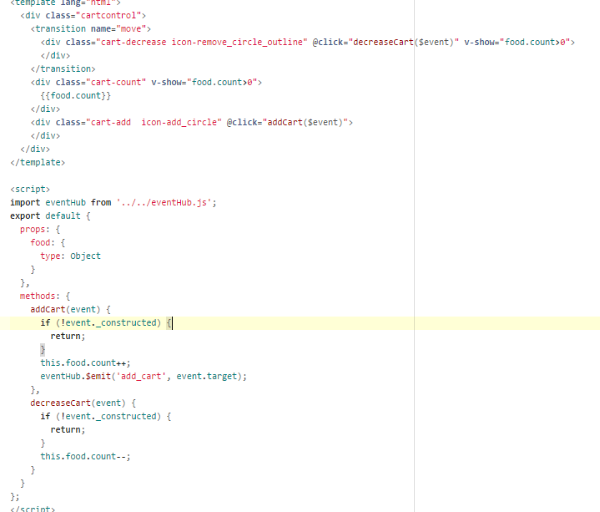 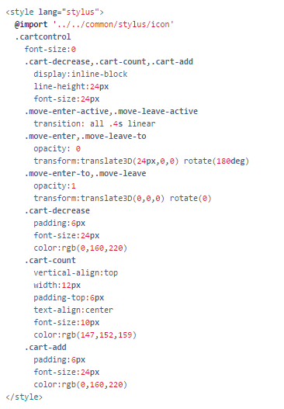

高性能计算网站

React 框架 + Koa +mysql

项目简介： 高性能计算网站是我的毕业设计。未使用手脚架，后端使用nodeJS中的Koa框架负责数据的增删改查,前台使用react框架，所有/api开头的请求都会被代理到服务器端，而其他请求则会作为页面请求，前端进行相应,react-bootstrap作为布局框架,mysql作为数据库。

已完成后台接口，在进行前端布局的编写。

项目结构

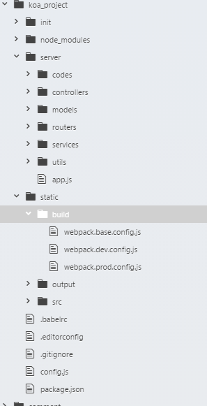

服务器中间件

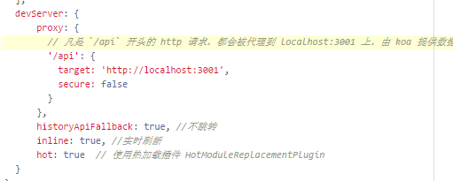

后台路由

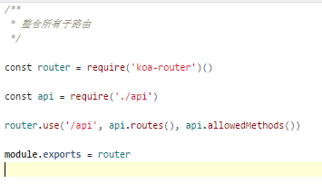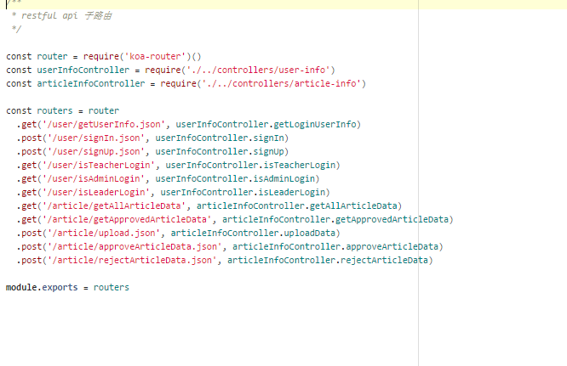

Medical App

MUI framework

Project introduction: medical App is part of the Suzhou Industrial Park provident fund system, facing the Suzhou Industrial Park citizen The insured citizen can use the App pay in the hospital, find out the specific reimbursement situation, check the subsidy policy and so on.

The front end uses the MUI framework, and the back end uses Java. I am responsible for adding new pages, adjusting part of pages and transmitting data to the background. The bottom of the MUI framework is JQuery, and the way of data transmission in JS is ajax.

饿了么App

Vue framework

Project introduction: 饿了么 App is my work on learning Vue. I used the scaffolding Vue-cli to build the project, and webpack as a packing tool. The background is mock's JSON data, using the devServer simulation in webpack to return the data.

The front end uses the Vue framework, the layout uses the native div+css, and the other layout frameworks are not used.

How to mock data?



The page





High performance computing web site

React framework + Koa +mysql

Project introduction: high performance computing website is my graduation design. Without the use of scaffolding, Koa is used in the nodeJS framework for data crud, the use of react framework, all at the beginning of the /api request will be proxy to the server, and other requests as front page requests, accordingly, react-bootstrap as the layout framework, MySQL as database.

The background interface has been completed, and the front end layout is written.

React + Koa +mysq

The Project structure

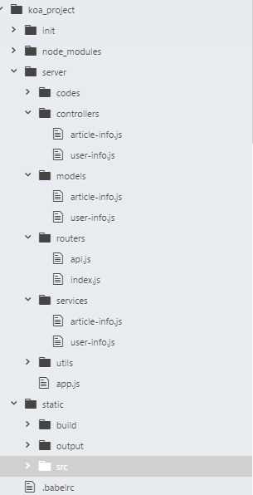

The middleware





The Server side