REAL-TIME RENDERING
IN GAME ENGINES

A Comprehensive Case Study
Topics Covered:
• The GPU Rendering Pipeline
• PBR, Lighting & Shadow Techniques
• Ray Tracing and Hybrid Rendering
• Unreal Engine 5, Unity HDRP & id Tech 7 Deep Dive
• DLSS, FSR & AI Upscaling
• Performance Benchmarks & VRAM Analysis
• Future of Real-Time Rendering
Submitted by
C092 Vihaan Patole
C094 Preet Shah
C108 Darren Dsilva

1. Introduction

1.1 What Is Real-Time Rendering?
Real-time rendering (RTR) is the process of generating photorealistic or visually compelling images fast enough to create the illusion of continuous motion — typically at 30, 60, or even 120 frames per second. Unlike offline rendering, which is used in film VFX and animation studios where a single frame can take hours to compute on a render farm, a game engine must produce each complete frame in a matter of milliseconds, all on the player's local hardware.
This fundamental constraint — the frame budget — is the driving force behind every technique, approximation, and architectural decision in real-time rendering. A 60 FPS target gives the GPU exactly 16.6 milliseconds to handle geometry processing, lighting, shadowing, post-effects, and display output. At 30 FPS, that budget doubles to 33.3 ms, while 120 FPS tightens it to just 8.3 ms.
The field sits at the intersection of mathematics, physics simulation, computer architecture, and artistic design. Rendering engineers must simultaneously satisfy a physicist's desire for accuracy, an artist's desire for beauty, and a hardware engineer's demand for efficiency. The result is a discipline defined by elegant approximations — techniques that look physically correct while costing a fraction of the true computation.

1.2 Offline vs. Real-Time: The Core Divide
Understanding what makes real-time rendering unique requires appreciating the contrast with its offline counterpart. Pixar's RenderMan, used for feature films, can trace millions of light bounces per pixel, model subsurface scattering through skin, and simulate atmospheric volumetrics — at the cost of minutes or hours per frame. Real-time rendering must achieve perceptually similar results using pre-computed data structures, clever screen-space heuristics, and increasingly, dedicated hardware and AI inference.
The gap between the two has been closing dramatically. Ray tracing — once strictly the domain of offline rendering — is now available on consumer GPUs. Physically Based Rendering (PBR), which uses the same foundational BRDF equations as offline renderers, is now the standard shading model across all major game engines. AI-powered denoising and upscaling now allow real-time renderers to produce output quality that would have required offline techniques just five years ago.

1.3 The Role of Game Engines
Game engines are the software frameworks that orchestrate every aspect of real-time rendering: scene management, asset streaming, shader compilation, draw call submission, post-processing pipelines, and platform abstraction. The major commercial engines — Unreal Engine 5, Unity HDRP, and specialized engines like id Tech 7 — are sophisticated pieces of engineering that represent decades of accumulated rendering knowledge.
These engines do not simply expose raw GPU APIs. They build complete rendering systems on top: Unreal's Nanite virtualizes geometry at a microscopic level, Lumen dynamically computes global illumination in real time, and Virtual Shadow Maps provide shadow resolution that scales with the scene's complexity. For a rendering engineer, understanding these systems is as important as understanding the underlying GPU pipeline they build upon.
This case study examines the full stack — from the low-level GPU pipeline stages that every rendered pixel passes through, up to the high-level rendering systems of leading game engines — analyzing the trade-offs, benchmarks, and innovations that define the current state of the art in real-time rendering.

1.4 Brief Historical Timeline
Era | Milestone | Key Tech
1970s–80s | Early wireframe & raster games | CPU-only rendering
1990s | 3D acceleration begins | Fixed-function GPUs (Voodoo, TNT)
Early 2000s | Programmable shaders | DirectX 8/9, vertex & pixel shaders
2010s | PBR & deferred rendering | GBuffer, HDR, SSAO, TAA
2018+ | Hardware Ray Tracing | NVIDIA Turing, DXR, RTX
2022+ | Fully path-traced games | DLSS 3, Nanite, Lumen, UE5

2. The GPU Rendering Pipeline

2.1 Overview
Every rendered frame passes through a sequence of programmable and fixed-function stages on the GPU. Understanding this pipeline is fundamental to all rendering techniques discussed in this case study.
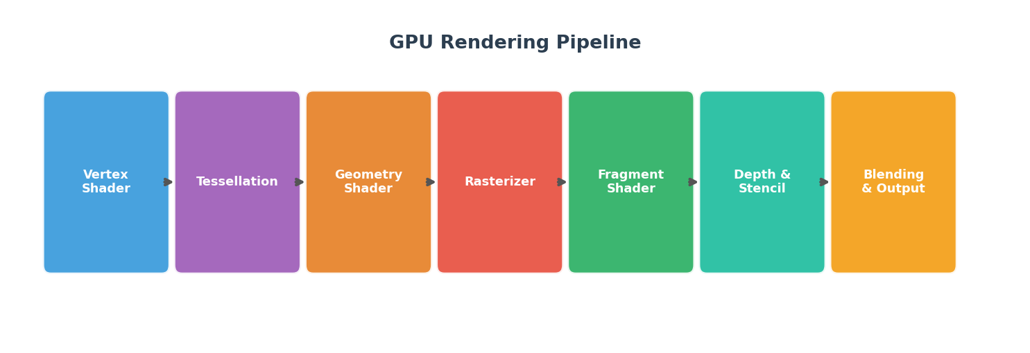
Figure 1 — The Modern GPU Rendering Pipeline

2.2 Key Pipeline Stages
Vertex Shader
Transforms 3D vertex positions from model space to clip space using the Model-View-Projection (MVP) matrix. Runs once per vertex, entirely on the GPU.
Tessellation
Optional stage that subdivides geometry on the fly to add fine detail (e.g., terrain displacement, character skin). Controlled by Hull, Domain, and Tessellator stages.
Geometry Shader
Optional stage that can emit, cull, or modify entire primitives. Used for shadow volume generation and particle systems.
Rasterizer (Fixed Function)
Converts vector geometry (triangles) into discrete pixel fragments, interpolating vertex attributes across the primitive. Handles clipping, back-face culling, and viewport transform.
Fragment / Pixel Shader
The most expensive stage: computes the final color of each pixel using lighting models, textures, and material properties. PBR, shadows, and most visual effects live here.
Depth & Stencil Test
Determines which fragments survive occlusion. Early-Z hardware optimization rejects occluded fragments before the expensive pixel shader runs.
Output Merger / Blending
Composites the surviving fragment color with existing framebuffer content. Handles alpha blending for transparency and HDR framebuffer writes.

2.3 CPU–GPU Bottleneck
A critical performance concern is the CPU-GPU bottleneck. The CPU submits draw calls to the GPU command buffer. With thousands of objects, this communication overhead dominates frame time. Techniques like GPU instancing, bindless resources, and indirect draw calls minimize this bottleneck.
Metric | Value
Typical draw calls — old-gen AAA | ~2,000–5,000 / frame
Typical draw calls — modern AAA (UE5 Nanite) | Millions of micro-polygons, ~few hundred draw calls
GPU command overhead per draw call (CPU) | ~2–10 μs
Optimal frame target (60 FPS) | < 16.6 ms total

3. Lighting & Shading Models

3.1 Evolution of Shading Models
Lighting models define how surfaces interact with light. The progression from Phong to PBR represents the biggest visual leap in real-time rendering history.
Model | Era | Pros | Cons
Flat Shading | Pre-1990 | Fastest | Faceted look, no interpolation
Gouraud | 1990s | Smooth gradients | Highlights computed at vertices only
Phong | 2000s | Per-pixel specular | Not energy conserving, artist-unfriendly
Blinn-Phong | 2000s–2010s | Cheaper than Phong | Still non-physical
PBR (GGX/Cook-Torrance) | 2013–present | Physically correct, consistent | More shader instructions

3.2 Physically Based Rendering (PBR)
PBR uses physically accurate microfacet BRDF models. Artists define materials with:
- Base Color (Albedo) — the diffuse reflectance of the surface
- Metallic — whether the surface is a metal (1) or dielectric (0)
- Roughness — microsurface irregularity controlling highlight spread
- Normal Map — encodes surface detail without extra geometry
- Ambient Occlusion — local shadowing in crevices
The core PBR rendering equation integrates incoming radiance over the hemisphere above each surface point, evaluated using the GGX normal distribution function (NDF) and Smith geometry term for self-shadowing.

3.3 Deferred vs. Forward Rendering
Modern engines choose between two major rendering architectures:
Attribute | Forward Rendering | Deferred Rendering
How it works | Shades each object with all lights in one pass | Stores geometry data in GBuffer; lights in separate pass
Light scalability | O(objects × lights) | O(objects + lights)
Transparency | Native | Difficult (requires forward pass)
MSAA support | Easy | Complex (MSAA on GBuffer costly)
Best for | Mobile, VR, limited lights | PC AAA games, many dynamic lights
Example engines | Unity (simple mode), id Tech 7 | Unreal Engine 5, Unity HDRP

4. Shadows & Global Illumination

4.1 Shadow Techniques
Shadow Mapping
The industry-standard real-time shadow technique. The scene is rendered from the light's perspective into a depth texture (shadow map). During the main render pass, each pixel computes whether it lies in shadow by comparing its depth to the shadow map sample.
- Resolution directly affects shadow acne and aliasing artifacts
- PCF (Percentage Closer Filtering) softens shadow edges
- Cascaded Shadow Maps (CSM) use multiple maps at different distances
Virtual Shadow Maps (Unreal Engine 5)
UE5's Virtual Shadow Maps (VSMs) virtualize an enormous shadow map (16K × 16K) and only cache and render the pages that are actually visible. This enables high-quality, consistent shadows across vast open worlds with dynamic objects.

4.2 Ambient Occlusion
Technique | Quality | Cost | Notes
SSAO (Screen-Space AO) | Low–Medium | Very Low | Horizon-based, limited radius, misses off-screen occluders
HBAO+ (Horizon-Based AO) | Medium | Low | NVIDIA technique, more physically accurate than SSAO
GTAO (Ground-Truth AO) | High | Medium | Full horizon integration, used in UE5
Ray-Traced AO | Highest | High | Physically correct; requires RTX hardware

4.3 Global Illumination
Global Illumination (GI) simulates indirect light bounces — the key to photorealistic rendering. Real-time GI is one of the hardest problems in the field.
Lumen (Unreal Engine 5)
Lumen is UE5's fully dynamic GI system. It uses a two-level approach: Screen-Space Radiance Cache for near-field GI, and a Scene Distance Field (SDF) + Voxel Lighting hierarchy for far-field indirect bounces. It handles emissive surfaces, sky lighting, and multi-bounce diffuse GI without baking.
Lightmaps (Legacy)
Offline-precomputed GI baked into texture atlases. Still used for static geometry in performance-constrained titles. Zero runtime cost but cannot handle dynamic lights or moving objects.
DDGI (Dynamic Diffuse GI)
NVIDIA's probe-based GI approach places irradiance probes in the scene and updates them each frame using ray tracing. Blended between hardware and software ray tracing variants.

5. Post-Processing Effects

5.1 The Post-Process Pipeline
After the 3D scene is rendered into the HDR framebuffer, a chain of full-screen image-space effects are applied before the final frame is displayed. These effects are composited in a single render pass on modern engines.
Effect | Purpose | Common Implementation
Tone Mapping | Map HDR to SDR display range | ACES Filmic, Reinhard, Uncharted 2
Bloom | Light bleed from bright areas | Dual Kawase blur on luminance threshold
Depth of Field | Lens focus simulation | Bokeh scatter, CoC-based blur
Motion Blur | Velocity buffer-based smear | Per-object or camera velocity buffer
Chromatic Aberration | Lens color fringing | Radial UV offset per channel
Film Grain | Cinematic noise texture | Temporal noise overlay
Color Grading | Artistic color correction | 3D LUT (Look-Up Table)
Vignette | Edge darkening | Radial gradient multiply

5.2 Anti-Aliasing Techniques
Aliasing (jagged edges) is an inherent artifact of rasterization. Multiple AA approaches are used depending on platform and quality targets:
- Highest geometric quality; expensive on deferred renderers; used in VR MSAA (Multi-Sample AA)
- Ultra-cheap post-process blur; blurs fine detail, limited quality FXAA (Fast Approximate AA)
- Accumulates sub-pixel samples over multiple frames; industry standard; can cause ghosting TAA (Temporal AA)
- NVIDIA full-resolution AI AA; best quality at native resolution DLAA (Deep Learning AA)
- Used in Forza Horizon series for highest-quality output MSAA + TAA hybrid

6. Ray Tracing in Real Time

6.1 Rasterization vs. Ray Tracing
Traditional rasterization projects geometry onto the 2D screen and approximates lighting. Ray tracing casts rays from the camera into the scene, computing accurate reflections, shadows, and GI by tracing rays to light sources and between surfaces.
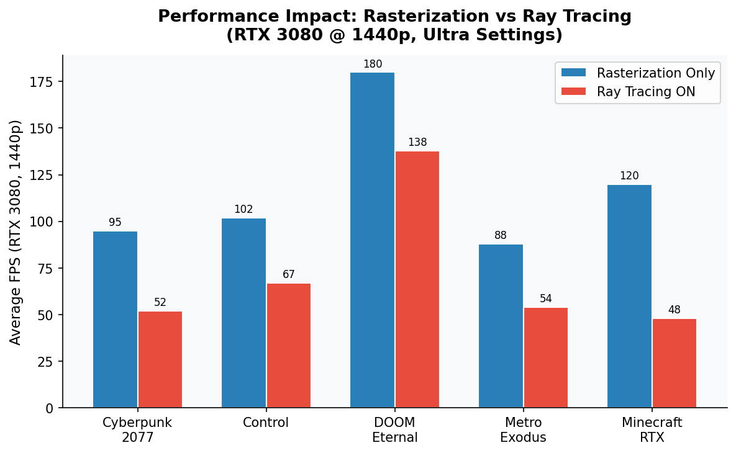
Figure 2 — FPS Comparison: Rasterization vs. Ray Tracing Enabled (RTX 3080, 1440p Ultra)

6.2 DXR and RTX Hardware
Microsoft's DirectX Raytracing (DXR) API and NVIDIA's RTX architecture (Turing, 2018) introduced dedicated RT Cores — fixed-function units that accelerate Bounding Volume Hierarchy (BVH) traversal, the core bottleneck of ray-scene intersection. RT Cores offload BVH traversal from shader units, making hybrid ray tracing practical.

6.3 Hybrid Rendering
No current consumer GPU can path-trace a full AAA game at 60+ FPS natively. Instead, modern games use hybrid rendering: rasterization for the base image, with selective ray tracing for effects where it matters most.
Metric | Value
RT Reflections — Cyberpunk 2077 | Replaces screen-space reflections on RTX hardware
RT Shadows — Control (Remedy) | Accurate contact shadows, replaces shadow maps for key lights
RT Ambient Occlusion — Metro Exodus | Full-scene AO without SSAO limitations
Path Tracing — Cyberpunk Overdrive Mode | Full path trace; requires DLSS 3.5 to be playable

6.4 Performance Impact Analysis
Ray tracing has significant performance costs. The chart above (Figure 2) shows that enabling ray tracing reduces FPS by 30–60% depending on the title and features enabled. This is why DLSS and FSR upscaling are essential companions to ray tracing in modern games.

7. Engine Case Studies
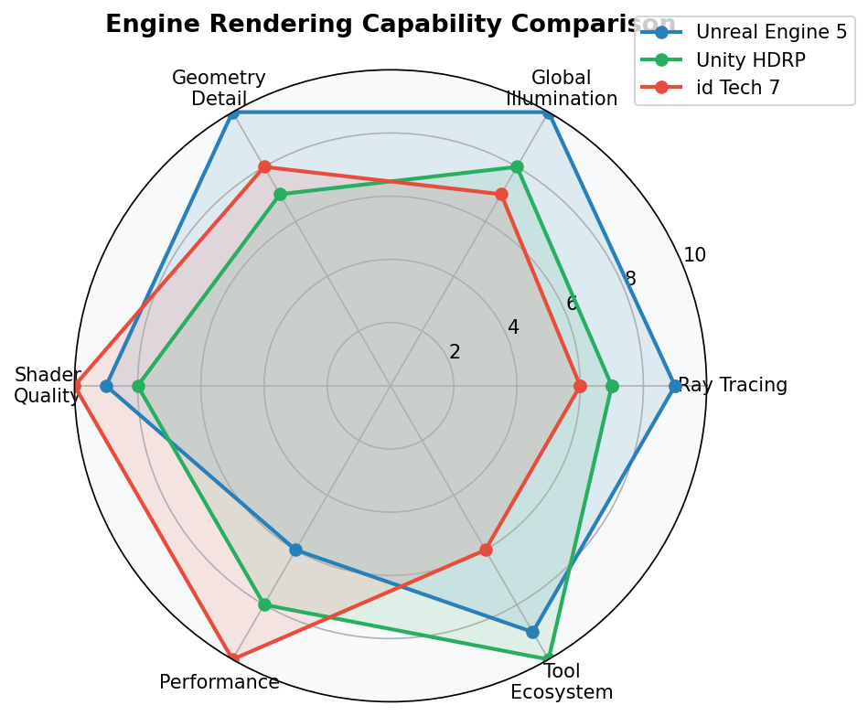
Figure 3 — Rendering Capability Radar: Unreal Engine 5 vs Unity HDRP vs id Tech 7

7.1 Unreal Engine 5
Nanite — Virtualized Geometry
Nanite is UE5's virtualized micropolygon geometry system. It streams and renders only the triangles and levels of detail needed for the current view, at the exact resolution of the screen. This removes traditional LOD pipelines and polygon budget constraints for static meshes.
- Internally clusters geometry into hierarchical groups
- Uses software rasterizer for tiny triangles (< 1 pixel) — faster than GPU hardware rasterizer at that scale
- Supports displacement maps in UE 5.3+
- Limitation: does not support dynamic deformation (skinned meshes, cloth)
Lumen — Fully Dynamic GI
Lumen provides fully dynamic global illumination and reflections without any offline baking. It uses Screen-Space tracing for nearby surfaces and Software/Hardware Ray Tracing for distant geometry, blending the two results seamlessly.
- Handles emissive surfaces as area lights natively
- Supports real-time sky and sun direction changes (day/night cycles)
- Hardware Lumen (ray traced) mode requires DXR support
Key Stats — Unreal Engine 5
Metric | Value
Triangle budget (Nanite scene) | Billions of source triangles → adaptive on-screen density
Lumen GI latency | ~1–3 frames temporal accumulation
VSM resolution (virtual) | 16,384 × 16,384 texels
Temporal Super Resolution | Built-in TAAU upscaling (similar to DLSS)
Minimum GPU for Lumen HW RT | NVIDIA RTX 2060 / AMD RX 6700 XT

7.2 Unity HDRP
Unity's High Definition Render Pipeline (HDRP) targets high-end PC and console hardware. It uses a deferred rendering architecture with an advanced Adaptive Probe Volume (APV) system for baked and dynamic GI.
- Adaptive Probe Volumes — subdivide probe density in areas of high geometric complexity
- Full DLSS, FSR, and XeSS support via Unity's Temporal Anti-aliasing Upsampling (TAAU)
- Screen Space Global Illumination (SSGI) for dynamic lit surfaces
- VFX Graph — GPU-simulated particle systems with millions of particles
Feature | HDRP | URP (Universal RP)
Target Platform | High-end PC/Console | Mobile, Low-end, VR
Global Illumination | APV + SSGI + RT GI | Limited, baked only
Lighting Model | Full PBR, area lights | Simplified PBR
Ray Tracing | Yes (DXR) | No
Post-Processing | Full suite | Limited

7.3 id Tech 7 — DOOM Eternal
id Software's id Tech 7 engine is purpose-built for blistering performance — targeting 60+ FPS on all platforms. It uses a highly optimized Clustered Forward Rendering approach with Vulkan/DirectX 12 backend.
Clustered Forward Rendering
The view frustum is divided into 3D clusters (tiles with depth slices). Each cluster receives a list of lights, decals, and particles that intersect it. The pixel shader then only evaluates the lights in its cluster — maintaining forward rendering simplicity with near-deferred scalability.
Megatextures
id Tech uses virtual texturing (Megatextures) — a single enormous texture atlas (up to 128K × 128K texels) that the engine streams at appropriate MIP levels, eliminating texture memory constraints for unique surface detail.
Metric | Value
Target Frame Rate | 60 FPS locked on base consoles, 1000 FPS uncapped PC
Vulkan Draw Calls / Frame | ~1,800 avg in busy scenes
Megatexture Resolution | Up to 128,000 × 128,000 texels virtual
GPU occupancy target | >90% GPU utilization across frame

8. Performance & Optimization

8.1 Frame Budget Breakdown
At 60 FPS, the entire frame — CPU logic, rendering, audio, and OS overhead — must complete in 16.6 milliseconds. The GPU portion is typically ~12–14ms. The chart below shows a representative AAA game's GPU time distribution.
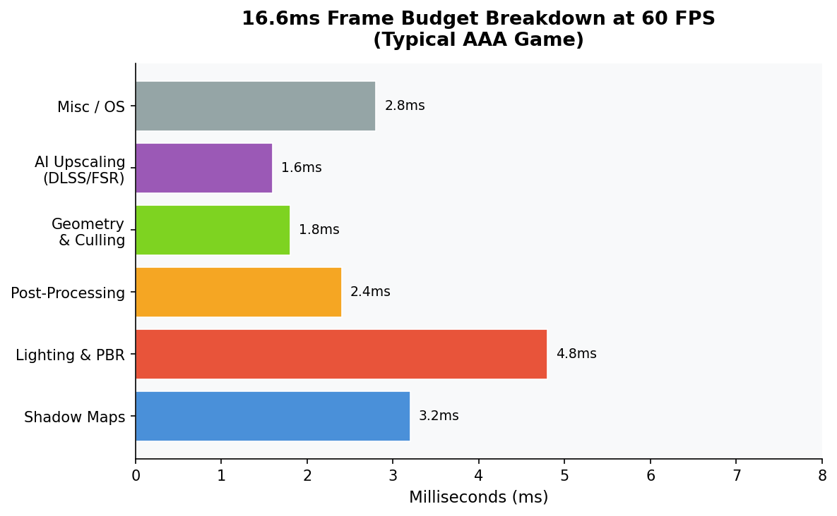
Figure 4 — Typical GPU Frame Budget at 60 FPS in a Modern AAA Game

8.2 Culling Strategies
- Objects outside the camera's view frustum are rejected before the GPU sees them Frustum Culling
- Objects behind large solid occluders (buildings, terrain) are culled via Hi-Z buffer or CPU portal/PVS systems Occlusion Culling
- Distant objects use simplified meshes. Nanite replaces traditional LOD with continuous streaming LOD (Level of Detail)
- GPU discards triangles facing away from camera — fixed-function, ~50% triangle reduction Backface Culling

8.3 GPU Profiling Tools
Tool | Platform | Key Feature
RenderDoc | PC (DX11/12, Vulkan, GL) | Full frame capture, shader debugger, pipeline inspector
NVIDIA Nsight Graphics | NVIDIA GPUs | GPU timeline, shader profiler, RT debugging
AMD Radeon GPU Profiler | AMD GPUs | Detailed GPU occupancy, cache hit analysis
PIX for Windows | DirectX 12 | GPU timing, draw call capture, memory analysis
Unreal Insights | Unreal Engine | CPU/GPU trace, frame timeline, Nanite stats
Apple GPU Frame Debugger | Metal (iOS/macOS) | Shader profiling, resource inspection

8.4 VRAM Consumption
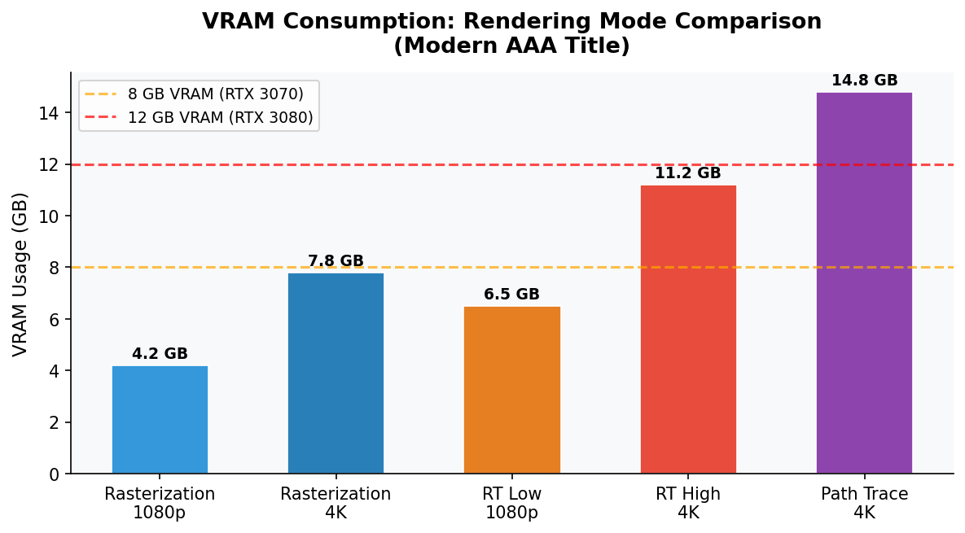
Figure 5 — VRAM Usage by Rendering Mode (Modern AAA Game)
Ray tracing nearly doubles VRAM consumption due to BVH data structures, denoising buffers, and larger history buffers for temporal techniques. Path tracing in Cyberpunk 2077 Overdrive requires 12+ GB VRAM for stable 4K operation.

9. AI-Assisted Upscaling

9.1 The Upscaling Revolution
Upscaling technologies render at a lower internal resolution and intelligently reconstruct a higher-resolution image. This allows games with ray tracing — which cuts FPS in half — to remain playable, and enables 4K output from mid-range GPUs.
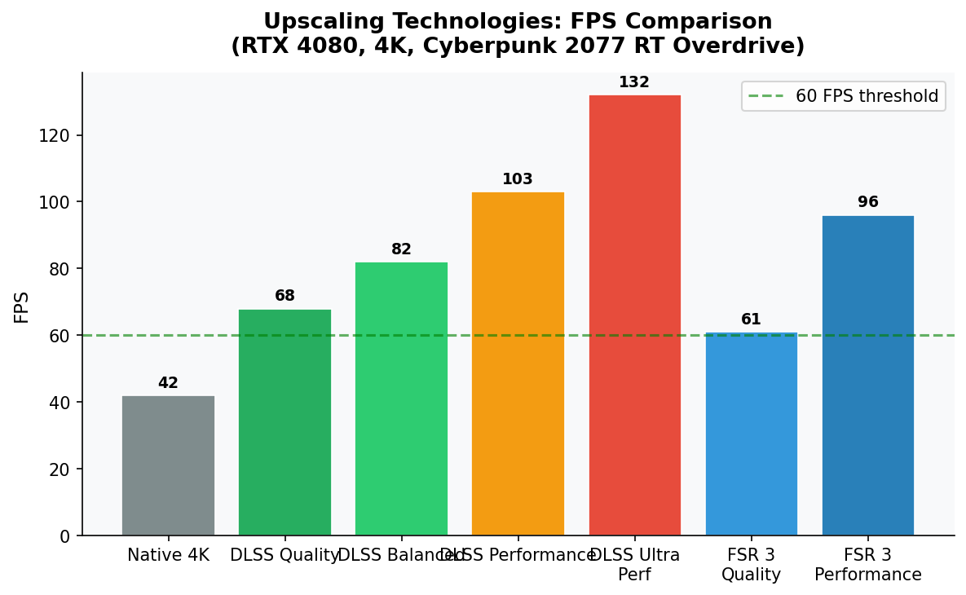
Figure 6 — Upscaling Technology FPS Comparison (RTX 4080, Cyberpunk 2077 RT Overdrive, 4K Output)

9.2 DLSS 3.5 (Deep Learning Super Sampling)
NVIDIA's DLSS uses a neural network (Tensor Core inference) trained on offline supersampled images. DLSS 3 added Frame Generation — synthesizing entire frames using optical flow — effectively doubling frame rate from 50 to 100+ FPS.
- DLSS 3.5 added Ray Reconstruction — a neural denoiser that replaces traditional denoising, producing cleaner ray-traced images
- Requires NVIDIA RTX GPU; Tensor Cores mandatory
- Typical quality uplift: 1.7×–2.5× FPS at Quality/Balanced modes

9.3 AMD FSR 3 (FidelityFX Super Resolution)
AMD's FSR is open-source and hardware-agnostic — running on any GPU including NVIDIA and Intel. FSR 3 added Frame Generation (Fluid Motion Frames) similar to DLSS 3.
- FSR 1 used spatial upscaling only (no history); works everywhere
- FSR 2 added temporal accumulation — approaching DLSS 2 quality
- FSR 3 adds frame generation; requires FSR 2 temporal data

9.4 Intel XeSS & Comparison
Attribute | DLSS 3.5 | FSR 3 | XeSS 1.3
Hardware Required | NVIDIA RTX only | Any GPU | Any GPU (Arc optimal)
Image Quality (Quality Mode) | Highest | Good | Good–Very Good
Frame Generation | Yes | Yes | No (planned)
Open Source | No | Yes (MIT) | Partial (DP4a path open)
Denoiser | Ray Reconstruction | Vanilla denoiser | None
Adoption | 300+ games | 200+ games | 80+ games

10. Future Trends in Real-Time Rendering

10.1 Full Path Tracing
Cyberpunk 2077's Overdrive Mode (2023) was the first consumer game to ship a full path tracer. Every light bounce — direct illumination, GI, reflections, AO, shadows — is computed via ray tracing. Currently requires DLSS 3 Frame Generation to be playable even on RTX 4090 at 4K.
The gap to realtime path tracing is closing: hardware RT performance doubles every 2 GPU generations, and AI denoising continues to improve output quality from sparser ray counts.

10.2 Neural Rendering & NeRF
Neural Radiance Fields (NeRF) represent scenes as neural networks that implicitly encode geometry and appearance. While currently too slow for real-time (seconds per frame), Instant-NGP by NVIDIA achieves interactive rates. Hybrid approaches are emerging where neural networks enhance rasterized output rather than replace the pipeline.

10.3 Generative Texturing & Materials
AI-generated textures and materials (using diffusion models like Adobe Firefly, StabilityAI's Point-E) are being integrated into engine asset pipelines. In real-time contexts, neural texture compression and synthesis could reduce VRAM pressure significantly.

10.4 Cloud & Streaming Rendering
Services like Xbox Cloud Gaming and NVIDIA GeForce NOW stream rendered frames from server-side GPUs to thin clients. Latency remains a constraint, but with 5G and Wi-Fi 6E, cloud-rendered ray-traced games at 60 FPS are becoming viable for less demanding genres.

10.5 Timeline Projection
Year | Milestone | Enabler
2024 | 60 FPS path tracing on RTX 5090 at 1440p | Next-gen RT cores + DLSS 4
2025–26 | Neural mesh LOD replacing polygon budgets | AI geometry synthesis
2026–27 | Real-time NeRF integration in AAA engines | Instant-NGP successors + hardware
2028+ | Path tracing as standard on mid-range GPUs | Hardware maturation, AI denoising

11. Conclusion
Real-time rendering in game engines is one of the most challenging and rapidly evolving fields in computer science. The tension between visual fidelity and computational budget drives constant innovation — from the elegant mathematical simplification of PBR, to the brute-force statistical correctness of path tracing, to the AI-powered reconstruction of DLSS.
Three key trends define the current era:
- Hardware Ray Tracing has moved from novelty to standard feature — nearly every high-end GPU now ships with dedicated RT acceleration hardware.
- AI Upscaling has fundamentally changed how we think about resolution and frame rate — rendering at 50% resolution and reconstructing to 4K is now indistinguishable from native in many cases.
- Engine abstraction has reached new heights — UE5's Nanite and Lumen systems automate decisions that previously required extensive manual tuning, democratizing high-fidelity rendering for smaller teams.
Looking forward, the boundary between real-time and offline rendering continues to blur. As path tracing becomes feasible on consumer hardware and neural rendering matures, the next decade promises visuals that are genuinely indistinguishable from reality — rendered in real time.
"The best rendering is the rendering no one notices — it simply feels real."

References & Further Reading
Akenine-Möller, T., Haines, E., & Hoffman, N. (2018). Real-Time Rendering, 4th Edition. CRC Press.
NVIDIA. (2023). DLSS 3.5 and Ray Reconstruction Technical Overview. developer.nvidia.com
Epic Games. (2023). Unreal Engine 5 Rendering Documentation — Nanite, Lumen, and Virtual Shadow Maps. docs.unrealengine.com
AMD. (2023). FidelityFX Super Resolution 3 Technical Overview. gpuopen.com
Pettineo, M. (2022). Clustered and Tile-Based Rendering Survey. therealmjp.github.io
Wihlidal, H. (2017). 4K Checkerboard in Battlefield 1 and Mass Effect Andromeda. GDC 2017 Talk.
Mikkelsen, M. (2014). Practical Real-Time Strategies for Accurate Indirect Occlusion. SIGGRAPH 2014.
Mittring, M. (2012). The Technology Behind the DirectX 11 Demo. NVIDIA GTC 2012.
Cigolle, Z. H. et al. (2014). Survey of Efficient Representations for Independent Unit Vectors. JCGT.
Microsoft. (2023). DirectX Raytracing (DXR) Specification. microsoft.com/directx

