PROJECT REPORT
on
Face Recognition Attendance System
(CSE V Semester Mini Project PCS-504)
2021-2022

HERE COMES UNIV. IMAGE

Submitted to: Submitted by:
Mrs. Teacher Name Mr. My Name
(CC-CSE-I-V-Sem) Roll. No.: XxxXxxX
Guided by: CSE-I-V-Sem
Mr. Guide Name Session: 2021-2022
(Project Guide)

DEPARTMENT OF COMPUTER SCIENCE AND ENGINEERING
UNIVERSITY NAME

CERTIFICATE

Certified that Mr. My name (Roll No.- ) has completed mini project on “Face Recognition Attendance System” for the CSE V Semester Mini Project Lab (PCS-504) in University Name. The project carried out by Student is their own work as best of my knowledge.

Date: 15-December-2021

(Mrs Coordinator)
Project Co-ordinator
CC-CSE-I-V-Sem
(CSE Department)
GEHU Dehradun

(Mr. Guide name)
Project Guide
Resource Person
(CSE Department)
GEHU Dehradun

ACKNOWLEDGEMENT
I wish to thank my parents for their continuing support and encouragement. I also wish to thank them for providing me with the opportunity to reach this far in my studies.
I would like to thank particularly my Co-ordinator Mrs. Manika Manwal and Project Guide Mr. Umang Garg for his patience, support and encouragement throughout the completion of this project and having faith in me.
At last but not the least I greatly indebted to all other persons who directly or indirectly helped me during this work.

Mr. My Name
Roll No.-
CSE-I-V-Sem
Session: 2021-2022
University
TABLE OF CONTENTS

TITLE PAGE NO.
ABSTRACT vi
TOOLS & LIBRARIES USED vii
1. Face Recognition Attendance System 8
1.1 Problem Statement & Motivation 8
1.2 Methodology Followed 8
1.2.1 Transforming into executable 9
1.3 Result Analysis 9
1.4 Project Screenshots 9
SOURCE CODE 10
REFERENCE 12

ABSTRACT
AIM OF THE PROJECT
The main purpose of the this project is to create a face recognition attendance system to enhance the traditional way of recording data. The current traditional way of recording attendance has lot of ambiguity that results in false information, and sometimes recording of someone else’s attendance in someone else’s.
The face is one natural trait that is almost different in every person, although twins or similar faced people doesn’t follow this, but are rare in all the people so for the time ignoring them, we will be using face to recognise who the person is and the other details.
Then, during the scan of face, attendance will be marked for the student, which can be easily retrieved by opening the excel file that has been created.
Thus, In short, it is an enhanced version of traditional attendance system, that reduces human effort as well as time.

Tools & Libraries Used:

- Open CV: OpenCV is a cross-platform library using which we can develop real-time computer vision applications. It mainly focuses on image processing, video capture and analysis including features like face detection and object detection.

- Dlib: Dlib is an open source modern C++ library implementing many machine learning algorithms and supporting functionality like threading and networking.

- OS: Python OS module allows us to use the operating system dependent functionalities and to interact with the underlying operating system in several different ways. For example, we can work with files, change the environment variables, and we can move files around, etc. This is as same as overriding all the os built-in functionalities in a module and using them in a file I/O and system handling.

- Face Recognition: Recognize and manipulate faces using python. It is build using dlib’s state of art face recognition built with deep learning.

- Wheel: Wheels are a component of the Python ecosystem that helps to make package installs just work. They allow for faster installations and more stability in the package distribution process.

- Cx Freeze: cx_Freeze is a set of scripts and modules for freezing Python scripts into executables, in much the same way that py2exe and py2app do. Unlike these two tools, cx_Freeze is cross-platform and should work on any platform that Python itself works on. It is a simple way of converting any python script into executable.
FACE RECOGNITION ATTENDANCE
SYSTEM

1.1 Problem Statement & Motivation
Marking attendance of students is hard task when it comes to 80- 90 students in a class. This takes more time when the number of students increase, but what if there could be a solution for this issue?
Rather than manually taking attendance of each student ans wasting a ton of time daily, there was a way by which we could reduce the time issue? Face recognition attendance system addresses the issue of time to take the attendance.

1.2 Methodology Followed
The methodology followed for creating this project is:
- Installation of libraries that are necessary
- Reading the image (source)
- Detecting the face location in the image (source)
- Encoding the image (source)
- For correct detection, using a rectangle box to check if the face has been detected properly (source)
- Same set of above instructions are followed for input (input)
- Comparing the detected face of image from source image to the input image. If the image matches then we proceed further, otherwise we do not.
- If the two faces match, we analyse with the face distance that how much is the face matching for accuracy.
- After this, we store the detected face name (which was earlier image name that was given to the program as a source image) and time.
- Then we check for if the face is read again for the same day, we do not store the result again, if not then we store the results.

TRANSFORMING THE PYTHON SCRIPT INTO EXECUTABLE
  - Using cx_freeze libaray conversion of the above program to software.
  - Attributes (name- attendance, icon, author, version, source and description).

1.3 Result Analysis
After analysing the result i find that the face detection was done properly but the storing of data in the sheet was improper, For which a few line were manipulated in attendance function, which allowed to store new data and not the duplicate one.

1.4 Project Screenshots
Some of the screenshots from project.
Tested from sample image.
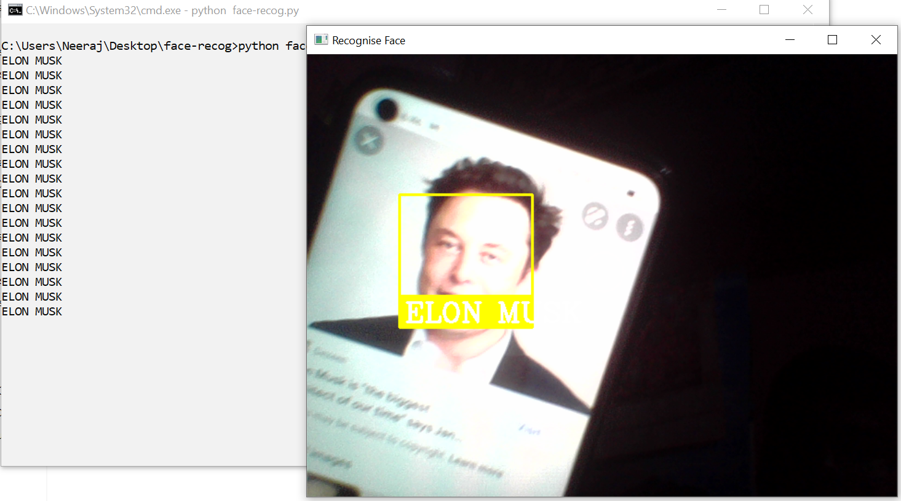

SOURCE CODE
Source Code of the project can be found at: https://github.com/via5k/FaceRecognitionSystem/
REFERENCE
1. Wikipedia
2. Open CV
3. Tutorials point
4. Pypi

