A = B + C * 2 using this grammar

Assign ← *id* = Sums

Sums ← Sums + Products

Sums ← Products

Products ← Products * Value

Products ← Value

Value ← *int*

Value ← *id*

|  |  |  |  |  |
| --- | --- | --- | --- | --- |
| **steps** | **Parse Stack** | **Look Ahead** | **Unscanned** | **Parser Action** |
| 0 | *empty* | *id* | = B + C*2 | Shift |
| 1 | *id* | = | B + C*2 | Shift |
| 2 | *id* = | *id* | + C*2 | Shift |
| 3 | *id* = *id* | + | C*2 | Reduce by Value ← *id* |
| 4 | *id* = Value | + | C*2 | Reduce by Products ← Value |
| 5 | *id* = Products | + | C*2 | Reduce by Sums ← Products |
| 6 | *id* = Sums | + | C*2 | Shift |
| 7 | *id* = Sums + | *id* | *2 | Shift |
| 8 | *id* = Sums + *id* | * | 2 | Reduce by Value ← *id* |
| 9 | *id* = Sums + Value | * | 2 | Reduce by Products ← Value |
| 10 | *id* = Sums + Products | * | 2 | Shift |
| 11 | *id* = Sums + Products * | *int* | *eof* | Shift |
| 12 | *id* = Sums + Products * *int* | *eof* |  | Reduce by Value ← *int* |
| 13 | *id* = Sums + Products * Value | *eof* |  | Reduce by Products ← Products * Value |
| 14 | *id* = Sums + Products | *eof* |  | Reduce by Sums ← Sums + Products |
| 15 | *id* = Sums | *eof* |  | Reduce by Assign ← *id* = Sums |
| 16 | Assign | *eof* |  | Done |

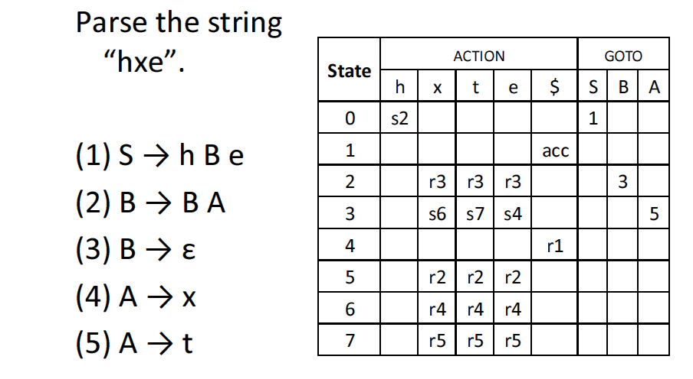

|  |  |  |
| --- | --- | --- |
| 0 | hxe | 0,h 🡪s2 |
| 0h2 | xe | 2x 🡪r3 |
| 0h2B | xe | (3,x)🡪s6 |
| 0h2Bx6 | e | 6,e 🡪 r4 |
| 0h2BA | e | BA🡪B |
| 0h2B | e | 3,e 🡪s4 |
| 0h2Be4 | $ | 4$-->r1 |
| 0S | $ | 1,$-->acc |

as an academic exercise….sigh

given

1. S 🡪 AB language: %^***# minimal string %#
2. A🡪 A^
3. A🡪 %
4. B🡪 *B
5. B🡪 #

parse: %^^*#

|  |  |  |  |
| --- | --- | --- | --- |
| 0 | %^^*#$ | 0,% 🡪 s1 |  |
| 0%1 | ^^*#$ | %1 🡪 R3 |  |
| 0A | ^^*#$ | (goto 2, ^)🡪 s3 |  |
| 0A^3 | ^*#$ | 3,^ ->R2 |  |
| 0A | ^*#$ | S3 |  |
| 0A^3 | *#$ | 3^🡪R2 |  |
| 0A | *#$ | Goto 2,*🡪S4 |  |
| 0A*4 | #$ | 4,#-->S5 |  |
| 0A*4#5 | $ | R5 |  |
| 0A*4B | $ | R4 |  |
| 0AB | $ | Goto 1 |  |
| 0S | $ |  |  |

|  |  |  |  |  |  |  |  |  |
| --- | --- | --- | --- | --- | --- | --- | --- | --- |
|  | ^ | % | * | # | $ | A | B | S |
| 0 |  | S1 |  |  |  | Goto 2 |  | accept |
| 1 |  | R3 |  |  | R4 |  | Goto 4 |  |
| 2 | S3 |  | S4 |  |  |  |  |  |
| 3 | R2 |  |  |  |  |  |  |  |
| 4 |  |  |  | S5 | R1 |  | Goto 1 |  |
| 5 |  |  |  |  | R5 |  |  |  |
| 6 |  |  |  |  |  |  |  |  |
| 7 |  |  |  |  |  |  |  |  |
| 8 |  |  |  |  |  |  |  |  |