OAAppStore MS Windows Installation Guide

Contents
OAAppStore MS Windows Installation Guide 1
Introduction 1
Source code 2
Download Windows Installer 2
Using your browser 2
Running OAAppStore from Windows 12
Program Installation location 15
Uninstalling OAAppStore from Windows 16
User Guide 17

Date | Version | Description | User | Note
May 05, 2024 | 1.0.x | Initial Document | Vince Via

Introduction

This document includes directions for installing and running OAAppStore.

OAAppStore is an application that allows users to add Applications that can be managed by the AppStore. This allows for running applications in multiple environments with different versions.
Applications can be ran as Server, Client, Single, etc. A Client application will connect to a Server.

The installer was created using Java jpackage and includes Java version 21.

OABuilder can be installed and ran from OAAppStore. Applications created using OABuilder will be able to be ran from OAAppStore.

Source code

OAAppStore is open source and is stored on GitHub. It is located at ViaOA, in the “oaappstore” project .
The github repo “oaappstore-run” is one of the locations that has applications that can be installed in OAAppStore.
See github for more information.

Download Windows Installer

Using your browser (image shows Chrome)
www.github.com/ViaOA/oaappstore-run/blob/master/windows-installer/OAAppStore.msi
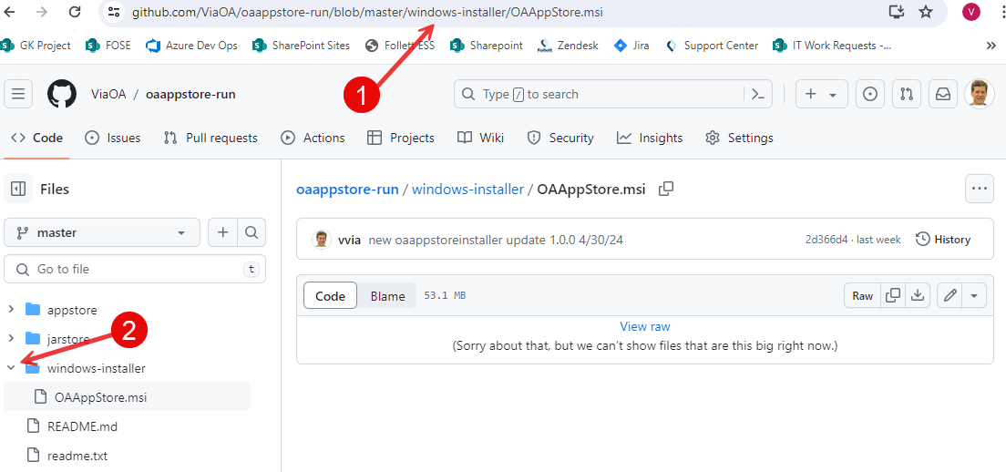

Download the file named OAAppStore.msi
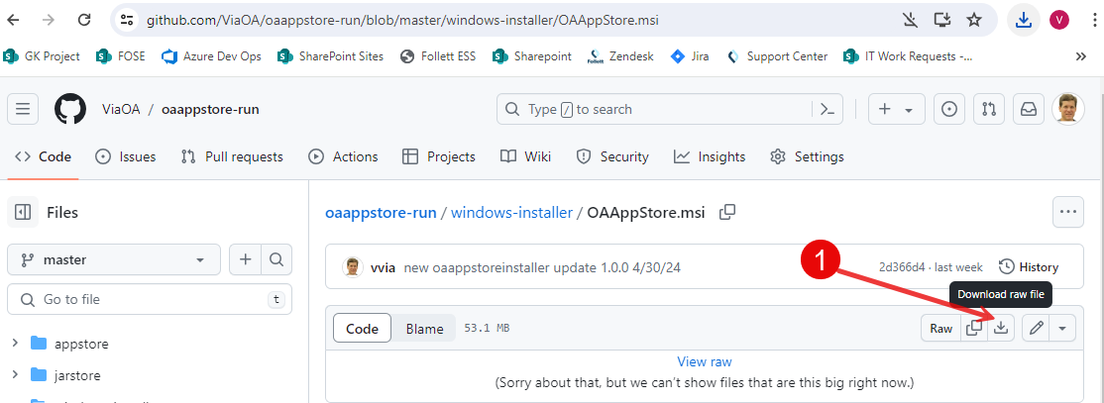

Open and run OAAppStore.msi

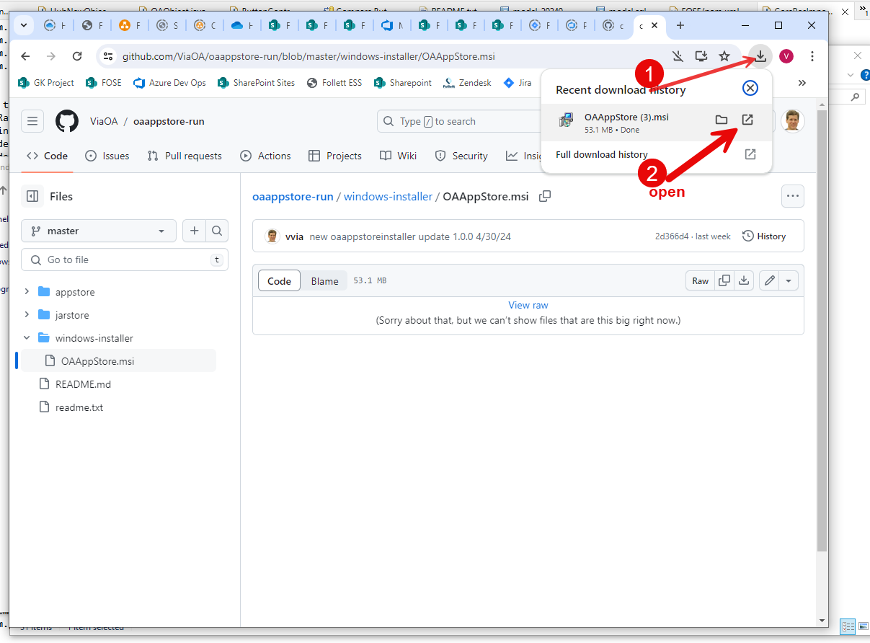

- Chrome’s downloads
- Run OAAppStore.msi
Running the Windows Installer will first show a Windows Defender message.
Select “More Info” to give permission to install.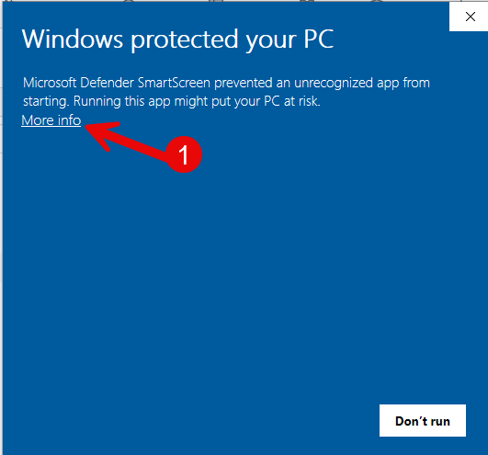

Select “Run anyway” button to begin installation.
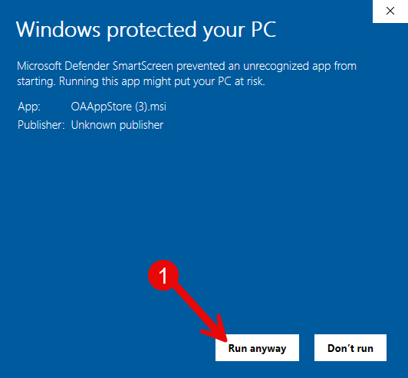

Setup will be displayed, select “Next” button.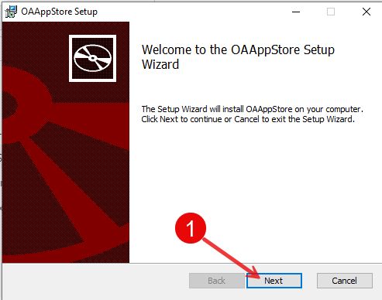
Accept the license, and select “Next” button.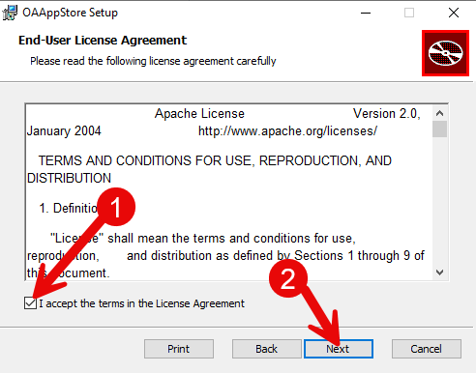

Select “Next” button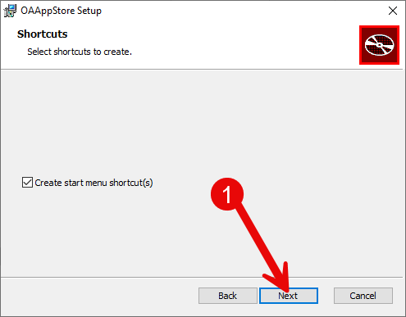

Select “Install”
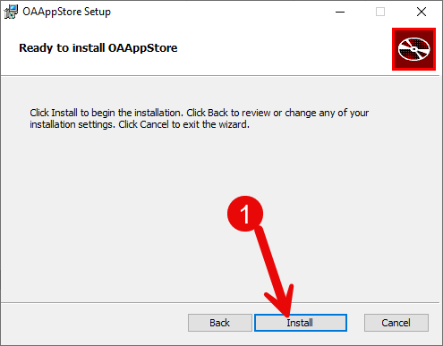

Install completed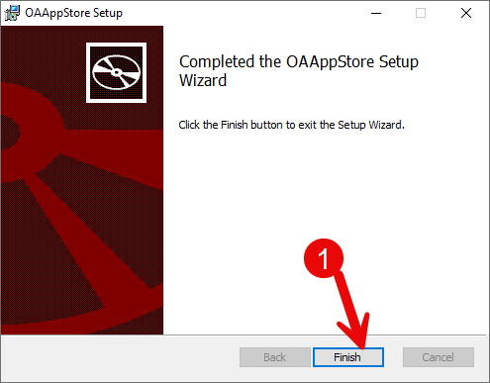

Running OAAppStore from Windows

1: Select Windows “Start” button, 2: type “OAAppStore”, 3: click App.
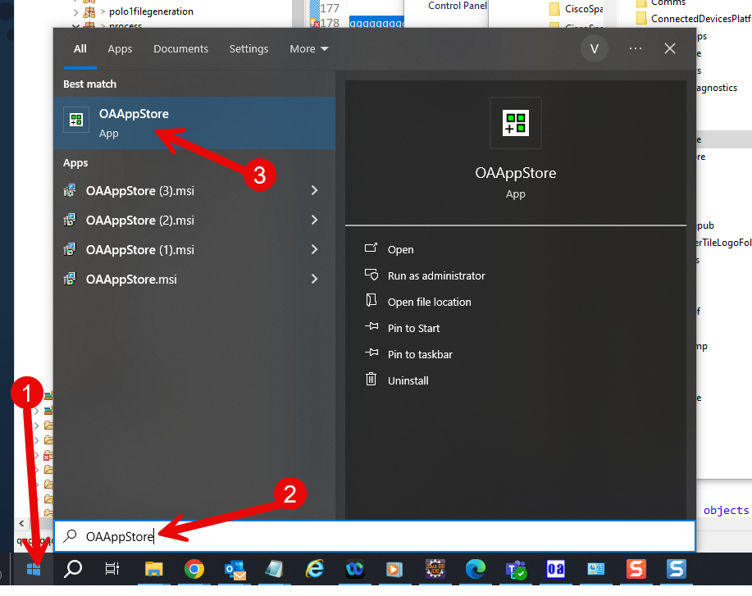

Application will run.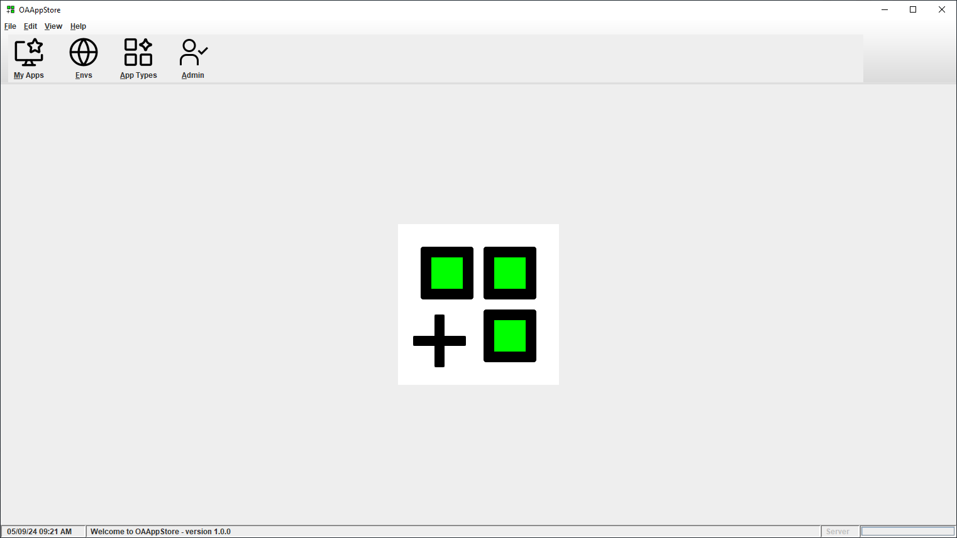

Choose menu “Help” and then “About” to see version and release information.
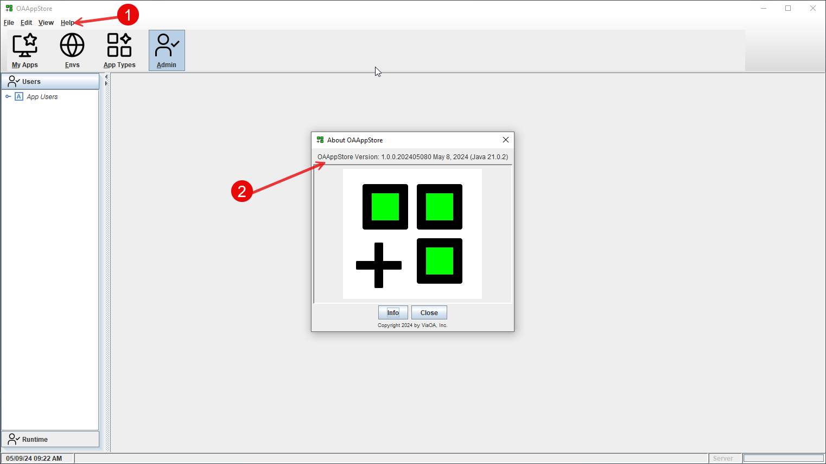

Program Installation location

Program will be running from Users “AppData\Local” directory.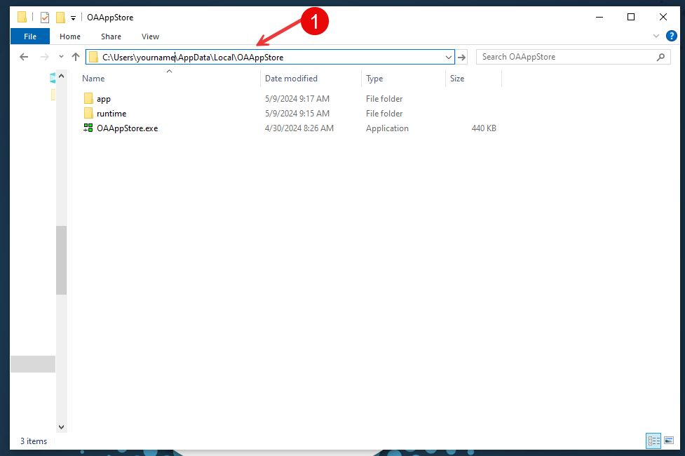

All Apps will be stored under the “appstore” directory, and all code (Java *.jar files) will be under the “jarstore” directory.
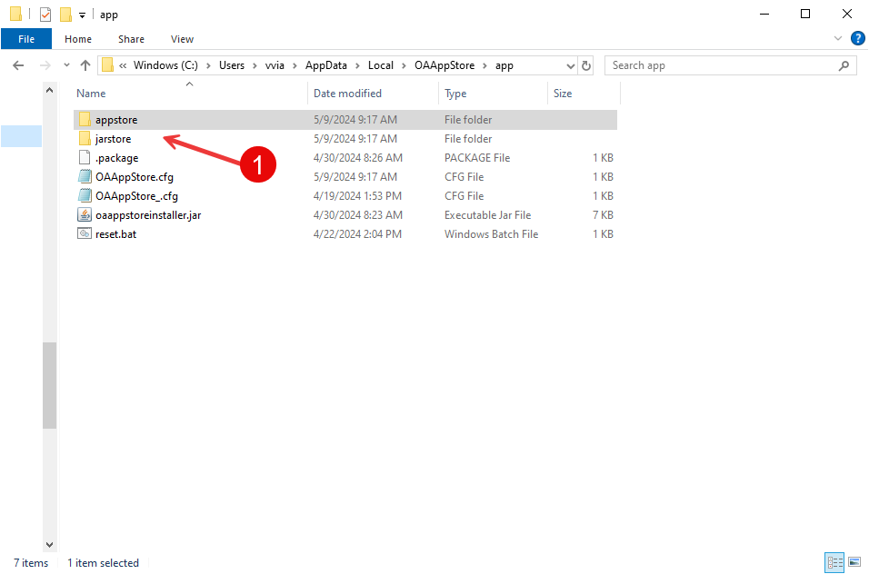

Uninstalling OAAppStore from Windows

1: Select Windows “Start” button, 2: enter “OAAppStore”, 3: mouse right-click, 4: choose “Uninstall” from the popup menu.

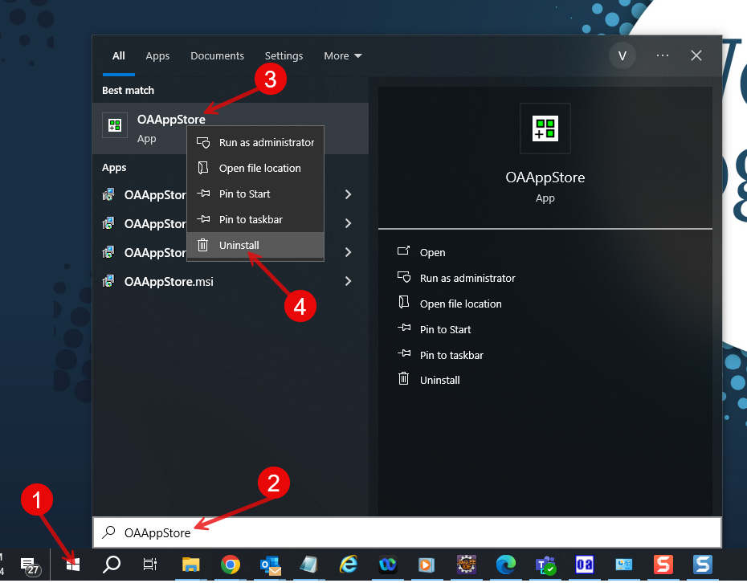

User Guide
See the OAAppStore User Guide for more information.

