OAAppStore User Guide

Contents
Introduction 2
Source code 2
Installation 3
Running from Windows 3
Program Installation location 6
Adding OABuilder to the OAAppStore 8
Create a new Application Type 8
Give User permissions to run the new Application Type 15
Select the Version to run. 17
Run OABuilder 18
Adding OATemplate to the OAAppStore 20
Create a new Application Type 21
Give User permissions to run the new Application Type 27
Select the Version to run. 29
Run OATemplate as single user (from desktop) 30
Setting up Environments 30
Running OATemplate as Server 38
Running OATemplate as Client to connect to Server 41
Take a tour 46
My Applications 47
My Apps that are Single User 48
Launching an Application 49
My Apps that run as a Server (multi-user) 52
My Apps that run as a Client (connect to a Server) 53
Application Environments 53
Setting up an Environment 55
Application Types 57
Check for new versions 60
Admin 64

Date | Version | Description | User | Note
May 09, 2024 | 1.0.x | Initial Document | Vince Via

Introduction

OAAppStore is an “Object Automation” software application developed by ViaOA, used to install and run applications created using OABuilder.

OAAppStore is an application that allows users to add Applications that can be managed by the AppStore. This allows for running applications in multiple environments. Applications can be ran as Server, Client, Single.

OAAppStore allows running other OAAppStores as a server, so that other computers can connect. For example, an OAAppStore can be ran on a server in a company’s “dev” environment that has all of the servers and applications in that environment.

OA Applications can be ran in the following 3+ modes.
- locally as Single
- on a Server, allowing users to connect using Client. Includes webservice, RESP API, scaling, etc.
- as a Client, that connects to a Server.
- Other modes include failover servers, distributed servers, web servers only, client command line, more.

OABuilder can be installed and ran from OAAppStore (see section for adding OABuilder), and any application created using OABuilder can be added to the OAAppStore. Any custom Java programs can also be included.

Source code

OAAppStore is open source and is stored on GitHub. It is located under ViaOA, in the “oaappstore” project .

Installation

The installation for OAAppStore was created using Java jpackage and includes Java version 21. Please see the OAAppStore Installation Guide for more details.

Running from Windows

- Select Windows “Start” button
- type “OAAppStore”
- click App.
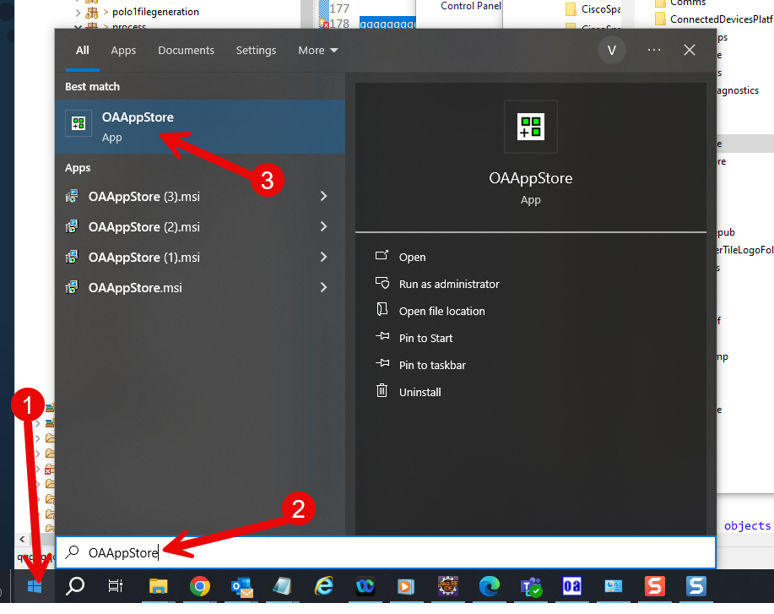

Application will run.
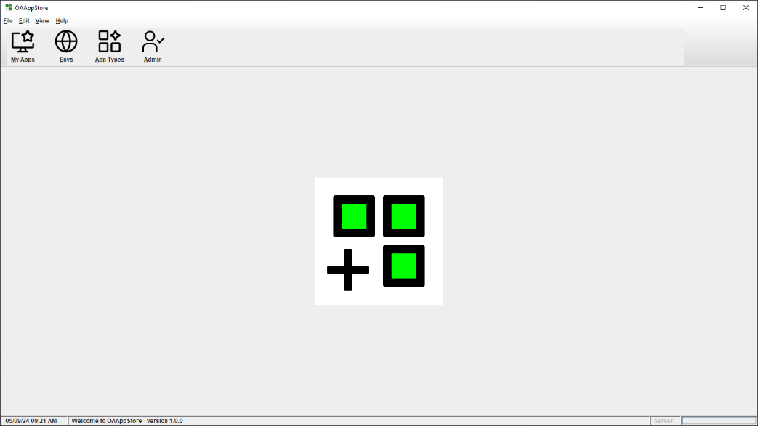
Choose menu “Help” and then “About” to see version and release information.
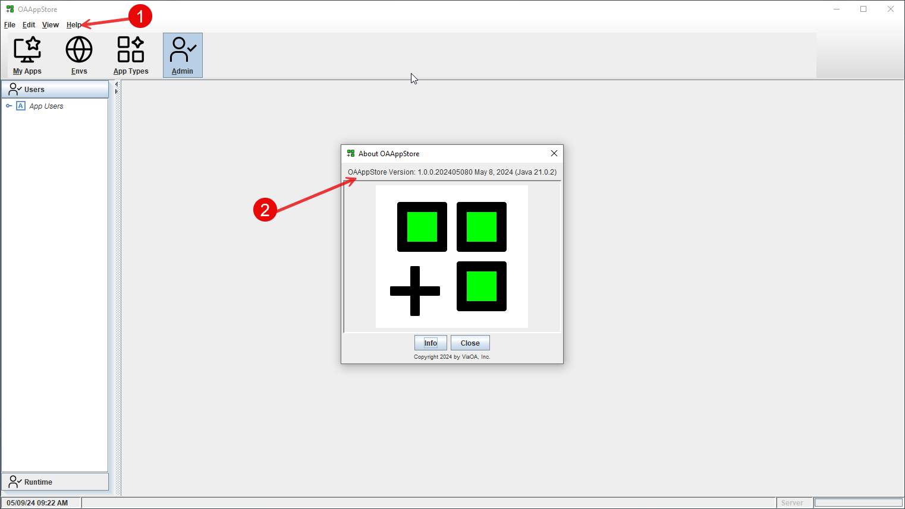

Program Installation location

From a Windows installation, the program will be running from Users “AppData\Local” directory.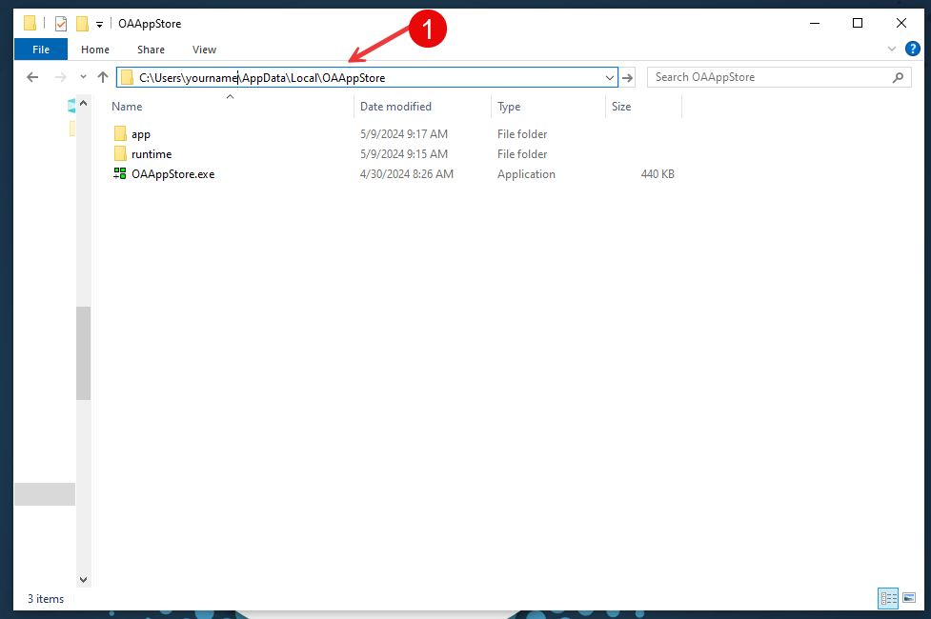

All of the OAAppStore “Apps” will be stored under the “appstore” directory, and all code (Java *.jar files) will be under the “jarstore” directory.
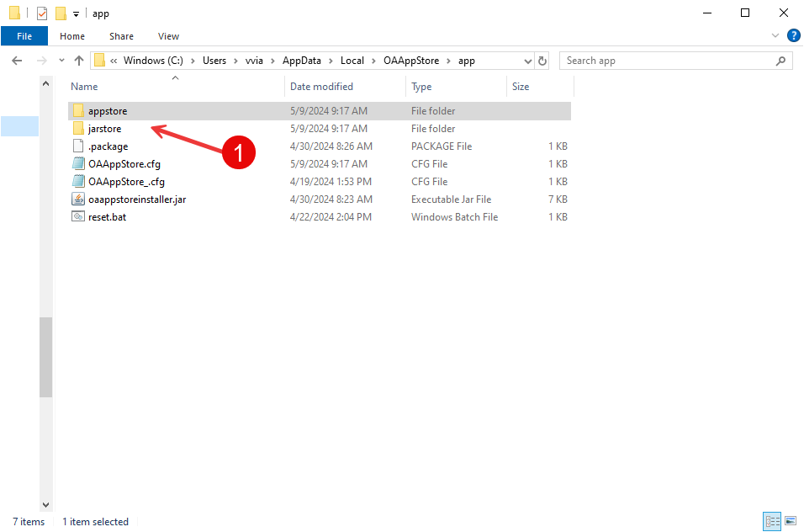

Adding OABuilder to the OAAppStore

OABuilder is a Software development tool for designing and generating applications.
For example, this application, “OAAppStore”, was created using OABuilder.

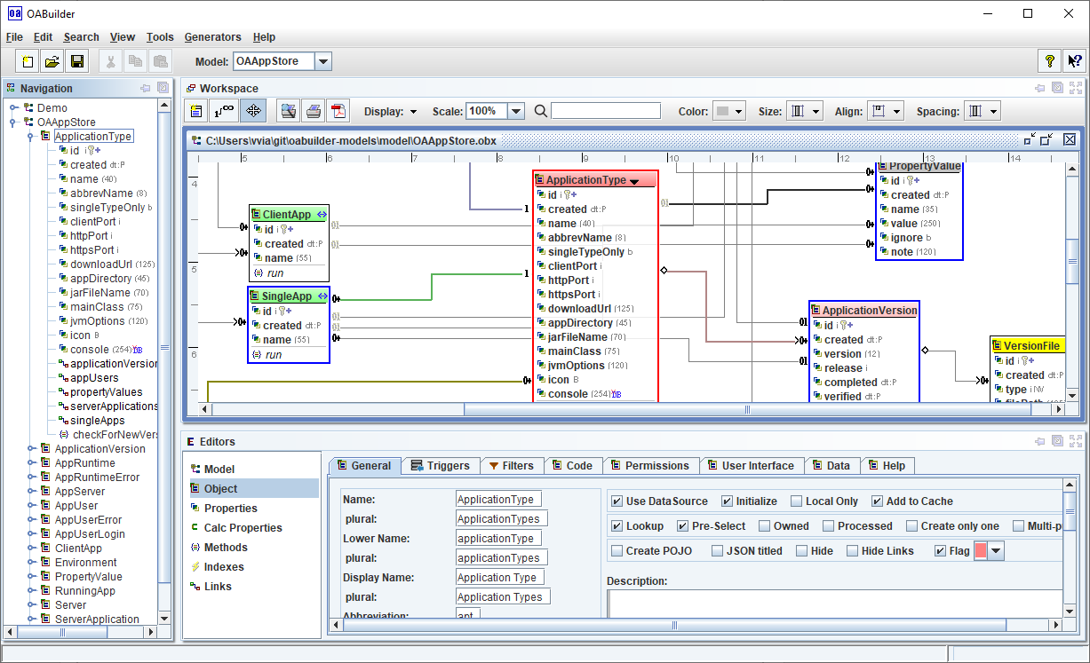

Create a new Application Type

To add a new Application to OAAppStore, you create an “Application Type”.
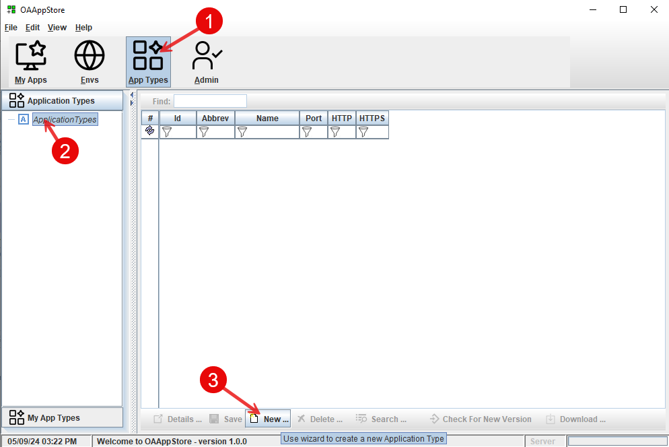

- Select “App Types” from toolbar.
- Select “Application Types” from side bar.
- Click “New” button, and follow the wizard.

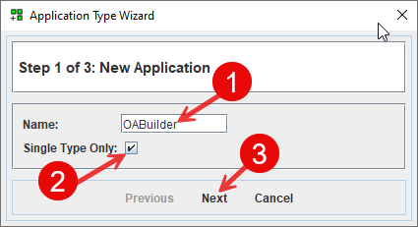

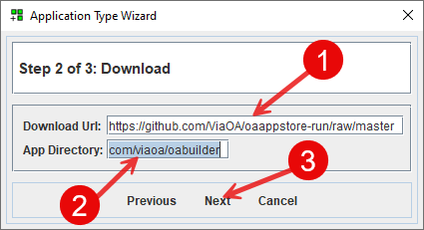
com/viaoa/oabuilder

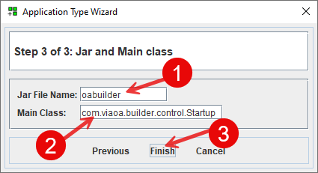
main class: com.viaoa.builder.control.Startup

The OABuilder application is now added.

The next step is to get the latest version of OABuilder.

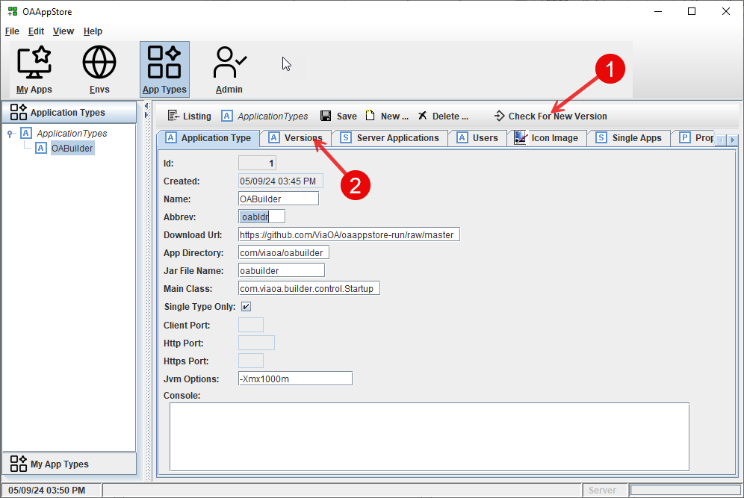
Click “Check for New Version”

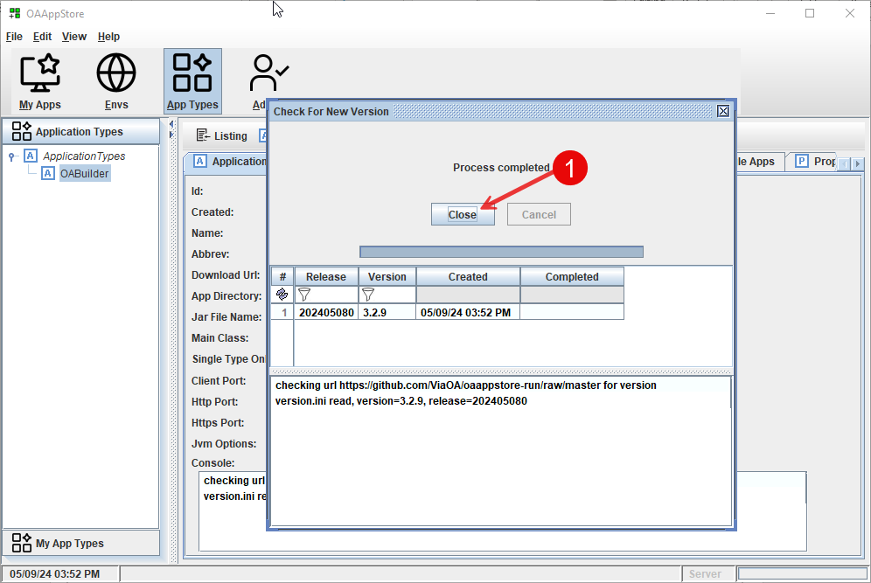
Information for the latest Version will be retrieved.

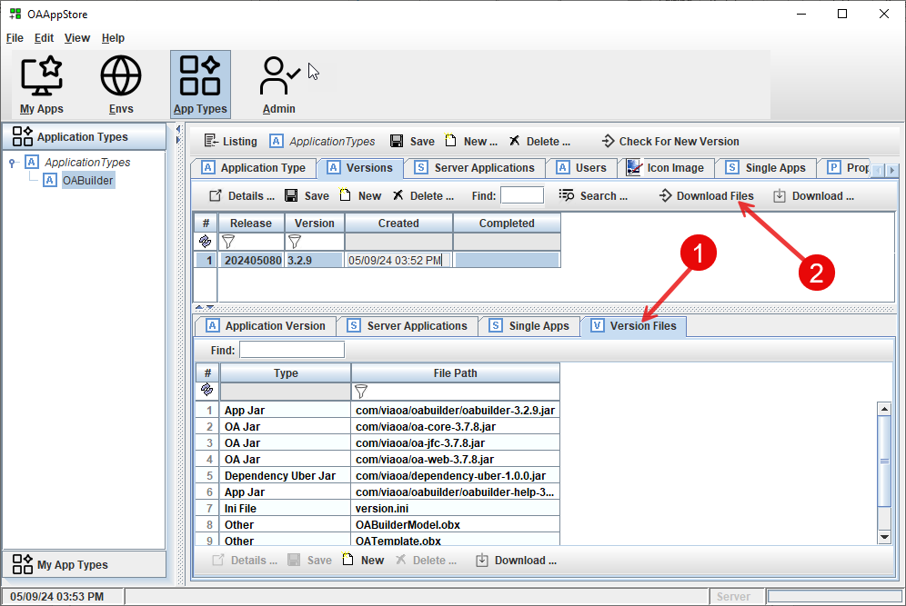
- Click the “version Files” to be able to view the files that are used by the application.
- Click “Download Files” button to have these files downloaded into the AppStore

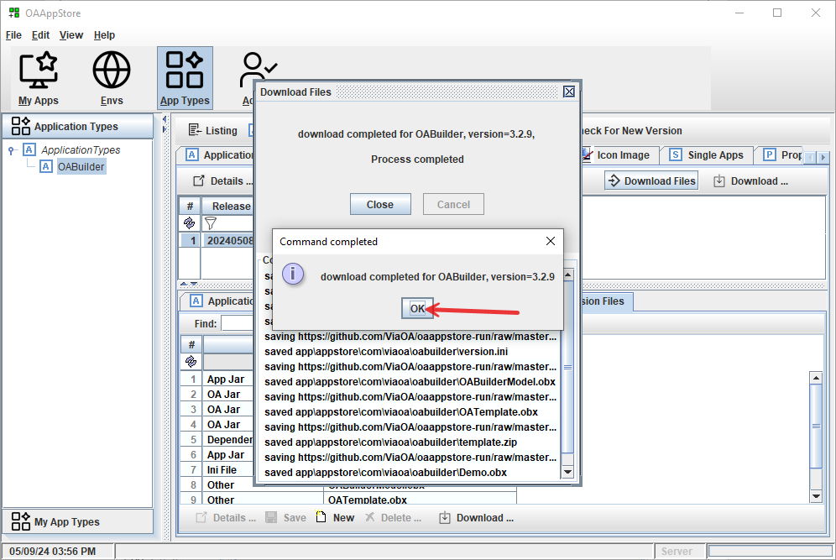
Files will be downloaded and able to run the program. Click “Ok” to close.

Give User permissions to run the new Application Type

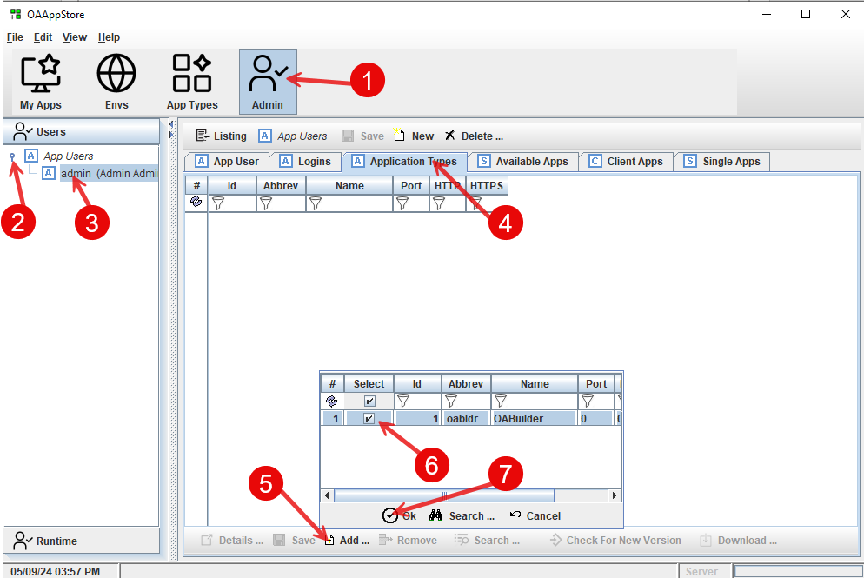
- Click on “Admin” toolbar button.
- Under “Users”, expand “App Users”
- Select a user (example: “Admin”)
- Go to “Application Types” tab, to add a new application type for this User.
- Select “Add” from bottom panel toolbar, to pop up the list choices.
- Check the “OABuilder”
- Click the “Ok” to have OABuilder added.

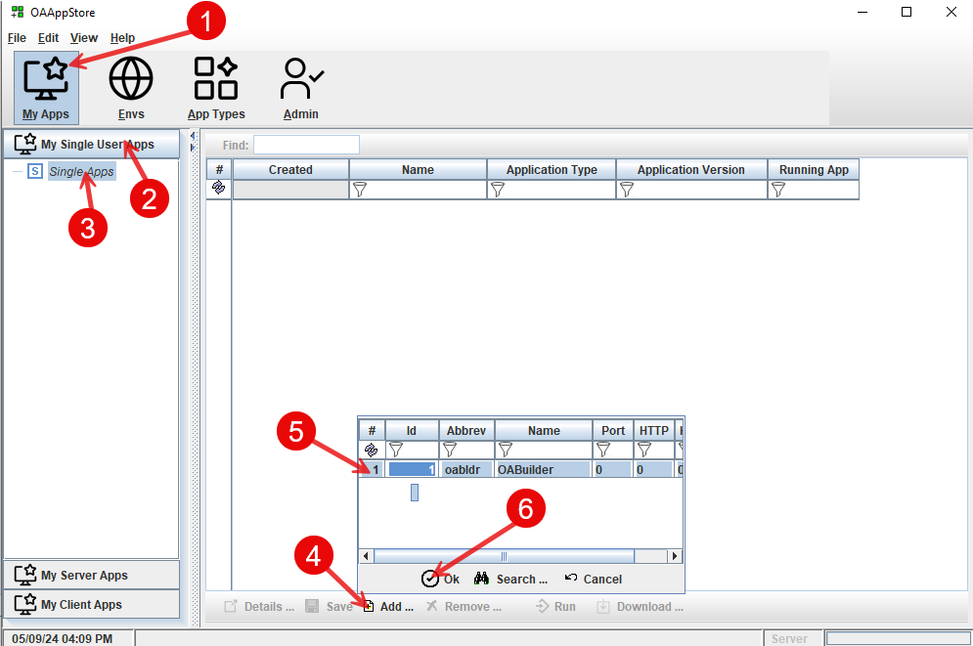

Select the Version to run.

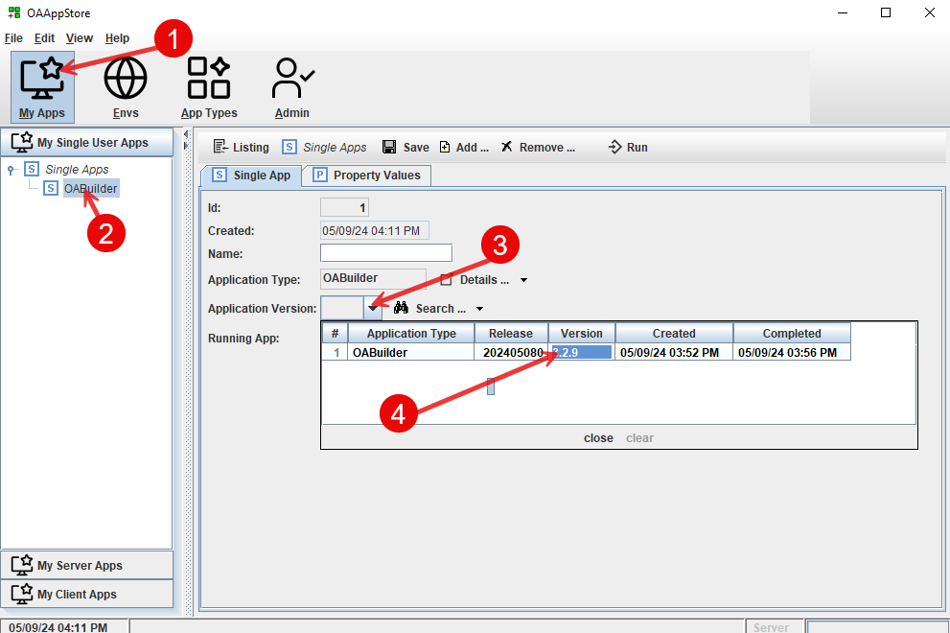

Run OABuilder

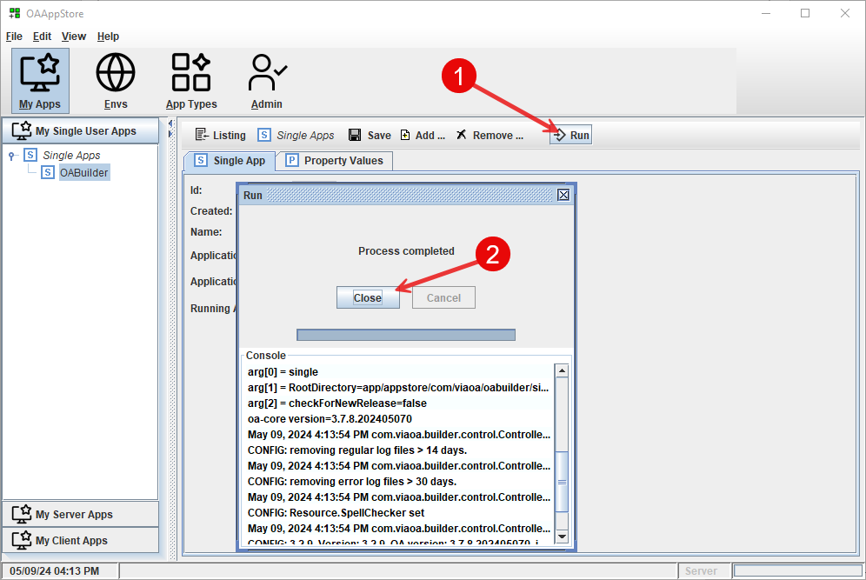

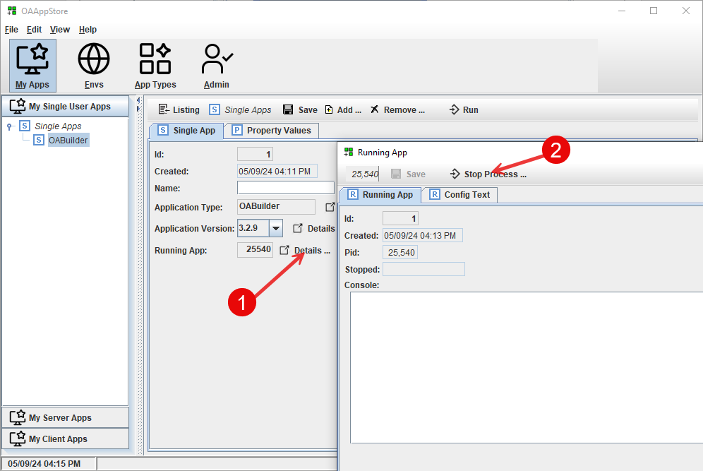

Adding OATemplate to the OAAppStore

OATemplate is a Java project that is used by OABuilder as a “template” for generating new applications from an OABuilder Object Model.

For example, this application, “OAAppStore”, was created using OABuilder to design the model and was then generated using the OATemplate project.

See: OATemplate project on github for more information.

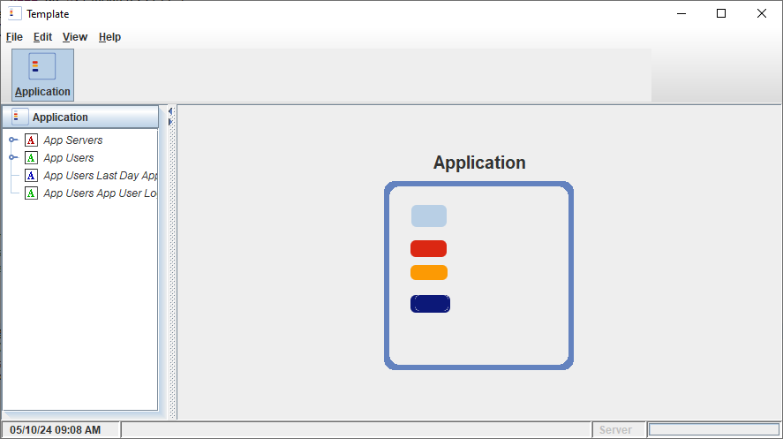

Create a new Application Type

The first step is to add a new Application Type “OATemplate”

- Select “App Types” from toolbar.
- Select “Application Types” from side bar.
- Click “New” button.

Follow the following images for adding a new application.

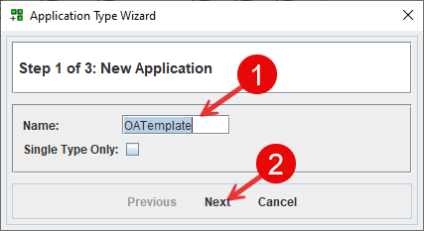

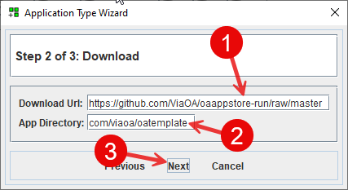
com/viaoa/oatemplate

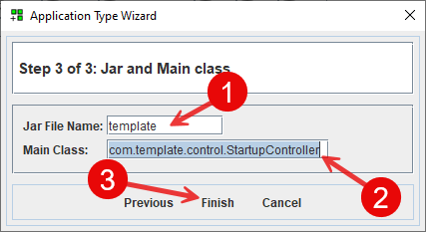
main class: com.template.control.StartupController

The OATemplate application is now added.

Now that the Application Type has been create, the next step is to get the latest version of OATemplate.

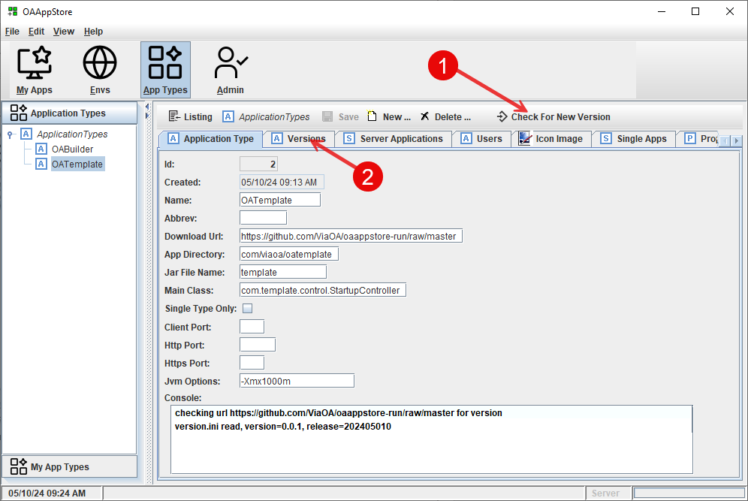

Click “Check for New Version”

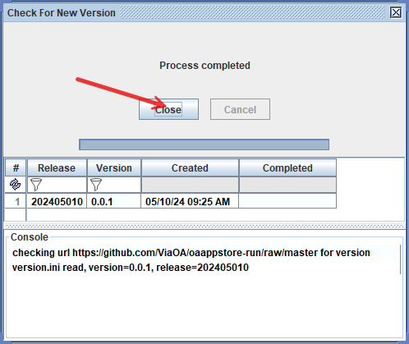

Information for the latest Version will be retrieved.

The next step is to download the files.

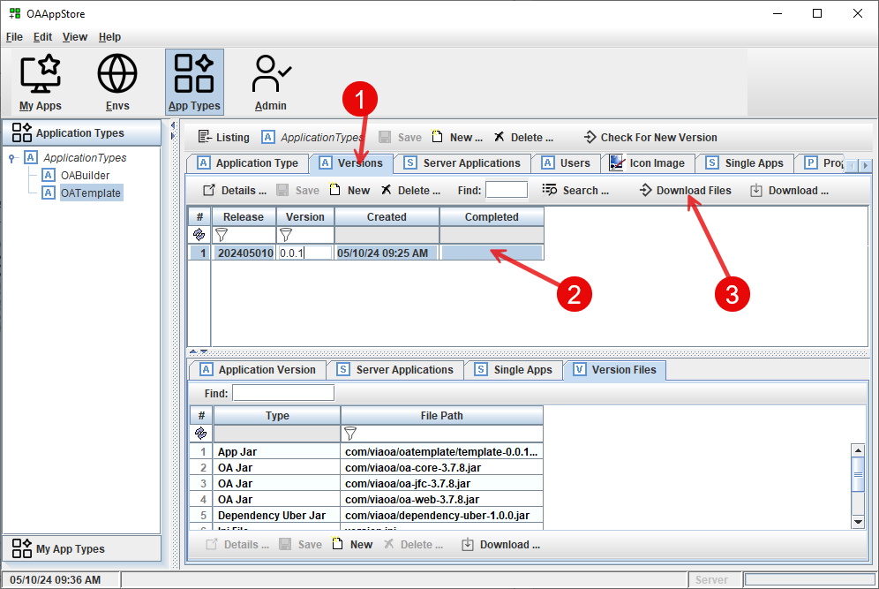

- Click the “Versions” tab.
- Select the release to download.
- Click “Download Files” button to have these files downloaded into the AppStore
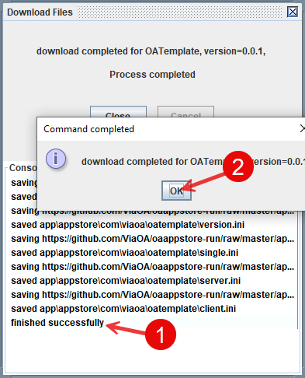

Files are now downloaded. Click “Ok” to close.

Give User permissions to run the new Application Type

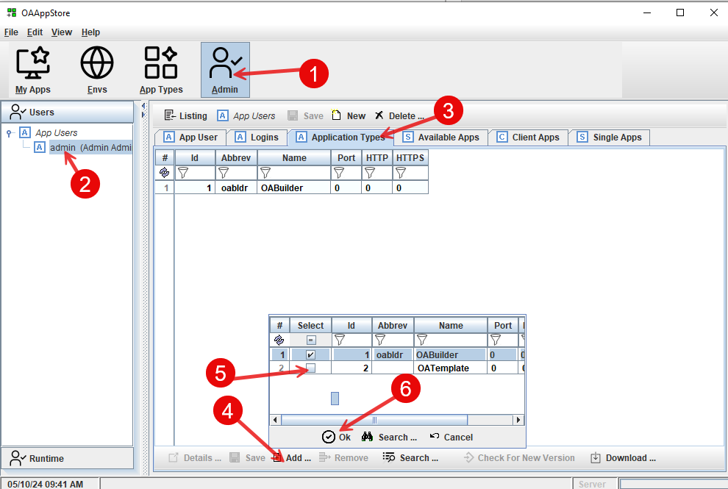

- Click on “Admin” toolbar button.
- Under “Users”, expand “App Users” and select a user (example: “Admin”)
- Go to “Application Types” tab, to add a new application type for this User.
- Select “Add” from bottom panel toolbar, to pop up the list choices.
- Check the “OATemplate”
- Click the “Ok” to have OATemplate added.

The next step is to add OATemplate to “My Apps”

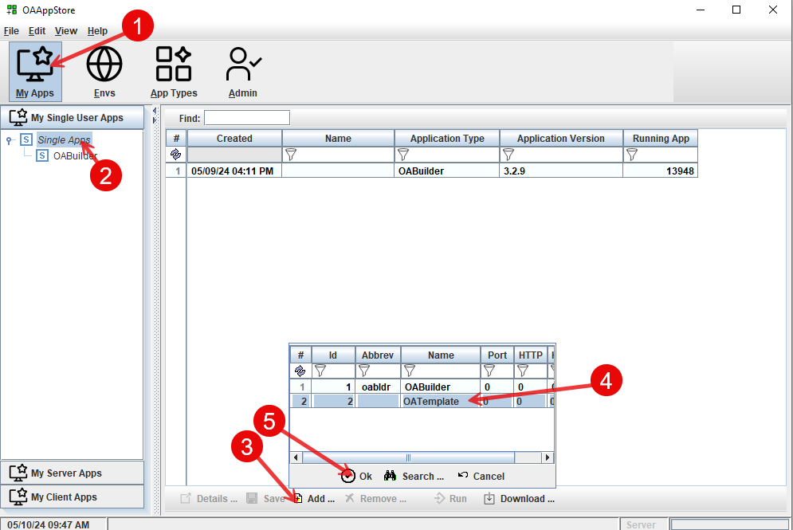

- Click “My Apps” from main toolbar.
- Under “My Single User Apps”, select “Single Apps”.
- Select “Add” from bottom toolbar.
- Select “OATemplate” from list.
- Select “Ok” to have it added.

Select the Version to run.

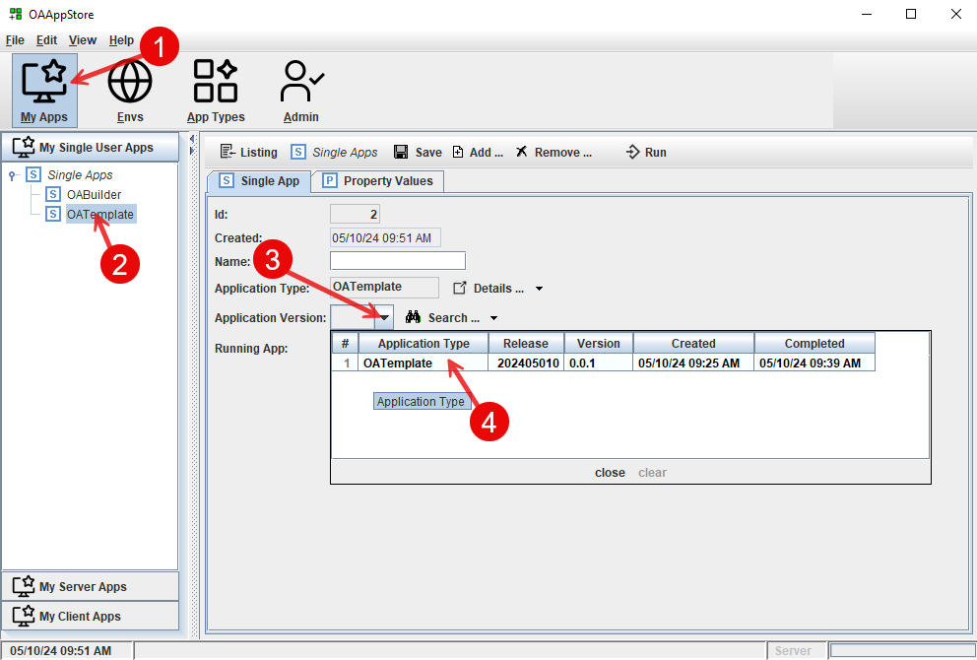

- Select “My Apps” from main toolbar.
- Select “OATemplate’ from “My Single User Apps” sidebar.
- Click “Application Version” drop down list.
- Select OATemplate from the list.

Run OATemplate as single user (from desktop)

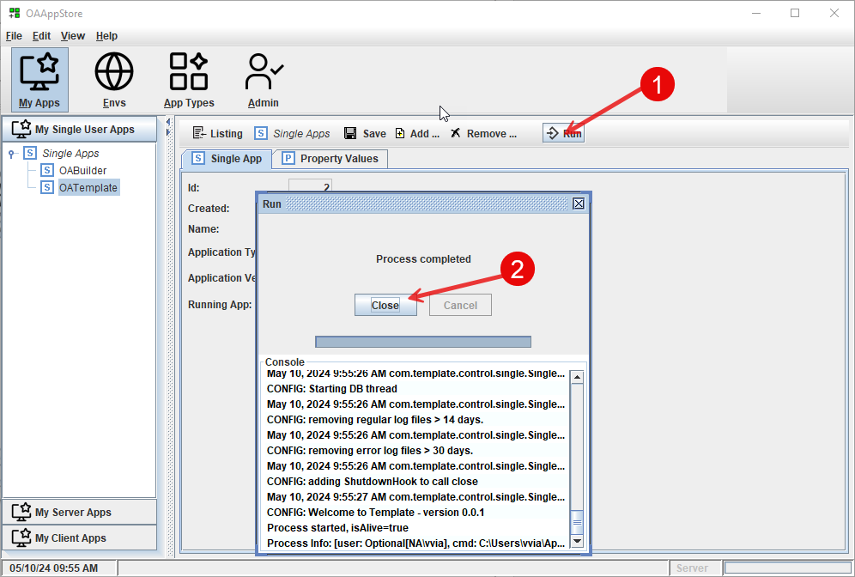

- Click the “Run” button to launch OATemplate as a single user .
- Click the “Close” button.

Setting up Environments

OAAppStore allows for setting up Environments, so that Server Applications can be ran and then accessed using Client. We will set up a server in OAAppStore, run OATemplate as a Server, and then connect to it using OATemplate as a Client(s).

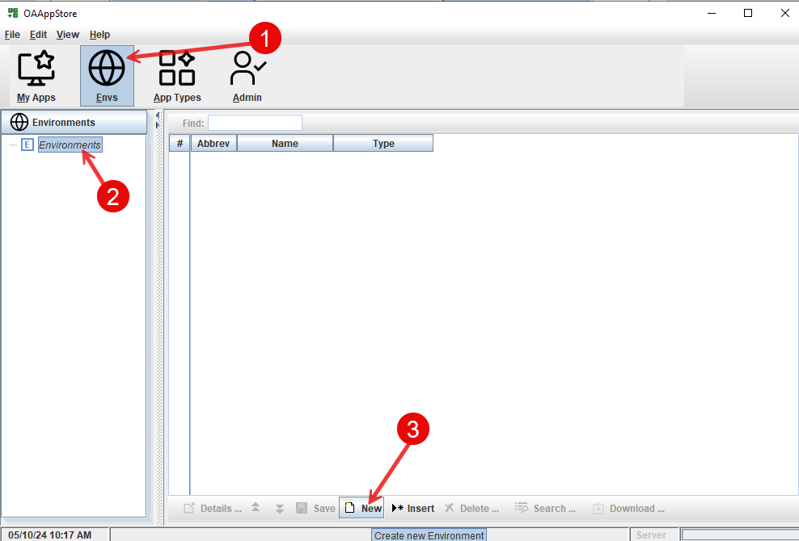

Create a new Environment
- Select “Envs” from main toolbar.
- Select “Environments” from side bar.
- Click “New” from bottom toolbar.

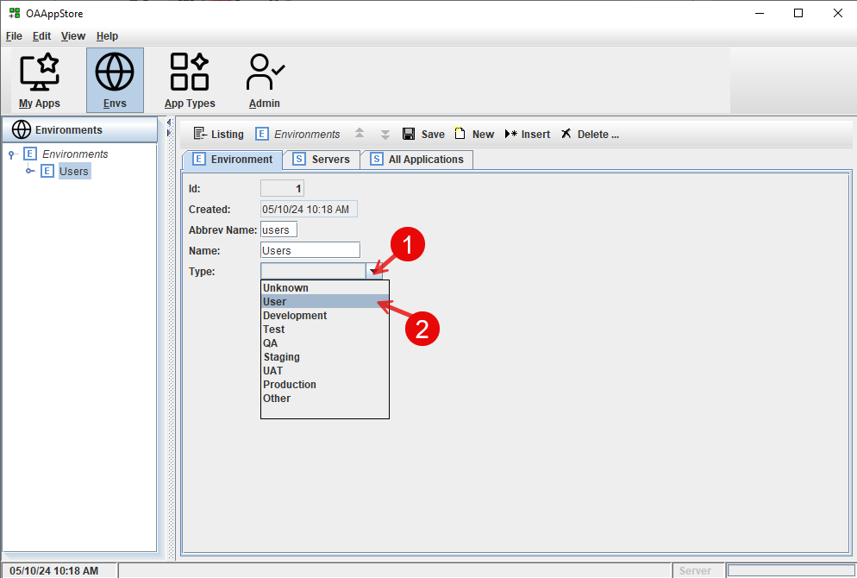

Create a new Environment for “Users”
From the new “Users” Environment
- Select the type as “User”

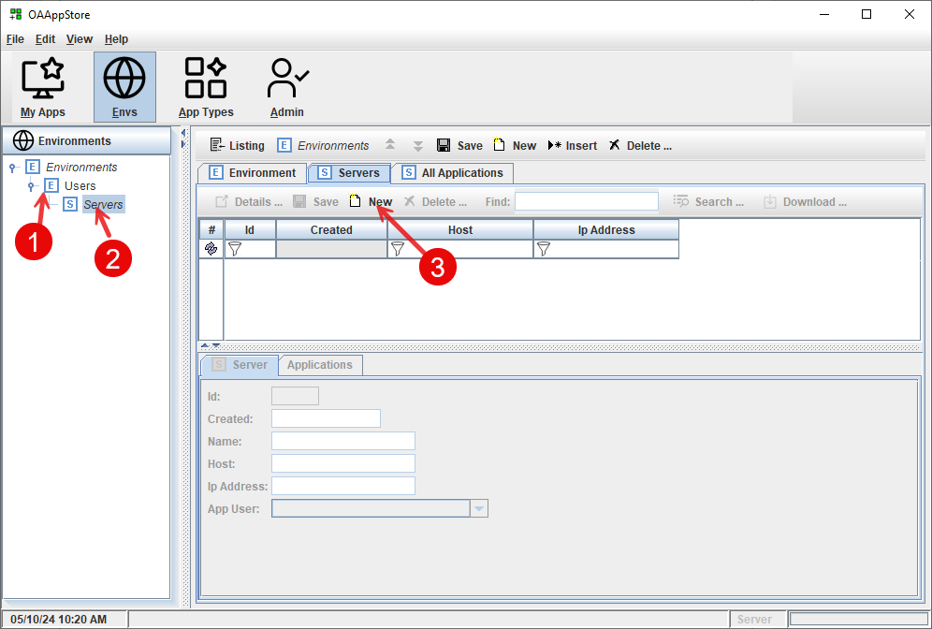
Create new server in “Users” environment

- Select new “Users” Environment
- Select “Server”
- Click “New” button from toolbar.
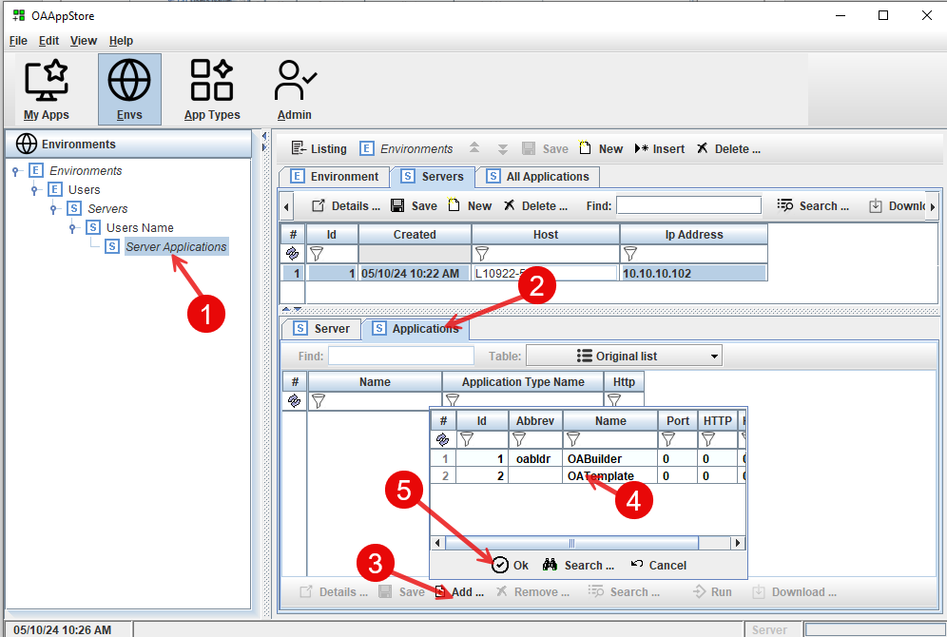
Add the “OATemplate” as an application that can be ran on this server.

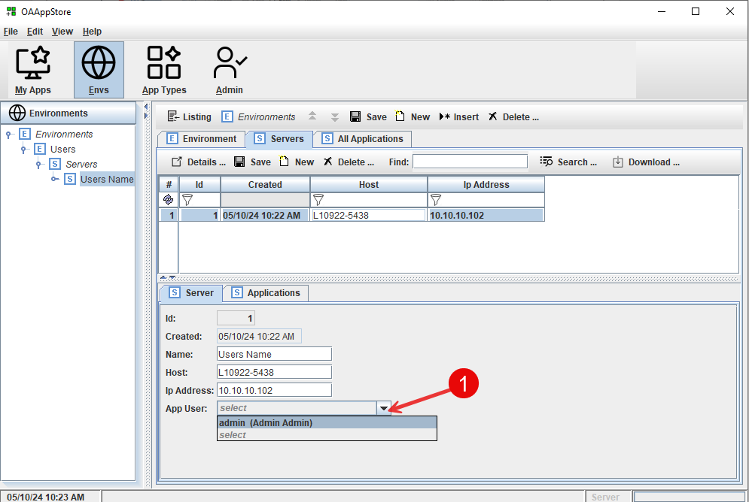

Enter information about the computer/server
Select the user of the Application.

Add an Application to the Server.

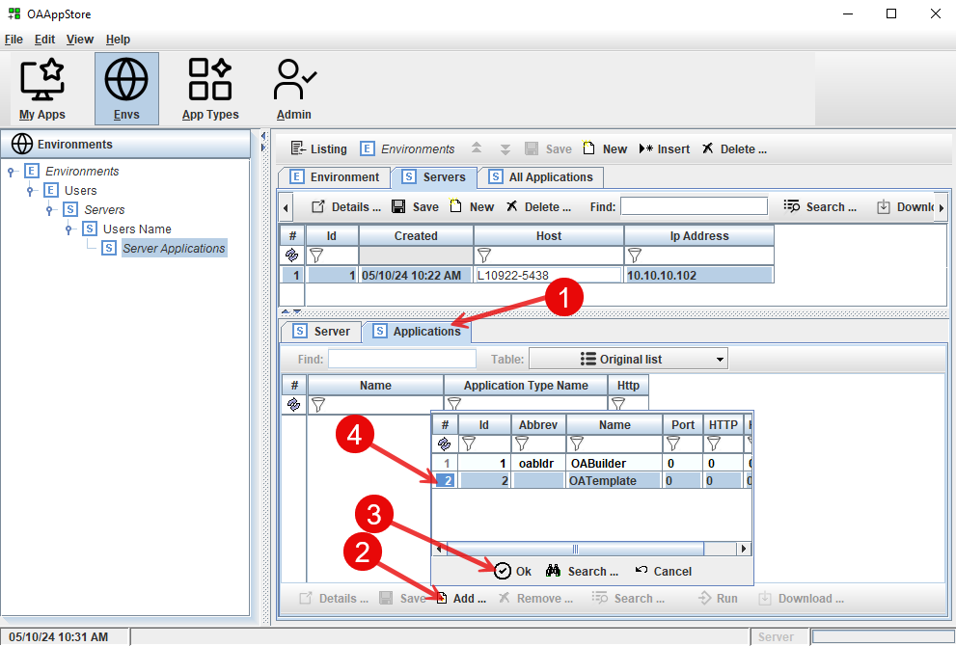

- Select the Applications tab
- Select “Add” button
- Choose OATemplate
- Click the “Ok” button to add the OATemplate

Add additional information about OATemplate for this Server.
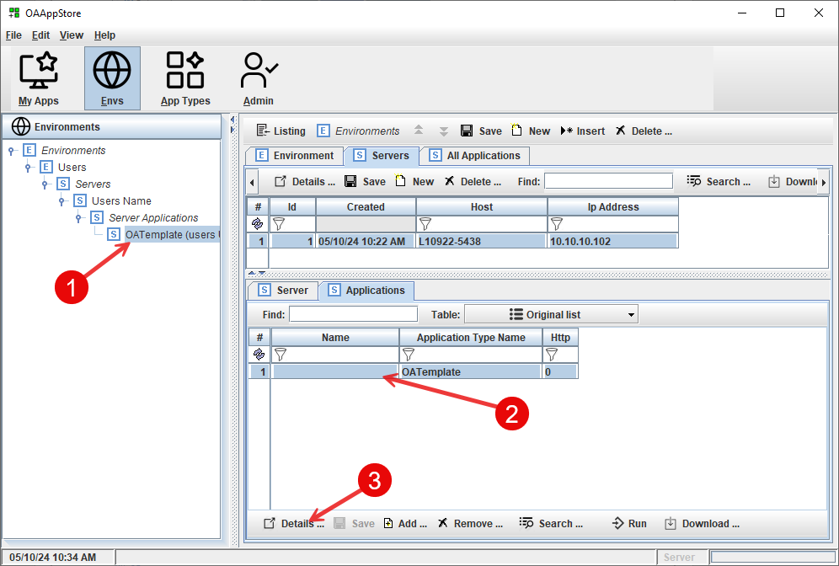
- Select the Server from the Environments navigation pane
- Select “OATemplate”
- Click on the “Details” button

Running OATemplate as Server

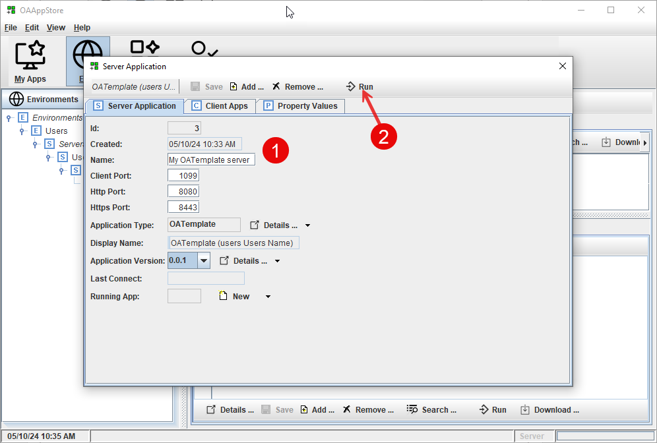

- Fill out information
- Click the “Run” button to run OATemplate as a Server Application.

The “Client Port” will be used when running OATemplate as Client and connecting to OATemplate Server.

The http/https ports will be where REST API, Swagger, webservices, Web APP are available.

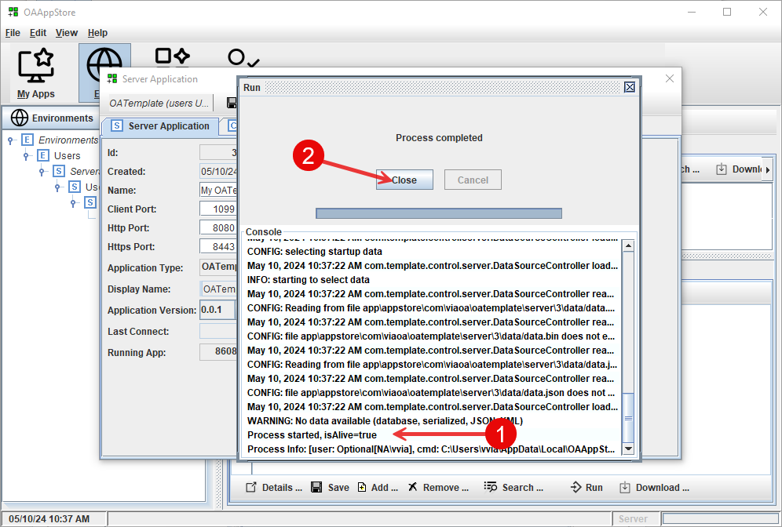

The display window will show the console display area.
- This shows that the process “isAlive” and running.
- Close this window.

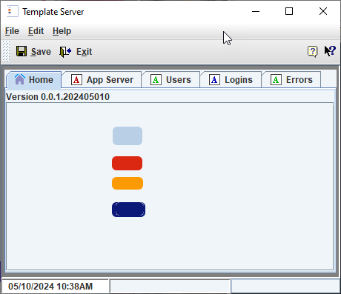

Template is now running as a Server

You should now see “OATemplate” under “My Server Apps”. This was set up in the previous task.
If it does not show, make sure that you selected your user (default is “admin”) for the Server that was set up in the previous task above when adding OATemplate as a Server application.

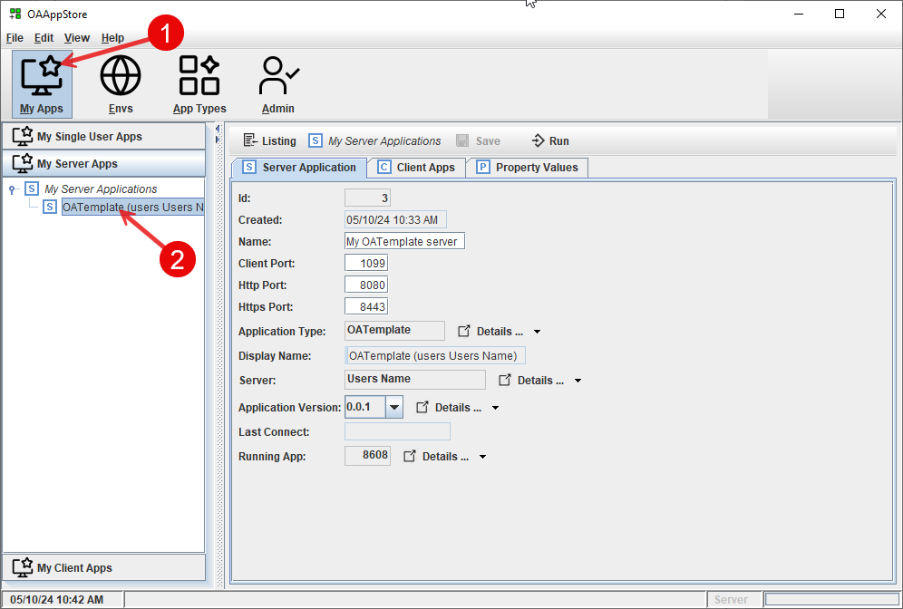

- Go to “My Apps”
- Verify that “OATemplate” is showing as an Application running on your Server.

The “Client Apps” tab will show OATemplate Clients that are connected (/running).

Running OATemplate as Client to connect to Server

Now that we have OATemplate running on a Server, we will connect to it using OATemplate client.

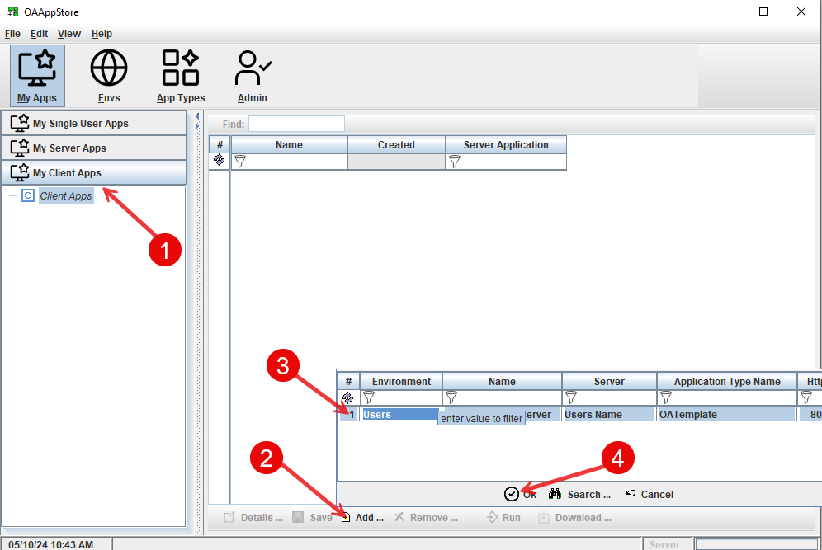

- From “My Client Apps”, click on “Client Apps’
- Click the “Add” button to popup list.
- Select the Server application.
- Click “Ok” to add to your Client Apps

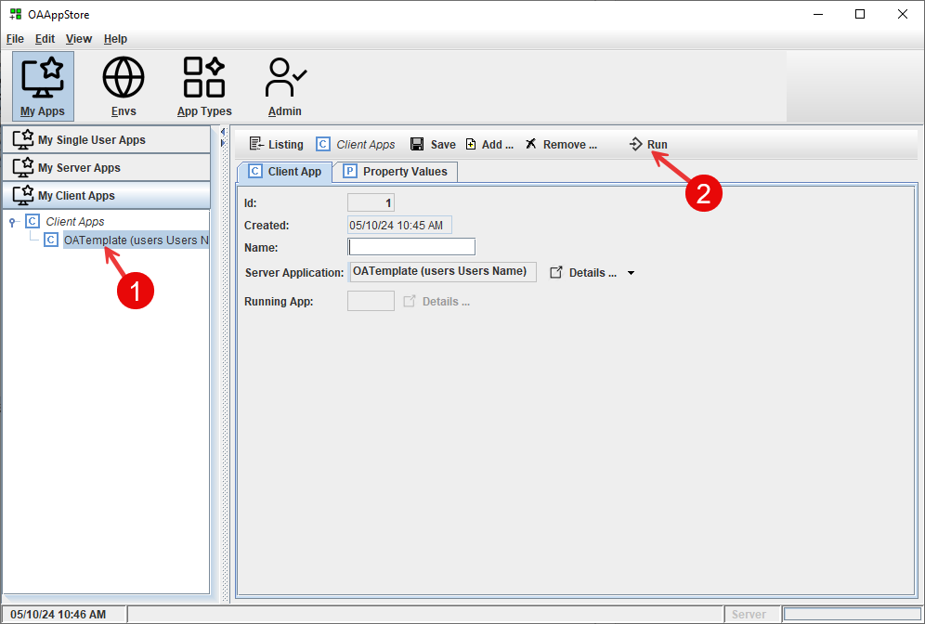

- From “My Client Apps”, choose “OATemplate”
- Click on the “Run” button to launch OATemplate and display login window.
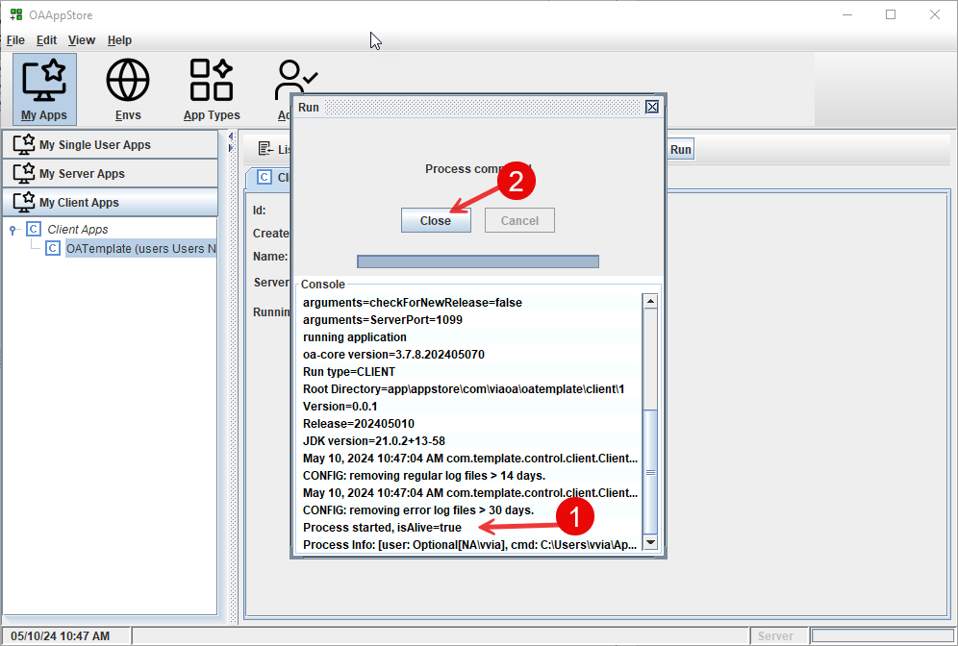

This shows the console

Login to the Server.

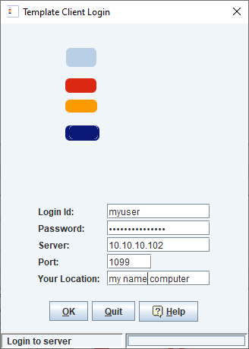

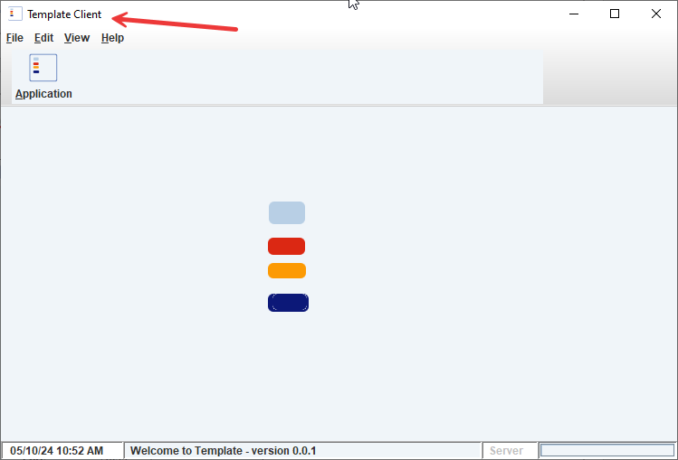

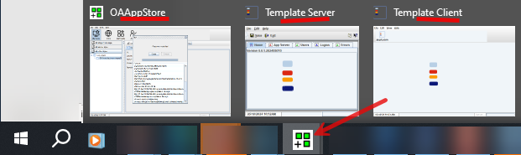

This shows the Windows taskbar, where the OAAppStore icon then shows all Apps that are running.

Take a tour

This tour will explain the concepts and features of the OAAppStore.

OAAppStore was created to allow users to be able to run Java applications without needing to do separate installations. From the AppStore, users are able to run and connect to applications running on other servers, and set up a hierarchy of environments and servers.

Follow the “Installation Guide” to install OAAppStore.

Follow the instructions in this guide to add the OABuilder and OATemplate applications to OAAppStore.

Run OAAppStore to display the desktop application UI.

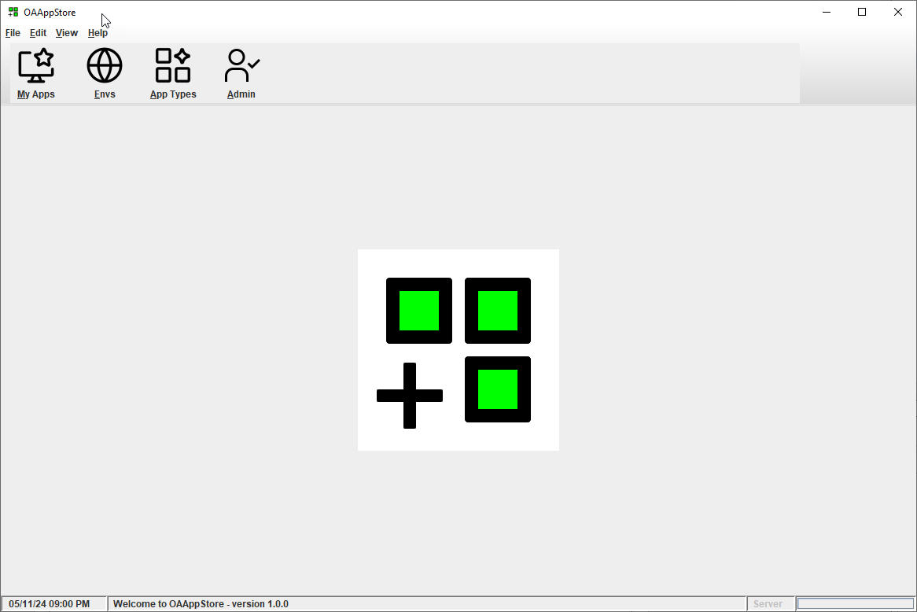
Startup window.

My Applications

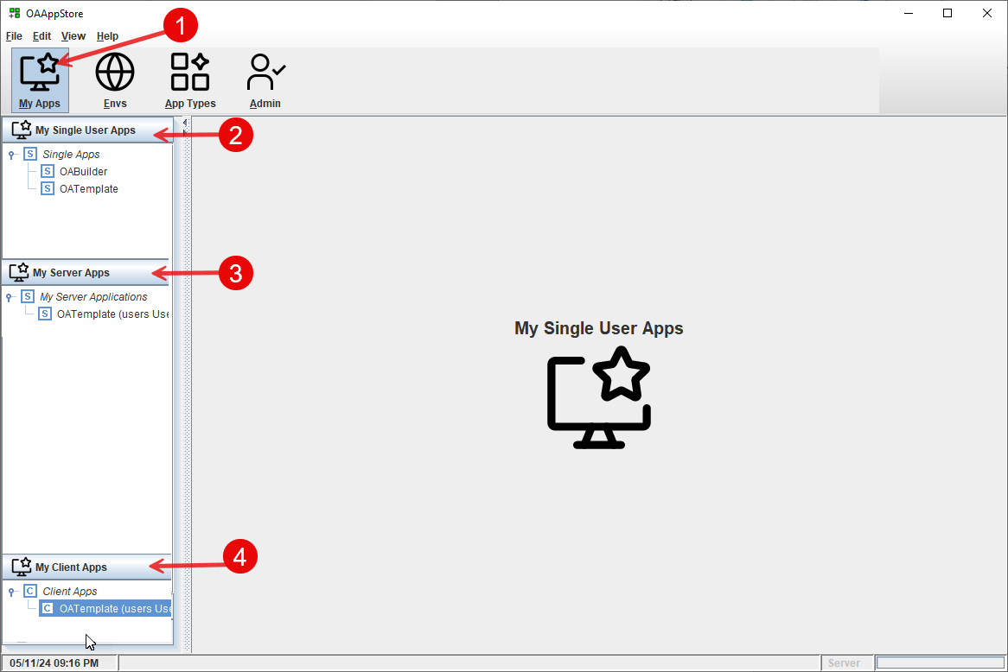

This window shows “My Apps”, that include:
- My Apps toolbar button
- My Single User Apps – which run on my computer.
- My Server Apps – apps that allow for other computers (/user) to connect to an App on my computer that is running as a server app.
- My Client Apps – server applications that I can connect to.

My Apps that are Single User

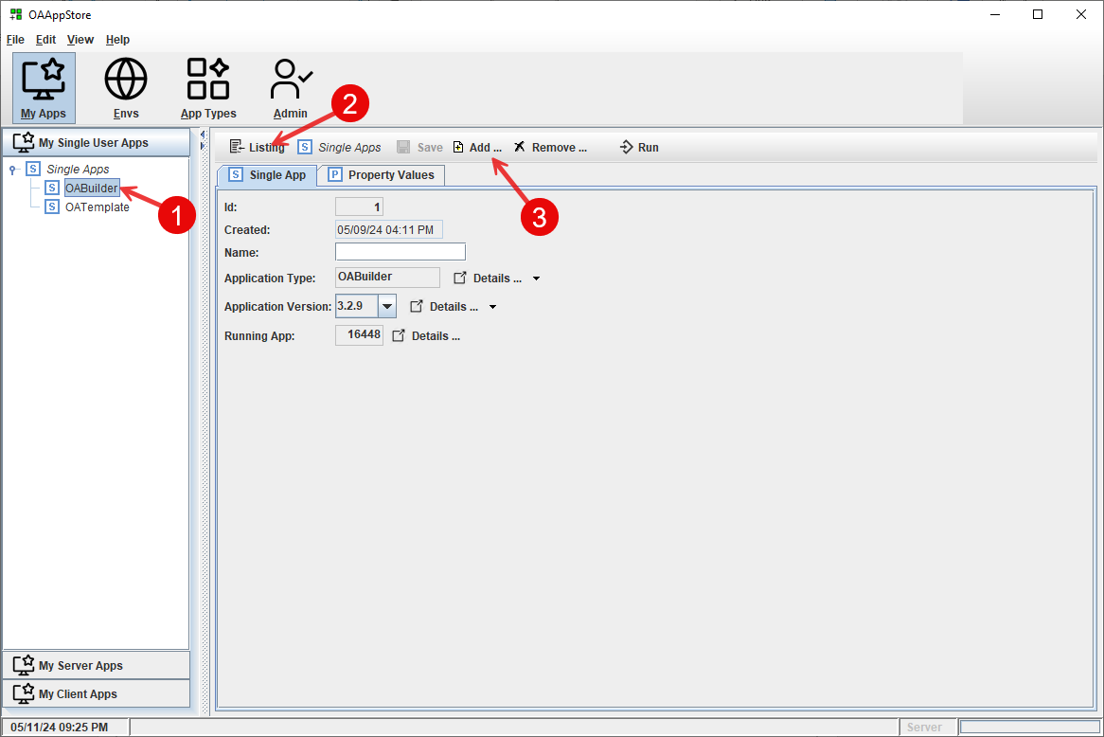

This window shows “My Single User Apps” that have been added.
See later: “App Types”, and “Admin” to install and give permissions to a user to access installed apps.

- Installed applications “OABuilder”, and OATemplate.
- Click “Listing” to see listing.
- Use the “Add” button to add another “Single App”

Launching an Application

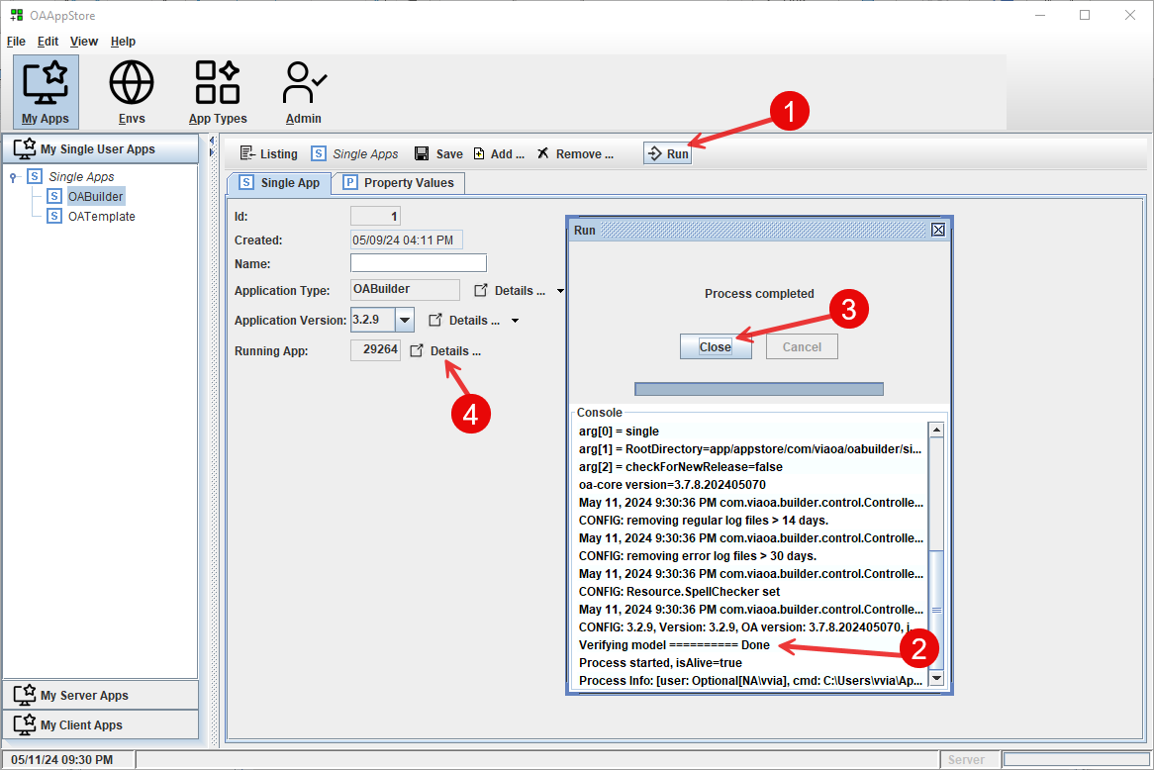

- Run command on toolbar
- The popup processing dialog will display the start console messages.
- Close this window.
- Click to view the running App’s process

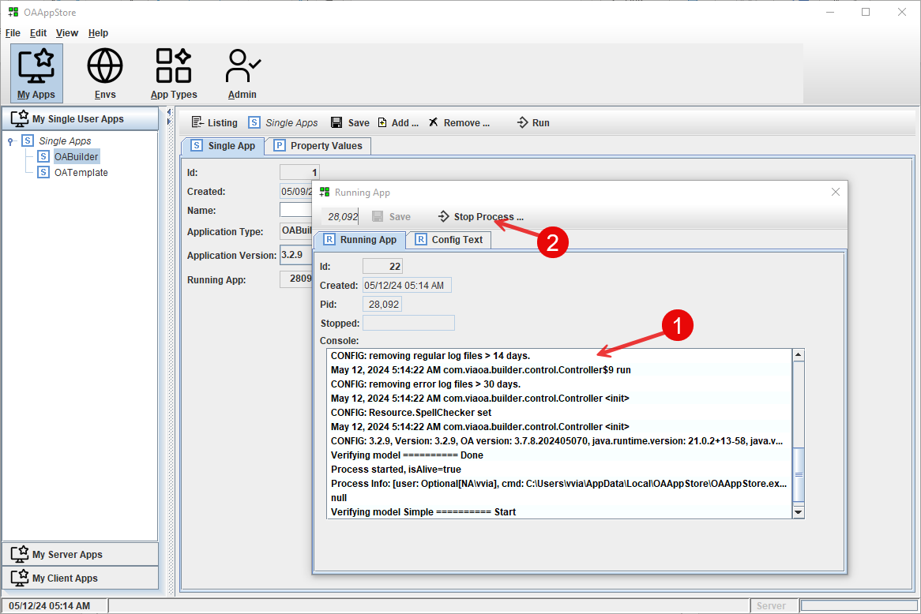

This shows:
- Information about the running application.
- Use the “Stop Application” to force the application to be stopped.

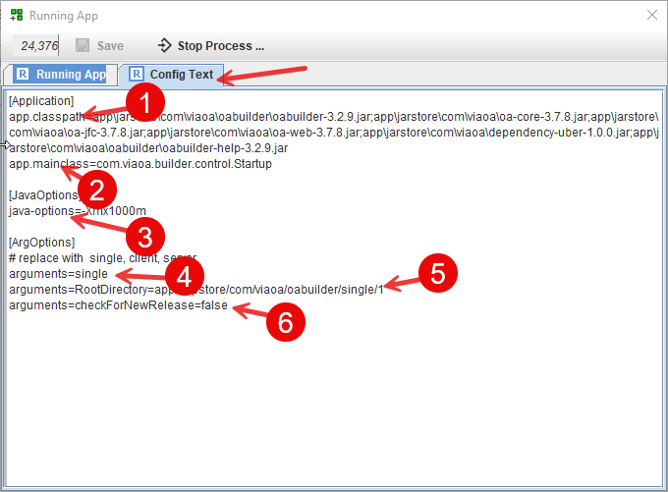

This shows the configuration settings for starting the application.

- Java classpath: Java jar files (/libraries) used by the program. Each are loaded in the installation folder, under the “jarstore” directory.
- Main class: is the Java class with the “main” method that starts the application.
- Java command line options
- Argument for how to start the application: single, server, client, etc.
- Root directory for application to use, from the OAAppStore’s installation directory.
- Other arguments sent to application.

My Apps that run as a Server (multi-user)

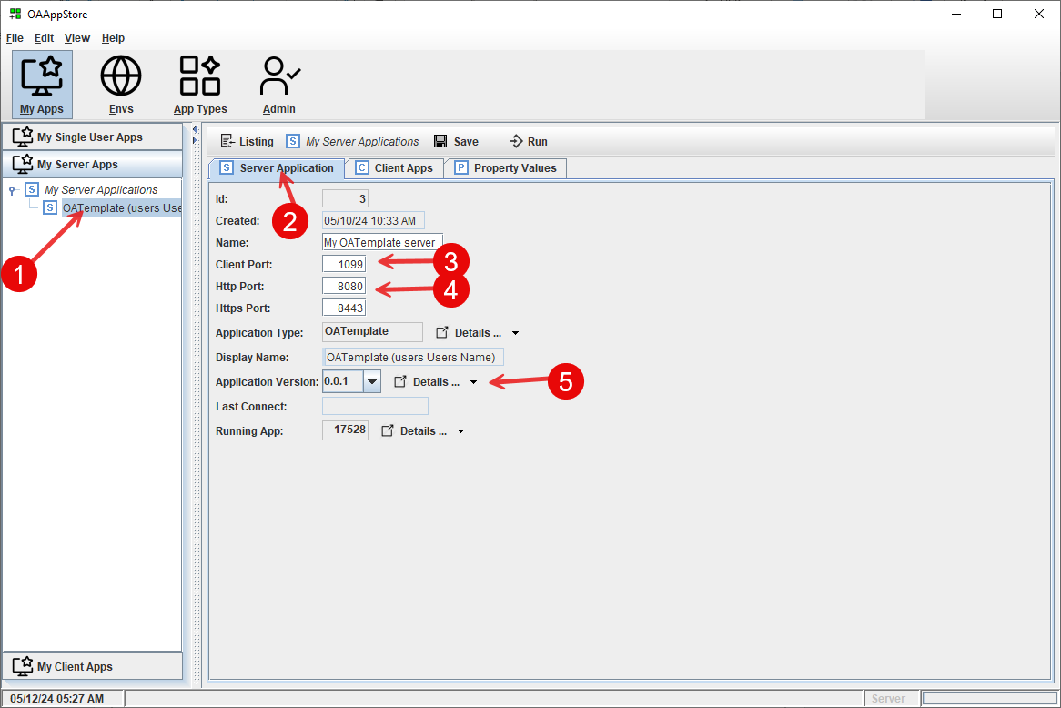

- List of “My” applications that run as a server. See: installing and running OATemplate as a server.
- Information as the application.
- Socket port number that clients will use to connect to the server.
- Http, Https ports used to connect to Server’s REST API, webservices and web pages.
- Version of the application to run.

My Apps that run as a Client (connect to a Server)

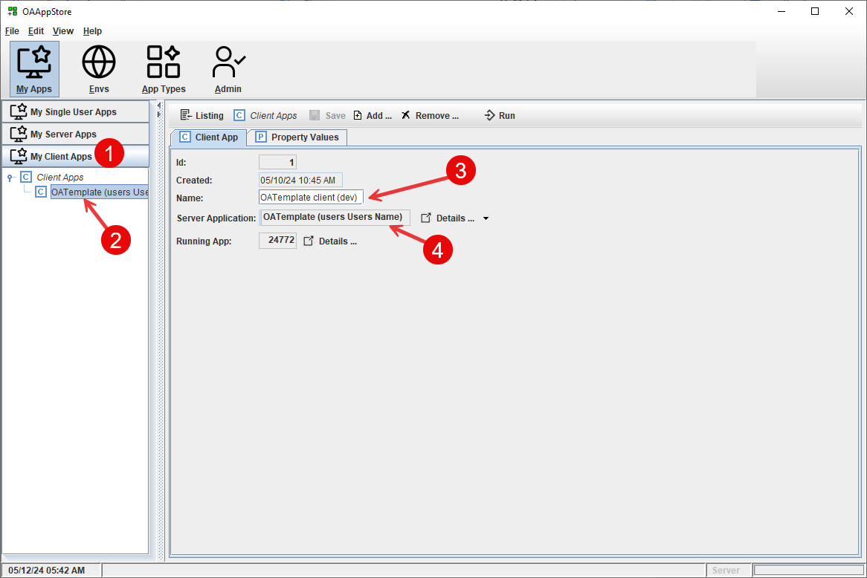

- Client application list
- Select application
- Give this application a name
- Server application information

Application Environments

App Environments are used to set up multiple environments that have servers with applications available.

This allows for creating an OAAppStore as a server app, configuring the environments, and then allow user local OAAppStores to connect to it as a client.
See: “creating a multi-user OAAppStore’

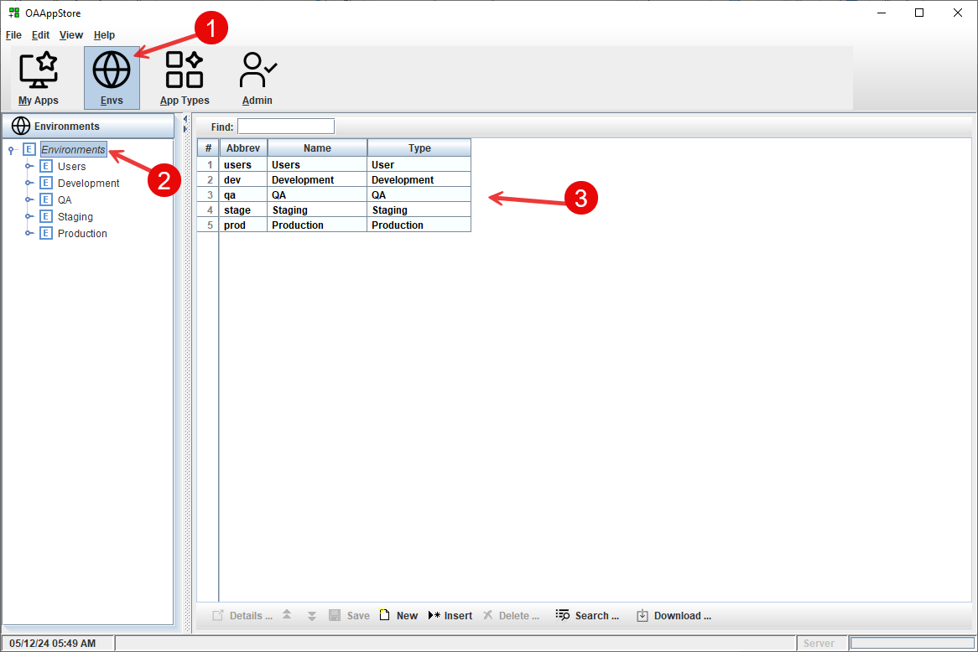

- Select “Envs” toolbar button.
- List of environments
- Listing panel

Setting up an Environment

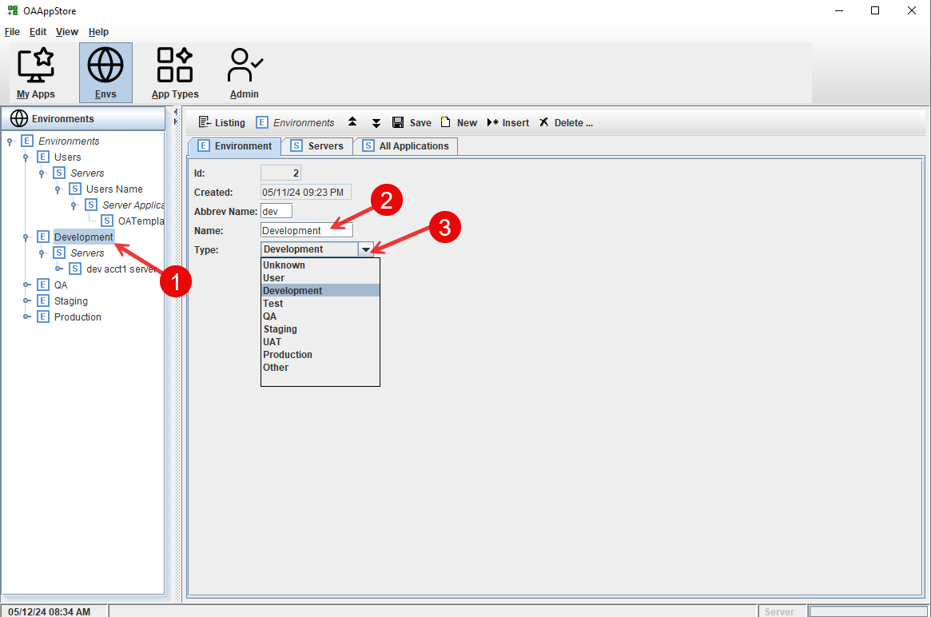

Select an existing or use the “New” button on the toolbar.
Enter a name
Choose type of environment

The environment type “User” is when you would like to have user computers (ex: developers) as a grouping.

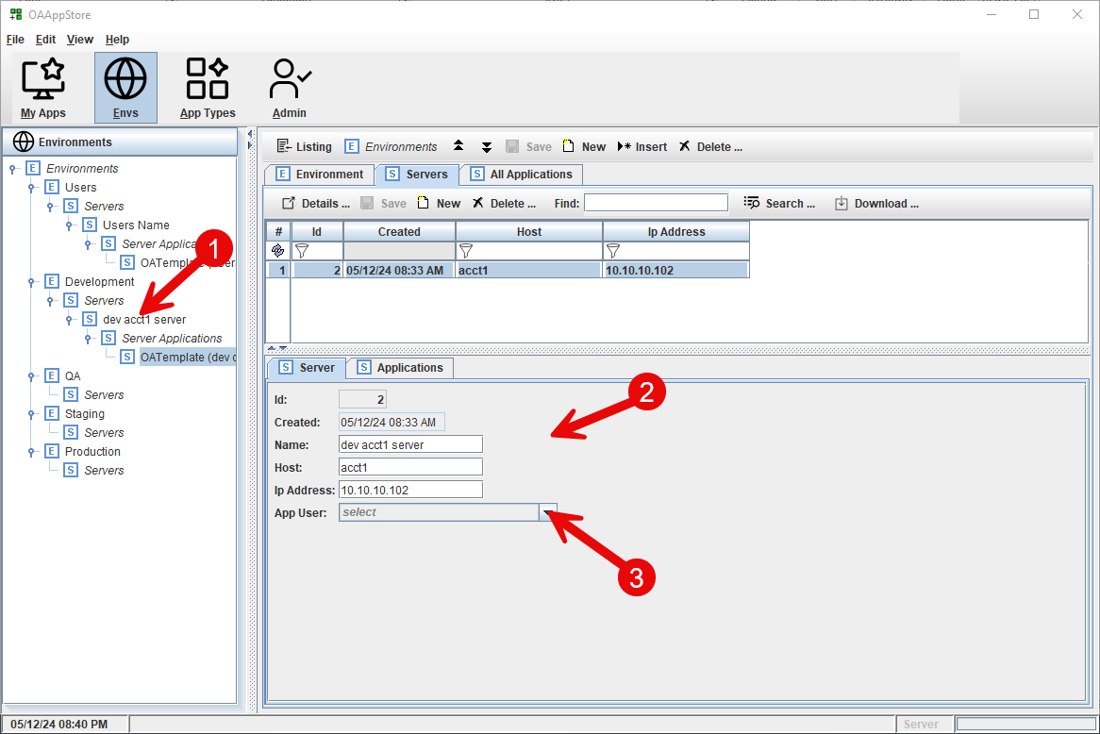

- Select Server from environment
- Fill out Server information
- If this is a User’s computer, then select App user name from dropdown list.

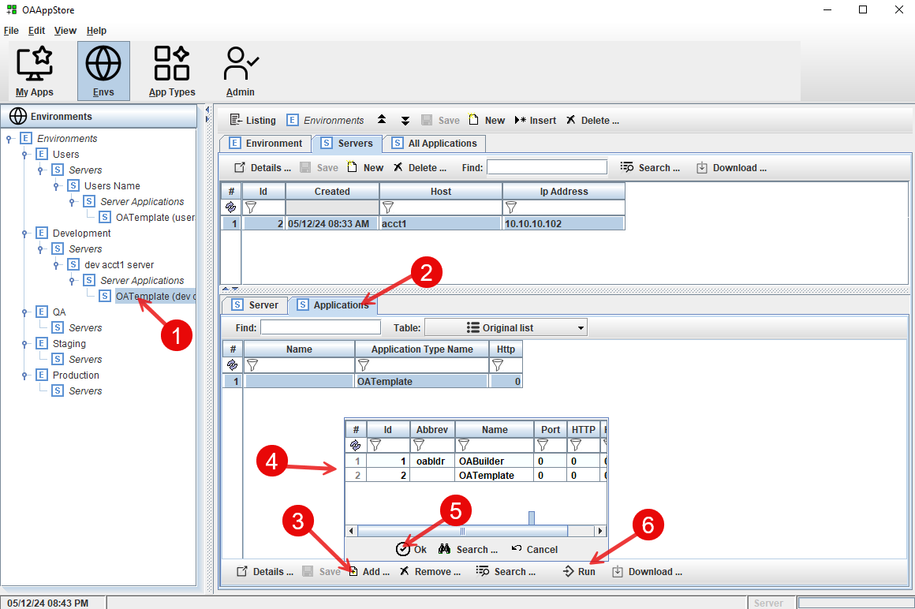

To edit or add Applications for a Server
- Expand Environment to get server, or select “New” Server on north panel toolbar.
- Select “Applications” tab.
- Select “Add” button to add an Application.
- Select App to add
- Click “Ok”
- Click the “Run” button to Run as Server.

Application Types

Application Types are used to define Apps that are added to the OAAppStore.
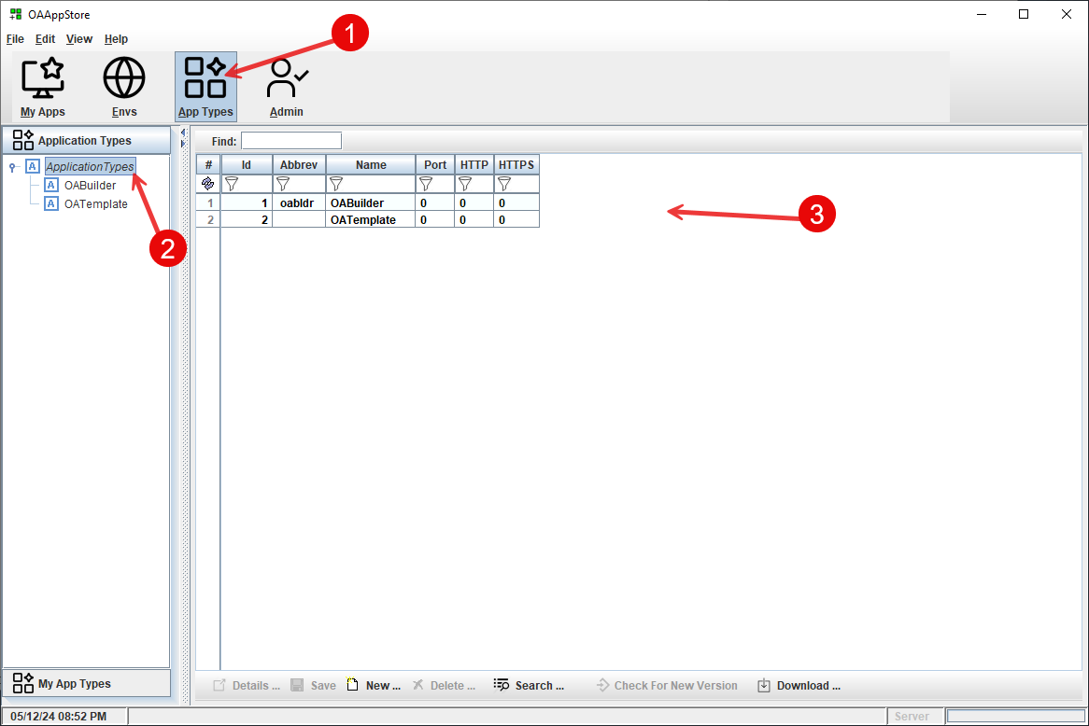

- Click the “App Types” main toolbar button
- Side bar shows list
- Listing details

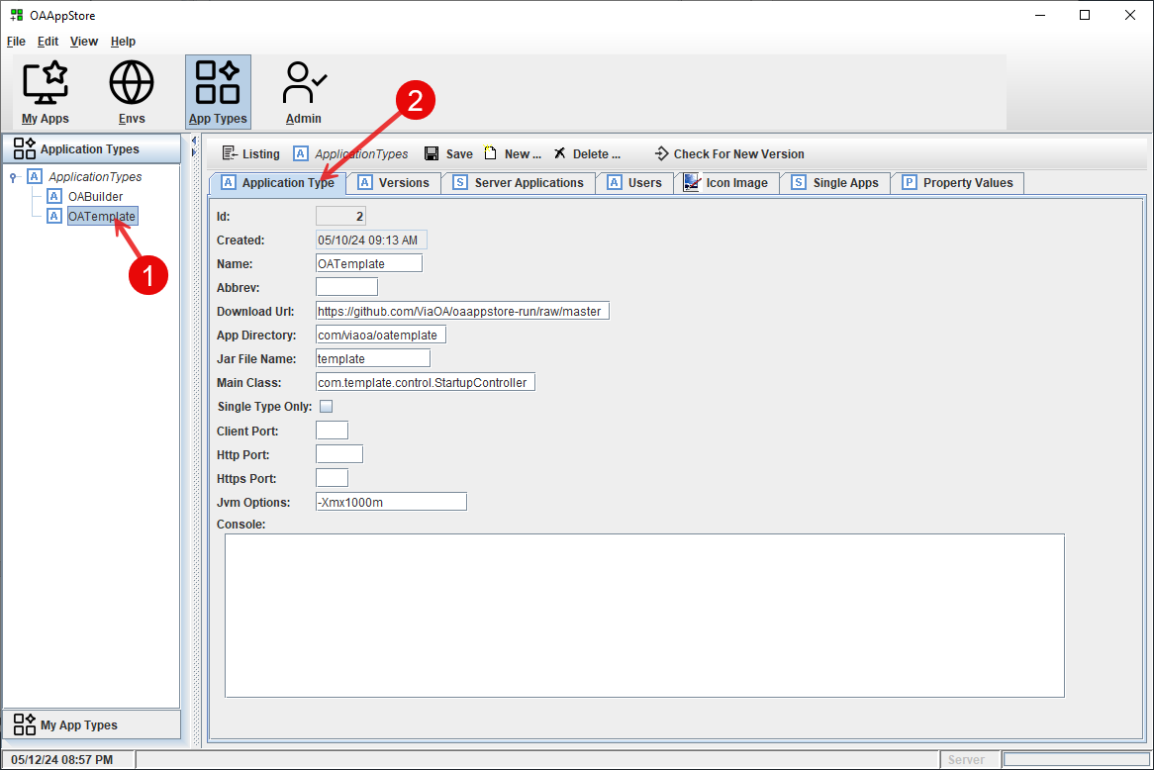

Set up a new Type of Application.

Check for new versions

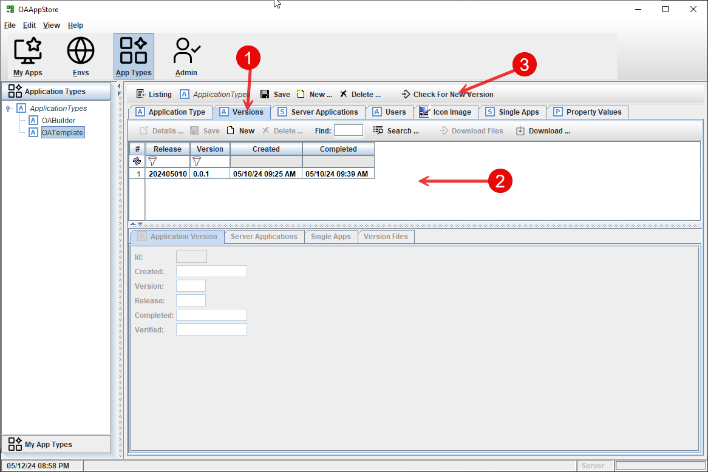

- Select the “Versions” tab.
- List of versions available.
- Click “Check For New Versions” to find if there is a new version available.

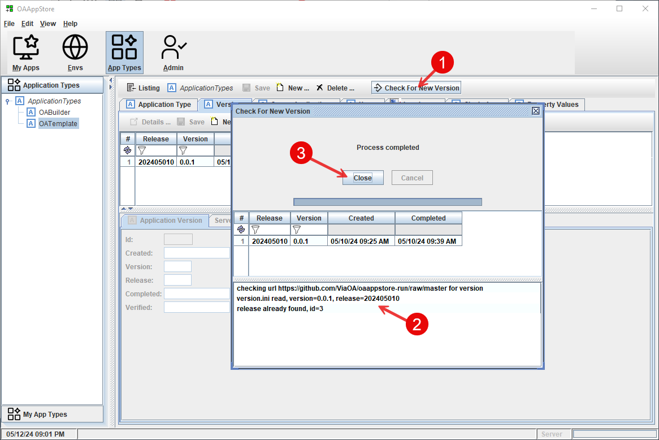

- Click “Check for new Version”
- Popup will show results.
- Close window.

Download version.
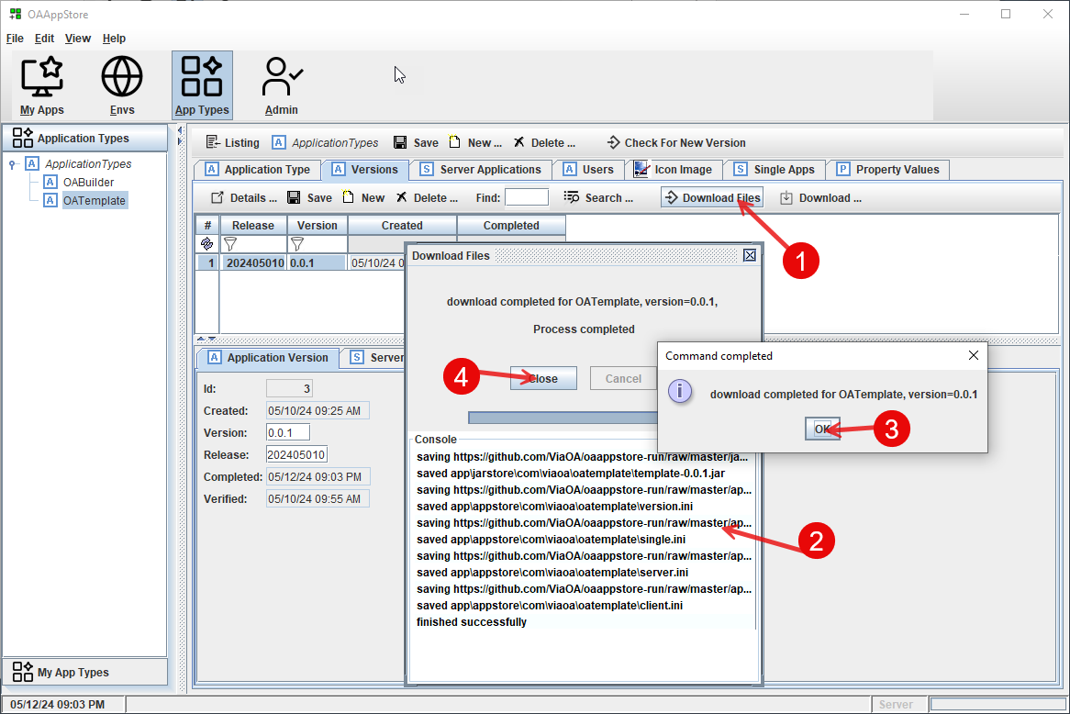

- Click “Download Files”
- Console will display activity.
- Confirmation
- Close window

“My App Types” sidebar.

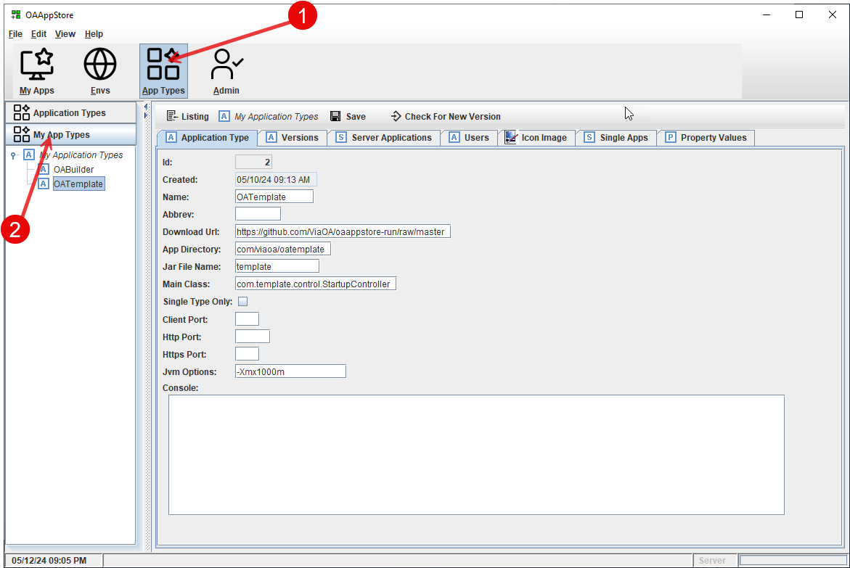

This will list the App Types for the current user.
See “admin”, where Users are assigned Application Types.

Admin

Add Applications for a User to use.
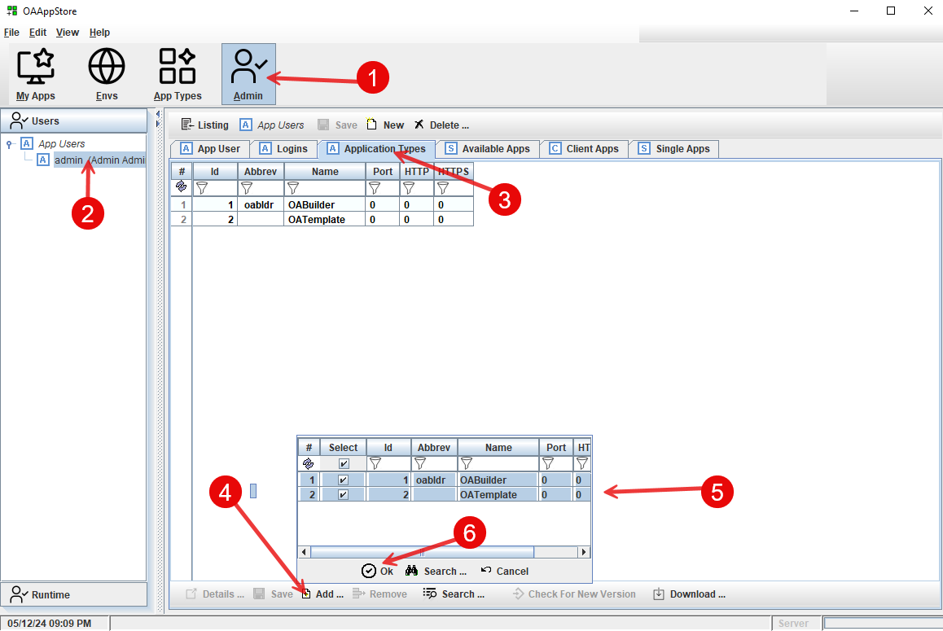

- Select “Admin” main toolbar.
- Select User or create a “New” one.
- Click Applicate Types tab to view list of Apps for this user.
- Use the “Add” button to select from popup list.
- Click “Ok” to close

