OA Dev Guide for Eclipse

Contents
Introduction 1
Software Development principals 2
Creating a new Project 3
Source code 3
Create Eclipse Project 3
Create a new OABuilder Model 4
Model setup 8
Run Code Generation for first time 9
Configure Eclipse as a Maven project 11
Change the Java Build Path. 12
Run Application 14
Run Application from Eclipse (first time) 14
Run as Server 20
Run as Client 23
Reviewing what was generated 27
Create new Version 32
Adding project to the OAAppStore 32

Date | Version | Description | User | Note
May 18, 2024 | 1.0.x | Initial Document | Vince Via

Introduction

This document will step through the creation of a new Software Product using OABuilder, Eclipse (Java IDE) and then running.

Software Development principals

Follows main principals behind “software that develops software”. Tools and libraries of designers, modelers, reverse and forward engineering, code generation, high-reuse libraries, full stack automation solutions.

Model Driven Development
“The Model is the Application”
“The Model drives the development”
“The Model is the Product’s Blueprint”

Commercial grade products with full stack support, security, monitoring, etc.

Agile, Iterative process.

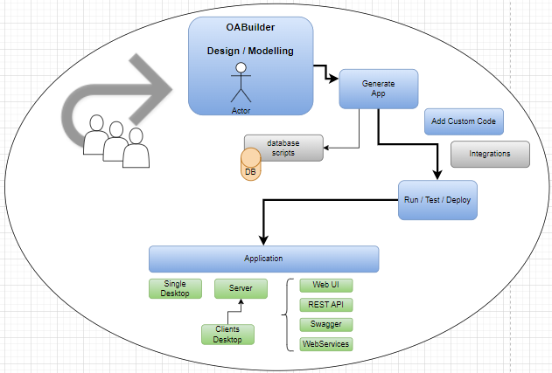

See Guides for further information on libraries and development tools.
OA-Core – github, javadoc
OA-JFC – github, +avadoc
OA-Web – github, javadoc
OAAppStore – Application Store for running all OA and Java applications - installer, User Guide
OABuilder – software development modeler and application generator - online help
See OAAppStore user guide for installing OABuilder.

Creating a new Project

Source code
Create a new project in Repo.

Example: use github, bitbucket, ADO, etc.

Create Eclipse Project
Clone the project from repo (copy to clipboard).
Import your project from Repo.

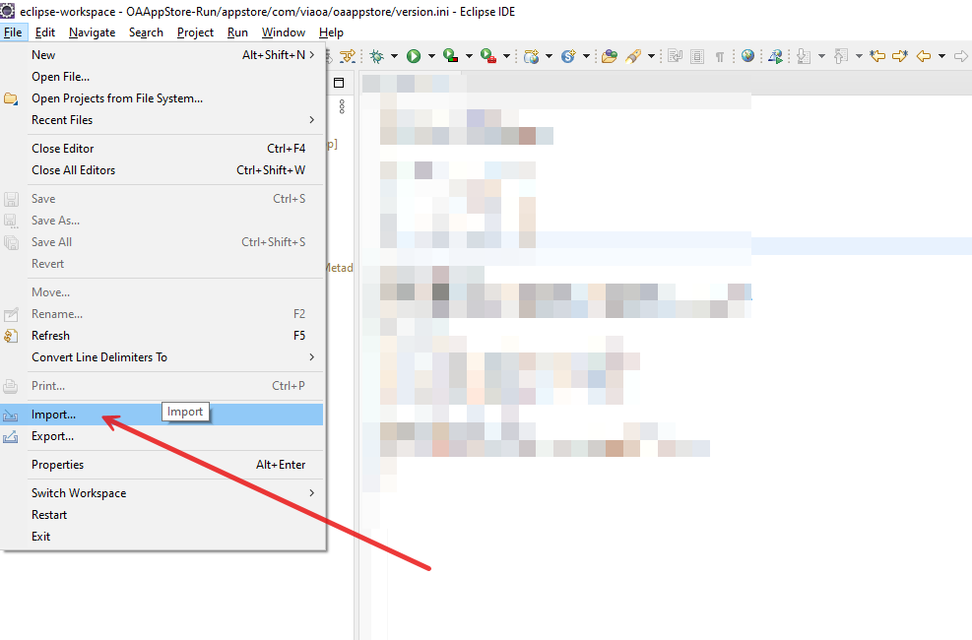
Do not do any additional configuration at this time.

Create a new OABuilder Model
Run OABuilder
Open model “OATemplate.obx” (located in the install directory, or get it from github OABuilder-models)

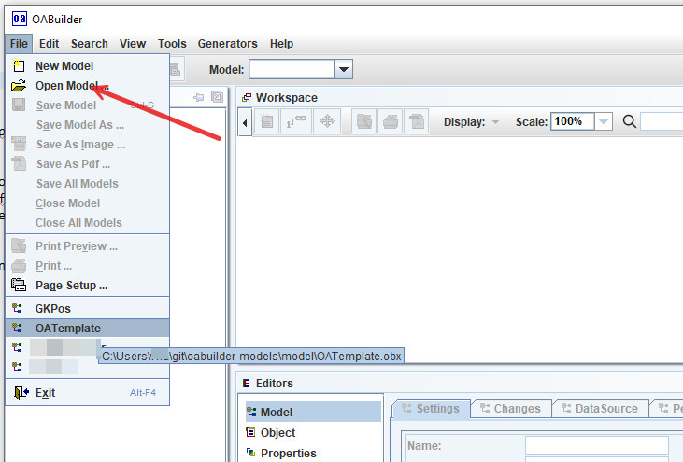

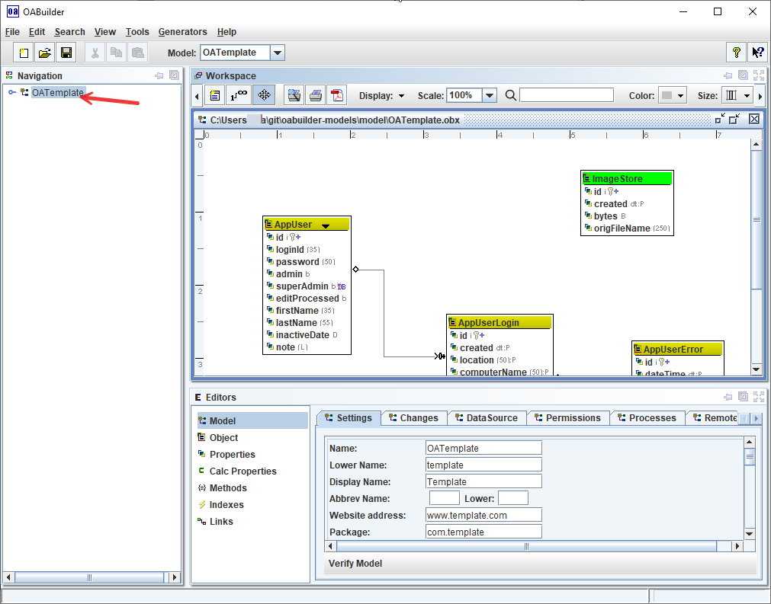

Choose “Save as” from the “File” menu, and use your project name as the new Model’s name.
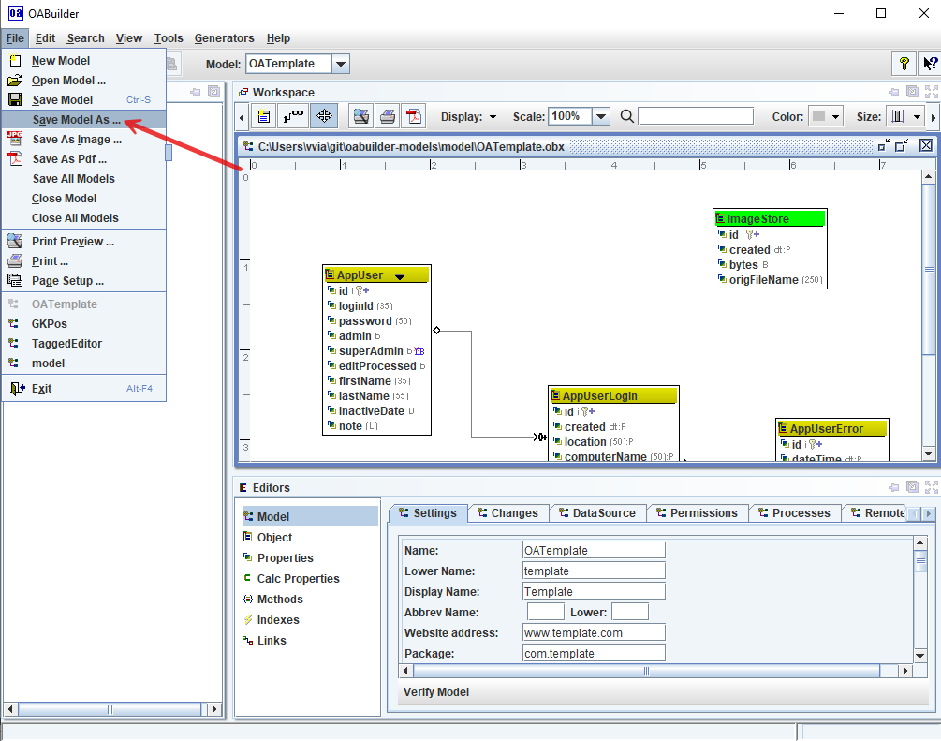

Model setup

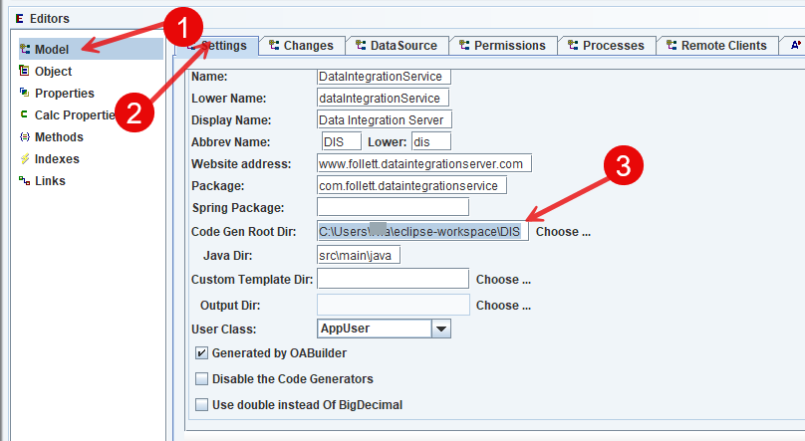
- Go to “Model” Editor
- Select “Settings” tab
- Set the “Code Gen Root Dir” to the directory for your project.

Run Code Generation for first time
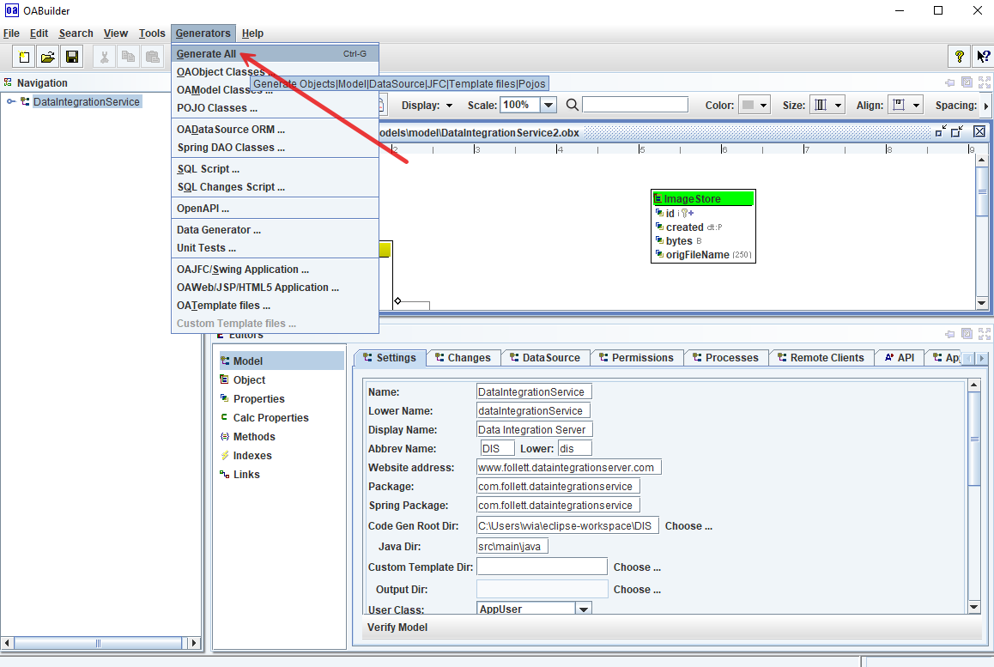
Eclipse now has code

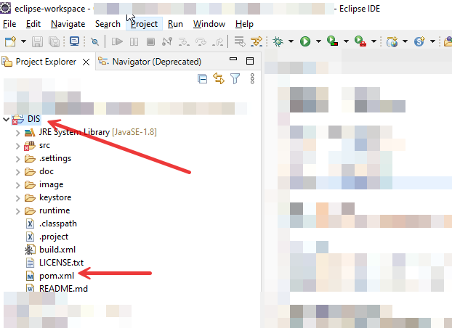
Refresh the project in Eclipse.

Configure Eclipse as a Maven project
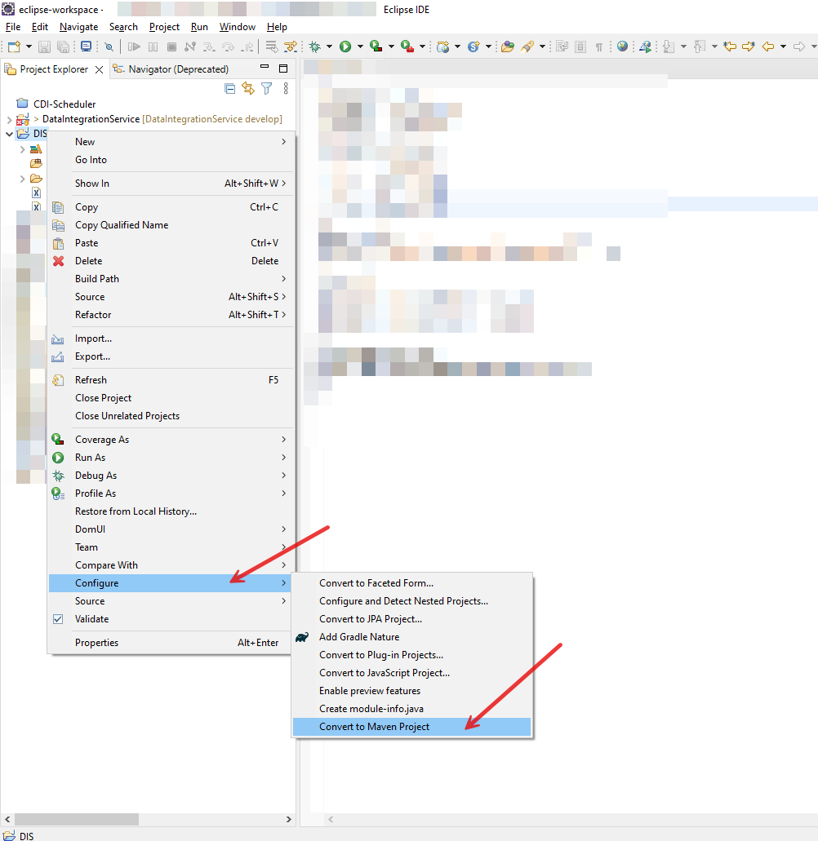

Change the Java Build Path.
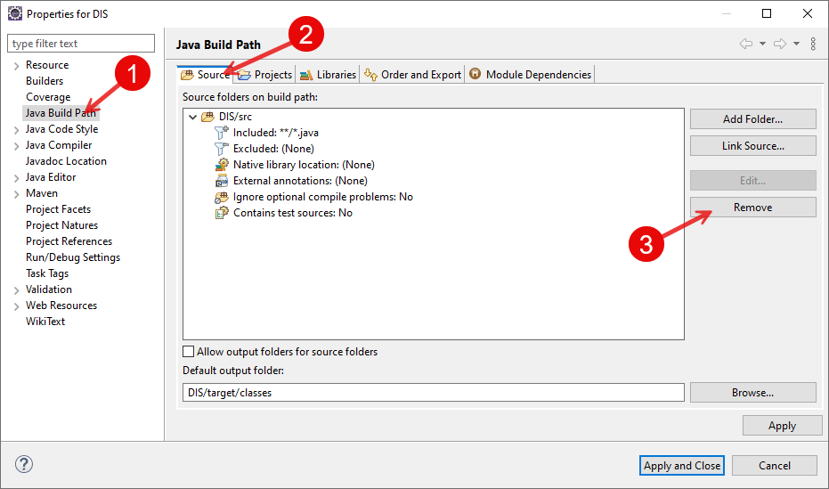

Right click the project and select “project properties”. Then:
- Select “Java Build Path”
- Select “Source” tab
- Click “Remove” to remove the current “source folder” location.

Set the “Source Folder” to match what Maven uses.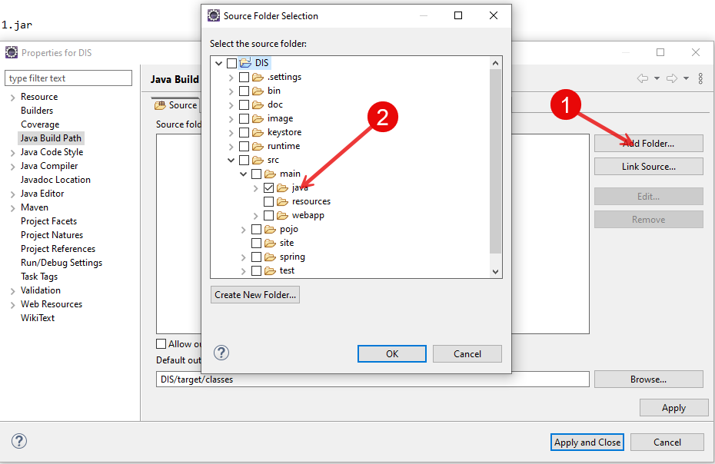
- Click Add Folder button to choose the source code directory.
- Check “src/main/java”

Run Application
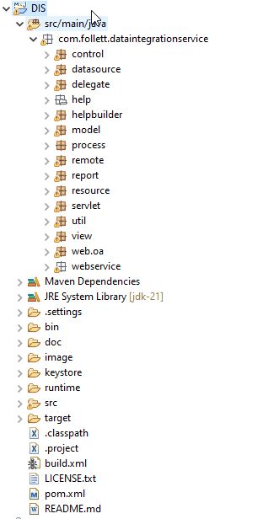
The code was generated and the project is free from any errors.

Run Application from Eclipse (first time)

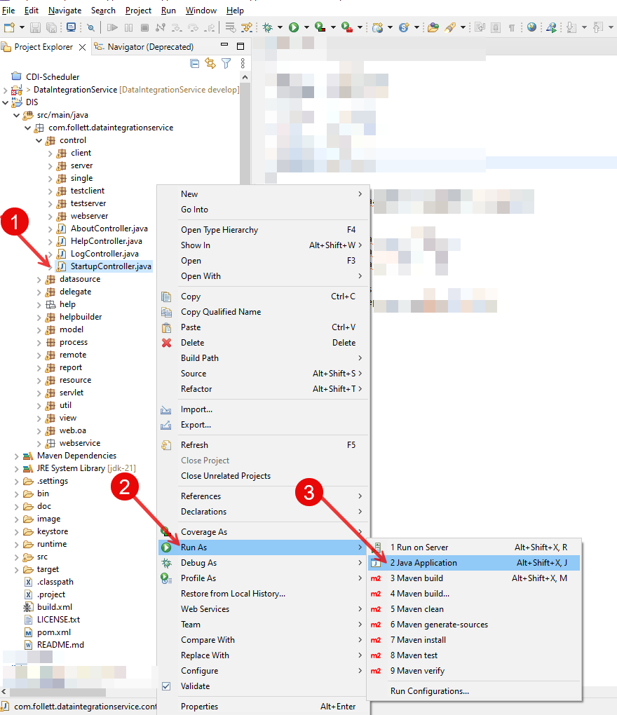
- Select “StartupController.java”
- Right click, and select “Run As” from the menu.
- Select “Java Application” from secondary menu.

This will run the application, but will exit with an error message in the console.

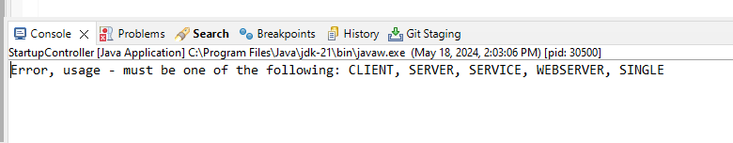

The next step is to make a few changes to the “run” configuration.

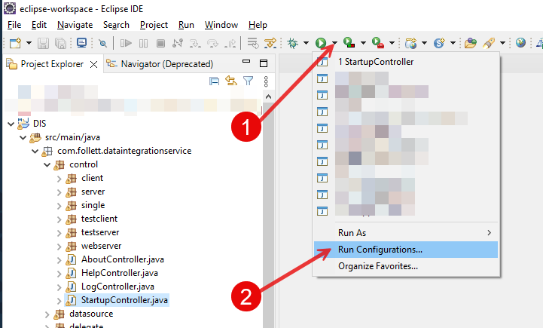
- Click “run” down-arrow button on main toolbar
- Select “Run Configurations”

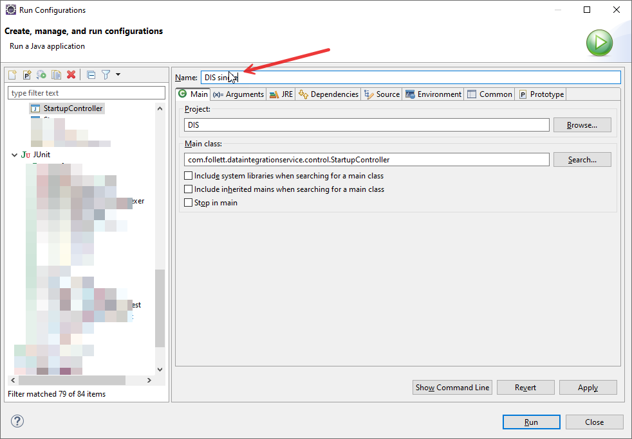

Change the name to project name + “single” since we’re first going to run it as a “single user” app.

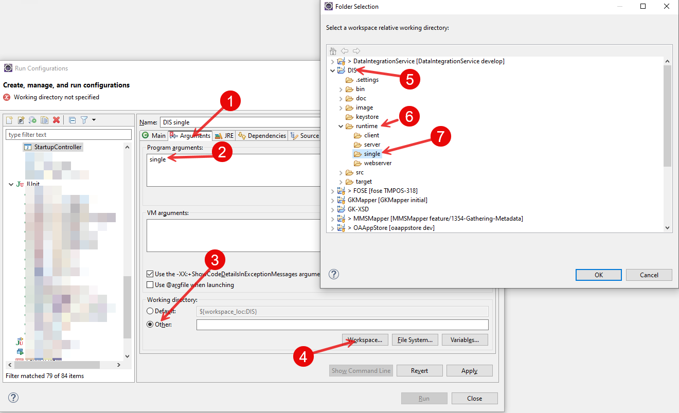
- Go to arguments tab
- Add “single” to program arguments.
- Set working directory to “other”
- Find your project name
- Expand to the “runtime” directory
- Choose single, this is where the program will be running from.

Select “Ok” and then click the “run”

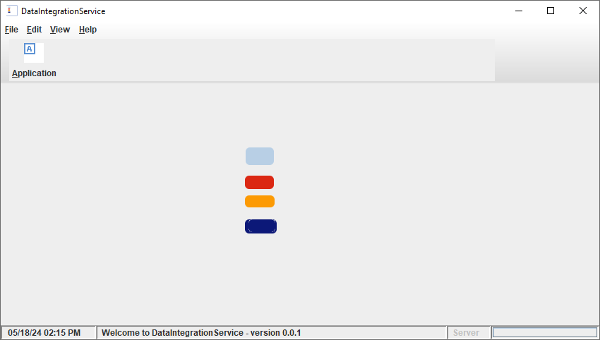
The app is now running as a single user application.

By default, the app is running in the “runtime/single” directory, and there is a subdirectory “data” for storing data (no database used at this time), the logs directory, and a single.ini file with properties.

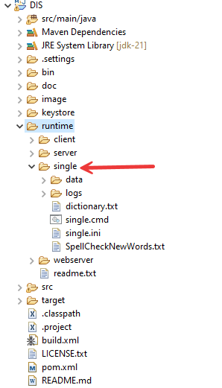
You will need to refresh the Eclipse project to see latest changes that are made outside of Eclipse.

Run as Server
Click on the menu for run configurations.

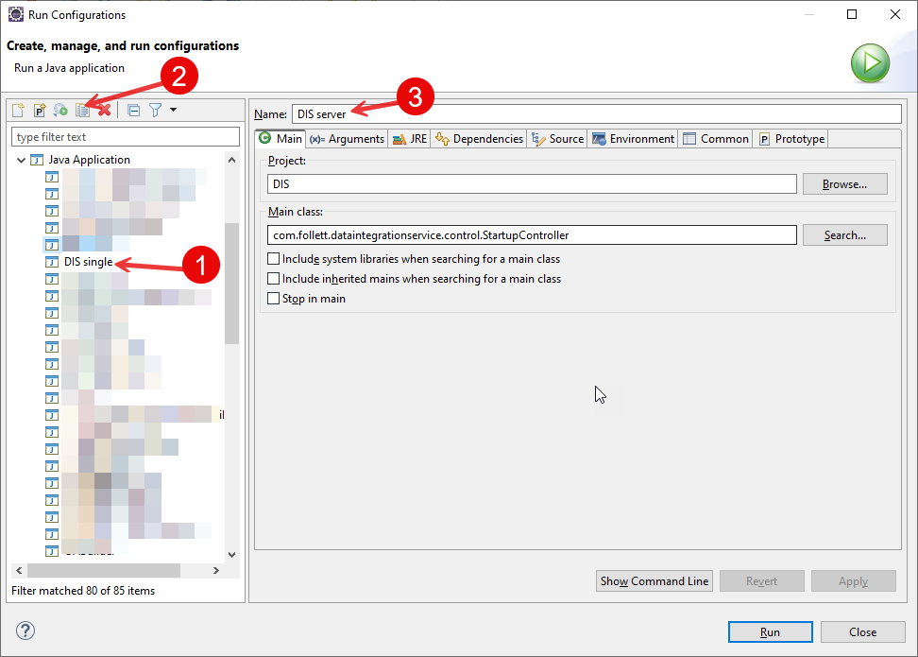

- Select the project.
- Click the “copy” button, which will create a new run configuration.
- Rename to “server”.

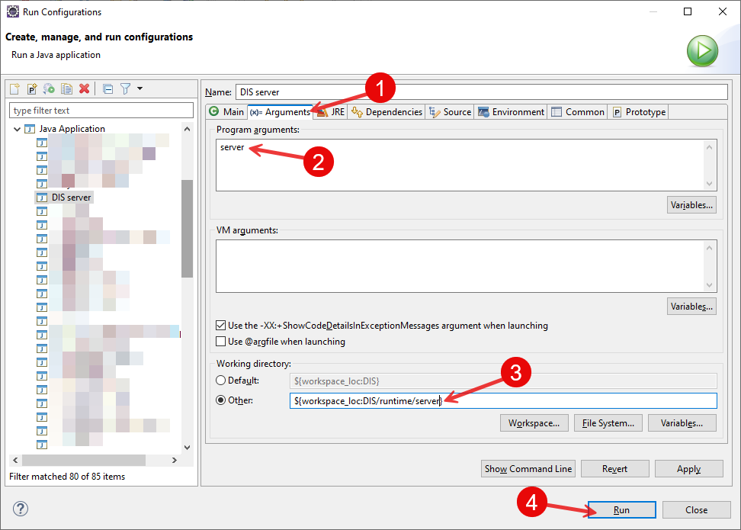

- Click the “Arguments” tab
- Change to “server”
- Change from “single” to “server”
- Click “run” button

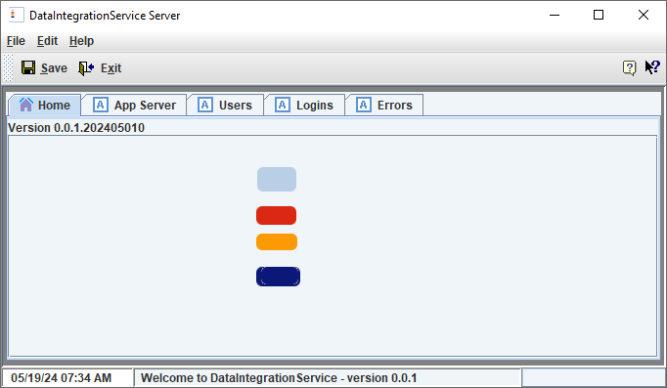
Application running as a server.

Run as Client
Click on the menu for run configurations.

- Select the project.
- Click the “copy” button, which will create a new run configuration.
- Rename to “client”.

- Click the “Arguments” tab
- Change to “client”
- Change from “single” to “client”
- Click “run” button

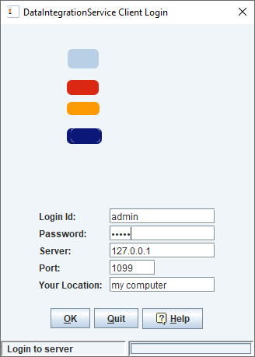
Login dialog for connecting to the application that is running as a “server” (above instructions).
Click “ok” button.

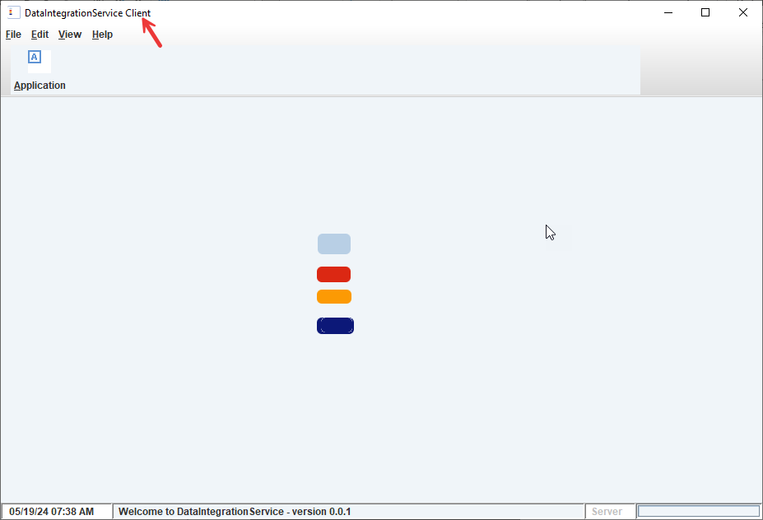
Window looks the same as running application as “single”, except it’s connected to server.
Run more than one instance to see how data stays in sync with the server and the other client applications.

Reviewing what was generated

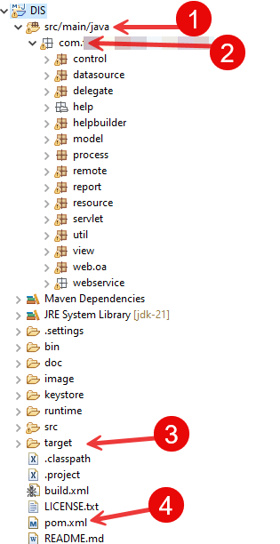
- Source code folder
- Java Package
- Target is where the complied classes are stored.
- Maven pom file.

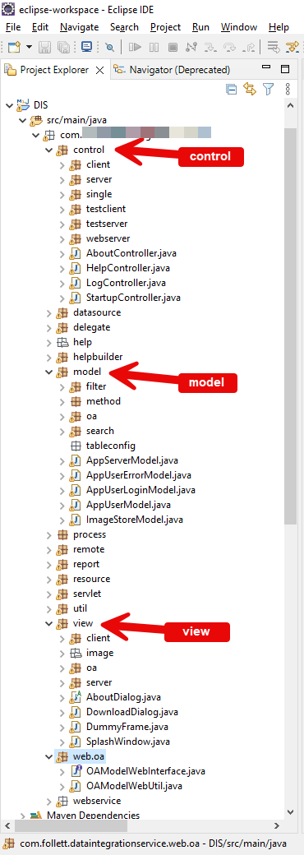
Follows MVC, “model / view / control”
“delegate” are helper methods for the Model Objects.
“datasource” has database mapping and ORM support.
“model” includes all of the Model Objects as OAObject (/entity), and includes *Model classes that preconfigures objects together based on the relationships (/links).
“process” is used for Model Object processing.
“remote” extends how an application can run as multi-user (ex: client/server) or distributed.
“report” for generating reports as html, pdf that can be used in a viewer or editor.
“resource” includes all of the properties for this project, listed in the values.properties.
“view” for Java Swing/JFC desktop application.
“web” for web components.

Program Startup and Controllers

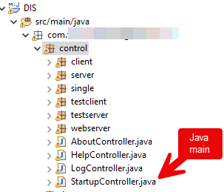
StartupController has the Java main method (application startup) and is responsible for receiving arguments. It requires an argument for application start type (single, server, client, webserver, webservice, test, etc). Depending on the start type, the matching *Controller will be called.

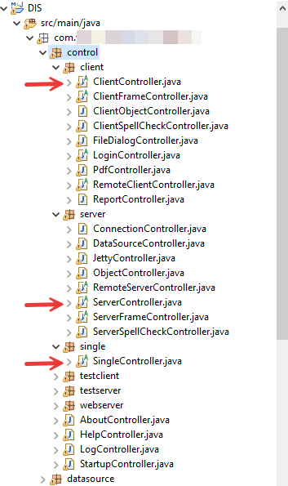

Each of the “type” controllers is then responsible for starting the other *Controllers.
Example: type = “server” will call the ServerController, which then create it’s other controllers.
JettyController manages the embedded Jetty webserver.
DataSourceController manages datasources, databases and ORM.
RemoteServerController manages multiplexer sockets for distributed communications.

Create new Version
Application has both a Version following “major.minor.patch”
The Release is the YYYYMMddX format.
The following need to be updated:
values.properties
pom.xml
Set version & release in version.ini in Appstore repo

Adding project to the OAAppStore
To run from OAAppStore, so that other users will have access.

Add to repo, jarstore Appstore
From OAAppStore, create new AppType …

qqqqqqqqqqqqqqqqqqq

follow user guide for OAAppStore

