OAAppStore User Guide

Contents
OAAppStore User Guide 1
Introduction 2
Source code 2
Running OAAppStore from Windows 2
Program Installation location 6
Take a tour of OAAppStore 7
Adding OABuilder to the OAAppStore 8
Create a new Application Type 8
Give User permissions to run the new Application Type 14
Select the Version to run. 16
Run OABuilder 17
Adding OATemplate to the OAAppStore 20
Create a new Application Type 20
Give User permissions to run the new Application Type 26
Select the Version to run. 28
Run OATemplate as single user (from desktop) 29
Setting up Environments 30
Running OATemplate as Server 37
Running OATemplate as Client to connect to Server 41

Date | Description | User | Note
May 09, 2024 | Initial Document | Vince Via

Introduction

This document is the User Guide for the OAAppStore.

OAAppStore is an “Object Automation” tool developed by ViaOA.

OAAppStore is an application that allows users to add Applications that can be managed by the AppStore. This allows for running applications in multiple environments with different versions. Applications can be ran as Server, Client, Single. A Client application will connect to a Server.

OA Applications are created to allow for running in the following 3+ modes.
- locally as Single
- on a Server, allowing users to connect using Client. Includes webservice, RESP API, scaling, etc.
- as a Client, that connects to a Server.
- Other modes include failover servers, distributed servers, web servers only, client command line, more.

OAAppStore is able to run as a server and allow other users to connect, and be given permissions to which Applications they are able to access. OAAppStore can also be set up to create a hierarchy of AppStores to support larger projects and enterprises.

The installation for OAAppStore was created using Java jpackage and includes Java version 21. Please see the installation guide for more details.

OAAppStore allows installing, managing and running other Applications.

OABuilder can be installed and ran from OAAppStore (see section for adding), and applications created using OABuilder will be able to be used from OAAppStore.

Source code

OAAppStore is open source and is stored on GitHub. It is located at ViaOA, in the “oaappstore” project .
Applications that have been made available to the AppStore are stored in the “oaappstore-run” project.
See github for more information.

Running OAAppStore from Windows

1: Select Windows “Start” button, 2: type “OAAppStore”, 3: click App.
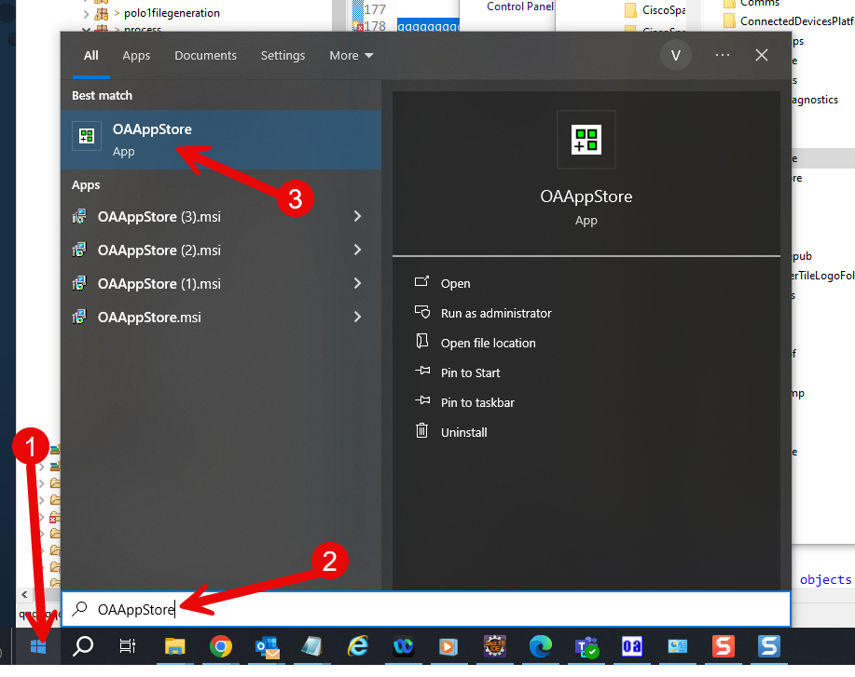

Application will run.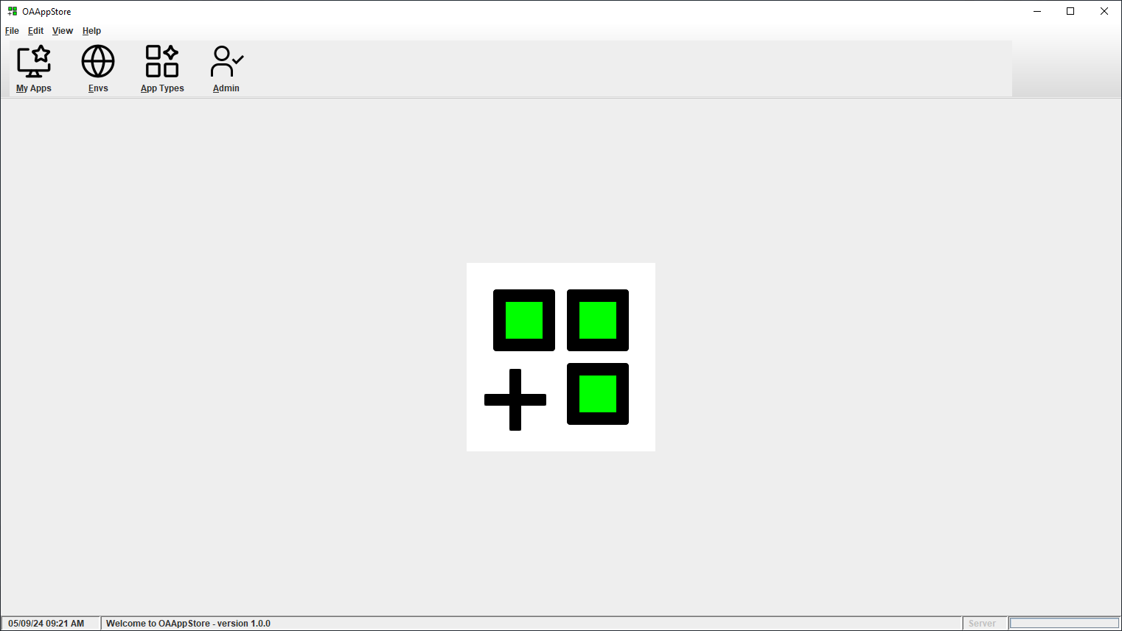

Choose menu “Help” and then “About” to see version and release information.
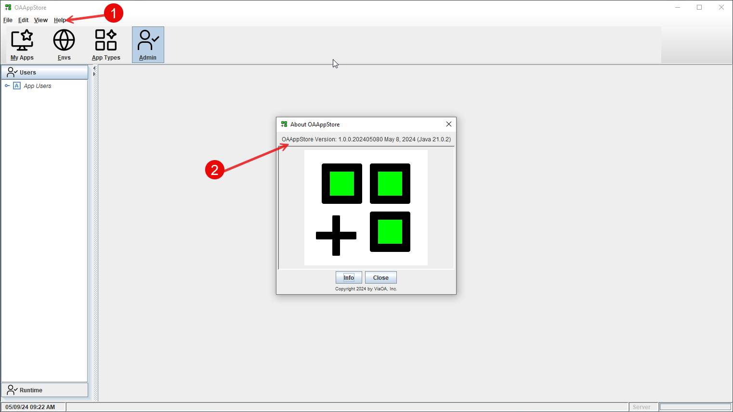

Program Installation location

From a Windows installation, the program will be running from Users “AppData\Local” directory.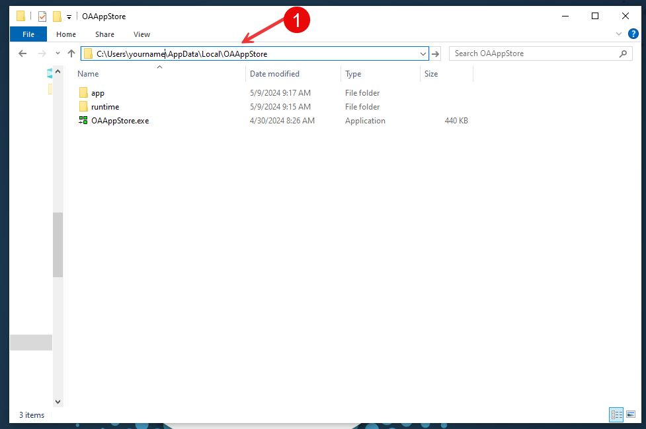

All Apps will be stored under the “appstore” directory, and all code (Java *.jar files) will be under the “jarstore” directory.
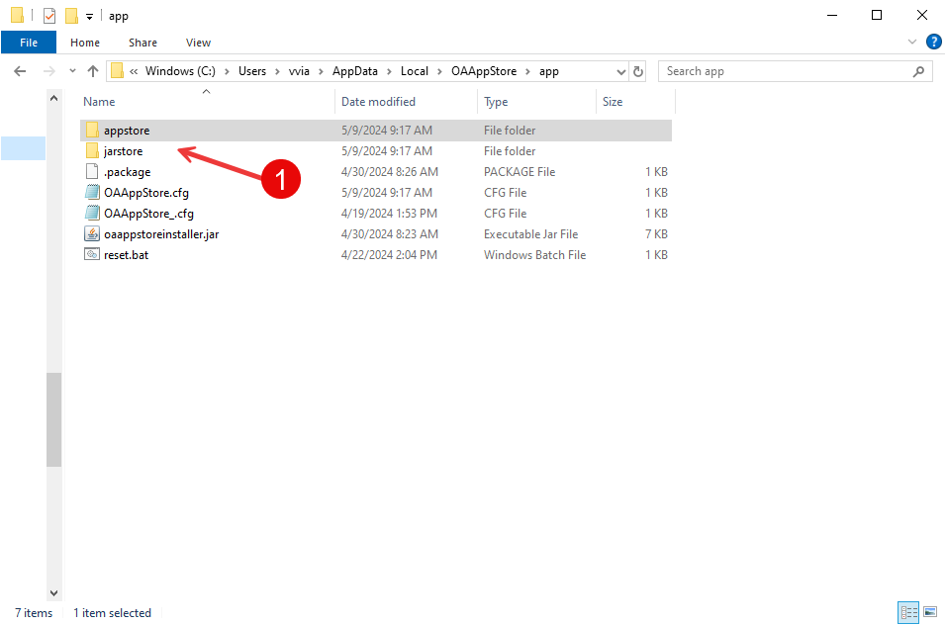

Take a tour of OAAppStore

< Under Construction >

Adding OABuilder to the OAAppStore
OABuilder is a Software development tool for designing and generating applications.
For example, this application, “OAAppStore”, was created using OABuilder.

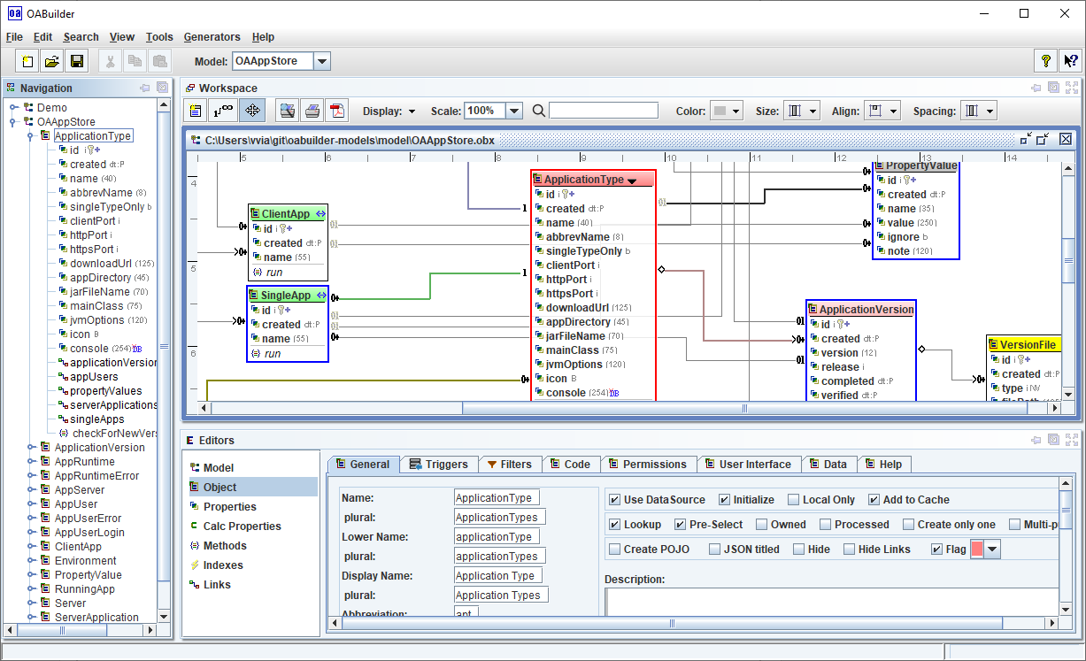

Create a new Application Type

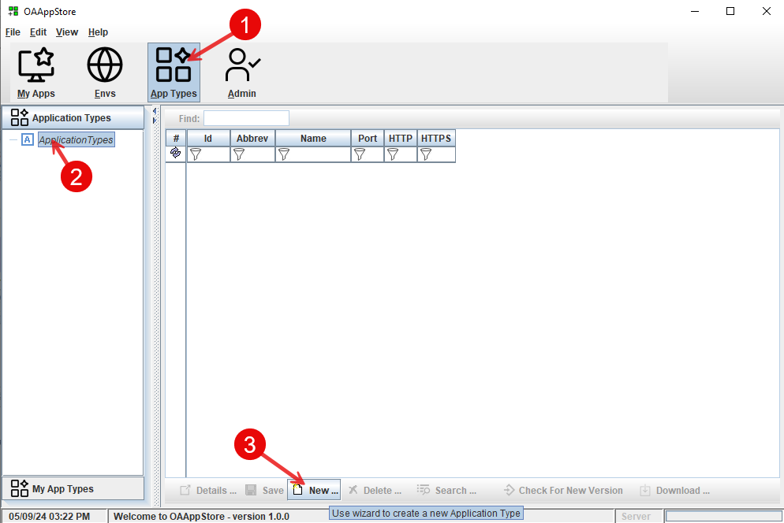

- Select “App Types” from toolbar.
- Select “Application Types” from side bar.
- Click “New” button.

Follow the following images for adding a new application.

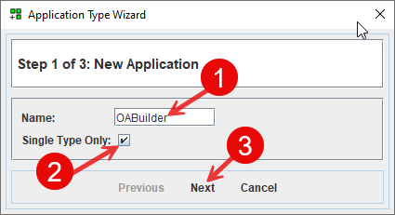

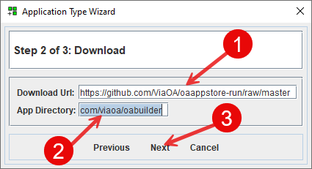
com/viaoa/oabuilder

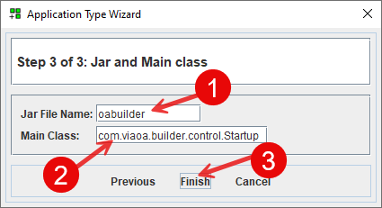
main class: com.viaoa.builder.control.Startup

This has now added the OABuilder application.

The next step is to get the latest version of OABuilder.
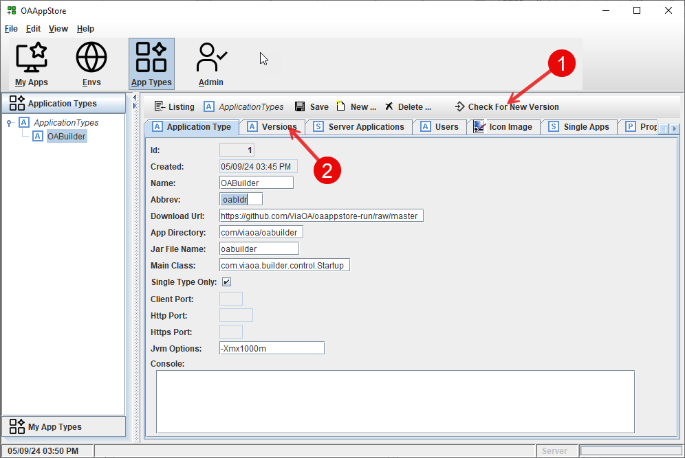
Click “Check for New Version”

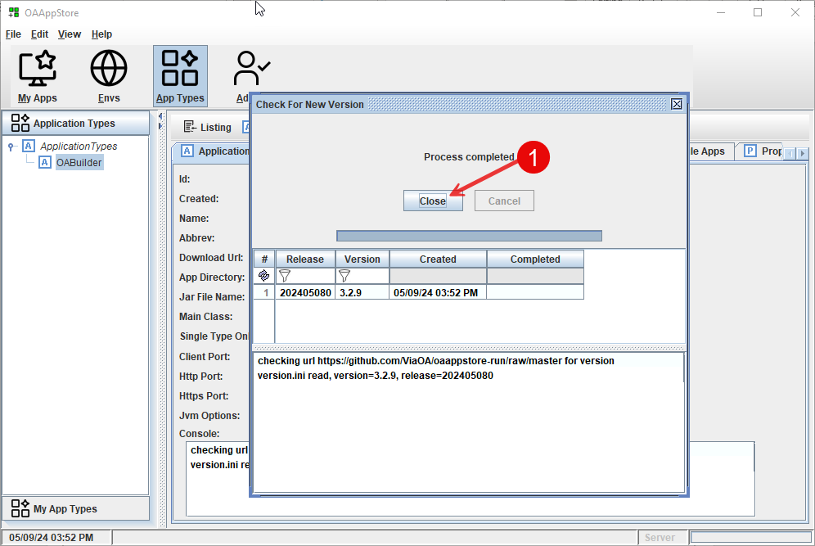
Information for the latest Version will be retrieved.

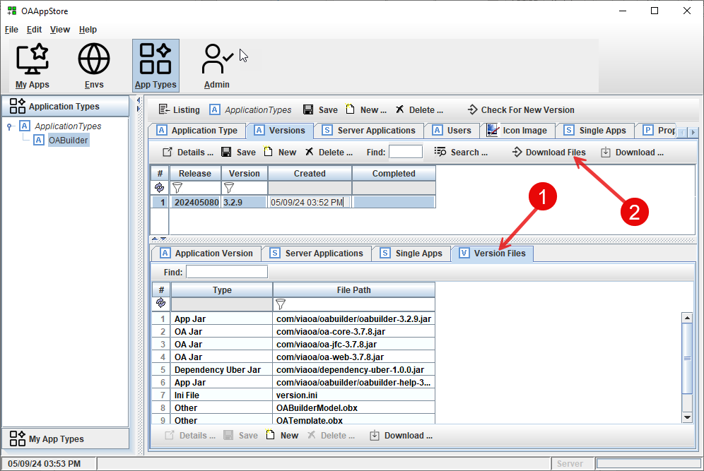
- Click the “version Files” to be able to view the files that are used by the application.
- Click “Download Files” button to have these files downloaded into the AppStore

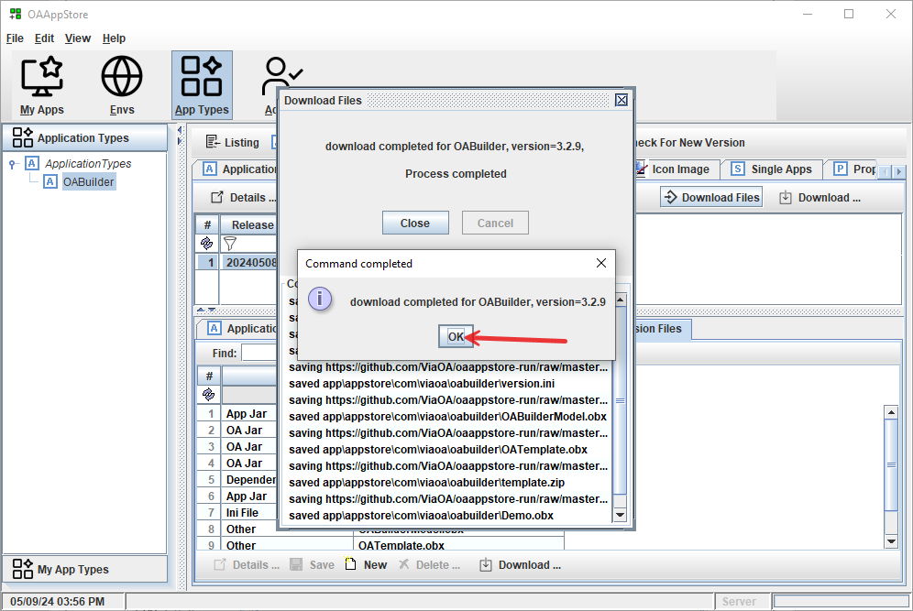
Files will be downloaded and able to run the program. Click “Ok” to close.

Give User permissions to run the new Application Type

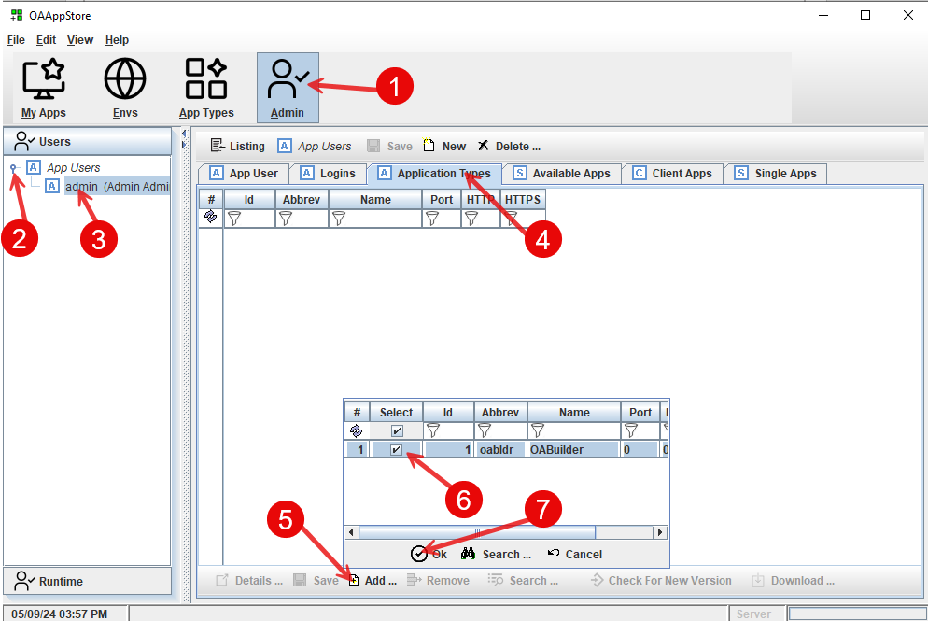
- Click on “Admin” toolbar button.
- Under “Users”, expand “App Users”
- Select a user (example: “Admin”)
- Go to “Application Types” tab, to add a new application type for this User.
- Select “Add” from bottom panel toolbar, to pop up the list choices.
- Check the “OABuilder”
- Click the “Ok” to have OABuilder added.

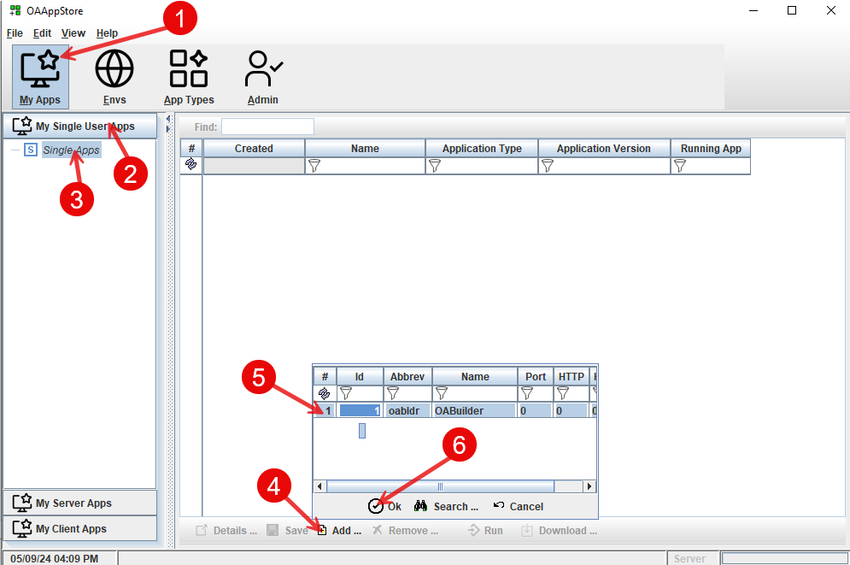

Select the Version to run.

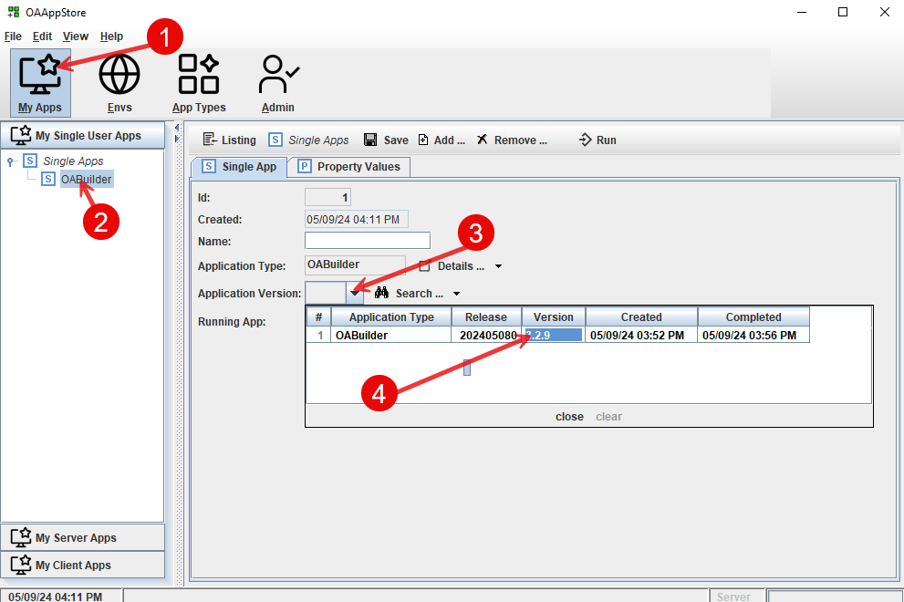

Run OABuilder

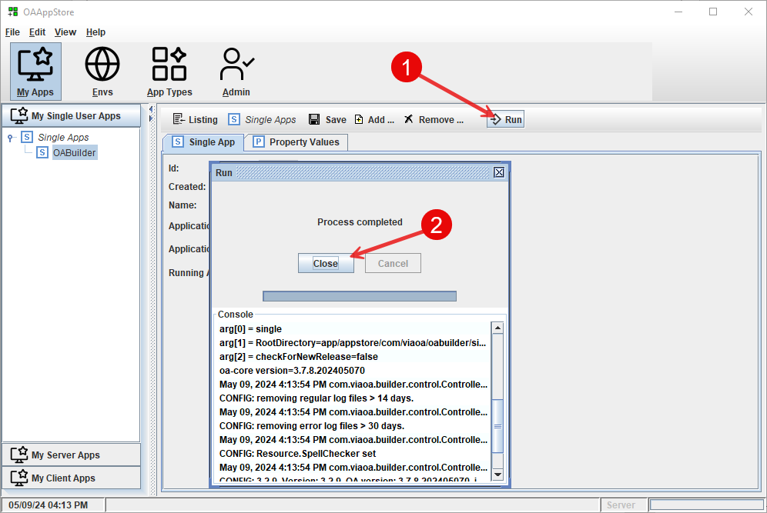

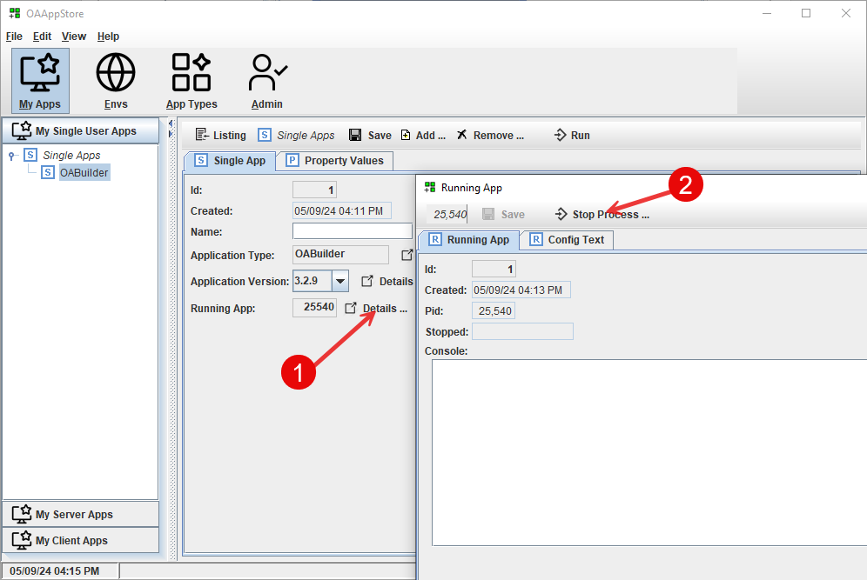

Adding OATemplate to the OAAppStore

OATemplate is a Java project that is used by OABuilder as a “template” for generating new applications from an OABuilder Object Model.

For example, this application, “OAAppStore”, was created using OABuilder to design the model and was then generated using the OATemplate project.

See: OATemplate project on github for more information.

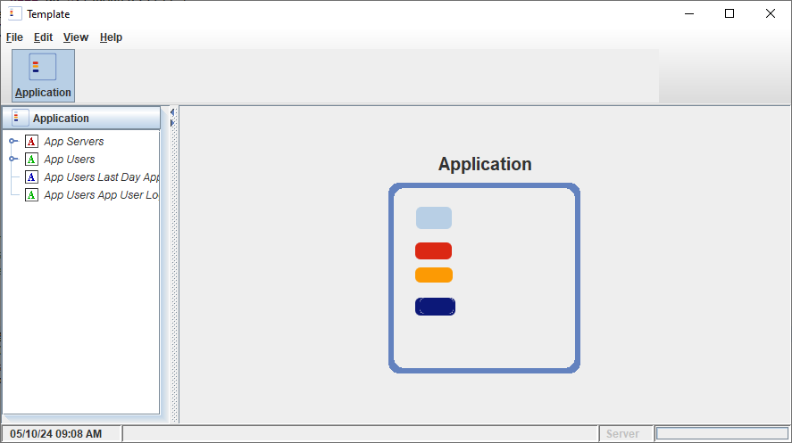

Create a new Application Type

The first step is to add a new Application Type “OATemplate”

- Select “App Types” from toolbar.
- Select “Application Types” from side bar.
- Click “New” button.

Follow the following images for adding a new application.

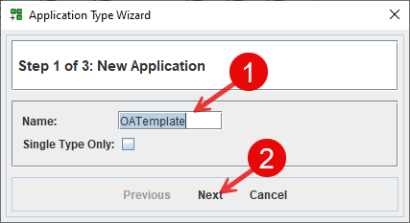

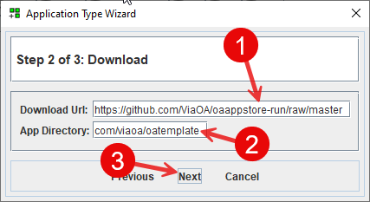
com/viaoa/oatemplate

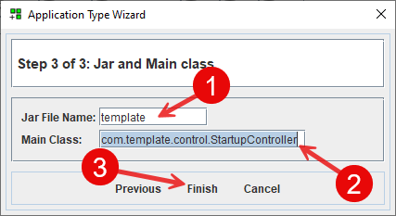
main class: com.template.control.StartupController

This has added the OATemplate application.

Now that the Application Type has been create, the next step is to get the latest version of OATemplate.
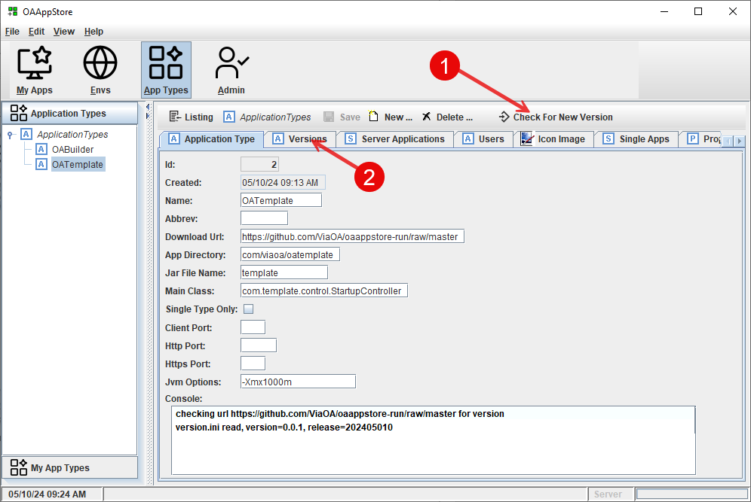
Click “Check for New Version”

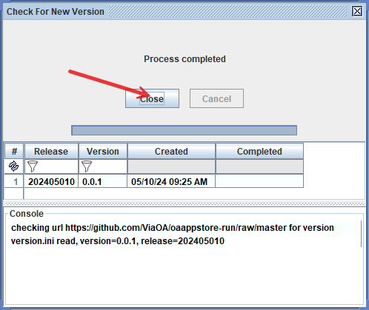
Information for the latest Version will be retrieved.

The next step is to download the files. 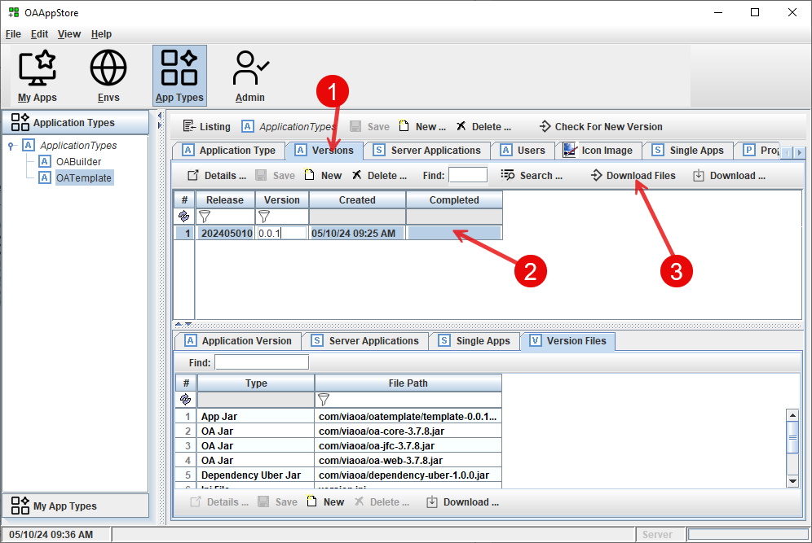

- Click the “Versions” tab.
- Select the release to download.
- Click “Download Files” button to have these files downloaded into the AppStore
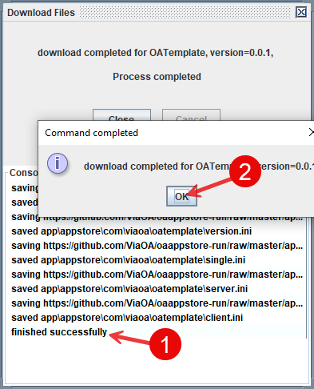

Files are now downloaded. Click “Ok” to close.

Give User permissions to run the new Application Type

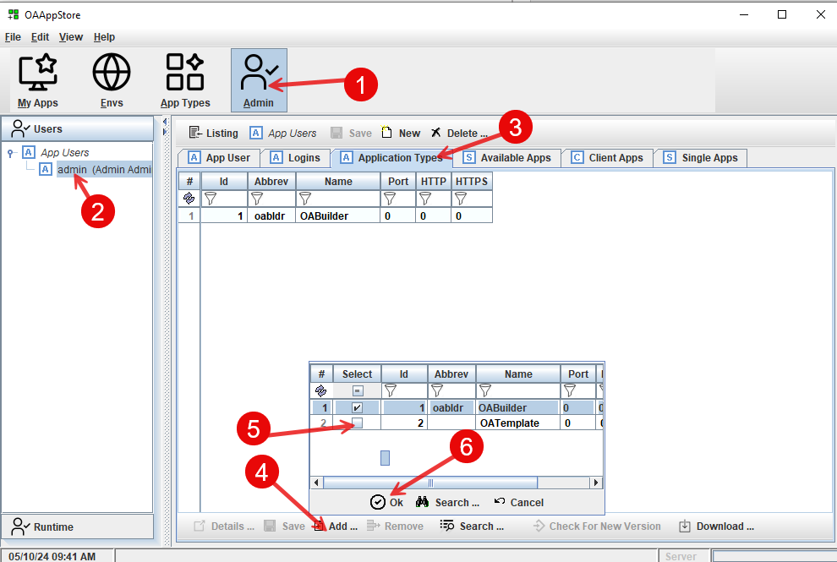

- Click on “Admin” toolbar button.
- Under “Users”, expand “App Users” and select a user (example: “Admin”)
- Go to “Application Types” tab, to add a new application type for this User.
- Select “Add” from bottom panel toolbar, to pop up the list choices.
- Check the “OATemplate”
- Click the “Ok” to have OATemplate added.

The next step is to add OATemplate to “My Apps”
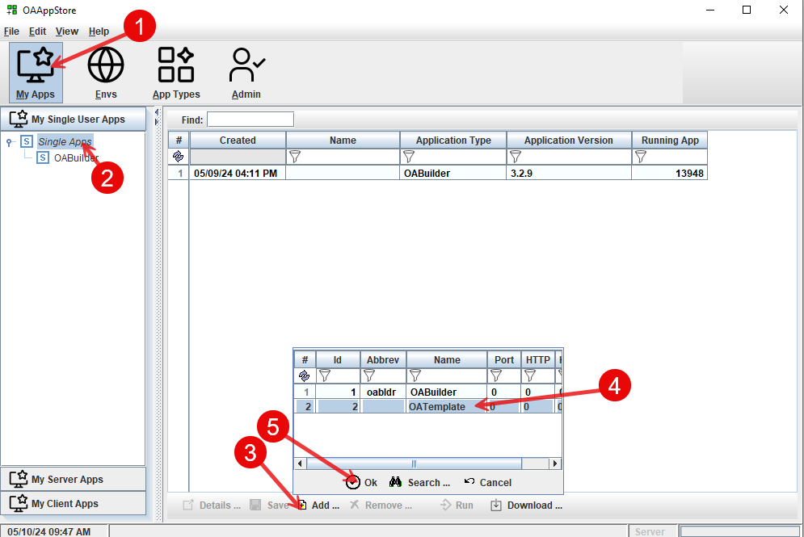

- Click “My Apps” from main toolbar.
- Under “My Single User Apps”, select “Single Apps”.
- Select “Add” from bottom toolbar.
- Select “OATemplate” from list.
- Select “Ok” to have it added.

Select the Version to run.

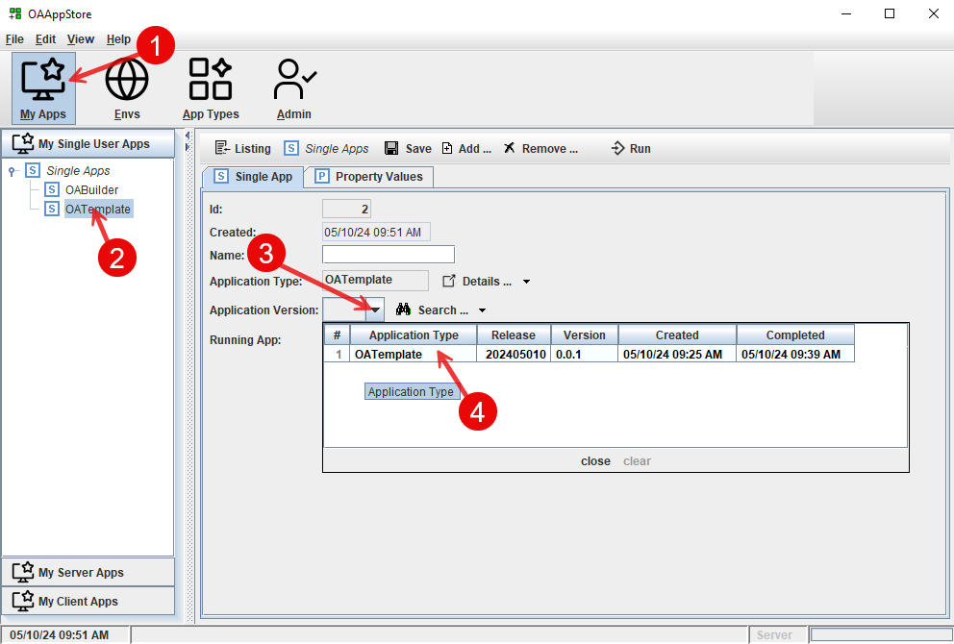

- Select “My Apps” from main toolbar.
- Select “OATemplate’ from “My Single User Apps” sidebar.
- Click “Application Version” drop down list.
- Select OATemplate from the list.

Run OATemplate as single user (from desktop)

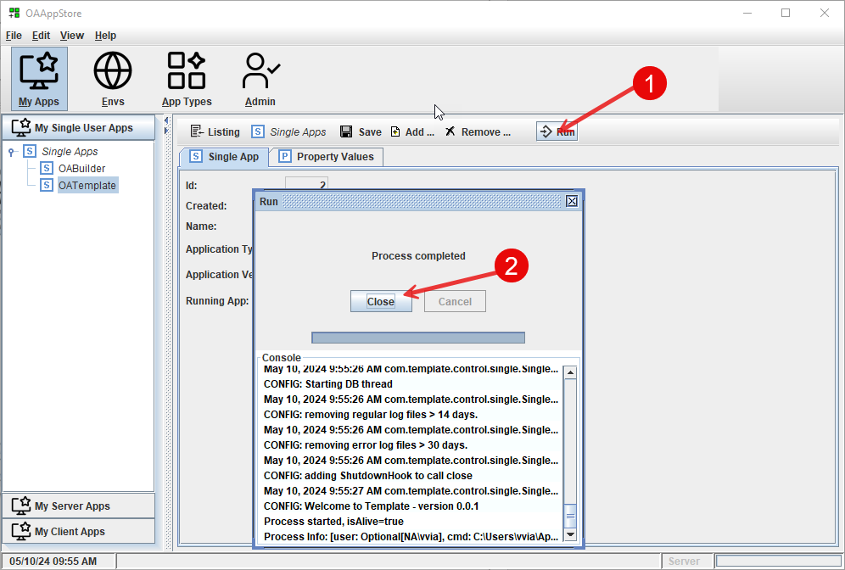

- Click the “Run” button to launch OATemplate as a single user .
- Click the “Close” button.

Setting up Environments

OAAppStore allows for setting up Environments, so that Server Applications can be ran and then accessed using Client. We will set up a server in OAAppStore, run OATemplate as a Server, and then connect to it using OATemplate as a Client(s).

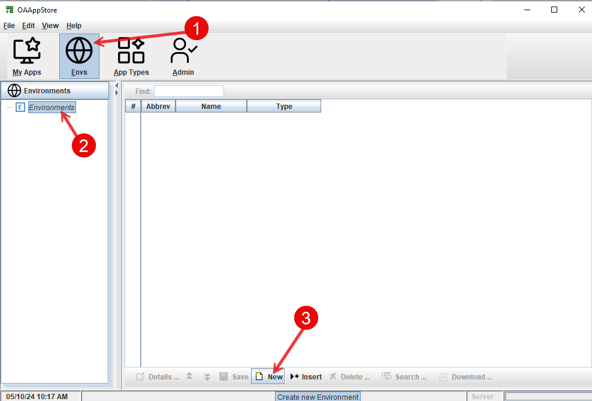

Create a new Environment
- Select “Envs” from main toolbar.
- Select “Environments” from side bar.
- Click “New” from bottom toolbar.

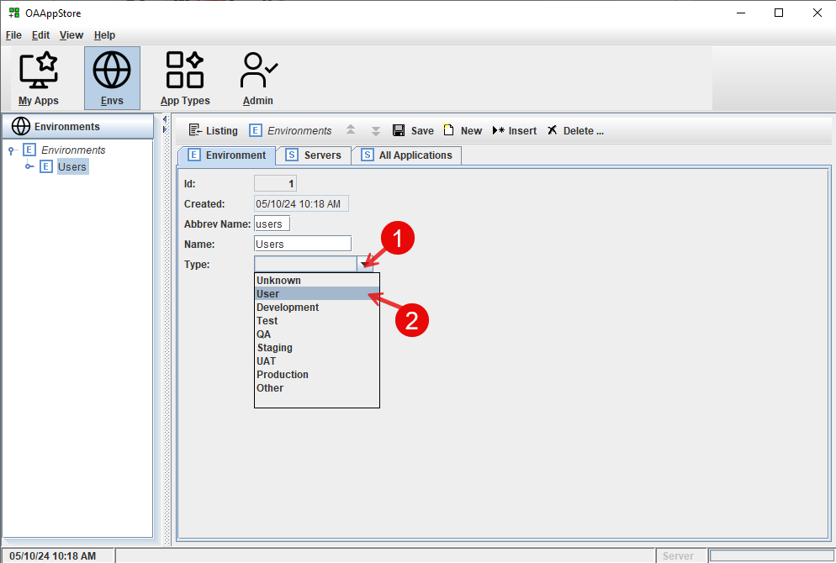

Create a new Environment for “Users”
From the new “Users” Environment
- Select the type as “User”

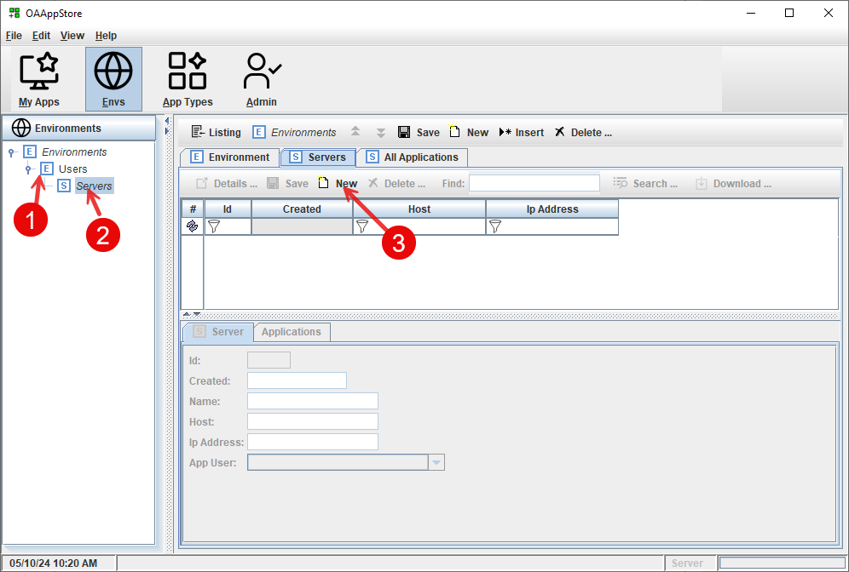
Create new server in “Users” environment

- Select new “Users” Environment
- Select “Server”
- Click “New” button from toolbar.
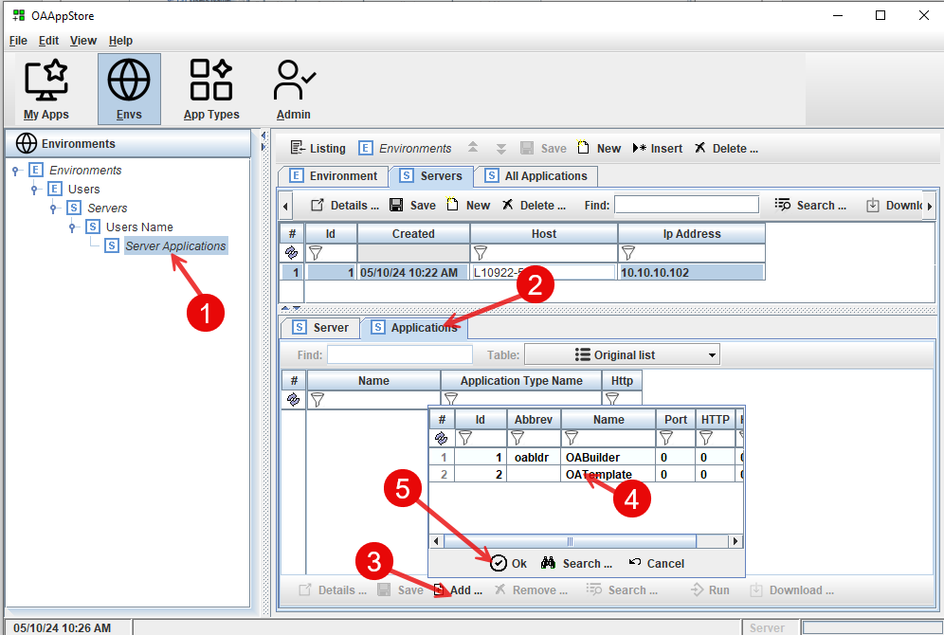
Add the “OATemplate” as an application that can be ran on this server.

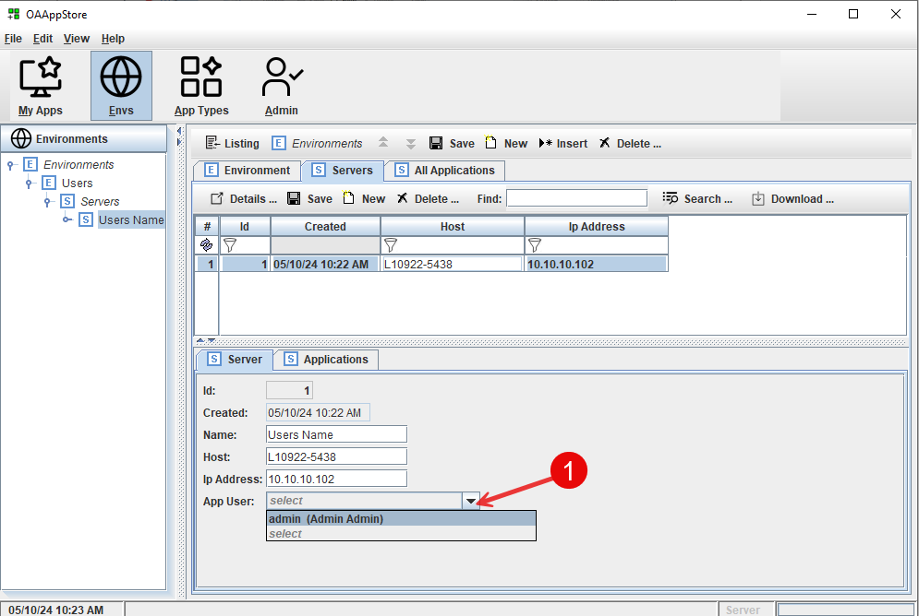

Enter information about the computer/server
Select the user of the Application.

Add an Application to the Server.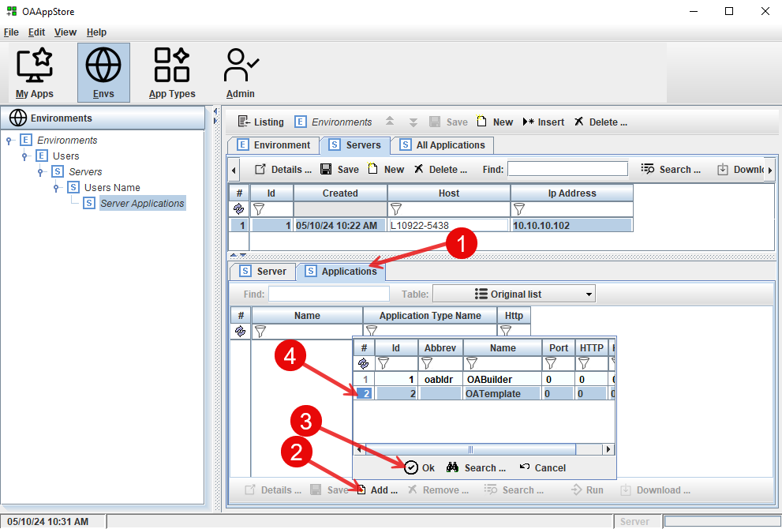

- Select the Applications tab
- Select “Add” button
- Choose OATemplate
- Click the “Ok” button to add the OATemplate

Add additional information about OATemplate for this Server.
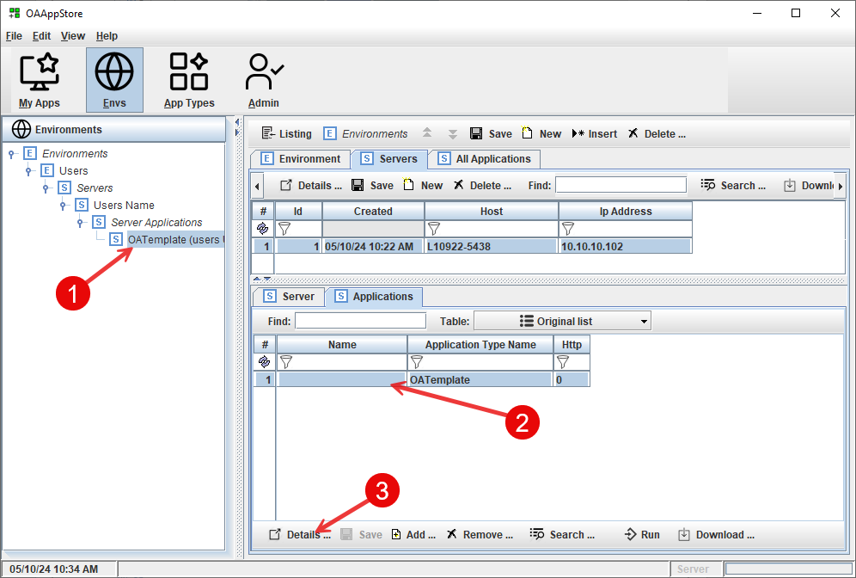
- Select the Server from the Environments navigation pane
- Select “OATemplate”
- Click on the “Details” button

Running OATemplate as Server

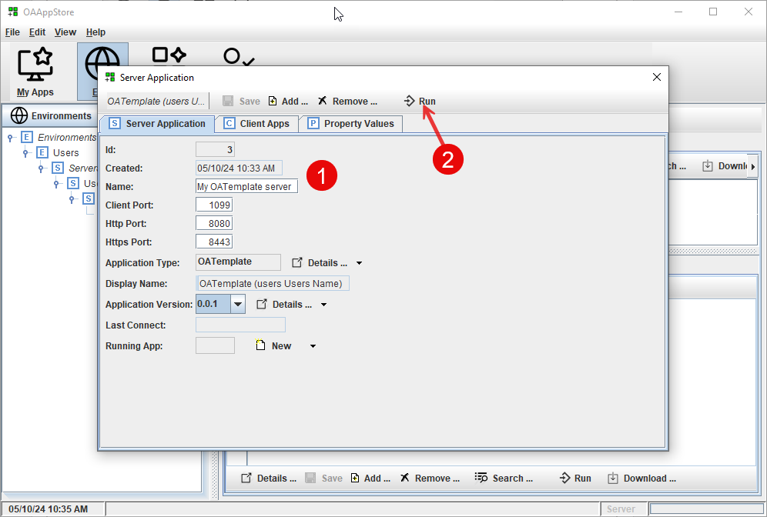

- Fill out information
- Click the “Run” button to run OATemplate as a Server Application.

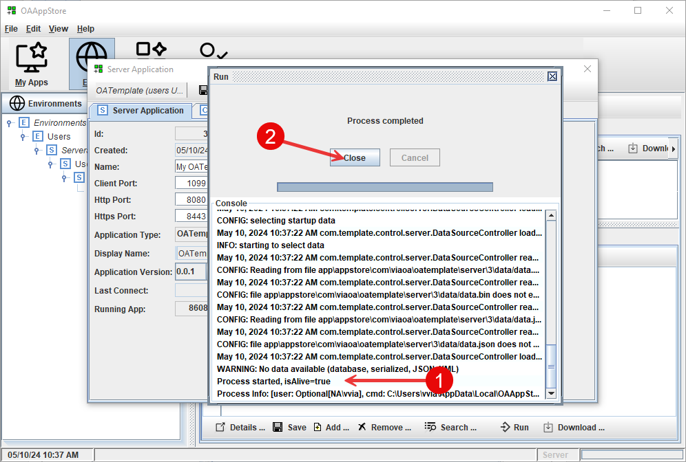

The display window will show the console display area.
- This shows that the process “isAlive” and running.
- Close this window.

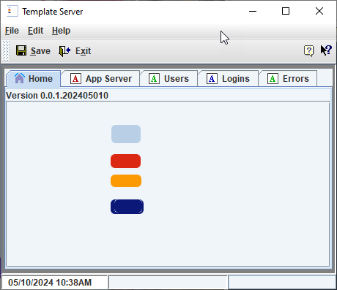

OATemplate is now running as a Server

You should now see “OATemplate” under “My Server Apps”. This was set up in the previous task.
If it does not show, make sure that you selected your user (default is “admin”) for the Server that was set up in the previous task above when adding OATemplate as a Server application.

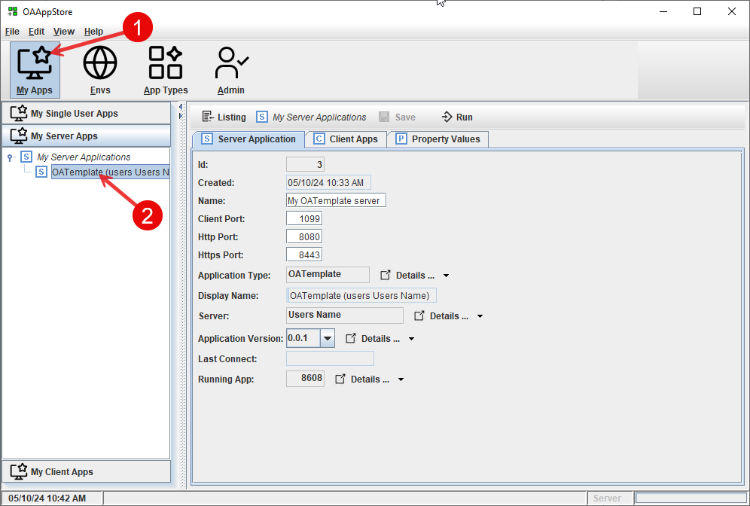

- Go to “My Apps”
- Verify that “OATemplate” is showing as an Application running on your Server.
The “Client Apps” tab will show OATemplate Clients that are connected (/running).

Running OATemplate as Client to connect to Server

Now that we have OATemplate running on a Server, we will connect to it using OATemplate client.

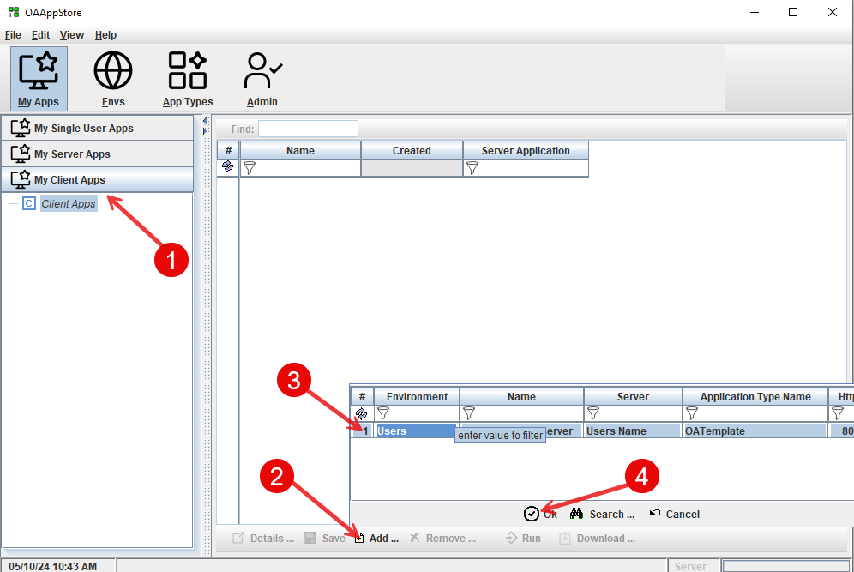

- From “My Client Apps”, clike on “Client Apps’
- Click the “Add” button to popup list.
- Select the Server application.
- Click “Ok” to add to your Client Apps

Now we are able to run OATemplate, have it login to the Server.
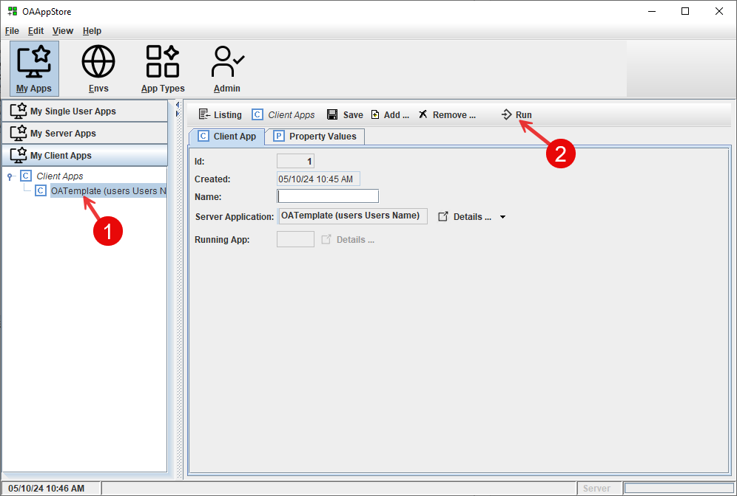

- From “My Client Apps”, choose “OATemplate”
- Click on the “Run” button to launch OATemplate and display login window.
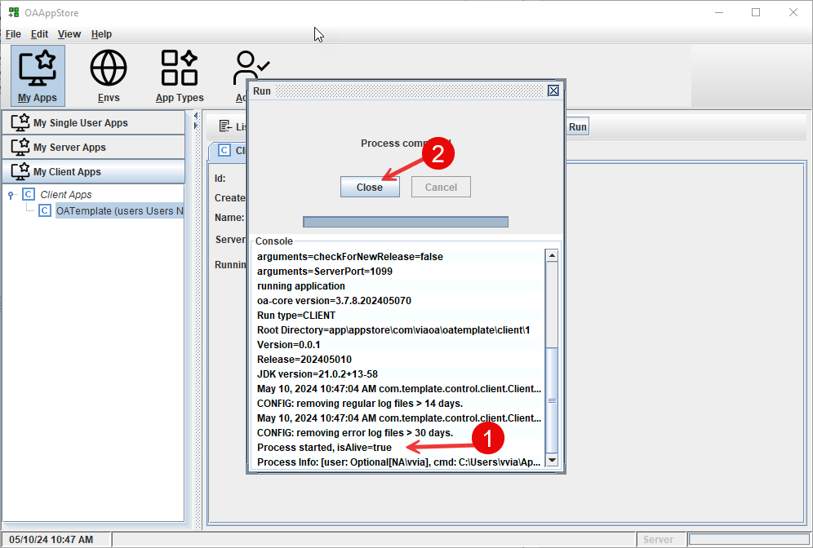

This shows the console

