OAAppStore MS Windows Installation Guide

Contents
OAAppStore MS Windows Installation Guide 1
Introduction 1
Source code 1
Download Windows Installer 2
Using your browser 2
Running OAAppStore from Windows 11
Program Installation location 14
Uninstalling OAAppStore from Windows 15

Introduction

This document describes installation and running OAAppStore, along with uninstallation instructions.
OAAppStore is an application that allows users to add Applications that can be managed by the AppStore. This allows for running applications in multiple environments with different versions. Applications can be ran as Server, Client, Single. A Client application will connect to a Server.
The installation was created using Java jpackage and includes Java version 21.
OAAppStore allows installing, managing and running other Applications.
OABuilder can be installed and ran from OAAppStore, and applications created using OABuilder will be able to be used from OAAppStore.

Source code

OAAppStore is open source and is stored on GitHub. It is located at ViaOA, in the “oaappstore” project .
Applications that have been made available to the AppStore are stored in the “oaappstore-run” project.
See github for more information.

Download Windows Installer

Using your browser (image shows Chrome)
www.github.com/ViaOA/oaappstore-run/blob/master/windows-installer/OAAppStore.msi
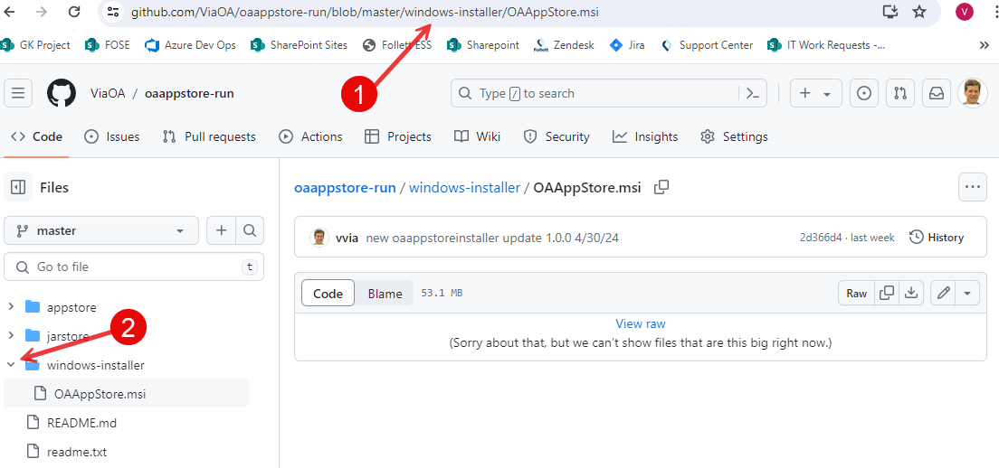

Download the file named OAAppStore.msi
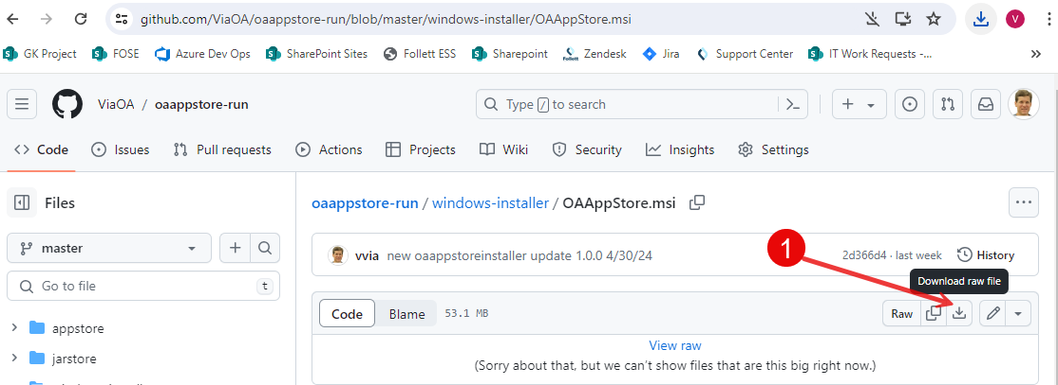

Open and run OAAppStore.msi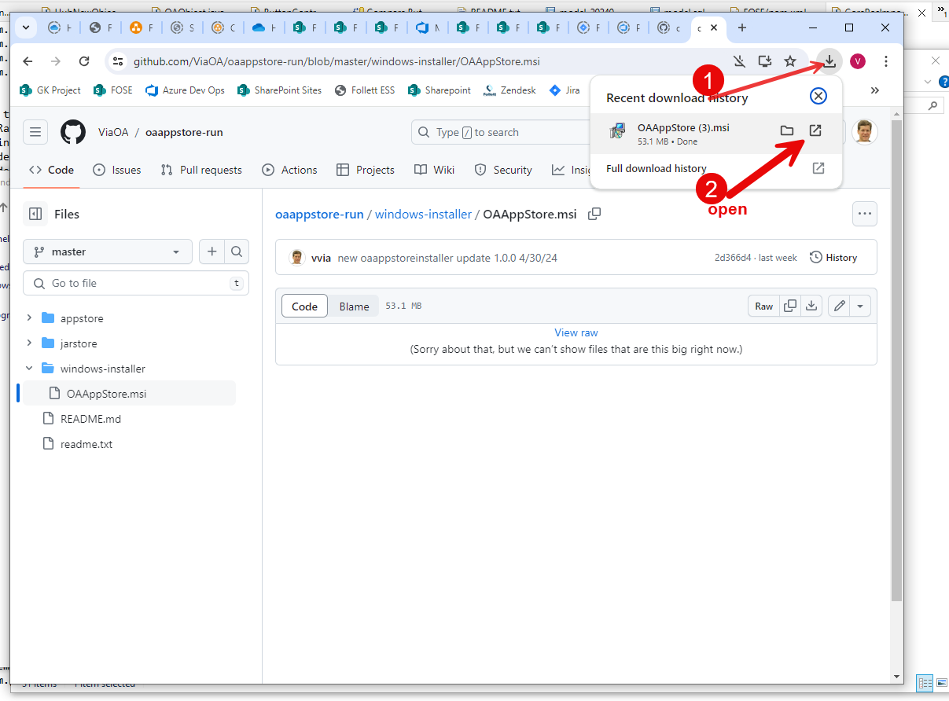

Running the Windows Installer will first show a Windows Defender message.
Select “More Info” to give permission to install.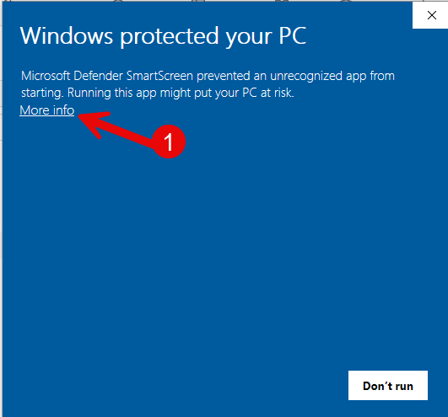

Select Run anyway to begin installation.
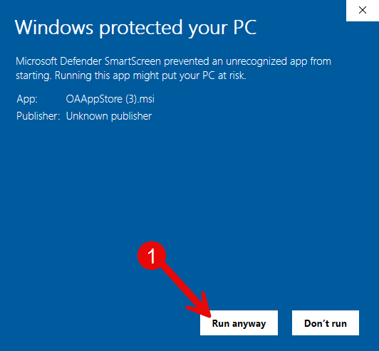

Setup will be displayed, select “Next” button.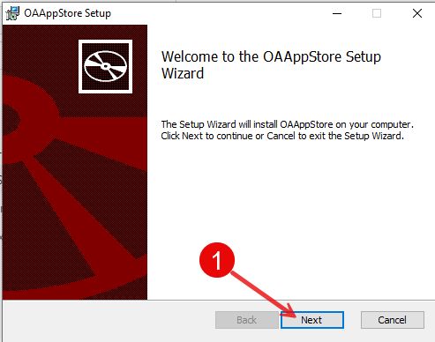
Accept the license, and select “Next” button.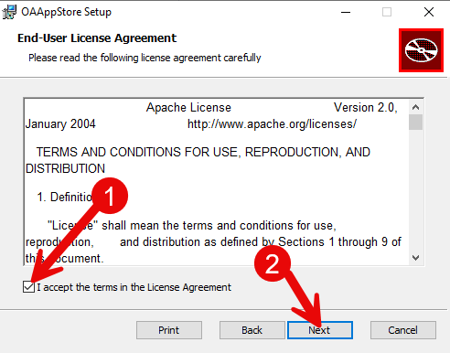

Select “Next” button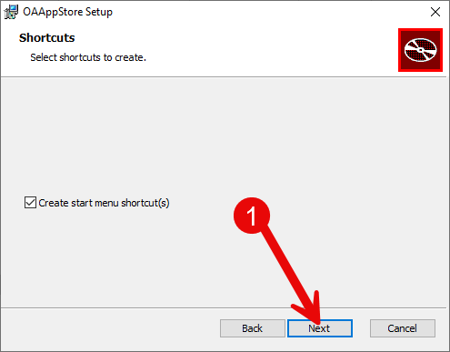

Select “Install”
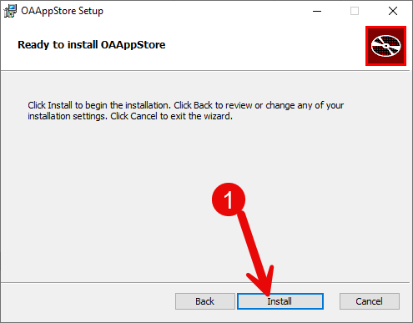

Install completed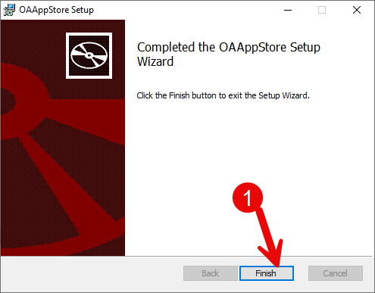

Running OAAppStore from Windows

1: Select Windows “Start” button, 2: type “OAAppStore”, 3: click App.
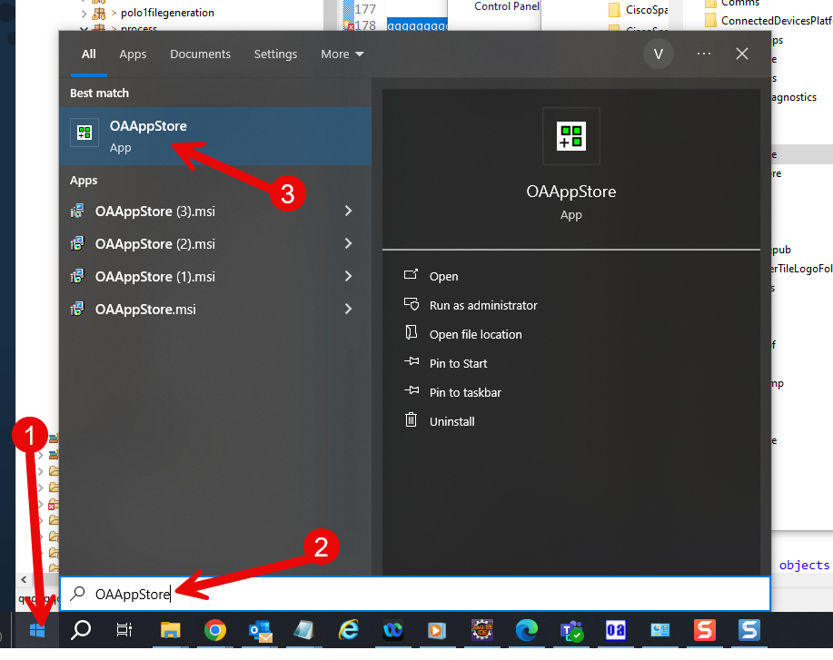

Application will run.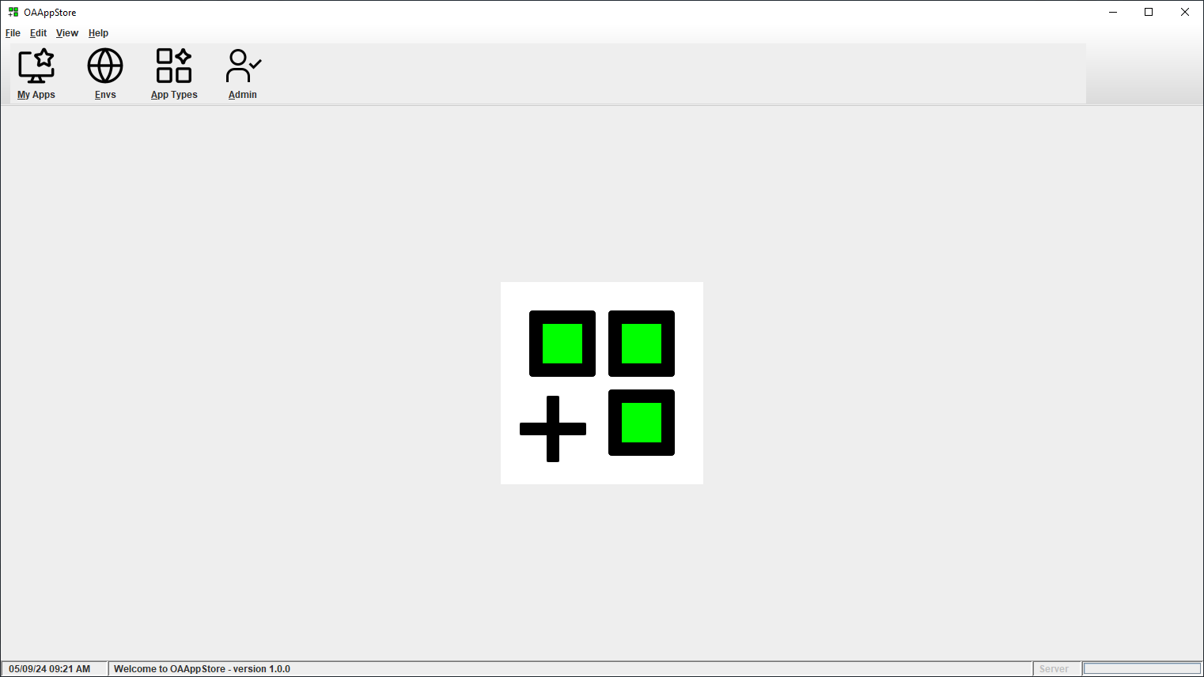

Choose menu “Help” and then “About” to see version and release information.
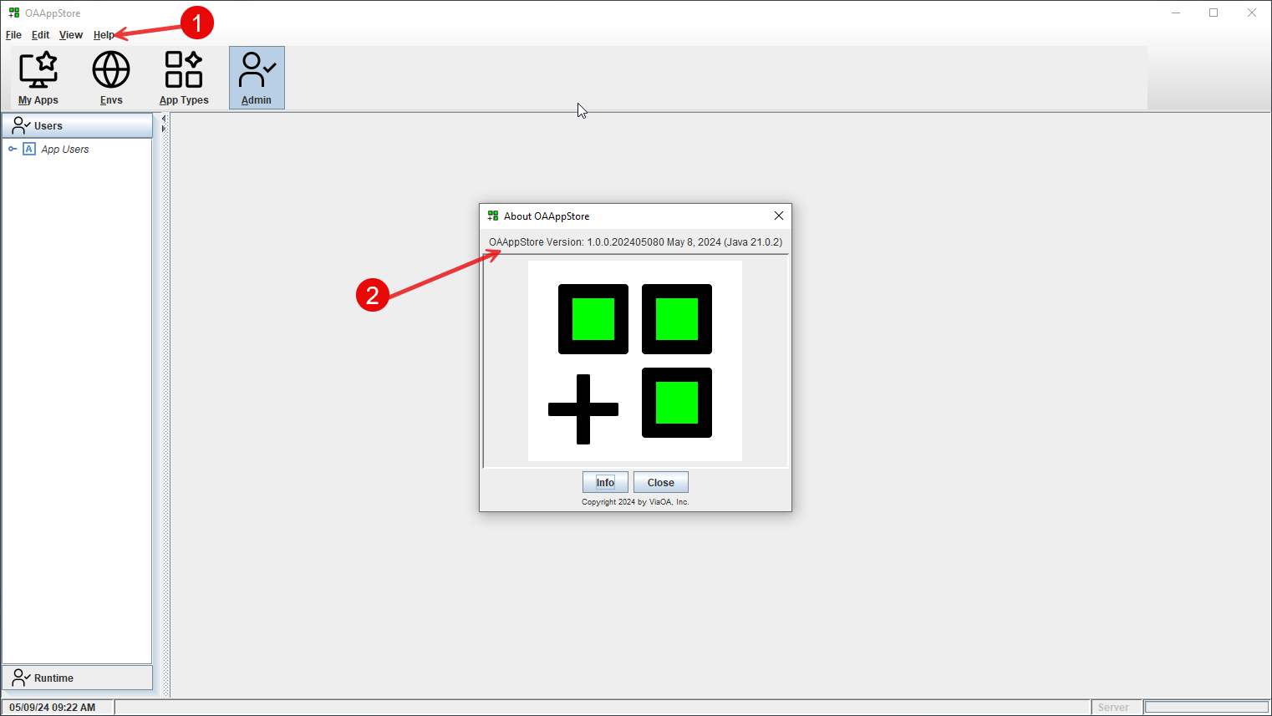

Program Installation location

Program will be running from Users “AppData\Local” directory.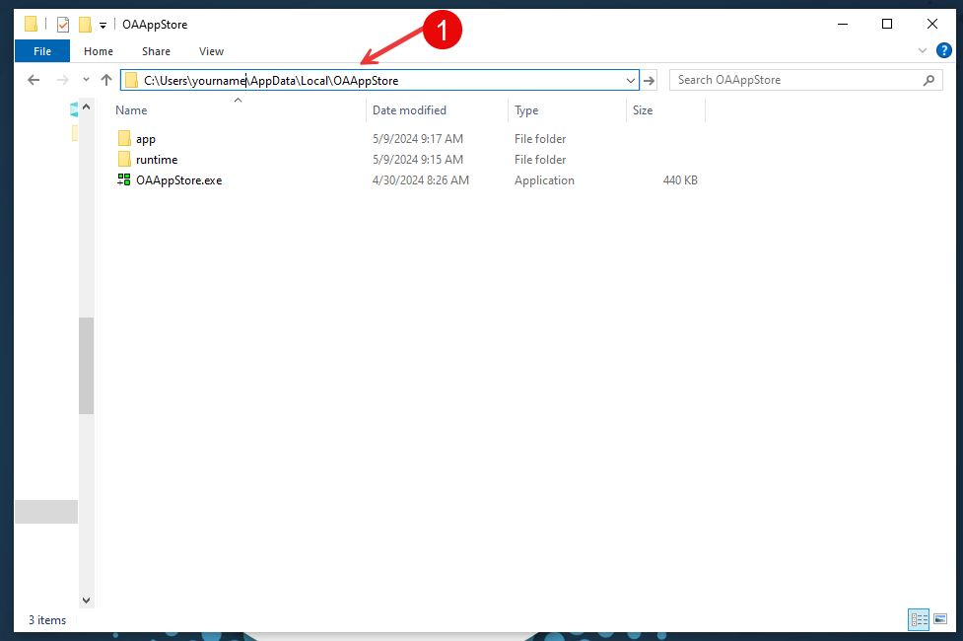

All Apps will be stored under the “appstore” directory, and all code (Java *.jar files) will be under the “jarstore” directory.
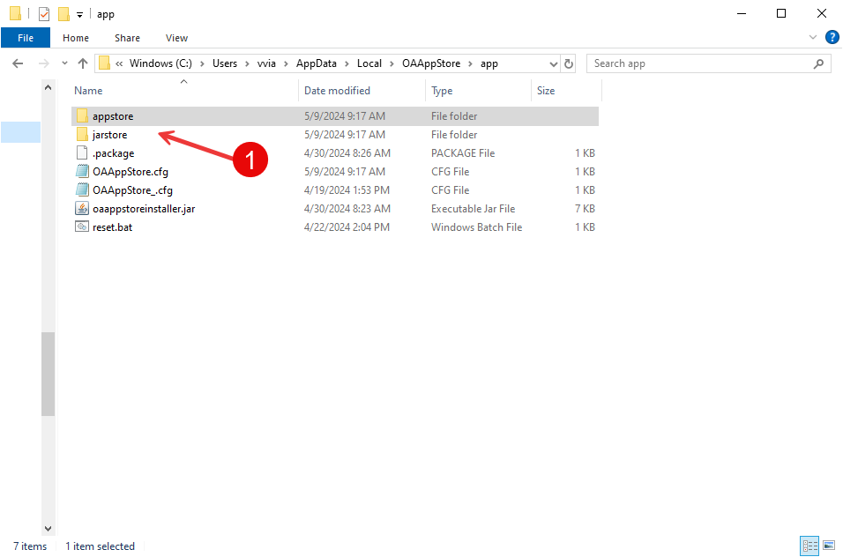

Uninstalling OAAppStore from Windows

1: Select Windows “Start” button, 2: enter “OAAppStore”, 3: mouse right-click, 4: choose “Uninstall” from the popup menu.

