**Final Exam Planner**

**Jan Lishak – 294322**

**Lenka Orincakova - 293085**

**Juan Iglesias Trebolle – 293143**

**João Bernardo Baptista Vieira Dias - 293133**

**Software Technology Engineering**

**1st Semester**

**18th September 2019**

Supervisor: Astrid Hanghøj, Michael Viuff | Number of words : 738

**Table of content**

Background Description 3

Problem Statement 4

Definition of purpose 5

Delimitation 6

Methodology 7

Time schedule 8

Risk assessment 9

Group contract 10

# Background Description

At the end of every semester, the examiners at the university need to plan exam schedule before the examination starts. This task may become very complex and time-wasting due to the number of students and the subjects in which the students are being examined.

The schedule plan must meet many specific criteria. For instance, one student should have one exam in consecutive days. Other external factors need to be considered as well. The rooms must be prepared beforehand so they correspond to the format of the examination. All those conditions make the process of planning more difficult and a real issue to be solved.

Some schools accomplish the planning of exams by making a spreadsheet and manually choose all the times for specific exams. The disadvantage is that the person that makes the plan must check if every exam is scheduled at a time that does not clash with any other exam.

Due to human factor, errors in planning might occur and the schedule might change at a time close before the examination. Those changes can make the exam stressful, both for students and professors. Such problem can be that the supposed room where the examination is held does not have the right technical functionalities such as HDMI port. This could be avoided if there was a system that could check all the criteria automatically.

Scheduling in general is simple task but when there are so many conditions for the right plan, the task can become very complex. Computers might possibly help to speed up the process of scheduling. Some solutions using computers already exist, but every university have different conditions and needs to plan their exams. It is hardly possible to make a system that will consider every need of all the different Universities. Therefore, it would be ideal if every university made their own system that meets their needs.

The whole problem also consists of the delivery of the exam plan. Even if the schedule plan was created perfectly without any errors, external factors might affect the schedule. A professor can become unable to come to work at the specified time or a student might become sick. The schedule must be flexible and delivered to the students in a way that the information is always updated and easy to access. If the schedule was delivered in a PDF file all the people being involved in the schedule would have to download a new file when a new version is published. It would be better if the schedule could be viewed by a student or a teacher in a way that it filters all irrelevant information.

With the use of modern technologies, it is possible to make the task much more efficient and easier than by using spreadsheets or just a pen and paper. Therefore, the problem is relevant to solve and open to new solutions.

# Problem Statement

Main problem:

The process of planning final exam is slow and inefficient because the examiners must enter all the information manually. It is not possible to automatically check if the plan includes all conditions and therefore the plan is prone to human errors. Delivery of the information to students is inefficient as well because the information is not automatically updated.

Sub-problems:

1. How can the process be made faster?

2. How can the system help the user to check if all conditions are met?

3. How should the schedule be shown?

4. Could software solve this problem? What are the benefits?

5. How can the system be made more automatic?

6. What kind of user interface would be the easiest to use?

**questions/ main problem is statement**

# Definition of purpose

The purpose is to improve the administrator’s efficiency. Making his job easier and faster.

# Delimitation

1. The service department will be contacted by the third party like the examiner itself.

2. The information about the students, classrooms, grades and the examiners schedule will also be inserted by the user.

# Methodology

The methodology chosen for this project is Waterfall, which is divided in 7 phases:

Firstly, **requirements phase**.  We met the customer to gather all the requirements needed for the project. This is a key part for the success of the project, because every other phase will be planned without further customer involvement.

Secondly, **analysis**. We analyzedthe system in order to properly generate the models that will be used in the application.

Thirdly, the **design** phase. This is broken up into 2 sub-phases:

Logical design sub-phase. Here we brainstormed theoretical possible solutions.

Physical design sub-phase. Here those theoretical ideas and schemas are made into concrete specifications.

Fourth, **implementation.** We assimilated the requirements and specifications from the previous phases and produce actual code.

Fifth, **testing**. Here the testers will discover and report issues with the application. The code from previous phases will be repeated and improved in order to eliminate those bugs.

Sixth, **verification**. The customer will review the product to make sure that it meets all the requirements laid out at the beginning of the project. The product shown to the customer is a “final product”.

Seventh, **maintenance**. In this phase, the customer will be using the product regularly, discovering bugs, inadequate features, etc. The team will work on those problems until the customer is satisfied.

# Time schedule

This timeline is based on our plan how to efficiently manage our time.

Firstly, focus will be on analysis of the project, where we will discuss what is the purpose. Also, this section includes discussing features and requirements given by the customer. Time spent on this part will be approximately 40 hours per person.

Secondly, we will discuss the design of final product. This would mean 10 hours per person.

Implementation of all information is one of the most important parts. Therefore, 25 hours per person is expected in the third part.

Testing is the last part of our project. Efficiency and clarity will be inspected. Expected time is 8 hours per person.

Total amount of hours is 83 hours per person.

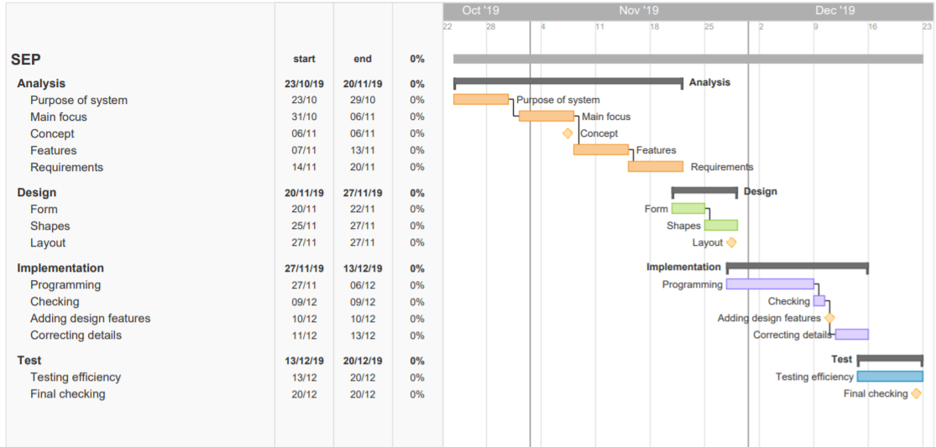

# Risk assessment

|  |  |  |  |  |  |  |
| --- | --- | --- | --- | --- | --- | --- |
| Risks | Likelihood  Scale: 1-5  5 = high risk | Severity  Scale: 1-5  5 = high risk | Product of likelihood and severity | Risk mitigation e.g. Preventive- & Responsive actions | Identifiers | Responsible |
| The software could crash due to the number of students. | 2 | 2 | 10 | Separate the students/classes into smaller groups. | Crash of the software. | João Dias |
| If the information is not handled properly there could be security fails. | 3 | 5 | 15 | Make the software run offline. | Spills in information. | Jan Lishak |
| There may be an overlap in the classroom reservation. | 1 | 3 | 3 | Leave an available room for written and one for oral exams. |  | Lenka Orincakova |
| There might be some student information incorrectly written | 4 | 4 | 16 | Put a button that will let the student suggest a fix. | Student having exams in time / subjects they should not | Juan Trebollle |

# Source of information

Example: NHS Evidence, 2003. National Library of Guidelines. [online] Available at: [Accessed 10 October 2009].

# Group contract

Group Name: **Group 8** Date: **07/10/2019**

These are the terms of group conduct and cooperation that we agree on as a team.

**Participation**:

We agree on equally participating in each project, being active and responsible. We will work effectively and be concentrated.

**Communication**:

We agree on communicate openly about issues and making decisions. We are expected to tell new ideas, opinions or disagreements with respect, please.

**Meetings**:

We agree to participate in every meeting we agreed on, unless the person informs the group in advance.

**Conduct**:

We agree on being polite, taking our responsibilities seriously, with good mood. 😊

**Conflict**:

We agree on discussing possible conflicts, solving them and making final agreement.

**Deadlines**:

We agree to finish our project on a deadline.

**Other Issues:**

Bringing snacks when you cook!

|  |  |  |
| --- | --- | --- |
| **Group member’s name** | **Student number** | **Signature** |
| Lenka Orincakova | 293085 |  |
| Juan Iglesias Trebolle | 293143 |  |
| Joao Bernardo Dias | 293133 |  |
| Jan Lishak | 294322 |  |