**Analysis**

**Jan Lishak – 294322**

**Lenka Orincakova - 293085**

**Juan Iglesias Trebolle – 293143**

**João Bernardo Baptista Vieira Dias - 293133**

**Software Technology Engineering**

**1st Semester**

**30th October 2019**

Supervisor: Astrid Hanghøj, Michael Viuff | Number of words :

# Summary

VIA University College needs to plan exam schedule before the examination starts. The schedule plan must meet many specific criteria. Scheduling in general is simple task but when there are so many conditions for the right plan, the task can become very complex. Computers might possibly help to speed up the process of scheduling.

Our system is able to do: 1) the administrator collects the information, 2) the administrator is uploading the information and system checks the requirements, 3) the schedule is created.

The system contains information about students, co-examiners and examiners. The schedule must be flexible and delivered to the students in a way that the information is always updated and easy to access. It would be better if the schedule could be viewed by a student or a teacher in a way that it filters all irrelevant information.

**Table of content**

Summary 2

Functional requirements 4

Non - functional requirements 5

Use Case Diagram 6

Use Case Description 6

Link between requirements and use cases 11

# Functional requirements

1. As an administrator, I want to be registered as only administrator with access to all information.
2. As an administrator, I want to be able to upload information about teachers, students and classrooms.
3. As an administrator, I want the system to check if there are two exams in the same day, with the right amount of time between them.
4. As an administrator, I want the system to check if the rooms are suitable for exams and if the examiners and co-examiners are available.
5. As an administrator, I want the system to check that the examiners’ and co-examiners’ work day is 8 hours max.
6. As an administrator, I want the system to check if the written exam is before oral exam.
7. As an administrator, I want the system to check if the time of the written exam is 3 hours and the time of the oral exam is 20 minutes.
8. As an administrator, I want the system to check if the exam on 7th semester is at least 3 days before graduation.
9. As an administrator, I want the system to check if the class for the exam is the same as class used during the semester.
10. As an administrator, I want the system to check if the service department is informed about the exam at least one day in advance to prepare the room for exam.
11. As an administrator, I want to be able to add, remove, edit and show information about exam.
12. As an administrator, I want to be able to add, remove, edit and show information about student.
13. As a student, I want to be registered as student with access to the schedule.
14. As a student, I want to be able to see the schedule.
15. As a teacher, I want to be registered as a teacher with access to the schedule.
16. As a teacher, I want to be able to see the schedule.

# Non - functional requirements

1. Every update in the system includes writing to a file.

# Use Case Diagram

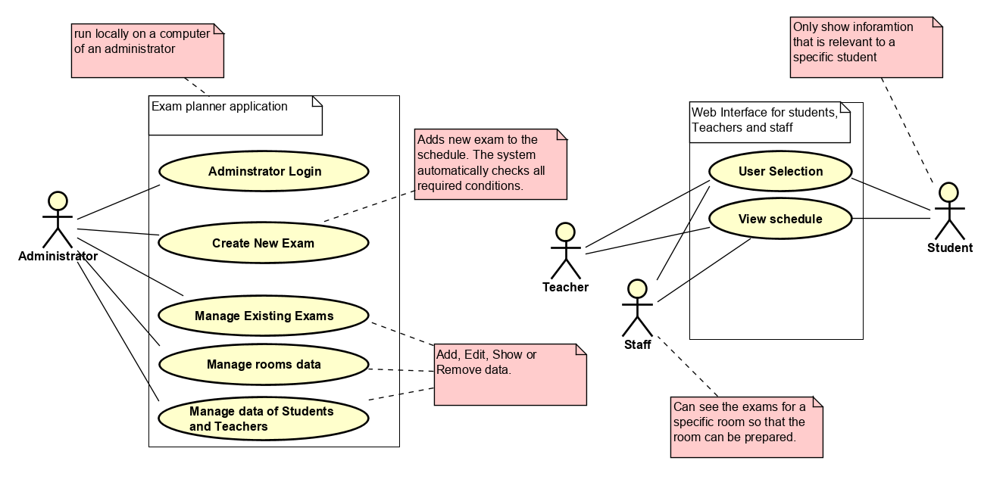

# Use Case Description

|  |  |
| --- | --- |
| **Use case** | **Administrator Login** |
| **Summary** | The system will require a valid password to access any other functions of the system. If the password has not been created the system will ask the administrator to create a new one.. |
| **Actor** | Administrator. |
| **Precondition** | The app has to be installed and working |
| **P Postcondition** | The system password is set, and the administrator is granted permission to use the system. |
| **Base sequence** | 1. If the administrator’s password has not been set:    1. System asks for a new password    2. System asks for a password again and checks whether they match.    3. If the entered password does not match, the system goes back to step (a.)    4. The password is set and saved to a file (in a hashed form).    5. The administrator can now continue to step 2 and Login. 2. The password is already set:    1. System ask for a password    2. If the password is valid, the administrators is granted permission to use all the functions of the system. |

|  |  |
| --- | --- |
| **Use case** | **Manage room data** |
| **Summary** | Add a new classroom, show the list of all classrooms, edit classroom’s properties or delete a classroom. |
| **Actor** | Administrator. |
| **Precondition** | Administrator needs to be logged in. |
| **P Postcondition** | A new classroom has been added to the list of classrooms, data for an existing classroom has been shown or updated or an existing classroom has been deleted from the list. |
| **Base sequence** | ADD:   1. If a new classroom needs to be added specify the values for    1. Name of the classroom    2. The capacity (numbers of places to sit for students)    3. For which class is this home classroom    4. Capabilities for projection (HDMI, VGA)    5. Actual examination format (oral or written)   Show:   1. Show a list of all classrooms recorded in the system. For each classroom show the defined values as in step number 1. 2. If required the list can be sorted by the name of classroom, capacity or examination format.   Edit:   1. The system shows all classrooms as in step number 2. 2. Select which of the classroom properties defined in step number 1 are required to change 3. Update the property with a new valid value   Remove:   1. Show a list of all classrooms recorded in the system. For each classroom show the defined values as in step number 2. 2. Select which of the existing classroom needs to be deleted. 3. Remove the specified classroom from the list of classrooms. |

|  |  |
| --- | --- |
| **Use case** | **Create new exam.** |
| **Summary** | Creates a new exam in the schedule specifying all the required information. |
| **Actor** | Administrator |
| **Precondition** | The Administrator has to be logged in and the student’s, room’s and teacher’s data must be already set up. |
| **Postcondition** | Exam is created with all necessary information. |
| **Base sequence** | 1. Enter the date of exam. 2. If the date is not in the exam period (January, June), go to step 1. 3. The system shows every program which is taught at VIA UC. For each program, teachers, students, rooms are set. Choose the program for exam. 4. Each program is divided in several semesters. Select the semester you want to have an exam in. 5. Every course from the semester is shown. Choose the course (SDJ, RWD, MSE, etc.) 6. System filters the classes. Choose the class for exam (X, Y, Z, etc.). 7. Choose the type of exam. The system will show the classroom which is assigned to specific class (E 301). If the exam is of type written and is before oral exam, list all the rooms which minimum size is 40 and list all the features of the classroom (HDMI, etc.). 8. If the specific classroom is not available, go to step 7 and choose another one. 9. Approve the selected exam or go to step 7 to select another. 10. System shows a list of examiners. Choose the examiner. 11. If the examiner has reached maximum hours (8 hours) and is not available on the specific date, go to step 10 to choose another one. 12. Approve the selected examiner or go to step 10 to select another. 13. System shows a list of co-examiners. Choose the co-examiner. 14. If the co-examiner has reached maximum hours (8 hours) and is not available on the specific date, go to step 13 to choose another one. 15. Approve the selected co-examiner or go to step 13 to select another. 16. The exam is uploaded with assigned date, examiner, co-examiner, time, room and list of the students. 17. If the exam is oral, the order of students is uploaded. |

|  |  |
| --- | --- |
| **Use case** | **Manage the data of Students and Teachers.** |
| **Summary** | Add, edit or remove users of the system. |
| **Actor** | Administrator |
| **Precondition** | Administrator needs to be logged on. The classrooms must be defined. |
| **Postcondition** | Information about students and teachers is set. |
| **Base sequence** | Show:   1. show a list of all users recorded in the system. 2. For each student show the name, ID, program, class and email. 3. For each teacher show the name, ID, teaching subject, classes they teach and email.   ADD:   1. If adding new student, then set up this information:    1. Name    2. ID    3. Program (whole name)    4. Class (just letters)    5. Email (in the format “id@via.dk 2. Else If adding a new Teacher, then set up this information:    1. Name    2. ID    3. Teaching subject (whole name)    4. List of Classes the teacher is teaching (just letters)    5. Email (in the format “id@via.dk). 3. System validates data and prompts for illegal values 4. If the values are valid, the system adds a new student/new teacher with given information.   Edit:   1. System shows a list of all users and all information as defined from step 1. to step 3. 2. Enter or edit values for one of the fields of the user. 3. System updates the selected field of the user.   Remove:   1. System shows a list of all users and all information as defined from step 1. to step 3. 2. Select a specific user from the list to be deleted 3. System removes the user from the list. |

|  |  |
| --- | --- |
| **Use case** | **Manage exam data** |
| **Summary** | Add, edit, remove or view exam data. |
| **Actor** | Administrator |
| **Precondition** | The Administrator has to be logged in and the student’s; room’s and teacher’s data must be already set up.. |
| **Postcondition** | The data in the schedule is replaced with the one specified. |
| **Base sequence** | ADD:   1. If adding new exam, then set up this information:    1. Date    2. Program (Software Engineering, etc.)    3. Semester    4. Class    5. Course    6. Type of exam    7. If the type of exam is written   then also features   * 1. Room   2. Examiners   3. Co-examiners  1. If the date and time steps over existing date and time, go to step 1 and choose another date and time. 2. If the semester is 7th and the date is not three days before graduation, go to step 1 and choose another date. 3. System validates data and prompts for illegal values. 4. If the input is valid then the system adds a new exam with given information.   SHOW:   1. System shows a list of exams with all information from step 1.   EDIT:  Step 1-4 as above and then   1. Enter or edit values for one of the exam fields from step 1. 2. System updates the selected field in the exam.     REMOVE:  Step 1-6 as above and then   1. Verify deleting the selected exam. 2. System approves the deletion and removes the exam from the list. |

|  |  |
| --- | --- |
| **Use case** | **User Selection** |
| **Summary** | User is asked to enter an ID number to view the schedule. |
| **Actor** | Staff, Students and Teachers. |
| **Precondition** | Open the webpage. |
| **P Postcondition** | The user can view all the relevant information about the exams. |
| **Base sequence** | 1. System asks for type of user (student, teacher or stuff). |

|  |  |
| --- | --- |
| **Use case** | **View schedule** |
| **Summary** | Showing the schedule to students, teachers and stuff. |
| **Actor** | Students, teachers, stuff. |
| **Precondition** | User must select the type of user. |
| **Postcondition** | The user can view information about the exams. |
| **Base sequence** | 1. System checks ,what type of user is logged in 2. Accordingly, to the type of user any irrelevant information is filtered out so that the schedule is easily readable. (the data is displayed as a table) |

# Link between requirements and use cases

**Use case Covered requirements**

Administrator Login 1,13,15,

Create new exam 2,3,4,5,6,7,8,9,10

Manage students’ and teacher’s data 12

Manage exam data 11

View schedule 14,16

User

