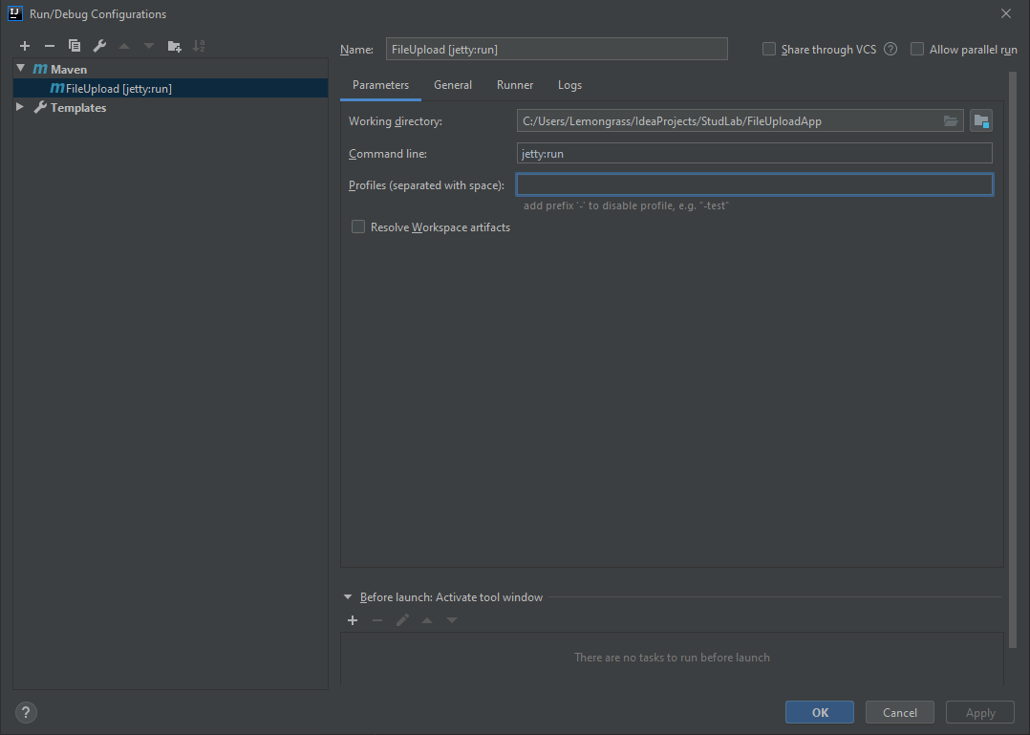 Run/Debug Configuration:

Heroku app link: <https://fileuploadapp-studlab.herokuapp.com/>