Viani_anova.R

Usuario

2023-05-18

# VAGM  
# ANOVA  
# 18/05/2023  
# Experimento ganancia en el peso basado en diferentes dietas   
# Niveles de factor: 4  
die1 <- c(2.4, 2.2, 3.4, 1.6)  
die2 <- c(2.2, 1.9, 1.7, 2.1)  
die3 <- c (3.3, 1.3, 2.8, 2.1)  
die4 <- c(1.6, 2.5, 1.4, 2.4)  
GP <- c(2.4, 2.2, 3.4, 1.6, 2.2, 1.9, 1.7, 2.1, 3.3, 1.3, 2.8, 2.1, 1.6, 2.5, 1.4, 2.4)  
trat <- gl(4,4,16, labels = c("die1", "die2", "die3", "die4"))  
bloque <- gl (4,4,16, labels = c("bajo", "Normal", "SP", "OB"))  
  
  
Dietas <- data.frame(trat, GP, bloque)  
boxplot(Dietas$GP ~ Dietas$trat, col="salmon",  
 xlab = "Dietas",  
 ylab = "Ganancia en peso (kg)")

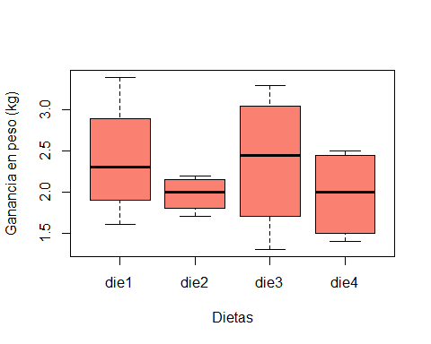

tapply(Dietas$GP, Dietas$trat, var)

## die1 die2 die3 die4   
## 0.56000000 0.04916667 0.75583333 0.30916667

fligner.test(Dietas$GP, Dietas$trat)

##   
## Fligner-Killeen test of homogeneity of variances  
##   
## data: Dietas$GP and Dietas$trat  
## Fligner-Killeen:med chi-squared = 4.6369, df = 3, p-value = 0.2004

bartlett.test(Dietas$GP, Dietas$trat)

##   
## Bartlett test of homogeneity of variances  
##   
## data: Dietas$GP and Dietas$trat  
## Bartlett's K-squared = 4.1152, df = 3, p-value = 0.2493

diet.aov <- aov(Dietas$GP ~ Dietas$trat)  
summary(diet.aov)

## Df Sum Sq Mean Sq F value Pr(>F)  
## Dietas$trat 3 0.682 0.2273 0.543 0.662  
## Residuals 12 5.022 0.4185

write.table(Dietas, "C:/R_Vianey/D_experimental/Scripts/Dietas.csv" ,   
 sep = ",")