Viani_germinacion1.R

Usuario

2023-05-25

#25/05/23  
# VAGM  
# Importar datos  
Germ <- read.csv("C:/R_Vianey/D_experimental/GERMINACION.csv", header = T)  
Germ$TRAT <- as.factor(Germ$TRAT)  
boxplot(Germ$PG ~ Germ$TRAT,   
 col="pink",  
 xlab = "Tratamientos Germinativos",  
 ylab = "% Germinacion",   
 ylim = c(0, 10))  
text(1,4.2, "a")  
text(2, 8.3, "b")  
text(3, 9.3, "b")  
text(4, 7.3, "b")  
text(5, 3.3, "a", col="pink")

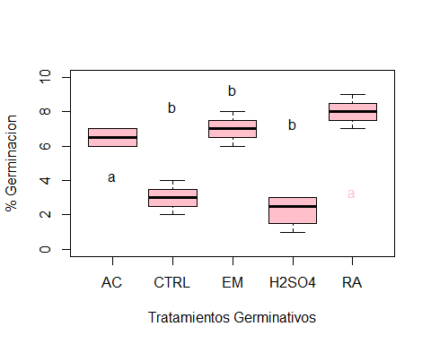

# ordenar tratamientos  
levels(Germ$TRAT)

## [1] "AC" "CTRL" "EM" "H2SO4" "RA"

Germ$TRAT <- factor(Germ$TRAT, levels = c("CTRL", "EM", "AC", "RA", "H2SO4"))  
levels(Germ$TRAT)

## [1] "CTRL" "EM" "AC" "RA" "H2SO4"

boxplot(Germ$PG ~ Germ$TRAT ,  
 col="pink")

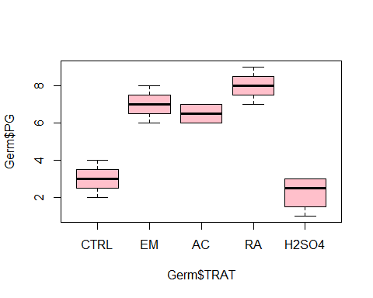

# Funcion tapply  
tapply(Germ$PG, Germ$TRAT, mean)

## CTRL EM AC RA H2SO4   
## 3.00 7.00 6.50 8.00 2.25

tapply(Germ$PG, Germ$TRAT, var)

## CTRL EM AC RA H2SO4   
## 0.6666667 0.6666667 0.3333333 0.6666667 0.9166667

#ANOVA  
germ.aov <- aov(Germ$PG ~ Germ$TRAT)  
summary(germ.aov)

## Df Sum Sq Mean Sq F value Pr(>F)   
## Germ$TRAT 4 104.80 26.20 40.31 7.42e-08 ***  
## Residuals 15 9.75 0.65   
## ---  
## Signif. codes: 0 '***' 0.001 '**' 0.01 '*' 0.05 '.' 0.1 ' ' 1

# prueba de tuckey   
TukeyHSD(germ.aov, conf.level = 0.95)

## Tukey multiple comparisons of means  
## 95% family-wise confidence level  
##   
## Fit: aov(formula = Germ$PG ~ Germ$TRAT)  
##   
## $`Germ$TRAT`  
## diff lwr upr p adj  
## EM-CTRL 4.00 2.2396122 5.760388 0.0000356  
## AC-CTRL 3.50 1.7396122 5.260388 0.0001587  
## RA-CTRL 5.00 3.2396122 6.760388 0.0000024  
## H2SO4-CTRL -0.75 -2.5103878 1.010388 0.6862491  
## AC-EM -0.50 -2.2603878 1.260388 0.9009428  
## RA-EM 1.00 -0.7603878 2.760388 0.4332120  
## H2SO4-EM -4.75 -6.5103878 -2.989612 0.0000045  
## RA-AC 1.50 -0.2603878 3.260388 0.1140897  
## H2SO4-AC -4.25 -6.0103878 -2.489612 0.0000175  
## H2SO4-RA -5.75 -7.5103878 -3.989612 0.0000004

plot(TukeyHSD(germ.aov), las=1, col="darkblue")

