Viani_semillas.R

Usuario

2023-05-29

# t-test dependientes   
 semilla <- read.csv("mainproduccion.csv", header = T)  
semilla$Tiempo <- as.factor(semilla$Tiempo)   
# Grafica boxplot  
boxplot(semilla$Tiempo , semilla$Kgsem)

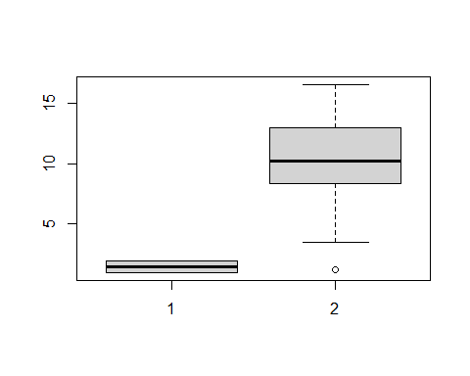

boxplot(semilla$BioRama , semilla$Tiempo)

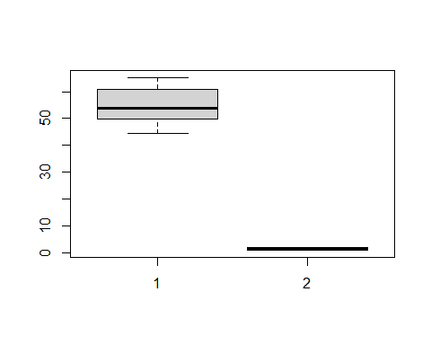

boxplot(semilla$Kgsem)

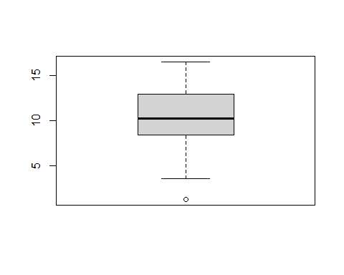

t.test(semilla$Kgsem ~ semilla$Tiempo, paired = TRUE)

##   
## Paired t-test  
##   
## data: semilla$Kgsem by semilla$Tiempo  
## t = -1.2538, df = 49, p-value = 0.2159  
## alternative hypothesis: true mean difference is not equal to 0  
## 95 percent confidence interval:  
## -2.0530953 0.4754953  
## sample estimates:  
## mean difference   
## -0.7888

t.test(semilla$Germ ~ semilla$Tiempo, paired =T)

##   
## Paired t-test  
##   
## data: semilla$Germ by semilla$Tiempo  
## t = -16.678, df = 49, p-value < 2.2e-16  
## alternative hypothesis: true mean difference is not equal to 0  
## 95 percent confidence interval:  
## -23.14844 -18.16996  
## sample estimates:  
## mean difference   
## -20.6592

t.test(semilla$BioRama ~ semilla$Tiempo, paired=T)

##   
## Paired t-test  
##   
## data: semilla$BioRama by semilla$Tiempo  
## t = -19.428, df = 49, p-value < 2.2e-16  
## alternative hypothesis: true mean difference is not equal to 0  
## 95 percent confidence interval:  
## -11.651431 -9.466969  
## sample estimates:  
## mean difference   
## -10.5592

t.test(semilla$H6 ~ semilla$Tiempo, paired=T)

##   
## Paired t-test  
##   
## data: semilla$H6 by semilla$Tiempo  
## t = -3.1053, df = 49, p-value = 0.003157  
## alternative hypothesis: true mean difference is not equal to 0  
## 95 percent confidence interval:  
## -5.340063 -1.143937  
## sample estimates:  
## mean difference   
## -3.242