EOIP Administrator Guide
KnowGridFlow / EOIP | 20 October 2026
This manual explains the current repository's primary web application. Authenticated journeys depend on the deployed API, graph backend, worker, policy and the reader's role. The screenshots show observed local states; they do not certify the entire workflow.

Ingest and validate data
Operate demo loading, file import, source registry, dry runs, jobs and validation in the current Administration UI.
Availability: Conditional - configured connectors and worker required
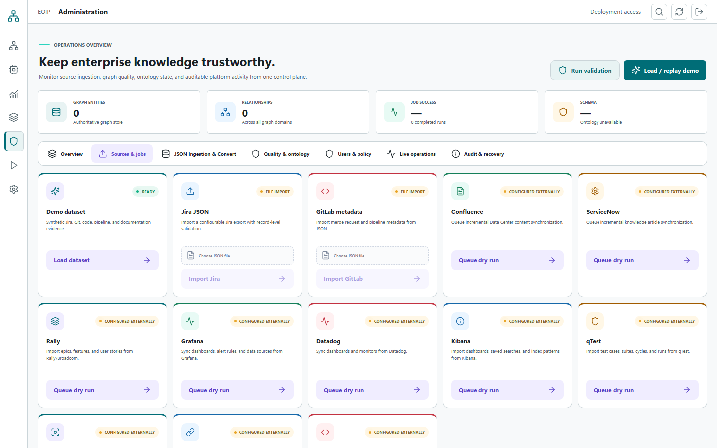
Observed screenshot: local primary web UI, not a production acceptance result

Start with a disposable dataset
Administration exposes a Demo dataset action for synthetic Jira, Git, code, pipeline and documentation evidence. Use a non-production environment and confirm that demo loading is permitted. For a production deployment set EOIP_LOAD_DEMO=false as documented by the repository. In the tested memory profile, the service panel misleadingly said HugeGraph READY; verify the actual backend configuration separately.
1. Open Administration and review system and graph status.
2. In a disposable environment, choose Load dataset.
3. Refresh counts and inspect the graph inventory before querying.

Import a JSON file
The UI has Jira JSON and GitLab metadata file import controls, and a JSON graph-ingestion area. Validate the source format and classification with the data owner first. Use a small, approved sample to check record-level errors before larger imports. A button indicates a request path; verify the resulting graph, error list and job state.
1. Choose the correct import source and select the approved JSON file.
2. Run the import and wait for the result or job ID.
3. Review accepted, rejected and errored records, not only a success banner.
4. Search for one imported canonical entity and inspect provenance.

Operate registered sources
The source registry exposes baseline, discovery, dry run, sync, reconciliation and replay actions. Named connectors such as Confluence, ServiceNow, Rally, Grafana, Datadog, Kibana, qTest, Figma, API Portal and GitHub require external configuration; do not assume credentials or access are present. Confluence and ServiceNow incremental options include checkpoint and Dry run only.
1. Load source control and choose an already registered, authorized source.
2. Review its endpoint, owner, scope and status without revealing credentials.
3. Run discovery or dry run first; record counts and rejected records.
4. Queue sync only after approval and monitor its durable job.
5. Reconcile source and graph counts, then inspect sampled entities and evidence.

Validate and recover
Run validation from Knowledge quality after a data change. Check evidence coverage, provenance coverage, schema compliance, completeness, freshness, orphan and duplicate rates plus individual findings. The Dead-letter queue lists rejection context without captured payloads. Replay only after the underlying cause is corrected and the data owner approves it.
1. Choose Run validation and record the checked entity and relationship counts.
2. Review each error and warning, then correct source mapping or data.
3. Use Load DLQ to inspect failed records and the reason, never to extract sensitive payloads.
4. Re-run a bounded dry run or replay and confirm no duplicate effects.

Security and access
Handle tokens, tenant scope, audit events, egress and derived artifacts as operational controls.
Availability: Controls require deployment-level verification
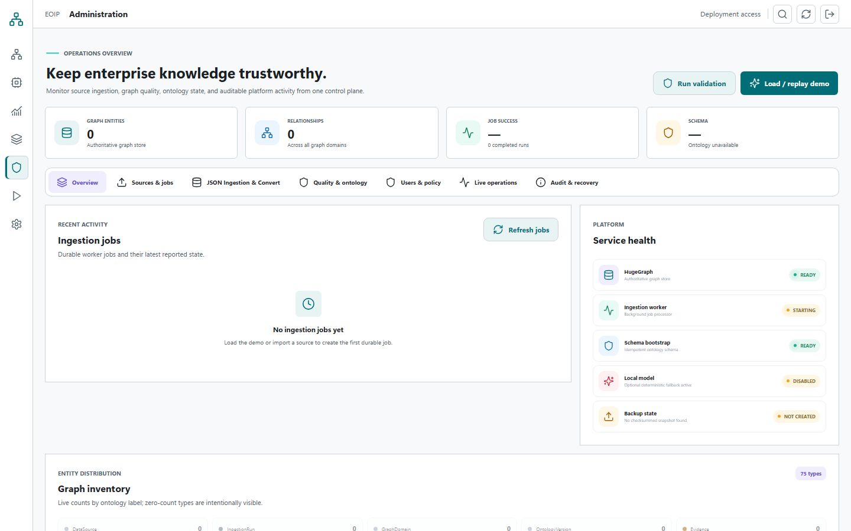
Observed screenshot: local primary web UI, not a production acceptance result

Protect the access token
The primary web UI keeps the token in memory and removes an older sessionStorage credential. Reload or Disconnect clears it. This does not replace HTTPS, secret rotation, least privilege or endpoint authorization in a real deployment. Do not share credentials in screenshots or support bundles.
1. Issue a scoped token through the approved deployment process.
2. Use the primary apps/web UI and a trusted origin.
3. Disconnect when complete; rotate a token if exposure is suspected.

Review audit events
Administration has a Load audit events action. The screen aims to show safe summaries, actors, outcomes and correlation identifiers without secret payloads. Review any action that changes source registration, graph state, policy, job recovery or export access.
1. Load the latest events and identify the relevant correlation ID.
2. Check actor, tenant, operation, outcome and time against the approved request.
3. Escalate missing, ambiguous or cross-tenant entries; do not infer a clean audit from an empty UI list.

Tenant and data boundaries
The project intends one authorization authority across UI, API, worker, MCP and developer channels. Current code requires further end-to-end qualification, including derived data and downloads. Administrators should test denied cross-tenant reads and revocation on the actual deployment before trusting a release claim.

External services and local models
Connectors need explicit credentials and source allowlists. Local AI and processing backends are optional. Application-level egress checks are not a network firewall; enforce no-egress at the host or orchestration layer where the data classification requires it, and verify with observed network tests.

