EOIP Operations and Troubleshooting
KnowGridFlow / EOIP | 20 October 2026
This manual explains the current repository's primary web application. Authenticated journeys depend on the deployed API, graph backend, worker, policy and the reader's role. The screenshots show observed local states; they do not certify the entire workflow.

Troubleshooting and recovery
Diagnose readiness, connection, empty results, stalled jobs and failed imports without leaking sensitive data.
Availability: Read-only first; recovery actions need approval
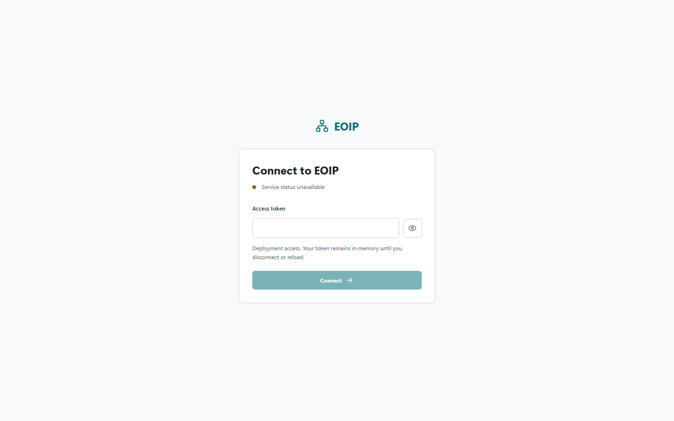
Observed screenshot: local primary web UI, not a production acceptance result

Service status unavailable
This is the expected connection-screen state when the web frontend runs without an API proxy or the API is unhealthy. Check /health/ready on the API. In Vite host development, set EOIP_DEV_API_URL before starting Vite. In containers, inspect the compose status and service logs. Do not repeatedly submit a token until readiness is understood.
1. Record the time and URL, not the token.
2. Check the API readiness endpoint and container status.
3. Confirm the correct web origin and API proxy, then reload.

Cannot connect
Connect requests administrative stats, system and jobs. A ready health endpoint can coexist with an invalid token or denied authorization. Read the toast and correlation ID. Confirm the deployment token and scope through the administrator; never paste the token into a ticket.
1. Check readiness first.
2. Record the error text and correlation ID.
3. Ask the deployment owner to verify token scope or rotate a compromised token.

No search results
Check the spelling and canonical ID, selected filters, source ingestion status and tenant access. A bounded or partial graph view can omit other permitted context. Compare one known imported record; do not conclude that the source has no data from a single empty query.

Import or job stalled
Use Administration to inspect durable queue state and dead-letter records. Distinguish pending, running, failed, cancelled and completed. Check worker health, lease behavior and storage before any replay. Re-run only with an idempotency and duplicate-effects check.
1. Capture the job ID and error summary, not sensitive payload.
2. Inspect worker status and source checkpoint.
3. Correct the root cause and obtain approval for replay.
4. Reconcile source counts, persisted graph state and audit events afterward.

Backups and restoration
The integrated container helper exposes backup and restore-test actions. A completed backup label is not proof of recoverability. Use the operations runbook and a disposable environment to perform a restore drill before relying on a snapshot. Do not delete named volumes merely to reset a test without confirming the target.

Support bundle
Include application version or git revision, deployment profile, UTC time, affected route, steps to reproduce, correlation/job ID, expected versus observed behavior and redacted logs. Exclude access tokens, raw source payloads, private graph exports and model prompts unless an approved secure channel exists.

