EOIP User Guide
KnowGridFlow / EOIP | 20 October 2026
This manual explains the current repository's primary web application. Authenticated journeys depend on the deployed API, graph backend, worker, policy and the reader's role. The screenshots show observed local states; they do not certify the entire workflow.

Explore the knowledge graph
Search, inspect entities and edges, trace impact and read evidence without assuming a bounded view is the entire graph.
Availability: UI implemented; result quality depends on graph and access
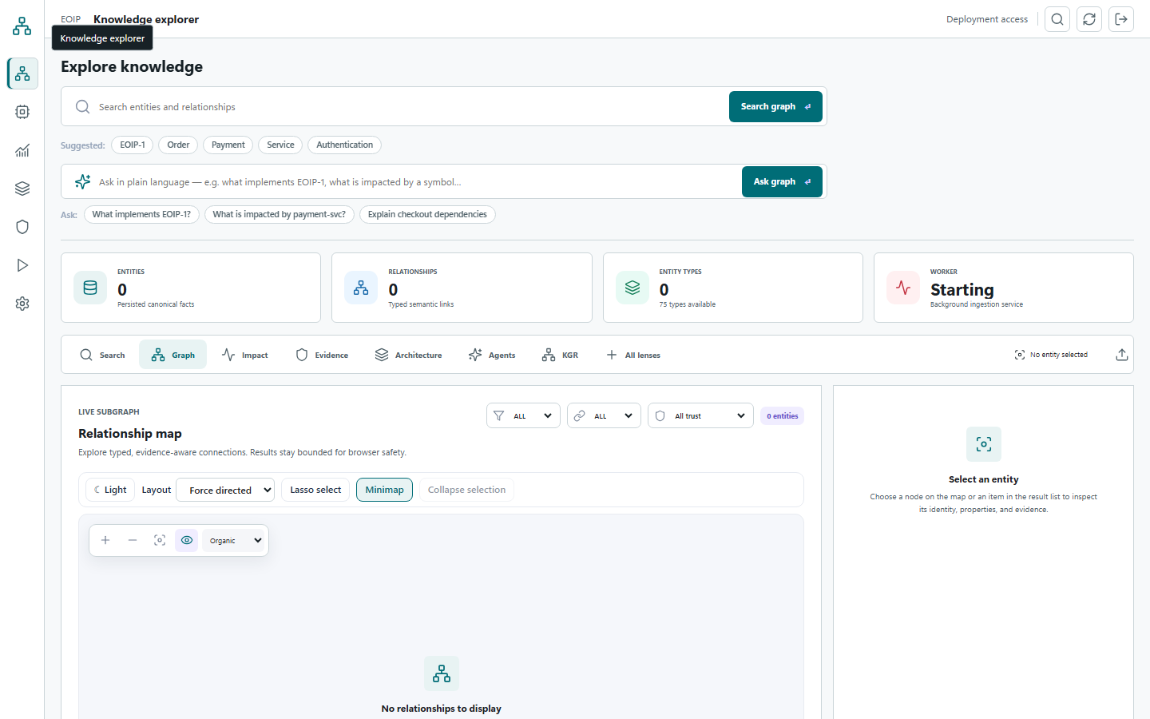
Observed screenshot: local primary web UI, not a production acceptance result

Search for a known entity
Open Knowledge explorer. Search by an issue key, symbol, commit, file or document identifier you already know. Results are grouped by knowledge domain and retain canonical graph IDs. An empty result can mean no matching data, an access restriction or an unavailable backend.
1. Enter a specific identifier in the search field and submit.
2. Read the match count and any partial-result warning.
3. Choose a result in its domain group to select the canonical entity.

Inspect an entity
The right inspector shows Overview and Evidence tabs. Overview lists properties; Evidence shows connected provenance where available. Property values and source references are data from the graph, not an independent fact check. Filter a large property list using the inspector filter.
1. Select an entity in results, the entity strip or graph canvas.
2. Inspect its type and canonical ID before sharing a link or using it in a path request.
3. Open Evidence and check source references; note when no direct evidence is returned.

Read the relationship map
The graph lens shows a bounded subgraph. Filter by domain, relationship class and deterministic or inferred trust state. A 'partial' warning means more context may exist. Select an edge to inspect direction, type, properties and evidence key. Thicker links indicate attached evidence, not necessarily validated truth.
1. Use filters to reduce clutter before interpreting connections.
2. Select a relationship and compare from and to IDs.
3. Expand a selected entity only when you need more context; results remain policy bounded.

Trace downstream impact
Select an anchor entity, then use Explore impact. The current UI describes a four-hop bound. Run TraceImpact invokes a deterministic read-only agent. Read the per-node rationale where returned; do not interpret absence of a path as evidence that no dependency exists outside the permitted scope.
1. Select an entity in Graph and switch to the Impact lens.
2. Run Explore impact, then inspect the returned path depth and evidence.
3. For two known IDs, enter both in Trace requirement to implementation and choose Find path.

Other lenses
Architecture shows the domains and relationship classes in the current bounded result, not a full inventory. The lens library distinguishes API-backed choices from disabled planned lenses. A disabled lens should remain disabled until its backend is delivered and qualified.

Query and ontology studio
Use the studio with known-answer queries and inspect schema before interpreting a result.
Availability: Conditional - backend dialect and role determine availability
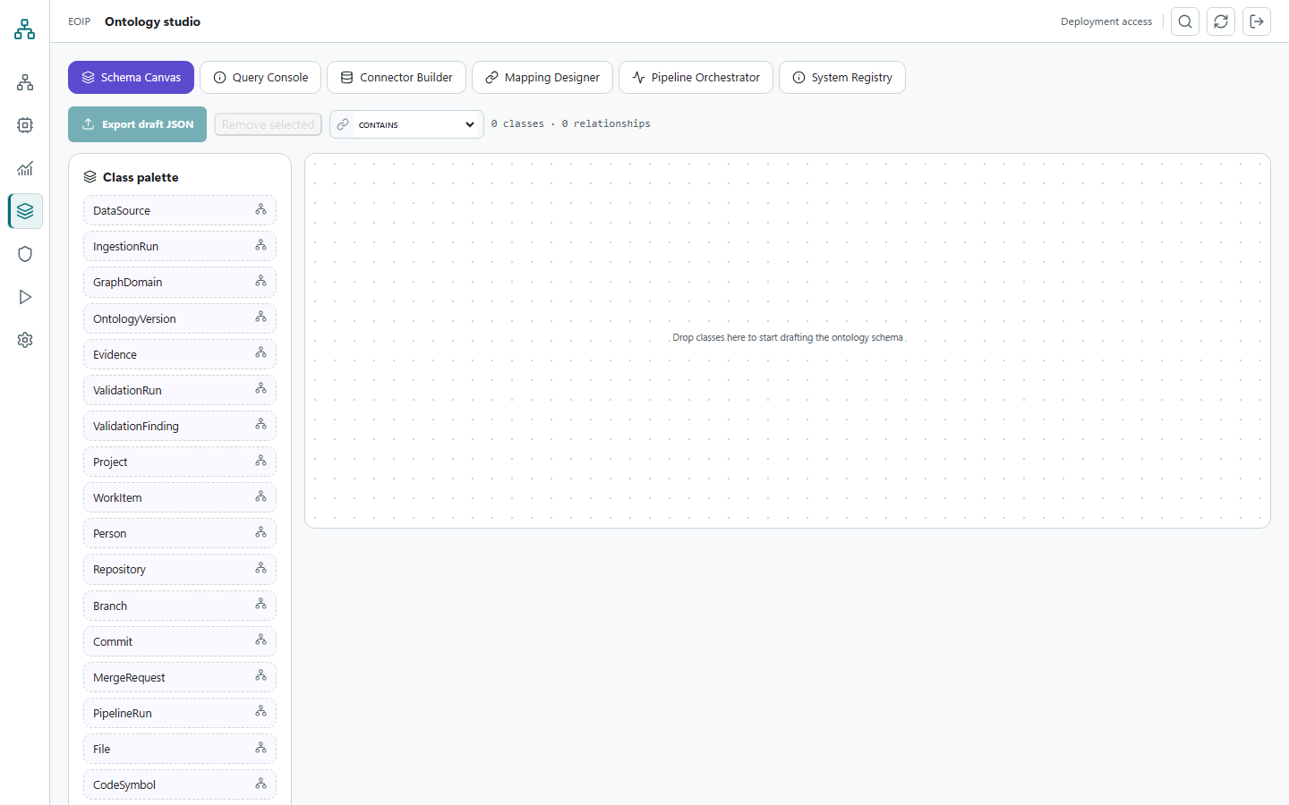
Observed screenshot: local primary web UI, not a production acceptance result

Open the studio
Choose Ontology studio from the workspace navigation. Its schema and query tools communicate with the configured API. A development memory graph may be empty; load only an approved demo or source dataset for meaningful results.
1. Connect to a ready API with an authorized token.
2. Open Ontology studio and inspect available schema or sample content.
3. Confirm the backend and ontology version before writing a query.

Run a controlled query
Start with a small known-answer question against an entity you are allowed to view. Use the studio's supported query form and limits; do not paste secrets or an unrestricted data export into a query. Check the returned count, warnings, provenance and any truncation. Compare one result with Knowledge explorer before relying on it.
1. Choose the supported query mode for the active backend.
2. Use an exact identifier or narrow filter and a bounded limit.
3. Execute, inspect errors and compare results with a known entity.
4. Refine one condition at a time and retain the final query for review.

Understand ontology versions
The administration view can load graph schema and inspect a JSON-LD context. Schema visibility does not grant permission to change ontology. Treat a version change as a migration with compatibility and validation checks.
1. Ask an administrator which schema version is active.
2. Review permitted labels and relationships before mapping data.
3. Run validation after approved ingestion or ontology changes.

When a query is unsupported
A dialect shown in requirements or code is not automatically qualified for the active graph backend. Preserve the query text, backend name, error and correlation ID, then use the deployment's supported query path. Do not silently rewrite an authorization failure as an empty result.

Dashboards and project status
Use the application dashboards and the separate offline audit tracker without confusing their purposes.
Availability: Conditional app dashboards; offline audit snapshot available

Cognitive dashboards
Choose Cognitive Dashboards in the signed-in workspace. Panels use the active API and data profile. Read panel titles, time range, source and warnings before drawing conclusions. If a panel is empty, check whether the dataset, permission and backing service exist; do not fill gaps with made-up figures.
1. Open the dashboard after connecting to a healthy API.
2. Inspect the source and scope of each visible measure.
3. Refresh after a known data change and compare with source counts.
4. Preserve a filtered view or export only through an authorized workflow.

