EOIP Documentation and Product Status
KnowGridFlow / EOIP | 20 October 2026
This manual explains the current repository's primary web application. Authenticated journeys depend on the deployed API, graph backend, worker, policy and the reader's role. The screenshots show observed local states; they do not certify the entire workflow.

Dashboards and project status
Use the application dashboards and the separate offline audit tracker without confusing their purposes.
Availability: Conditional app dashboards; offline audit snapshot available
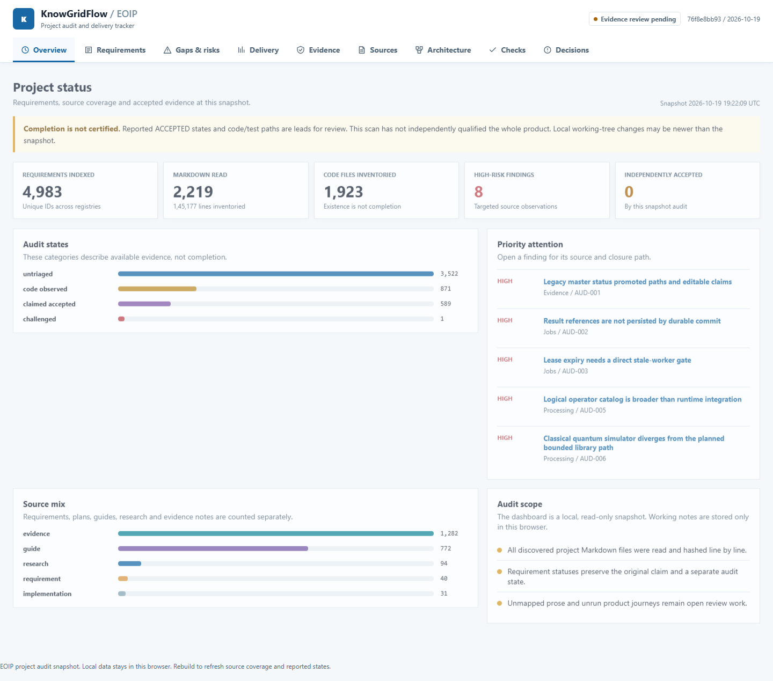
Observed screenshot: offline project audit snapshot

Offline project audit dashboard
EOIP-master-dashboard.html at the repository root is a separate project-delivery tracker, not the application analytics portal. Open it directly in a browser. Tabs cover overview, requirements, gaps, delivery, evidence, sources, architecture, checks and decisions. The file contains a point-in-time snapshot; rebuild with python scripts/build_unified_audit.py after source changes.
1. Open the root dashboard HTML without a server.
2. Search a requirement ID and inspect both its reported state and audit state.
3. Use Gaps and Evidence to see closure actions and evidence limits.
4. Export filtered CSV or local decision notes; these exports do not change acceptance.

Interpret status honestly
The current structural audit indexed thousands of requirement IDs but independently certified none in a full runtime release gate. 'Code observed' means a referenced path exists, not that the user journey works. 'Claimed accepted' preserves a historical ledger statement, not an independently verified production outcome.

