EOIP Quick Start
KnowGridFlow / EOIP | 20 October 2026
This manual explains the current repository's primary web application. Authenticated journeys depend on the deployed API, graph backend, worker, policy and the reader's role. The screenshots show observed local states; they do not certify the entire workflow.

Connect and first session
Start a local profile, check readiness, connect with a token and find the workspace.
Availability: Available screen; backend required for sign in
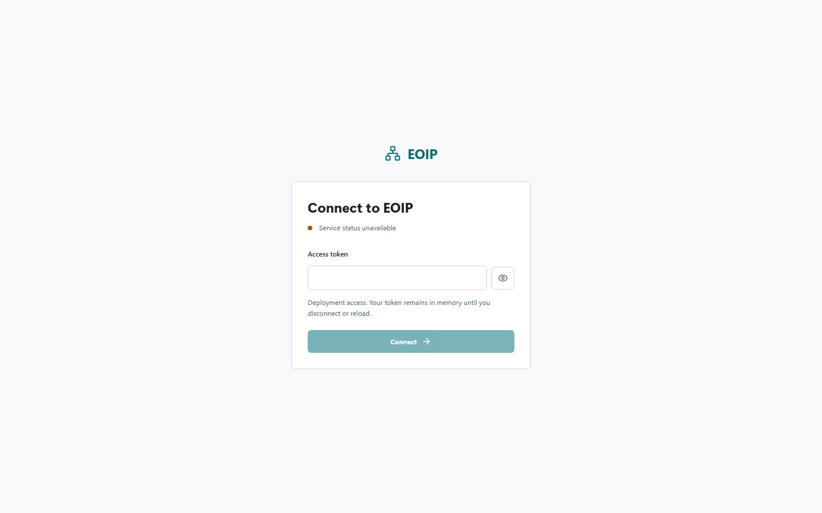
Observed screenshot: local primary web UI, not a production acceptance result

Before you begin
Use Python 3.11 or later and Node.js 22 for host development. The integrated profile requires a supported OCI container runtime with Compose. Obtain the token from the deployment owner; do not put it in chat, screenshots, source files or support tickets.

Option A - integrated containers
From the repository root in PowerShell, run .\scripts\container.ps1 detect, then .\scripts\container.ps1 up. On Linux or macOS use ./scripts/container.sh detect and ./scripts/container.sh up. The helper creates a private deploy/.env on first use, with generated EOIP_API_TOKEN and HUGEGRAPH_PASSWORD. Wait for health, then open http://localhost:8080/app. The API documentation is at http://localhost:8000/docs.
1. Run the detect command and resolve any missing runtime before starting.
2. Run up and wait for service health instead of assuming an open port means ready.
3. Read EOIP_API_TOKEN from deploy/.env locally without exposing it in a command transcript.
4. Open the web explorer, enter the token, and choose Connect.

Option B - host-only development
Create a virtual environment and install the development extra with python -m pip install -e ".[dev]". Set EOIP_API_TOKEN to a disposable local value of at least 24 characters, EOIP_GRAPH_BACKEND=memory, and EOIP_DATA_DIR to a private local directory. Start python -m uvicorn apps.api.main:create_app --factory --host 127.0.0.1 --port 8000 --reload. In a second shell, run npm --prefix apps/web ci, set EOIP_DEV_API_URL=http://127.0.0.1:8000, then run npm --prefix apps/web run dev. Use the Vite URL shown by the terminal.
1. Keep the API and Vite shells running while you use the web UI.
2. Check http://127.0.0.1:8000/health/ready before connecting.
3. Do not start a separate memory-backed worker and expect it to share graph state with the API.

Connect to EOIP
The connection page displays local service readiness and an Access token field. The show/hide control changes only field visibility. The token is held in browser memory until disconnect or reload. Connect calls administrative summary endpoints, so a token can still be denied by policy even when /health/ready reports ready.
1. Confirm the local service indicator says ready. If unavailable, inspect the API/proxy before entering the token.
2. Enter the deployment token and select Connect.
3. Wait for the workspace shell. If an error toast appears, record its correlation ID but never the token.
4. Use Disconnect when finished; reload also clears the in-memory token.

Find your way
The workspace navigation contains Knowledge explorer, Cognitive Engineering, Cognitive Dashboards, Ontology studio, Administration, Guided demo and Appearance. Roles and backend configuration can restrict actions. A visible menu item is not proof that its backing service is configured.

