









UNIVERSITY OF MAKATI
J.P. Rizal Extension, West Rembo Makati City

COLLEGE OF COMPUTING AND INFORMATION SCIENCES

Date

Prof. [RECIPIENT'S NAME]
[Recipient's Position]
[Department Name]

Prof. [RECIPIENT'S NAME]
[Recipient's Position]
[Department Name]

Dear Sir:

Good day!

[Your Names], bona fide fourth-year [Course] students, are writing to formally request your approval to change the title of their thesis from "[Current Thesis Title]" to "[New Title]".
The primary reasons for this proposed change are:
- [Reason 1]
- [Reason 2]
- [Reason 3]
A brief summary detailing the changes in the scope and focus of the thesis, which justify this title change, is attached. The proponents believe that the new title will enhance the clarity and impact of the thesis. We respectfully seek your approval for this modification and are available to discuss this further or provide any additional information if needed.
We are hoping for your favorable action on this matter. Thank you for your time and attention.

Very truly yours,

Student 1
Student 2
Student 3
Student 4

Approved By:

Prof. <Name>
Panel Chair

Prof. <Name>
Panel 2

Prof. <Name>
Panel 3

Noted by:

Prof. <Name>
Technical Adviser

Prof. Mary Ellaine R. Cervantes, MTE, MIS
Course Adviser

Prof. Ali A. Naim, MIS
Program Director, CS & IS and Allied Programs
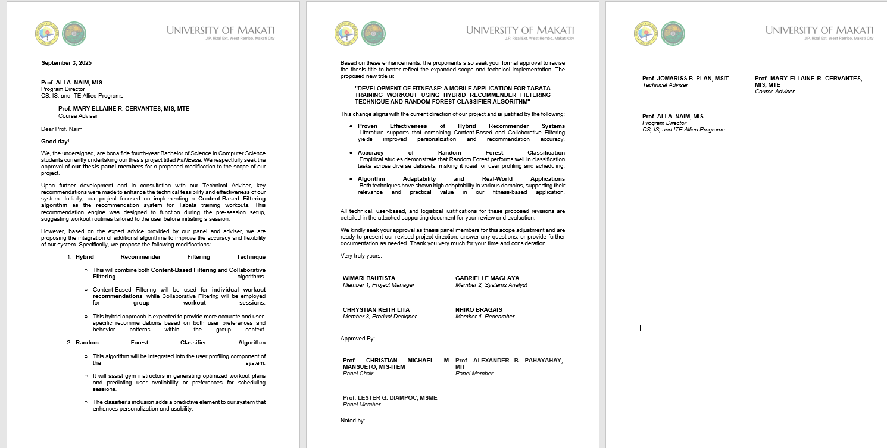
Sample only

