VibeOps Defense Compliance Report
――――――――――――――――――――――――――――――
Prepared for: FDSDFFS
Date:
Project Context: SDFSDFSDF
Executive Summary
The compliance assessment of project SDFSDFSDF for FDSDFFS reveals a strong commitment to meeting regulatory requirements. However, there are areas that require attention to ensure full compliance and mitigate potential risks.
Compliance Summary
Overall, the project is on track with compliance efforts, but there is room for improvement in certain areas to ensure long-term adherence to industry regulations.
Risk Assessment
The project faces moderate risks related to data security and access controls. Addressing these risks promptly will help in maintaining compliance and avoiding potential regulatory penalties.
Recommendations
Implement regular compliance training for all team members.
Strengthen access control measures to protect sensitive data.
Conduct periodic internal audits to monitor compliance status.
Enhance incident response procedures to address compliance breaches effectively.
Compliance Objectives
Ensure adherence to DoD and federal regulations.
Maintain audit-ready documentation for all compliance areas.
Implement robust cybersecurity measures.
Overview Table
Compliance Area | Status | Audit Date | Notes
Data Security | Compliant | 2022-03-15 | Data encryption protocols in place.
Access Control | Non-Compliant | 2022-03-15 | Insufficient user access restrictions identified.
Incident Response | Partially Compliant | 2022-03-15 | Response procedures need enhancement for regulatory reporting.

Company Branding
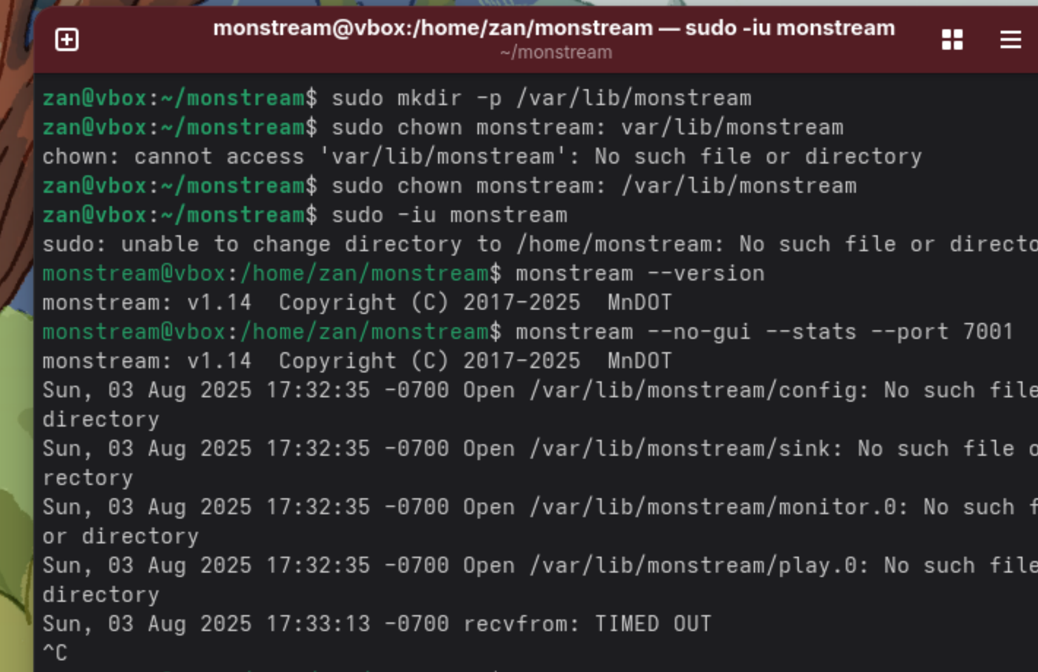
For more, visit VibeOps.ca - VibeOps.ca -

Appendix: Supporting Data
Detailed cost breakdowns, risk assessments, and technical specifications are available upon request.

