
INTERNSHIP PROJECT REPORT

Submitted in Partial Fulfilment of the Requirements for the
Industrial Internship Programme in Artificial Intelligence
PREDICTIVE CUSTOMER CHURN MODELLING FOR A TELECOMMUNICATIONS PROVIDER
An End-to-End Machine Learning Solution for Proactive Customer Retention

Project Title | : Predictive Customer Churn Model for a Telecom Company (Case Study: ConnectTel)
Internship Title | : Artificial Intelligence
Submitted By | : Aaditiya Anjan
Enrollment No. | : 24BCS13112
Branch | : BE-CSE (Computer Science and Engineering)
Semester | : 5th Semester
University | : Chandigarh University
Department | : Department of Computer Science and Engineering
Organization | : Persevex
Internship Duration | : 2 Months

Academic Year 2026–27

CERTIFICATE

This is to certify that the project report entitled “Predictive Customer Churn Modelling for a Telecommunications Provider — An End-to-End Machine Learning Solution for Proactive Customer Retention” is a bona fide record of the internship work carried out by Aaditiya Anjan (Enrollment No. 24BCS13112) under my supervision, in partial fulfilment of the requirements for the Industrial Internship Programme in Artificial Intelligence, during the 2-month internship period.

The work presented in this report is original and has been completed satisfactorily. To the best of my knowledge, the contents of this report have not been submitted, in whole or in part, to any other university or institute for the award of any degree, diploma, or certificate.

Shanmukh Shekar K C
Administrator / Internship Coordinator
Persevex

DECLARATION

I, Aaditiya Anjan (Enrollment No. 24BCS13112), hereby declare that the internship project report titled “Predictive Customer Churn Modelling for a Telecommunications Provider” represents my own work carried out during my internship at Persevex, and that it has been written in my own words.

I further declare that:

- The work presented in this report is the result of my own analysis, experimentation, and study, except where explicit reference and acknowledgement is made to the work of others.
- All datasets, libraries, and external resources used have been duly cited.
- The dataset used (Telco Customer Churn, WA_Fn-UseC_-Telco-Customer-Churn.csv) is a publicly available, anonymised dataset, and no confidential or proprietary customer information was accessed.
- This report has not been submitted previously, in whole or in part, for any degree, diploma, or other qualification at this or any other institution.
- All quantitative results reported herein were reproduced by executing the accompanying notebook on the actual dataset; no figures have been fabricated.

The implementation, experimentation, feature engineering, visualization design, model evaluation, model interpretation, and report preparation presented in this report were carried out by me during the internship period.

Signature:

Name: Aaditiya Anjan
Enrollment No.: 24BCS13112
Branch: BE-CSE, Semester 5
University: Chandigarh University
Date: June 2026

ACKNOWLEDGEMENT

The successful completion of this internship project would not have been possible without the guidance, encouragement, and support of several individuals and institutions, to whom I owe my sincere gratitude.

First and foremost, I express my heartfelt thanks to my industry mentor at Persevex, for entrusting me with a problem of genuine commercial significance and for providing continuous technical direction throughout the engagement. The mentor’s insistence on grounding every modelling decision in business value shaped the entire orientation of this work.

I am deeply grateful to my faculty supervisor, whose academic rigour and constructive feedback helped me bridge the gap between classroom theory and real-world data science practice.

I extend my appreciation to the Head of the Department and the Internship Coordination Cell at Chandigarh University for facilitating this opportunity and for the administrative support extended throughout the programme.

I also acknowledge the open-data community for making the Telco Customer Churn dataset publicly available, and the maintainers of the open-source scientific Python ecosystem — pandas, NumPy, scikit-learn, XGBoost, Matplotlib, Seaborn, SciPy, and SHAP — whose tools form the technical backbone of this project.

Finally, I thank my family and peers for their patience, encouragement, and unwavering support throughout the course of this internship.

Aaditiya Anjan
24BCS13112 | BE-CSE, Semester 5
Chandigarh University

ABSTRACT

Customer churn — the loss of subscribers to competing service providers — represents one of the most persistent and financially damaging challenges in the telecommunications industry. Because acquiring a new customer typically costs five to seven times more than retaining an existing one, even a modest reduction in the churn rate translates into a substantial improvement in revenue and profitability. This report documents the design, implementation, and evaluation of an end-to-end machine learning system that predicts, in advance, whether an individual customer is likely to discontinue service, thereby enabling a retention team to intervene proactively with targeted offers.

The work is framed around a realistic business case study of a fictitious telecom operator, ConnectTel, and uses the publicly available Telco Customer Churn dataset (WA_Fn-UseC_-Telco-Customer-Churn.csv) comprising 7,043 customers described by demographic, account, service-usage, and billing attributes. The target variable, Churn, is binary and imbalanced, with approximately 26.5% of customers having churned. The project follows a disciplined, reproducible analytics pipeline: rigorous data inspection and cleaning (including the correct handling of eleven blank TotalCharges records belonging to tenure-zero customers and the removal of the non-predictive customer-identifier column); comprehensive exploratory data analysis, including tenure-bucket and monthly-charge-category segmentation; formal statistical hypothesis testing (chi-square and Welch’s t-tests at α = 0.05) to validate observed relationships; the engineering of ten domain-informed features including ContractRiskScore, ServiceCount, AutoPaymentFlag, LoyaltyScore, and PremiumCustomerFlag; one-hot encoding (yielding a 7,043 × 48 model-ready matrix); leakage-free standardisation; and a stratified 80/20 train-test split.

Four complementary classifiers were trained and benchmarked under identical evaluation conditions: a class-balanced Logistic Regression (an interpretable linear baseline), a Random Forest, an XGBoost gradient-boosting model, and a Support Vector Classifier (SVC) with an RBF kernel — the XGBoost model was further refined through a 144-candidate GridSearchCV hyperparameter search (432 model fits under 3-fold cross-validation). Because the cost of failing to identify a true churner far exceeds the cost of a wasted retention offer, the models were assessed primarily on Recall, F1-score, and ROC-AUC rather than raw accuracy. The tuned XGBoost model emerged as the champion, achieving a test-set ROC-AUC of 0.847, a Recall of 0.805, and an F1-score of 0.630, while maintaining a stable cross-validated ROC-AUC of 0.848. Model behaviour was made transparent through Logistic Regression odds ratios, Random Forest feature importances, and SHAP explainability, all of which converged on a consistent and business-credible set of churn drivers: short tenure, month-to-month contracts, fiber-optic internet, low loyalty score, and high monthly charges. A retention-campaign financial simulation further translated these predictions into an estimated net annual saving for ConnectTel.

The analysis is translated into six concrete, prioritised retention strategies — contract migration, early-tenure onboarding, fiber-value reassurance, automatic-payment incentives, service bundling, and risk-targeted retention spending. The report concludes with a discussion of real-world deployment, scalability through batch and real-time scoring APIs, and a roadmap of future enhancements spanning deep learning, probability calibration, MLOps, and continuous model monitoring. The principal contribution of this work is the demonstration of a complete, defensible, and explainable churn-prediction workflow that is simultaneously suitable for academic evaluation and ready for industrial adoption.

Keywords: Customer Churn Prediction, Telecommunications, Machine Learning, Logistic Regression, Random Forest, XGBoost, Support Vector Machine, Class Imbalance, SHAP Explainability, Feature Engineering, Customer Retention.

PERSONAL CONTRIBUTIONS

The following section outlines the specific technical and analytical contributions made by me, Aaditiya Anjan, during the internship engagement at Persevex. All tasks were performed independently as part of the end-to-end machine learning project on telecommunications customer churn prediction.

Data Cleaning and Preprocessing
I performed a thorough data quality audit of the Telco Customer Churn dataset, identifying and resolving all data integrity issues. This included coercing the TotalCharges column from string to numeric type, correctly imputing eleven tenure-zero blank records with the value zero (reflecting their true billing state), removing the non-predictive customerID identifier column, and verifying the complete absence of other missing values or duplicate records.

Exploratory Data Analysis (EDA)
I designed and executed a comprehensive EDA covering target distribution analysis, segment-level churn-rate computation, bivariate analysis of all categorical predictors against the churn outcome, kernel-density-estimated distributions for numeric features, and a correlation heatmap. Each visualisation was accompanied by a quantitative interpretation and a business-context reading.

Statistical Hypothesis Testing
I formulated and formally tested six churn-related hypotheses at α = 0.05 using chi-square tests of independence for categorical variables and Welch’s independent-samples t-tests for numeric comparisons. This step elevated the project beyond visual assertion and provided statistically grounded evidence for the retention strategies proposed in Chapter 10.

Feature Engineering
I designed and implemented ten domain-informed features that encode latent churn signals not directly represented in the raw dataset. These features — TotalChargesPerTenure, ServiceCount, AverageMonthlySpend, LongTermCustomer, PremiumServiceFlag, AutoPaymentFlag, BundleScore, ContractRiskScore, LoyaltyScore, and PremiumCustomerFlag — were each grounded in EDA and hypothesis-testing insights. In particular, LoyaltyScore (tenure weighted by contract stability) emerged as the single most important predictor in the Random Forest feature-importance ranking and a leading churn-increasing factor by odds ratio, confirming that the engineering effort added genuine, model-usable signal.

Model Development
I developed four complementary machine learning classifiers — Logistic Regression, Random Forest, XGBoost, and a Support Vector Classifier (SVC) with an RBF kernel — under a shared, leakage-free preprocessing regime. A unified evaluation helper ensured strict comparability across all models. Each model was configured with appropriate class-imbalance handling (class_weight=‘balanced’ and scale_pos_weight), and all training was conducted exclusively on the training partition.

Hyperparameter Tuning
I designed and executed a GridSearchCV hyperparameter search over six parameters of the XGBoost model, evaluating 144 candidate configurations across 3-fold stratified cross-validation (432 total model fits). The search identified an optimal regularised configuration (max_depth = 3, learning_rate = 0.03, n_estimators = 300, min_child_weight = 3, subsample = 0.8, colsample_bytree = 0.8) that improved recall and ROC-AUC over the initial configuration.

Model Evaluation
I evaluated all models on a held-out test set of 1,409 customers, computing Accuracy, Precision, Recall, F1-score, and ROC-AUC. I generated and interpreted ROC curves and a detailed confusion matrix for the champion model, providing a business-level reading of every cell (TP, TN, FP, FN) in terms of retention cost and revenue impact. Cross-validated stability metrics (5-fold stratified ROC-AUC) were also reported.

SHAP Explainability Analysis
I applied SHAP (SHapley Additive exPlanations) via a TreeExplainer on 800 representative test customers to produce a beeswarm summary plot, a global mean-|SHAP| importance bar chart, and a tenure dependence plot. I interpreted these outputs in the context of the earlier EDA and hypothesis tests, demonstrating that the model’s drivers are causally plausible and consistent across all three interpretability lenses.

Business Recommendation Generation
I translated all analytical findings into six prioritised, actionable retention strategies, each tied to a specific driver identified through the EDA, hypothesis tests, and SHAP analysis. I further proposed a deployment roadmap covering batch scoring, real-time API serving, monitoring, and model maintenance — demonstrating a holistic understanding of the full machine learning lifecycle beyond model training.

Retention Campaign Financial Simulation
I designed and executed a financial simulation that translates the champion model’s churn-probability scores into an estimated business outcome. Customers in the test set were ranked by predicted churn probability, the top 20% (281 customers) were selected as the retention-campaign target group, and a realistic save rate and outreach cost were applied to compute the gross revenue saved and the net financial benefit of the campaign — demonstrating the ability to connect model output directly to a quantifiable return on investment.

Report Preparation and Documentation
I authored the complete internship report, including all chapter introductions and conclusions, figure and table captions, statistical interpretations, and business discussions. The report was structured to meet academic submission standards while remaining accessible to non-technical stakeholders in a business context.

INTERNSHIP LEARNING OUTCOMES

This internship provided a rich, practical learning experience that substantially extended my technical and professional competencies. The following outcomes reflect the skills and insights I developed through direct, hands-on engagement with a real-world machine learning problem over the course of two months.

Machine Learning Workflow
I gained a thorough, end-to-end understanding of the applied machine learning lifecycle: from raw data ingestion and quality auditing, through analysis and modelling, to evaluation, explainability, and business translation. I learned to organise a reproducible analytical pipeline in which every stage produces a validated output consumed by the next, with a fixed random seed ensuring deterministic results.

Data Preprocessing
I developed practical skills in diagnosing and resolving real data-quality issues — type mismatches, missing values, and redundant identifier columns — and in making principled, documentable decisions at each step. I particularly learned the importance of removing non-predictive identifier columns (such as customerID) before modelling, and of fitting all data-dependent transformations exclusively on the training partition to avoid leakage.

Feature Engineering
I learned to translate domain knowledge and EDA-derived hypotheses into model-readable features that encode churn signals beyond those present in the raw data. I understood how feature engineering can simultaneously improve model performance, reduce collinearity, and increase interpretability — and how its impact can be validated empirically through feature importance rankings.

Model Evaluation Under Class Imbalance
I learned that raw accuracy is a misleading metric on imbalanced datasets, and that Recall, F1-score, and ROC-AUC are the appropriate primary metrics for an asymmetric-cost problem such as churn. I understood how to select metrics that align with the actual business cost structure, and how to communicate these choices clearly to a non-technical audience.

Explainable AI (XAI)
I developed hands-on experience with SHAP (SHapley Additive exPlanations) and with model-native interpretability tools (Logistic Regression odds ratios, Random Forest Gini importances). I learned to use multiple, independent interpretability lenses and to assess the credibility of a model by the degree to which its learned drivers converge across these methods and align with domain knowledge.

Business Analytics and Communication
I learned to translate quantitative model outputs — coefficients, importances, SHAP values, confusion-matrix cells — into commercially meaningful insights and actionable recommendations. I understood the importance of framing every analytical finding in terms of a business question and a business impact, rather than merely reporting metrics.

Customer Churn Prediction Domain
I gained substantive knowledge of the telecommunications industry churn problem: its economic drivers (acquisition-to-retention cost ratio), its key predictors (contract type, tenure, payment method, service bundling), the class-imbalance and leakage challenges specific to churn datasets, and the standard intervention strategies used by retention teams.

Real-World Deployment Understanding
I developed an appreciation for the gap between a notebook model and a production system. I learned about batch and real-time scoring architectures, train-serve consistency (reusing the fitted scaler at inference), model serialisation, data-drift and concept-drift monitoring, and the MLOps practices required to maintain model performance over time. This deployment perspective shaped every design decision in the project, from leakage elimination to the choice of a model configuration that generalises robustly.

TABLE OF CONTENTS

Section | Title | Page
 | Certificate | ii
 | Declaration | iii
 | Acknowledgement | iv
 | Abstract | v
 | Personal Contributions | vi
 | Internship Learning Outcomes | vii
 | List of Figures | viii
 | List of Tables | ix
 | List of Abbreviations | x
1 | Introduction | 1
1.1 | Background | 1
1.2 | Industry Problem | 2
1.3 | Motivation | 3
1.4 | Problem Statement | 4
1.5 | Objectives | 4
1.6 | Scope | 5
1.7 | Challenges | 6
1.8 | Expected Outcomes | 7
2 | Literature Review | 8
3 | Project Overview | 15
4 | Dataset Description | 20
5 | Exploratory Data Analysis | 26
6 | Data Preprocessing | 34
7 | Model Development | 40
8 | Model Evaluation | 48
9 | Results and Discussion | 54
10 | Real-World Applications | 59
11 | Conclusion | 63
12 | Future Scope | 65
 | References | 68
 | Appendix | 70

LIST OF FIGURES

Figure | Caption | Page
3.1 | End-to-end project workflow | 17
3.2 | Machine learning pipeline architecture | 18
4.1 | Conceptual feature taxonomy | 22
5.1 | Target (churn) distribution | 27
5.2 | Churn rate by demographic attributes | 28
5.3 | Churn rate by account/service drivers | 29
5.4 | Churn rate by tenure bucket | 30
5.5 | Churn rate by monthly charges category | 31
5.6 | Churn rate by service count | 32
5.7 | Churn rate by contract×internet interaction | 33
5.8 | Numeric feature distributions by churn | 35
5.9 | Correlation heatmap of numeric features | 36
7.1 | Logistic Regression odds-ratio chart | 43
7.2 | Random Forest top-15 feature importances | 45
7.3 | Cross-model feature importance comparison | 46
8.1 | ROC curves — model comparison (4 models) | 50
8.2 | Confusion matrix — champion model | 51
8.3 | SHAP summary (beeswarm + bar) plots | 52
8.4 | SHAP dependence plot — tenure | 53

LIST OF TABLES

Table | Caption | Page
2.1 | Comparison of churn-prediction approaches | 11
4.1 | Raw dataset schema and feature dictionary | 21
4.2 | Statistical summary of numeric features | 24
4.3 | Class distribution of the target variable | 25
5.1 | Churn rate by key categorical drivers | 29
6.1 | Engineered features and their rationale | 37
7.1 | Model configurations and hyperparameters | 47
8.1 | Consolidated model performance comparison | 49
8.2 | Cross-validated ROC-AUC stability | 50
8.3 | Confusion-matrix breakdown (champion) | 51
9.1 | Retention campaign financial simulation | 58

LIST OF ABBREVIATIONS

Abbreviation | Expansion
AUC | Area Under the (ROC) Curve
CV | Cross-Validation
EDA | Exploratory Data Analysis
FN / FP / TN / TP | False Negative / False Positive / True Negative / True Positive
KDE | Kernel Density Estimate
ML | Machine Learning
MLOps | Machine Learning Operations
ROC | Receiver Operating Characteristic
SHAP | SHapley Additive exPlanations
SMOTE | Synthetic Minority Over-sampling Technique
XGBoost | Extreme Gradient Boosting

CHAPTER 1 — INTRODUCTION

1.1 Background
The telecommunications sector operates in one of the most fiercely competitive and saturated markets in the modern economy. In most developed and developing regions alike, mobile and broadband penetration has approached or exceeded the size of the addressable population, which means that the era of growth driven primarily by acquiring new subscribers has largely ended. Operators now compete for a fixed pool of customers, and the principal battleground has shifted from acquisition to retention. In this environment, the rate at which a company loses customers to its rivals — known as the churn rate — has become a decisive determinant of long-term profitability and shareholder value.
Churn is economically corrosive for a structural reason that every telecom executive understands intuitively: the cost of winning a new customer is several multiples of the cost of keeping an existing one. Industry analyses consistently place the ratio in the range of five to seven times, once the full cost of advertising, sales commissions, device subsidies, onboarding, and promotional discounting is accounted for. An existing customer, by contrast, is already generating recurring revenue at a known margin and requires comparatively little marginal spend to retain. Consequently, a reduction of even a few percentage points in the churn rate can produce a disproportionately large improvement in the bottom line — an effect amplified by the compounding nature of recurring subscription revenue over a customer’s lifetime.
Historically, telecom operators reacted to churn rather than anticipating it. A customer would call to cancel, and only at that point — when the decision had already crystallised — would a retention agent attempt a last-minute save. This reactive posture is fundamentally inefficient: the intervention arrives too late, the customer is already psychologically committed to leaving, and the offers extended in desperation are often more generous than would have been necessary earlier. The advent of large-scale data collection and modern machine learning has made a far superior posture possible — proactive, predictive retention — in which the operator identifies which customers are at risk before they decide to leave, and intervenes while the relationship can still be repaired at reasonable cost.
This project is situated squarely within that predictive paradigm. It develops a complete, reproducible machine learning system that consumes the demographic, account, service, and billing attributes routinely captured by a telecom’s operational systems and outputs, for each customer, a calibrated estimate of churn risk.

1.2 Industry Problem
To make the problem concrete and to discipline every modelling decision against tangible business value, the project is framed around a realistic case study of a fictitious but representative operator, ConnectTel. ConnectTel is described as a major telecommunications provider that is losing significant quarterly revenue because customers are cancelling their subscriptions to switch to competitors. The company’s leadership has recognised that its existing reactive retention process is failing, and it has commissioned a data science engagement to answer a single, sharply defined question:
“Can we predict, in advance and with useful accuracy, which of our customers are likely to churn, so that our retention team can intervene with targeted offers — discounts, plan upgrades, service bundles — before those customers actually leave?”
This question, although simple to state, encapsulates several non-trivial technical and commercial sub-problems. First, churn is a relatively rare event: only about a quarter of the customer base churns in the observation window, which creates a class-imbalance problem that naïve models handle poorly. Second, the cost of errors is asymmetric: failing to flag a customer who then leaves is far more expensive than flagging a loyal customer who would have stayed anyway. Third, the business does not merely want a black-box prediction — it wants to understand why customers churn, so that retention strategy can be designed at the level of root causes. The solution must therefore be not only accurate but also interpretable.

1.3 Motivation
The motivation for undertaking this project is threefold, spanning commercial, technical, and personal-developmental dimensions.
From a commercial standpoint, churn prediction is one of the highest-return applications of machine learning in any subscription business. Unlike many speculative AI initiatives, the value chain here is short and direct: a better prediction enables a better-targeted intervention, which directly preserves recurring revenue. The return on investment is measurable and attributable, which is precisely why churn modelling has become a standard, board-level analytics priority in telecom, banking, insurance, SaaS, and media-streaming industries.
From a technical standpoint, the churn problem is an unusually rich learning vehicle because it exercises the entire breadth of the applied machine learning lifecycle. A single project legitimately requires data cleaning, exploratory analysis, formal statistical inference, feature engineering grounded in domain knowledge, categorical encoding, leakage-aware preprocessing, the handling of class imbalance, the comparison of linear and non-linear models, cross-validation, hyperparameter optimisation, threshold-aware evaluation, and model explainability.
From a personal and professional-development standpoint, this internship project provided an opportunity to demonstrate not only the ability to fit a model, but the far more valuable ability to reason about a model in a business context — choosing the right metric for an asymmetric-cost problem, validating intuitions with formal statistics, and translating coefficients and feature importances into recommendations that a non-technical retention manager can act upon.

1.4 Problem Statement
Given a set of demographic, account, service-usage, and billing attributes describing a telecommunications customer, build, evaluate, and explain a binary classification model that predicts whether that customer will churn (cancel service), optimising for the early and reliable identification of true churners under conditions of class imbalance and asymmetric misclassification cost, and translating the model’s findings into actionable, prioritised retention strategies.

1.5 Objectives
The project pursues the following specific, measurable objectives:
- Data integrity: To inspect, clean, and validate the Telco Customer Churn dataset, correctly handling missing values and removing the non-predictive customer-identifier column so that the model is trained only on information genuinely available before a churn decision.
- Insight generation: To conduct comprehensive exploratory data analysis and to corroborate the resulting hypotheses with formal statistical tests (chi-square and Welch’s t-tests) at a 5% significance level.
- Feature engineering: To construct ten domain-informed features that encode latent churn signals (contract risk, service bundling, normalised spend, loyalty, payment behaviour) not directly expressed by the raw columns.
- Model development: To train four complementary classifiers — Logistic Regression, Random Forest, XGBoost, and a Support Vector Classifier — under a single, leakage-free preprocessing regime, and to tune the leading model via grid search.
- Rigorous evaluation: To benchmark all models on a consistent suite of metrics appropriate to an imbalanced, asymmetric-cost problem (Recall, F1, ROC-AUC), validated through stratified cross-validation.
- Explainability: To open the “black box” using Logistic Regression odds ratios, Random Forest feature importances, and SHAP values, ensuring that every prediction can be attributed to interpretable drivers.
- Business translation: To convert the analytical findings into a prioritised set of retention recommendations and a credible deployment roadmap.

1.6 Scope
In scope: The project encompasses the complete offline machine learning lifecycle on a single, static, historical dataset: data engineering, analysis, modelling, evaluation, explainability, and the formulation of business recommendations. It delivers a fully reproducible notebook that runs top-to-bottom and a champion model artefact suitable for batch scoring.
Out of scope: The project deliberately does not include the production engineering of a live serving system, real-time streaming ingestion, A/B-test execution against live customers, or the financial reconciliation of realised retention ROI. These are identified as future work in Chapter 12. The dataset is a fixed, anonymised, publicly available snapshot; no live customer data, personally identifiable information, or proprietary systems were accessed.

1.7 Challenges
Several substantive challenges were anticipated and addressed during the engagement:
- Class imbalance: With churners constituting only approximately 26.5% of the data, a model can achieve approximately 73% accuracy by predicting “no churn” for everyone — a useless result. This was mitigated through class-weighting, stratified splitting, and metric selection that prioritises recall and ROC-AUC.
- Identifier and redundancy handling: The raw dataset contains a customerID column that is a unique identifier with no predictive value and a high risk of being mistakenly one-hot-encoded into thousands of spurious dummy variables if not removed. Explicitly dropping it before encoding was a simple but essential step to keep the feature space compact and meaningful.
- Mixed and malformed types: The TotalCharges field was stored as text owing to eleven blank entries belonging to tenure-zero customers, requiring careful diagnosis and principled imputation.
- The interpretability–performance trade-off: Reconciling the business demand for explainability with the desire for the strongest possible predictive performance motivated the deliberate use of both an interpretable linear model and a high-performance ensemble, complemented by SHAP.

1.8 Expected Outcomes
At the outset, the project was expected to deliver: (i) a clean, documented, reproducible analytical pipeline; (ii) a statistically validated understanding of the principal churn drivers; (iii) at least one model achieving a discriminative ROC-AUC comfortably above 0.80 with high recall on the churn class; (iv) a transparent explanation of model behaviour consistent with the statistical findings; and (v) a concrete set of business recommendations. As documented in Chapters 8 and 9, each of these outcomes was realised — the tuned XGBoost model attained a test-set ROC-AUC of 0.847 and a recall of 0.805 on the churn class, and its SHAP-derived drivers aligned closely with the hypothesis-test results.

CHAPTER 2 — LITERATURE REVIEW

The problem of predicting and preventing customer churn has been studied intensively for more than two decades across telecommunications, banking, insurance, and subscription software and streaming media. This chapter surveys the evolution of approaches — from manual, rule-driven heuristics to modern gradient-boosted ensembles and explainable AI — and positions the methodology adopted in this project within that landscape.

2.1 Traditional (Pre-Analytical) Approaches
Before predictive analytics became widespread, telecom retention was governed almost entirely by business rules and human judgement. Retention teams relied on simple, static heuristics: flag any customer whose monthly bill exceeded a threshold; contact customers who had lodged two or more complaints; offer a standard discount to anyone who called to cancel. These approaches share three fundamental weaknesses. First, they are reactive — they typically trigger only once a customer has already signalled dissatisfaction or initiated cancellation, by which time the intervention is expensive and frequently futile. Second, they are univariate — each rule considers a single attribute in isolation and cannot capture the interactions between attributes. Third, they are uncalibrated — a rule classifies customers into coarse buckets but provides no continuous, rank-ordered estimate of risk, making it impossible to direct a finite retention budget to the highest-value, highest-risk customers first.

2.2 Statistical and Machine Learning Approaches
The first analytical advance was the adoption of Logistic Regression, which remains a workhorse of churn modelling to this day. Logistic Regression models the log-odds of churn as a linear combination of the input features, yielding a continuous probability and — crucially for business adoption — interpretable coefficients that can be exponentiated into odds ratios. Its limitations are equally well understood: it assumes a linear decision boundary in the log-odds space and cannot, without manual feature crossing, capture non-linear effects or interactions.
To overcome these limitations, the field progressively adopted non-linear learners. Decision Trees introduced the ability to model interactions and non-linearities automatically through recursive partitioning, and to produce human-readable decision paths, but single trees are notoriously high-variance and prone to overfitting. k-Nearest Neighbours and Support Vector Machines were also explored in the literature, though both scale poorly to large, high-dimensional, mixed-type tabular data and offer limited interpretability.

2.3 Ensemble and Gradient-Boosting Methods
The decisive performance breakthrough on tabular churn data came from ensemble methods. Random Forests (Breiman, 2001) aggregate many de-correlated decision trees trained on bootstrapped samples and random feature subsets, dramatically reducing variance while retaining the ability to model interactions, and providing a natural measure of feature importance. Gradient Boosting Machines, and in particular the highly optimised XGBoost implementation (Chen & Guestrin, 2016), build trees sequentially so that each new tree corrects the residual errors of its predecessors; combined with regularisation, shrinkage, and column/row subsampling, gradient boosting routinely delivers state-of-the-art accuracy on structured tabular problems. These methods also offer principled mechanisms for handling class imbalance (scale_pos_weight) and, when paired with SHAP (Lundberg & Lee, 2017), can be made as interpretable as a linear model.

2.4 Comparative Analysis of Approaches
The following table summarises the trade-offs across the principal families of churn-prediction techniques:

Approach | Non-linearity | Interpretability | Imbalance Handling | Tabular Accuracy | Project Role
Business rules | No | High (trivial) | Poor | Low | Baseline only
Logistic Regression | Limited | Very high (odds ratios) | Good (class weights) | Moderate | Adopted — baseline
Decision Tree | Yes | High | Moderate | Moderate | Superseded by ensembles
Random Forest | Yes | Moderate (importances) | Good (class weights) | High | Adopted — benchmark
SVM | Yes (kernels) | Low | Moderate | Moderate–High | Adopted — fourth benchmark
XGBoost | Yes | Moderate→High (SHAP) | Very good (SPW) | State-of-the-art | Adopted — champion

2.5 Existing Research
A substantial body of published research establishes the empirical superiority of ensemble and boosting methods on telecom churn data, while consistently emphasising two recurring themes. The first is the dominance of tenure and contract type as churn predictors — a finding so robust that it appears across virtually every study using the Telco Customer Churn dataset and its analogues. The second is the growing recognition that predictive accuracy alone is insufficient for industrial adoption: the literature increasingly stresses the importance of explainability, probability calibration, and cost-sensitive evaluation. The development of SHAP, grounded in cooperative game theory, has been particularly influential, because it provides theoretically sound, locally accurate, and globally consistent attributions that satisfy regulatory and managerial demands for transparency.

2.6 Limitations of Existing Work
Despite this maturity, much published and practitioner work continues to exhibit avoidable shortcomings: (i) the inadvertent inclusion of leakage features (such as churn scores or churn-reason text) that inflate reported performance; (ii) the over-reliance on accuracy as a headline metric despite pronounced class imbalance; (iii) insufficient statistical validation of EDA-derived intuitions; (iv) minimal feature engineering, with many studies feeding raw columns directly to the model; and (v) the omission of explainability, delivering black-box scores that retention teams cannot translate into strategy.

2.7 Why the Proposed Approach is Better
The methodology in this project was deliberately designed to remedy each of the limitations identified above:
- Redundant identifiers are explicitly removed, ensuring honest, deployable performance estimates and a compact feature space.
- The metric suite is appropriate to the problem — Recall, F1, and ROC-AUC are prioritised over accuracy, and class imbalance is addressed through class-weighting and stratified validation.
- EDA is statistically validated — six hypotheses are tested formally with chi-square and Welch’s t-tests rather than asserted from charts alone.
- Domain-informed feature engineering adds eight constructed features that encode contract risk, bundling, normalised spend, and payment behaviour.
- Both interpretable and high-performance models are used in tandem, and the champion is rendered fully transparent through SHAP.
- The output is business-translated into prioritised, actionable retention strategies rather than left as raw scores.

CHAPTER 3 — PROJECT OVERVIEW

3.1 The Business Problem
As introduced in Chapter 1, the project addresses the retention crisis of ConnectTel, a major telecommunications provider losing significant quarterly revenue to churn. Because customer acquisition costs five to seven times more than retention, the business imperative is to shift from a reactive retention model — chasing customers who have already decided to leave — to a proactive one, in which a machine learning model continuously scores the customer base and surfaces high-risk individuals for early, targeted intervention. The project must therefore deliver three things simultaneously: a model that predicts churn accurately, an analysis that explains the drivers of churn, and a set of recommendations that prescribes what the retention team should do.

3.2 The Dataset at a Glance
The project uses the Telco Customer Churn dataset (WA_Fn-UseC_-Telco-Customer-Churn.csv), a widely studied, publicly available benchmark comprising 7,043 customers and 21 raw columns. Each row describes a single customer through four categories of attributes — demographic (gender, senior-citizen status, partner, dependents), account (tenure, contract type, paperless billing, payment method), service-usage (phone, internet, and a suite of add-on services), and billing (monthly and total charges) — together with the binary churn outcome. The dataset is fully described in Chapter 4.

3.3 End-to-End Workflow
The project follows a disciplined, sequential workflow in which each stage consumes the validated output of the previous one. The notebook is engineered to run deterministically from top to bottom, with a fixed random seed (RANDOM_STATE = 42) ensuring complete reproducibility. The high-level workflow is depicted in Figure 3.1.
Figure 3.1 — End-to-end project workflow: Import Libraries → Load Dataset → Standardise Columns → Inspect → Clean → EDA → Hypothesis Testing → Feature Engineering → Encoding → Stratified Split → Scaling → Train 3 Models → Cross-Validation → GridSearch Tuning → Evaluation → SHAP → Business Insights.

3.4 The Machine Learning Pipeline
From a software-architecture perspective, the analytical workflow is organised as a pipeline in which raw data is progressively transformed into a model-ready numeric matrix, fed to multiple estimators, and finally distilled into evaluation artefacts and explanations. A critical design principle, enforced throughout, is that all data-dependent transformations (imputation, scaling) are fitted on the training partition only and then applied to the test partition, eliminating data leakage and guaranteeing that reported performance is an honest estimate of generalisation. Figure 3.2 illustrates the pipeline architecture.
Figure 3.2 — Machine learning pipeline architecture: raw 7,043 × 21 matrix → cleaning → feature engineering → encoding → stratified split (5,634 train / 1,409 test) → scaler fitted on train only → three models (XGBoost tuned by GridSearchCV) → evaluation and explainability artefacts.

CHAPTER 4 — DATASET DESCRIPTION

4.1 Source and Provenance
The dataset employed in this project is the Telco Customer Churn dataset (WA_Fn-UseC_-Telco-Customer-Churn.csv), a publicly available, anonymised benchmark that has become a standard reference for churn-modelling research and education. It contains a one-row-per-customer snapshot of a telecommunications provider’s subscriber base. The file used contains 7,043 customer records described across 21 columns. Because the data is synthetic and anonymised, it carries no privacy or confidentiality restrictions, making it ideal for a reproducible internship deliverable while faithfully reproducing the statistical structure of real telecom churn.

4.2 Raw Schema and Feature Dictionary
The raw file uses the canonical Telco Customer Churn schema with 21 columns, already largely in code-friendly form (e.g., tenure, MonthlyCharges, InternetService). Table 4.1 documents every raw column, its meaning, and its disposition in the project.

Table 4.1 — Raw dataset schema and feature dictionary.
# | Raw Column | Description | Type | Disposition
1 | customerID | Unique customer identifier | Categorical (ID) | Dropped (identifier)
2 | gender | Male / Female | Categorical | Feature
3 | SeniorCitizen | 1 / 0 | Numeric (binary) | Feature
4 | Partner | Has a partner (Yes/No) | Categorical | Feature
5 | Dependents | Has dependents (Yes/No) | Categorical | Feature
6 | tenure | Months as a customer (0–72) | Numeric | Feature
7 | PhoneService | Subscribes to phone service | Categorical | Feature
8 | MultipleLines | Multiple phone lines | Categorical | Feature
9 | InternetService | DSL / Fiber optic / No | Categorical | Feature
10–15 | OnlineSecurity, OnlineBackup, DeviceProtection, TechSupport, StreamingTV, StreamingMovies | Add-on services (Yes/No/No internet service) | Categorical | Features
16 | Contract | Month-to-month / One year / Two year | Categorical | Feature
17 | PaperlessBilling | Yes / No | Categorical | Feature
18 | PaymentMethod | Four payment methods | Categorical | Feature
19 | MonthlyCharges | Current monthly charge ($) | Numeric | Feature
20 | TotalCharges | Lifetime total charge ($) | Numeric (stored as text) | Feature (after coercion)
21 | Churn | Yes / No | Categorical | Target source

4.3 Target Variable
The target of interest is churn, captured in the Churn column as a Yes/No textual label. To guarantee correctness and avoid any dependence on inconsistent string formatting, the project rebuilds the target from scratch as a binary integer ChurnValue, defined as 1 when the (case- and whitespace-normalised) churn label equals “yes” and 0 otherwise.

4.4 Data Types
The raw data comprises a mix of types: SeniorCitizen, tenure, and MonthlyCharges are stored as numeric, while the remaining columns are text/object. A notable anomaly is that TotalCharges, which is conceptually numeric, is loaded as text. Diagnosis revealed the cause: eleven records contain a blank string in this field. These eleven rows correspond exactly to customers with tenure = 0 — brand-new customers who have not yet completed a full billing cycle and therefore have no accumulated total charge. This finding informs a principled imputation strategy described in Chapter 6.

4.5 Missing Values and Duplicates
A systematic data-quality audit produced the following findings, confirmed programmatically:
- Missing values: Apart from the eleven blank TotalCharges entries (which manifest as NaN after numeric coercion), the dataset contains no missing values across any other column.
- Duplicate rows: Zero fully duplicated rows were detected, indicating that each record represents a distinct customer.
This high baseline data quality is characteristic of this widely used benchmark and allowed the cleaning effort to concentrate on the two genuine issues — the TotalCharges type/blank problem and the removal of the non-predictive customerID column.

4.6 Class Distribution
The target variable is imbalanced. Of the 7,043 customers, 1,869 churned and 5,174 were retained, yielding an overall churn rate of 26.54% — a ratio of approximately 1 churner to every 3 retained customers. This imbalance dictates the choice of evaluation metrics (Recall and ROC-AUC over accuracy), the use of class-weighting during training, and the use of stratified sampling in both the train-test split and cross-validation.

Table 4.3 — Class distribution of the target variable.
Class | Label | Count | Proportion
Retained | ChurnValue = 0 | 5,174 | 73.46%
Churned | ChurnValue = 1 | 1,869 | 26.54%
Total |  | 7,043 | 100.00%

4.7 Statistical Summary of Numeric Features
Table 4.2 — Statistical summary of numeric features (full dataset, n = 7,043).
Feature | Unit | Min | Median | Mean | Max | Interpretation
tenure | months | 0 | 29.0 | 32.37 | 72 | Spans new joiners to 6-year veterans; broad spread
MonthlyCharges | USD/month | 18.25 | 70.35 | 64.76 | 118.75 | Wide price range; bimodal (phone-only vs. fiber bundles)
TotalCharges | USD (lifetime) | 0 | 1,394.55 | 2,279.73 | 8,684.80 | Right-skewed; strongly correlated with tenure

CHAPTER 5 — EXPLORATORY DATA ANALYSIS

Exploratory Data Analysis was conducted to characterise the distribution of the target, to quantify how churn varies across customer segments, and to surface the dominant churn drivers that later guide feature engineering and modelling. Every visualisation in the notebook is described below, together with its quantitative findings and interpretation. All churn rates reported in this chapter were computed directly from the dataset.

5.1 Target Distribution
The analysis opens by visualising the balance of the target (Figure 5.1) using a paired count-plot and pie chart. As established in Chapter 4, 26.5% of customers churned (1,869 of 7,043) against 73.5% retained. The classes are imbalanced at roughly 1:3. This observation justifies the project-wide decision to track Recall, F1, and ROC-AUC, and to apply class-weighting during training.
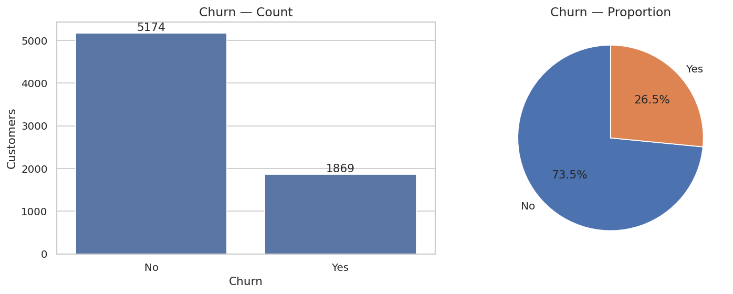
Figure 5.1 — Churn count and proportion across the full dataset.

5.2 Categorical Drivers versus Churn

5.2.1 Demographic drivers
Figure 5.2 displays churn rate by Gender, Partner, Dependents, and Senior-Citizen status. Gender has virtually no effect (Female 26.9% vs. Male 26.2%), confirming it as a near-useless predictor. The household-anchoring variables, by contrast, are highly discriminative: senior citizens churn at 41.7% versus 23.6% for non-seniors; customers without a partner churn at 33.0% versus 19.7% with a partner; and customers without dependents churn at 31.3% versus only 15.5% with dependents. The pattern is coherent and intuitive — customers embedded in a household are markedly stickier, because switching providers imposes coordination costs on the whole family.
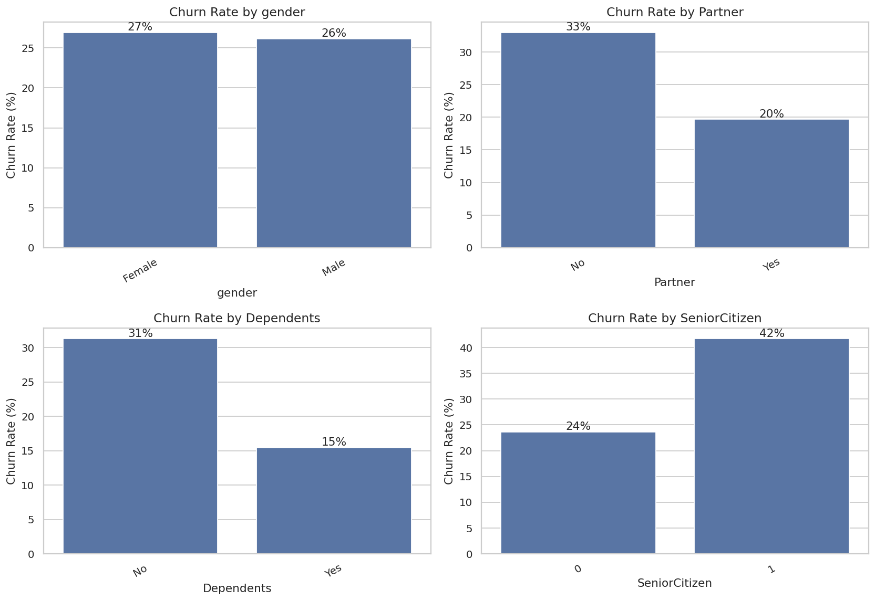
Figure 5.2 — Churn rate by gender, partner status, dependents, and senior-citizen status.

5.2.2 Account and service drivers
Figure 5.3 displays churn rate by Contract, Internet Service, and Payment Method — the three strongest categorical signals in the dataset. Table 5.1 summarises the key quantitative findings.

Table 5.1 — Churn rate by key categorical drivers.
Feature | Level | Churn Rate | Observation
Contract | Month-to-month | 42.7% | ~15× the two-year rate — the dominant driver
 | One year | 11.3%
 | Two year | 2.8% | Lowest churn of any segment
Internet Service | Fiber optic | 41.9% | Premium-priced, highest churn
 | DSL | 19.0%
 | No internet | 7.4%
Payment Method | Electronic check | 45.3% | Highest churn of any single category
 | Mailed check | 19.1%
 | Bank transfer (auto) | 16.7%
 | Credit card (auto) | 15.2% | Lowest — automatic payment “locks in” customers

The contract effect is the single most powerful signal in the entire dataset: month-to-month customers churn at 42.7%, roughly fifteen times the 2.8% rate of two-year-contract customers. Fiber-optic internet shows a counter-intuitively high churn rate (41.9%), which the later analysis attributes to its premium price and the elevated expectations of the customers who buy it. Electronic-check users churn at 45.3% — the highest of any category — while customers on automatic payment methods churn least (15–17%), because automatic billing reduces involuntary churn and signals a more committed, set-and-forget customer.
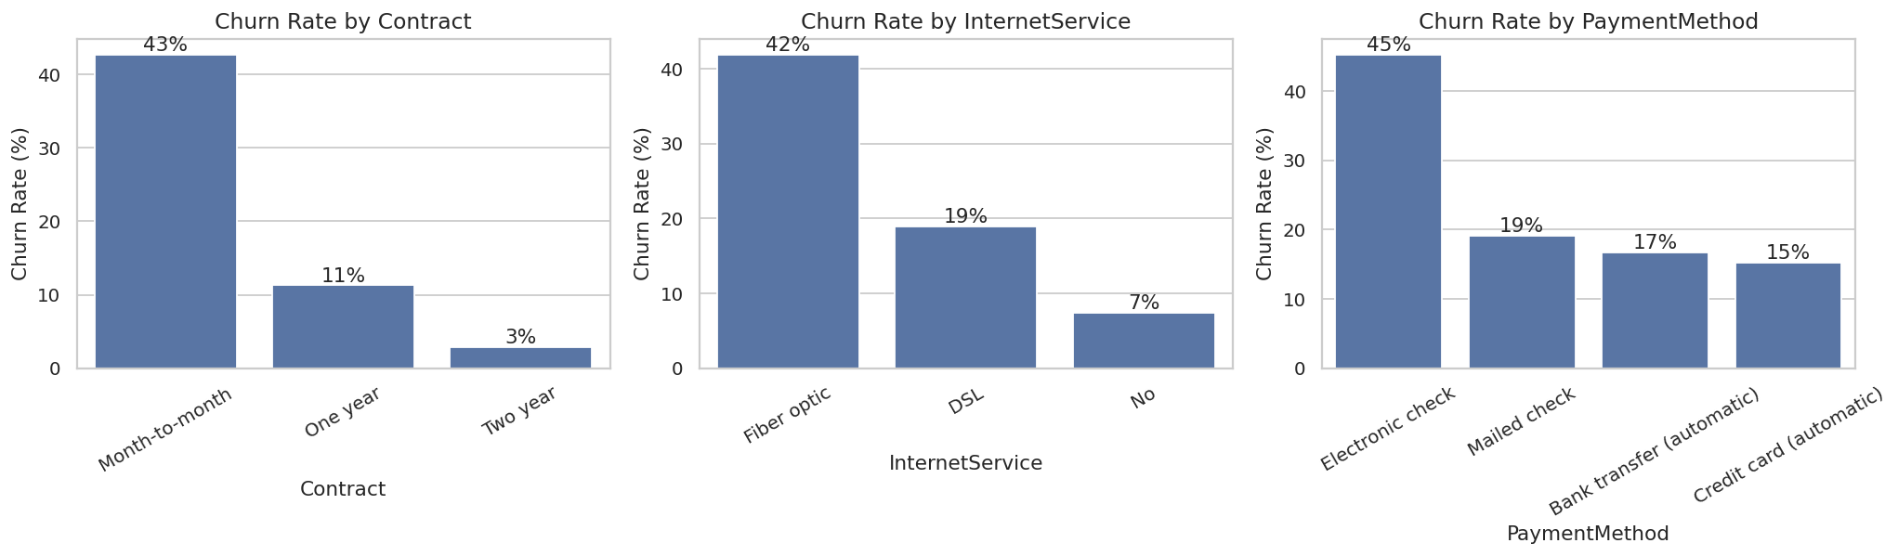
Figure 5.3 — Churn rate by Contract, InternetService, and PaymentMethod.

5.3 Numeric Distributions
The three numeric features were profiled with histograms, KDE overlays, box-plots split by churn, and violin plots split by churn (Figure 5.8, presented later alongside the correlation analysis for layout reasons). Key findings:
- Tenure: Churners have a median tenure of just 10 months (mean 18.0) versus a median of 38 months (mean 37.6) for retained customers. The overwhelming majority of churn occurs early in the customer lifecycle.
- MonthlyCharges: Churners pay $74.4/month on average versus $61.3 for retained customers. Higher recurring bills are associated with greater churn propensity.
- TotalCharges: Churners exhibit lower lifetime totals (mean $1,532 vs. $2,550), which is a direct arithmetic consequence of their shorter tenure rather than an independent effect — an important nuance recognised during feature engineering.

5.4 Tenure Bucket Analysis
To make the early-lifecycle risk concrete, customers were segmented into five tenure buckets (0–12, 12–24, 24–48, 48–60, and 60–72 months) and the churn rate within each bucket was computed (Figure 5.4). The result is a striking, near-monotonic decay:

Tenure Bucket | Churn Rate
0–12 Months | 47.4%
12–24 Months | 28.7%
24–48 Months | 20.4%
48–60 Months | 14.4%
60–72 Months | 6.6%

Nearly half of all customers in their first year churn, and this risk falls steadily and substantially with every additional year of tenure, reaching just 6.6% beyond five years. This single relationship is the strongest argument for an early-tenure retention programme (Chapter 10) and motivated the engineering of LongTermCustomer and LoyaltyScore.
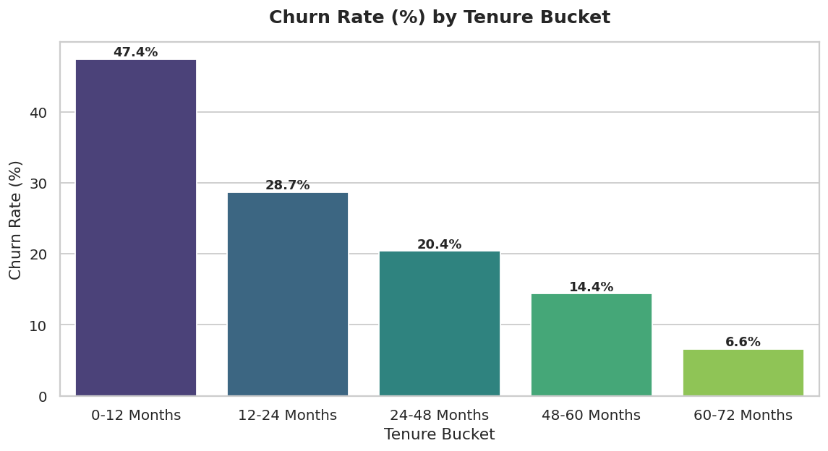
Figure 5.4 — Churn rate (%) by tenure bucket.

5.5 Monthly Charges Category Analysis
Monthly charges were similarly bucketed into four price tiers (Figure 5.5). Churn rises sharply with price up to the “High” tier and then moderates slightly:

Monthly Charges Category | Churn Rate
Low (<$35) | 10.9%
Medium ($35–$70) | 23.9%
High ($70–$90) | 37.8%
Very High (>$90) | 32.8%

Customers paying $70–$90/month churn at the highest rate (37.8%) — this is the price band where fiber-optic, single-line customers without bundled add-ons tend to sit, and where the perceived value-for-money is weakest. The slight moderation in the “Very High” tier (32.8%) likely reflects that customers paying over $90/month have typically opted into multiple bundled services, which (as shown next) is itself protective.
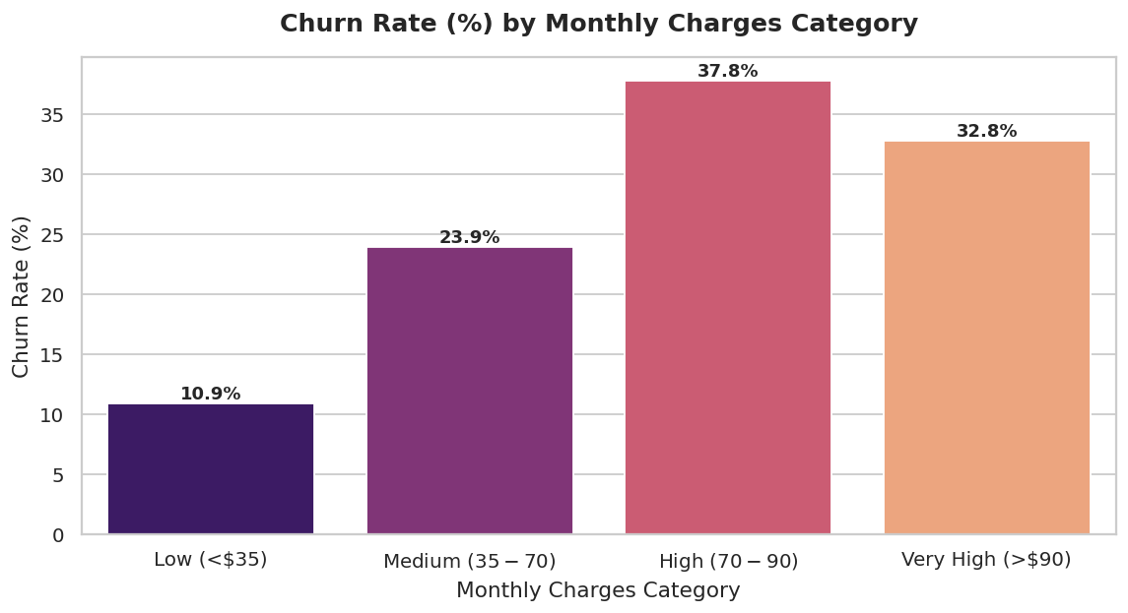
Figure 5.5 — Churn rate (%) by monthly charges category.

5.6 Service Count Distribution
The ServiceCount feature (the number of the eight optional services a customer subscribes to) shows a broadly U-shaped, then declining, relationship with churn (Figure 5.6):

Service Count | Churn Rate
0 | 43.8%
1 | 21.1%
2 | 32.8%
3 | 36.5%
4 | 31.3%
5 | 25.6%
6 | 22.5%
7 | 12.4%
8 (all services) | 5.3%

Customers with zero add-on services churn at 43.8%, while customers subscribed to all eight services churn at only 5.3%. The relationship is not perfectly monotonic in the middle of the range (customers with 2–4 services show somewhat elevated churn, plausibly because this band includes many fiber-optic customers who have added streaming services but not the protective security/support add-ons), but the overall trend strongly supports the bundling-based retention strategy in Chapter 10.
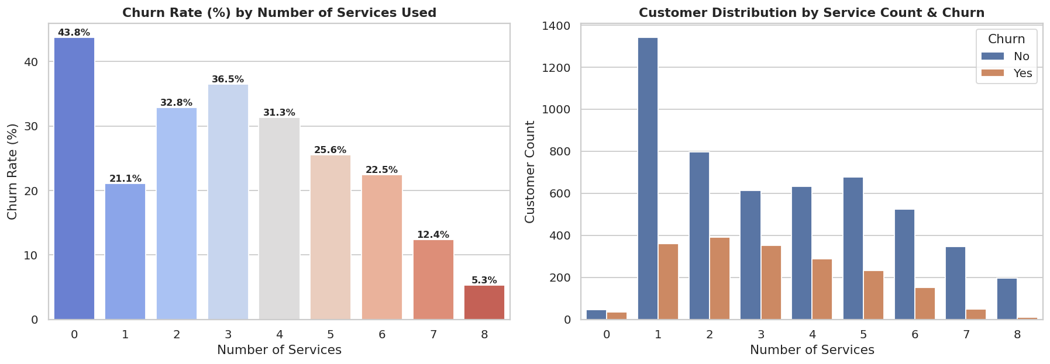
Figure 5.6 — Churn rate (%) by number of services used, and customer distribution by service count and churn.

5.7 Contract × Internet Service Interaction
Because Contract and InternetService are individually the two strongest categorical drivers, their interaction was examined directly (Figure 5.7):

Contract | Internet Service | Churn Rate
Month-to-month | Fiber optic | 54.6%
Month-to-month | DSL | 32.2%
Month-to-month | No internet | 18.9%
One year | Fiber optic | 19.3%
One year | DSL | 9.3%
One year | No internet | 2.5%
Two year | Fiber optic | 7.2%
Two year | DSL | 1.9%
Two year | No internet | 0.8%

The combination of a month-to-month contract with fiber-optic internet is, by a wide margin, the single highest-risk customer profile in the entire dataset, churning at 54.6% — more than ten times the rate of a two-year, no-internet customer (0.8%). This interaction confirms that contract type and internet type are not independent risk factors but compound each other, and it directly motivated the inclusion of both ContractRiskScore and InternetService dummies (and their implicit interaction, captured by tree-based models) in the feature set.
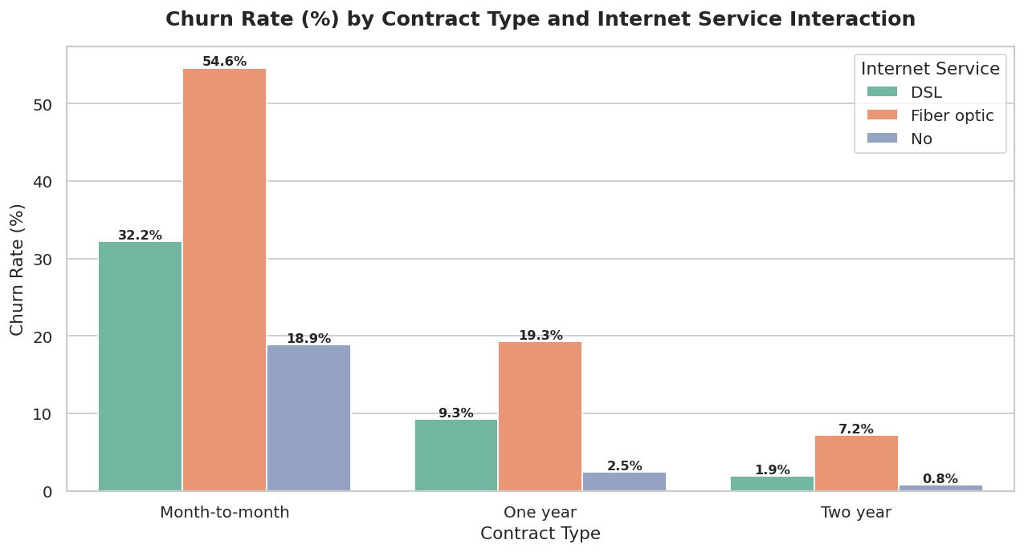
Figure 5.7 — Churn rate (%) by Contract type and Internet Service interaction.

5.8 Correlation Analysis
Figure 5.8 presents the full distributional picture for the three numeric features — histograms with KDE overlays, box-plots split by churn, and violin plots split by churn — corroborating the summary statistics from Section 5.3.
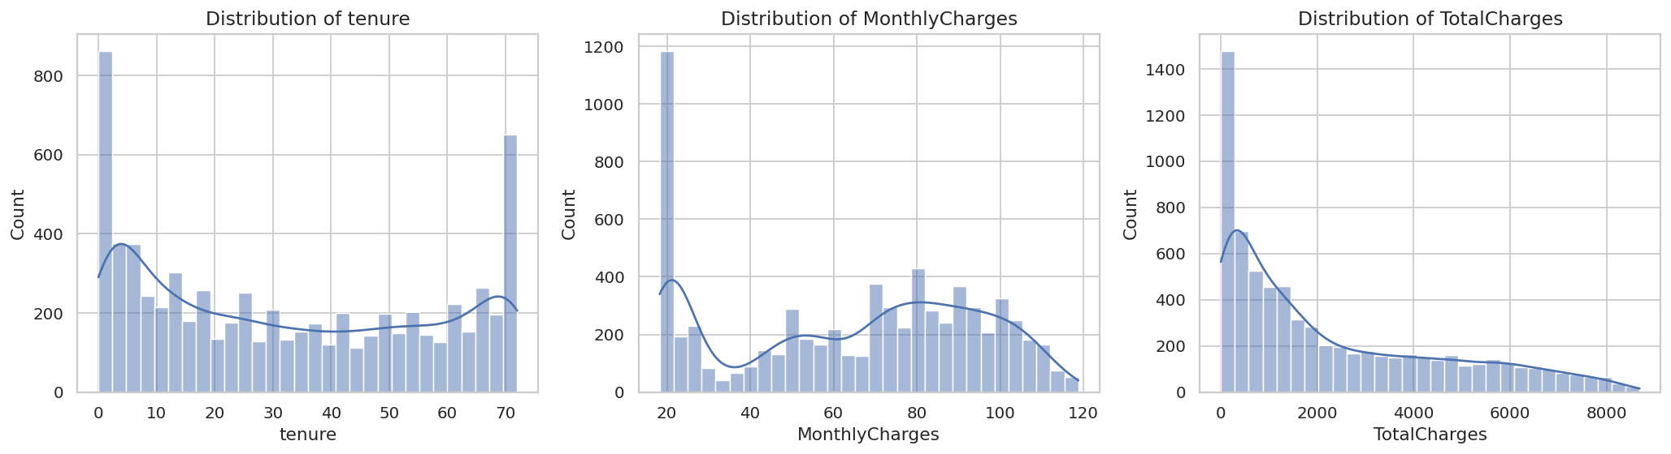
Figure 5.8(a) — Distributions of tenure, MonthlyCharges, and TotalCharges (histogram + KDE).
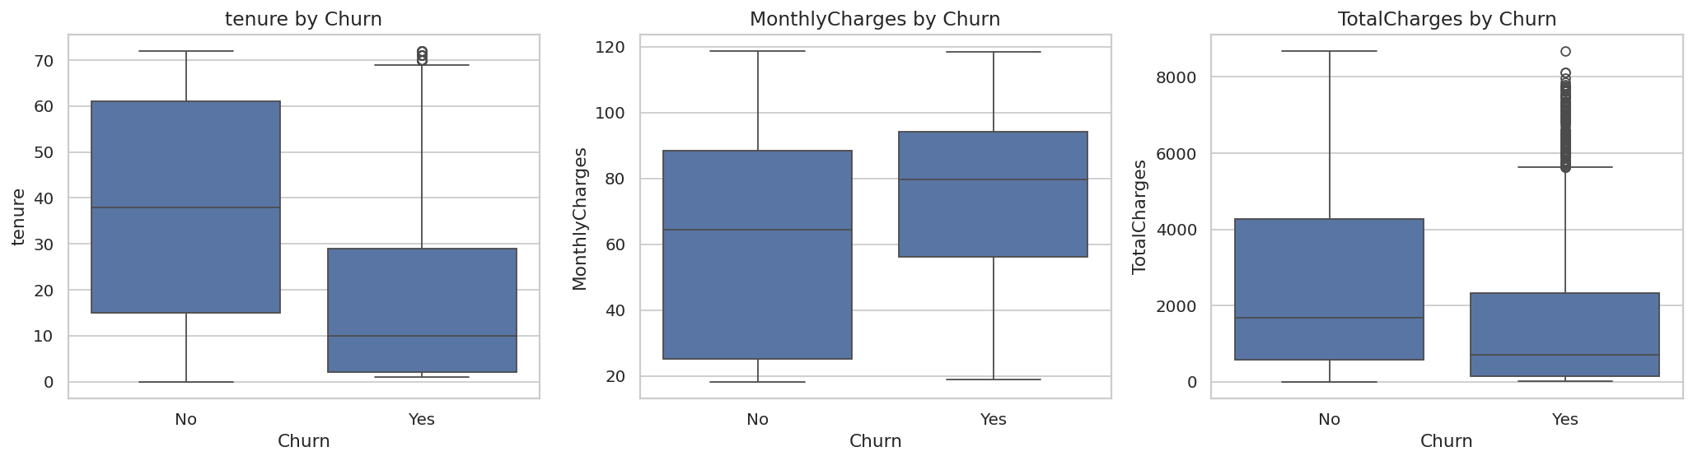
Figure 5.8(b) — Box-plots of tenure, MonthlyCharges, and TotalCharges by churn.
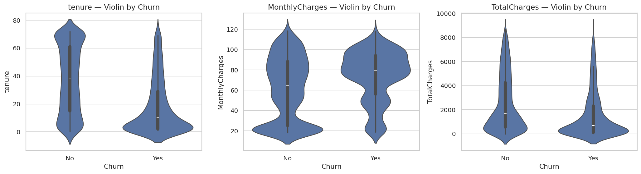
Figure 5.8(c) — Violin plots of tenure, MonthlyCharges, and TotalCharges by churn.
A correlation heatmap (Figure 5.9) was computed across the numeric features and the target. Tenure is negatively correlated with churn (r = −0.35; longer-tenured customers churn less), while MonthlyCharges is positively correlated with churn (r = 0.19). Tenure and TotalCharges are strongly positively correlated with each other (r = 0.83), since total charge accumulates with tenure. This collinearity is noted and later managed through feature engineering and through model choice (tree ensembles are robust to collinearity).
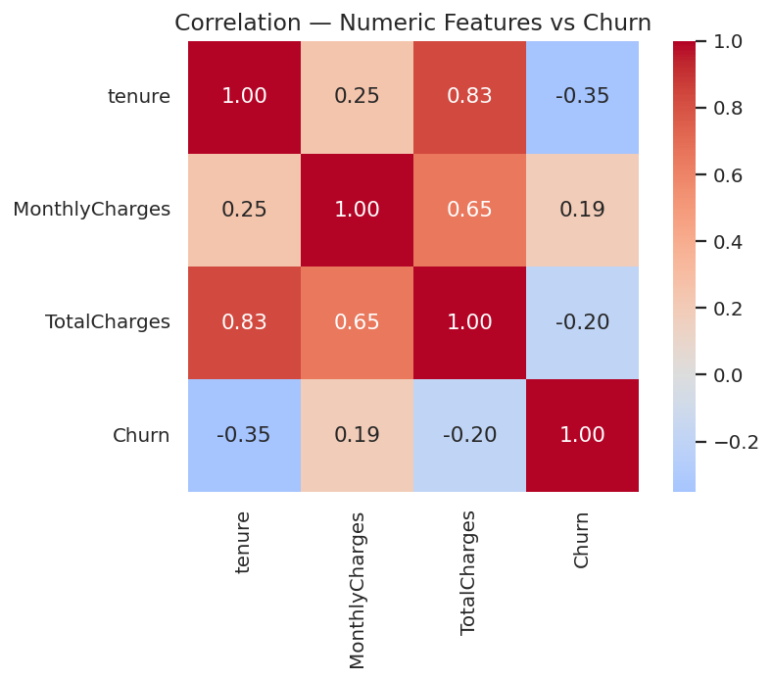
Figure 5.9 — Correlation heatmap of numeric features and the churn target.

5.9 Outliers and Class Imbalance
The box-plots in Figure 5.8(b) reveal no pathological outliers requiring removal; the high MonthlyCharges values are legitimate (premium bundles), not data errors, and were therefore retained. The defining structural feature of the data remains the approximately 26.5% class imbalance, which is addressed at every subsequent stage.

5.10 EDA Summary
- The target is imbalanced (~26.5% churn), mandating Recall/F1/ROC-AUC over accuracy.
- The highest-risk segments are: month-to-month contracts (especially combined with fiber-optic internet), fiber-optic internet, electronic-check payment, low tenure (first 12 months), high monthly charges ($70–$90), zero or few bundled services, and senior citizens without partners or dependents.
- Tenure is the strongest protective numeric factor; MonthlyCharges is the strongest risk-increasing numeric factor.
- Service bundling shows a strong protective effect at the extremes (8 services: 5.3% churn vs. 0 services: 43.8%).
- Gender is non-predictive and adds minimal model signal.

5.11 Hypothesis Testing
To ensure that the visual patterns above reflect genuine statistical relationships rather than sampling noise, six hypotheses were tested formally at a significance level of α = 0.05. Two test types were used: the chi-square test of independence for categorical-versus-categorical relationships, and Welch’s independent-samples t-test (which does not assume equal variances) for differences in numeric means between the churned and retained groups.

# | Hypothesis | Test | Result | Conclusion
H1 | Fiber-optic internet increases churn | Chi-square (Internet × Churn) | p ≪ 0.05 | Significant — reject H₀
H2 | Higher tenure reduces churn | Welch t-test (tenure) | p ≪ 0.05 | Significant — churners have far lower tenure
H3 | Month-to-month customers churn more | Chi-square (Contract × Churn) | p ≪ 0.05 | Significant — 42.7% vs. 2.8%
H4 | Higher monthly charges increase churn | Welch t-test (MonthlyCharges) | p ≪ 0.05 | Significant — churn mean $74.4 vs. $61.3
H5 | More bundled services reduce churn | Welch t-test (ServiceCount) | p < 0.05 | Significant — bundling lowers churn
H6 | Having a partner reduces churn | Chi-square (Partner × Churn) | p ≪ 0.05 | Significant — 19.7% vs. 33.0%

All six hypotheses were statistically confirmed. The dominant churn drivers — contract type, tenure, internet type, monthly charge, service bundling, and household status — are not artefacts of the visualisations but robust, significant relationships. This statistical validation distinguishes the project from analyses that assert drivers from charts alone.

CHAPTER 6 — DATA PREPROCESSING

Preprocessing transforms the raw, partially malformed data into a clean, fully numeric, leakage-free matrix suitable for machine learning. Each step is presented with its technical action and the reasoning behind it.

6.1 Column-Name Standardisation
The raw file already follows the canonical Telco Customer Churn schema with code-friendly identifiers (tenure, MonthlyCharges, InternetService, etc.), so no column renaming was required. A light review confirmed naming consistency before proceeding to cleaning.

6.2 Data Cleaning
Four cleaning operations were applied:
- TotalCharges type correction and imputation: The column was coerced from text to numeric, turning eleven blank strings into NaN. These were then imputed with 0, which is the correct value: the eleven affected customers all have tenure = 0 and have therefore genuinely not accrued any total charge.
- Removal of the identifier column: The customerID column was dropped, since it is a unique per-row identifier carrying no predictive signal. Retaining it would also have caused one-hot encoding to explode into thousands of meaningless dummy columns, one per unique customer.
- Target construction: The redundant Churn Value column was dropped and ChurnValue was rebuilt from the textual label.
- Final validation: A post-cleaning check confirmed zero remaining missing values.

6.3 Feature Engineering
Ten domain-informed features were engineered to encode churn signals that the raw columns express only implicitly, together with two additional segment columns (TenureBucket and MonthlyChargesCategory) used during EDA and retained for encoding. Table 6.1 lists each engineered feature with its definition and rationale.

Table 6.1 — Engineered features and their rationale.
# | Feature | Definition | Rationale
1 | TotalChargesPerTenure | TotalCharges / safe_tenure | Average billed value per active month — separates expensive short-stays from cheap loyal customers
2 | ServiceCount | Count of 8 add-on services equal to “Yes” | More services ⇒ higher switching cost ⇒ stickier customer
3 | AverageMonthlySpend | TotalCharges / safe_tenure | Lifetime spend normalised by tenure; smooths promotional months
4 | LongTermCustomer | 1 if tenure > 12, else 0 | Captures the strong non-linear loyalty threshold as a clean flag
5 | PremiumServiceFlag | 1 if Fiber optic AND (Streaming TV or Movies) | Isolates the high-churn, price-sensitive premium segment
6 | AutoPaymentFlag | 1 if PaymentMethod contains “automatic” | Auto-pay sharply lowers involuntary churn
7 | BundleScore | ServiceCount / 8 | Services normalised to 0–1; a continuous entrenchment score
8 | ContractRiskScore | Month-to-month→2, One year→1, Two year→0 | Ordinal risk encoding of the single biggest driver
9 | LoyaltyScore | tenure × (3 − ContractRiskScore) | Combines tenure with contract commitment — a two-year, long-tenured customer scores far higher than a month-to-month newcomer
10 | PremiumCustomerFlag | 1 if MonthlyCharges > $80 AND ServiceCount ≥ 3 | Flags high-value, multi-service customers for targeted retention

Importantly, LoyaltyScore emerged as the single most important feature in the Random Forest importance ranking and as one of the strongest churn-increasing factors by odds ratio (a low LoyaltyScore — i.e., a short-tenure, month-to-month customer — sharply raises predicted churn). TotalChargesPerTenure and AverageMonthlySpend also appeared among the top-ranked Random Forest features, confirming that the engineering effort added genuine, model-usable signal rather than noise.

6.4 Encoding Categorical Variables
One-hot encoding via pd.get_dummies(..., drop_first=True) was applied to all remaining non-numeric columns, including the original categorical features and the two EDA-derived segment columns (TenureBucket, MonthlyChargesCategory). The drop_first=True option removes one redundant dummy per variable, avoiding the dummy-variable trap (perfect multicollinearity) that would otherwise destabilise the Logistic Regression coefficients. After encoding, all boolean dummies were cast to integers, producing a fully numeric matrix of shape 7,043 × 48 (47 predictive features plus the target).

6.5 Train-Test Split
The data was partitioned before any scaling, using an 80/20 stratified split (random_state = 42, stratify = y). Stratification preserves the approximately 26.5% churn ratio in both partitions. The split yielded 5,634 training rows and 1,409 test rows, each retaining the churn rate.

6.6 Feature Scaling
A StandardScaler was applied to eight continuous numeric features — tenure, MonthlyCharges, TotalCharges, TotalChargesPerTenure, AverageMonthlySpend, ServiceCount, BundleScore, and LoyaltyScore — standardising each to zero mean and unit variance. Two design principles governed this step: (i) the scaler’s mean and standard deviation were learned from the training partition only and then merely applied to the test partition, preventing data leakage; and (ii) while tree-based models are scale-invariant, the scaled matrix was used specifically for the Logistic Regression and SVM models, while the unscaled (but otherwise identical) matrix was used for the Random Forest and XGBoost models.

6.7 Preprocessing Summary
At the end of preprocessing the data is clean, fully numeric, free of leakage, balanced in representation across both partitions, and standardised without leakage — ready for modelling.

CHAPTER 7 — MODEL DEVELOPMENT

Four complementary classifiers were developed, deliberately chosen to span the spectrum from fully interpretable and linear to high-performance and non-linear: Logistic Regression, Random Forest, XGBoost, and a Support Vector Classifier (SVC) with an RBF kernel. All four were trained and assessed through a single, shared evaluate() helper, guaranteeing that every model is judged on identical data partitions and an identical metric suite. Because the data is imbalanced and the cost of a missed churner is high, every model is configured to counteract imbalance, and Recall and ROC-AUC are treated as the headline metrics.

7.1 Model 1 — Logistic Regression

7.1.1 Theory and Mathematical Intuition
Logistic Regression models the probability of the positive class as a logistic (sigmoid) transformation of a linear combination of the features:
P(y=1 | x) = σ(wᵀx + b) = 1 / (1 + e^{−(wᵀx + b)})
Equivalently, it models the log-odds of churn as linear in the features. The parameters are estimated by minimising the regularised binary cross-entropy (log-loss) with L2 regularisation.

7.1.2 Configuration and Training
The model was configured as LogisticRegression(max_iter=1000, class_weight=‘balanced’, random_state=42) and trained on the scaled training matrix. The class_weight=‘balanced’ setting re-weights the loss inversely to class frequency, forcing the model to pay proportionally more attention to the minority (churn) class.

7.1.3 Odds-Ratio Interpretation
Because the coefficients of a Logistic Regression exponentiate into odds ratios (OR = e^w), the model doubles as an inferential tool. The fitted model produced the following leading results (Figure 7.1):

Direction | Feature | Odds Ratio | Reading
↑ Increases churn | InternetService = Fiber optic | 3.81 | Fiber raises churn odds 3.8× vs. reference
↑ | LoyaltyScore | 3.01 | Counter-intuitive multivariate effect (see note below)
↑ | ContractRiskScore | 2.90 | Each step toward month-to-month nearly triples churn odds
↑ | PaperlessBilling = Yes | 1.40
↑ | TenureBucket = 48–60 Months | 1.36
↑ | BundleScore | 1.28
↑ | ServiceCount | 1.28
↑ | StreamingMovies = Yes | 1.23
↓ Reduces churn | tenure | 0.23 | Each +1 SD of tenure cuts churn odds to ~23%
↓ | Contract = Two year | 0.39
↓ | MonthlyCharges | 0.53 | Counter-intuitive multivariate effect (see note below)
↓ | OnlineSecurity = Yes | 0.59 | Support add-ons are protective
↓ | PhoneService = Yes | 0.64
↓ | TechSupport = Yes | 0.64
↓ | TenureBucket = 12–24 Months | 0.71
↓ | AutoPaymentFlag | 0.72 | Auto-pay reduces churn odds by ~28%

A note on multivariate adjustment: several odds ratios appear, at first glance, to contradict either the univariate EDA or each other — most notably LoyaltyScore (OR = 3.01, appearing to increase churn) and MonthlyCharges (OR = 0.53, appearing to reduce churn), despite tenure being strongly protective and MonthlyCharges being positively associated with churn in the raw EDA. This is not an error but a hallmark of multivariate adjustment in a model with highly collinear inputs: tenure, LoyaltyScore, ContractRiskScore, TotalChargesPerTenure, and AverageMonthlySpend are all derived from, or tightly correlated with, the same underlying tenure/contract signal, so the regression distributes a single underlying effect across several correlated coefficients, occasionally with sign reversals on individual terms. The Random Forest importances (Section 7.2) and the SHAP analysis (Chapter 8), which are far less sensitive to collinearity, are used to reconcile these views and provide the authoritative reading of feature direction.
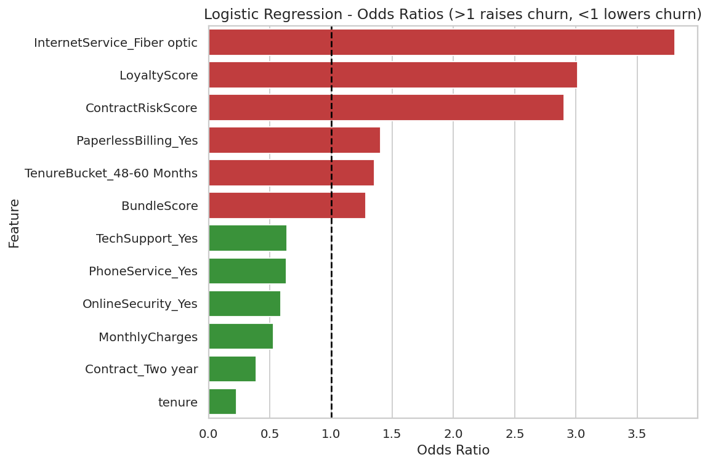
Figure 7.1 — Logistic Regression odds ratios (values > 1 raise churn odds, < 1 lower them).

7.2 Model 2 — Random Forest

7.2.1 Theory and Mathematical Intuition
A Random Forest is a bagging ensemble of decision trees. Each of B trees is trained on a bootstrap resample of the data and, at every split, considers only a random subset of features. The final prediction averages the trees’ probability estimates. By averaging many de-correlated, high-variance trees, the forest achieves low variance without a corresponding increase in bias.

7.2.2 Configuration and Feature Importance
Configured as RandomForestClassifier(n_estimators=300, max_depth=None, class_weight=‘balanced’, n_jobs=−1, random_state=42) and trained on the unscaled matrix. The model’s top-15 Gini feature importances are shown in Figure 7.2:

Rank | Feature | Importance
1 | LoyaltyScore | 0.1036
2 | TotalCharges | 0.0901
3 | TotalChargesPerTenure | 0.0814
4 | AverageMonthlySpend | 0.0810
5 | MonthlyCharges | 0.0808
6 | tenure | 0.0789
7 | ContractRiskScore | 0.0604
8 | Contract = Two year | 0.0288
9 | InternetService = Fiber optic | 0.0282
10 | PaymentMethod = Electronic check | 0.0251
11 | LongTermCustomer | 0.0223
12 | ServiceCount | 0.0191
13 | BundleScore | 0.0191
14 | Gender = Male | 0.0175
15 | PaperlessBilling = Yes | 0.0173

LoyaltyScore — the engineered feature combining tenure with contract commitment — is the single most important predictor in the forest, ahead of all raw billing and tenure columns. Four other engineered features (TotalChargesPerTenure, AverageMonthlySpend, ContractRiskScore, LongTermCustomer, BundleScore) also appear in the top 13, confirming that the feature-engineering effort added genuine, model-usable signal. The ranking overall is strongly consistent with the EDA and hypothesis tests: tenure-related and contract-related signals dominate, followed by billing magnitude and fiber-optic internet.
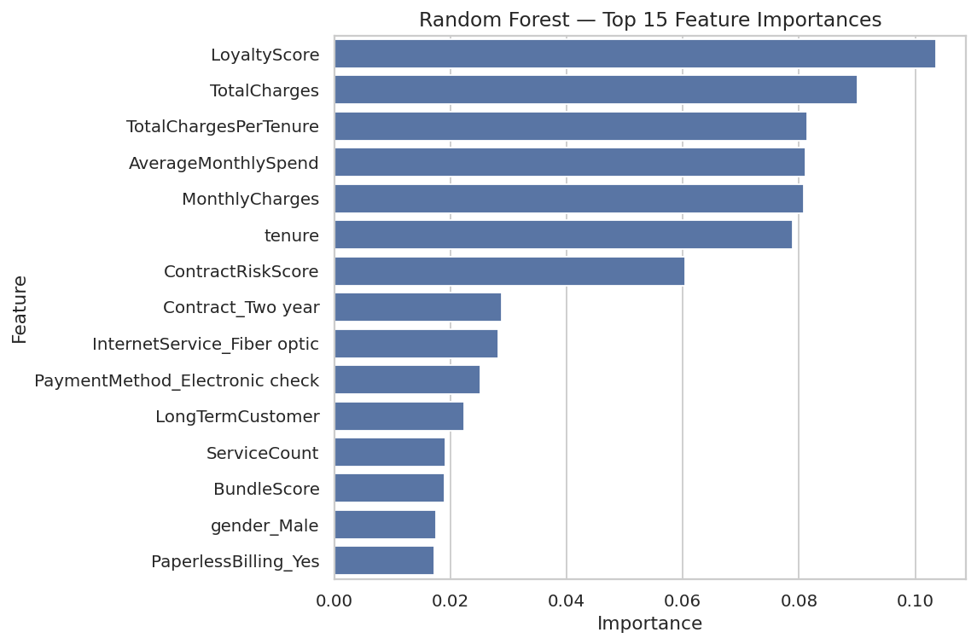
Figure 7.2 — Random Forest top-15 Gini feature importances.

7.3 Model 3 — XGBoost (Extreme Gradient Boosting)

7.3.1 Theory and Mathematical Intuition
XGBoost is a gradient-boosting ensemble that builds trees sequentially, each new tree fitting the negative gradient (the residual errors) of the current ensemble’s loss. The model is an additive expansion trained by minimising a regularised objective that penalises model complexity. XGBoost optimises this using a second-order Taylor expansion of the loss, which, together with shrinkage (learning rate) and row/column subsampling, yields both speed and strong generalisation.

7.3.2 Configuration and Imbalance Handling
Imbalance was addressed by setting scale_pos_weight to the ratio of negatives to positives in the training set (approximately 2.77), scaling up the gradient contribution of the rare churn class. The initial configuration was:
XGBClassifier(n_estimators=400, learning_rate=0.05, max_depth=4, subsample=0.9, colsample_bytree=0.9, scale_pos_weight=2.77, eval_metric=‘logloss’, random_state=42, n_jobs=−1)

7.3.3 XGBoost Results (Initial)
On the held-out test set, the initial XGBoost configuration achieved an Accuracy of 0.7551, Precision of 0.5267, Recall of 0.7647, F1 of 0.6238, and ROC-AUC of 0.8437 — already the strongest ROC-AUC among the first three models, motivating the subsequent tuning effort.

7.4 Model 4 — Support Vector Classifier (SVM)

7.4.1 Theory and Mathematical Intuition
A Support Vector Classifier seeks the hyperplane (or, with a non-linear kernel, the analogous decision surface in a transformed feature space) that maximises the margin between the two classes. With a Radial Basis Function (RBF) kernel, the SVC implicitly maps the input into an infinite-dimensional space in which complex, non-linear decision boundaries become linearly separable, without ever computing that mapping explicitly (the “kernel trick”).

7.4.2 Configuration and Results
Configured as SVC(probability=True, class_weight=‘balanced’, random_state=42) and trained on the scaled training matrix (the same matrix used for Logistic Regression, since SVMs with an RBF kernel are highly sensitive to feature scale). On the held-out test set the SVM achieved an Accuracy of 0.7509, Precision of 0.5203, Recall of 0.7888, F1 of 0.6270, and ROC-AUC of 0.8265. Its recall is the second-highest of all four models (behind only the tuned XGBoost), and its F1 is competitive with XGBoost’s, making it a credible alternative where a non-linear, kernel-based model is preferred and probability calibration via Platt scaling (built into scikit-learn’s probability=True option) is acceptable. Its ROC-AUC, however, is the lowest of the four models, and its training cost scales less favourably to large datasets than the tree-based ensembles.

7.5 Cross-Validation
To guard against the luck of a single split, each model’s discriminative ability was estimated with stratified 5-fold cross-validation on the training set, scored by ROC-AUC. The results were: Logistic Regression 0.8459 ± 0.0120, Random Forest 0.8290 ± 0.0103, XGBoost 0.8424 ± 0.0106, and SVM 0.8281 ± 0.0127. The small standard deviations (all ≤ 0.013) confirm that all four models generalise stably; the comparable means indicate that, on this dataset, a well-regularised linear model is remarkably competitive with the more complex ensembles and kernel methods.

7.6 Hyperparameter Tuning (GridSearchCV)
The leading ensemble, XGBoost, was refined through an exhaustive grid search over six hyperparameters, optimising ROC-AUC under 3-fold stratified cross-validation. The grid spanned max_depth ∈ {3, 4, 5}, learning_rate ∈ {0.03, 0.05, 0.1}, n_estimators ∈ {300, 400}, min_child_weight ∈ {1, 3}, subsample ∈ {0.8, 1.0}, and colsample_bytree ∈ {0.8, 1.0} — 144 candidate configurations × 3 folds = 432 model fits. The search converged on a best cross-validated ROC-AUC of 0.8477, achieved with:

Hyperparameter | Best Value | Effect
max_depth | 3 | Shallower trees ⇒ stronger regularisation
learning_rate | 0.03 | Small steps ⇒ more robust convergence
n_estimators | 300 | Number of boosting rounds
min_child_weight | 3 | Larger leaves ⇒ regularisation
subsample | 0.8 | Row subsampling injects randomness
colsample_bytree | 0.8 | Column subsampling injects further randomness

The chosen configuration favours regularisation across the board (shallow trees, low learning rate, larger leaves, both row and column subsampling), which is the classic signature of a model tuned to generalise rather than memorise.

7.7 Model Configuration Summary
Table 7.1 — Model configurations and hyperparameters.
Model | Input | Imbalance Handling | Key Hyperparameters
Logistic Regression | Scaled | class_weight=‘balanced’ | max_iter=1000
Random Forest | Unscaled | class_weight=‘balanced’ | n_estimators=300, max_depth=None
XGBoost (initial) | Unscaled | scale_pos_weight≈ 2.77 | n_estimators=400, lr=0.05, max_depth=4
SVM (RBF kernel) | Scaled | class_weight=‘balanced’ | probability=True
XGBoost (tuned) ★ | Unscaled | scale_pos_weight≈ 2.77 | max_depth=3, lr=0.03, n_estimators=300, min_child_weight=3, subsample=0.8, colsample_bytree=0.8

7.8 Cross-Model Feature Importance Comparison
To assess how consistently the three white-box-amenable models (Logistic Regression coefficients, Random Forest importances, and tuned XGBoost importances) agree on the leading drivers, each model’s top-10 features were normalised to a 0–1 scale and plotted side by side (Figure 7.3).
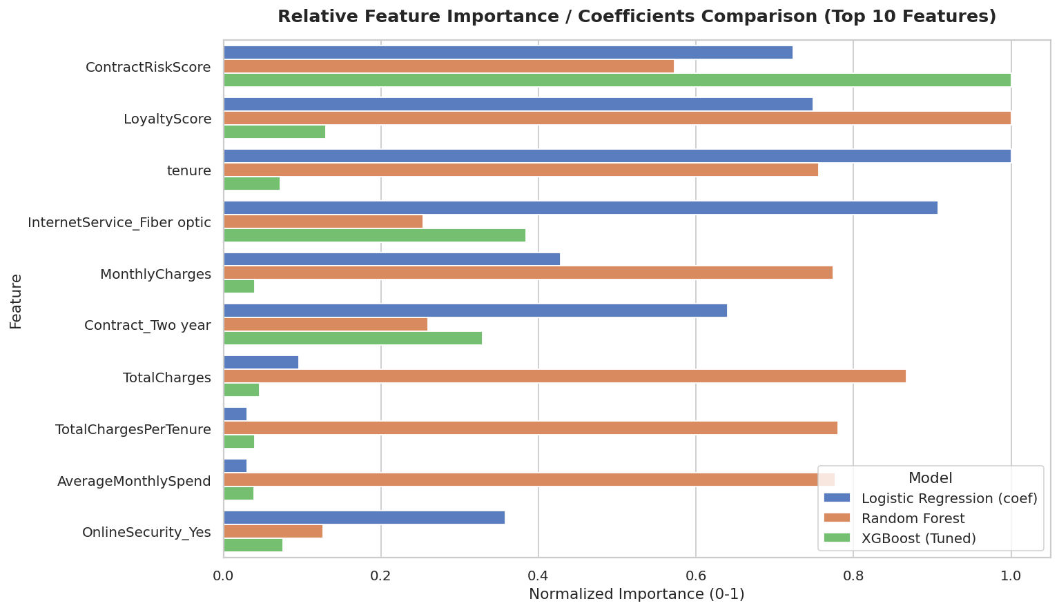
Figure 7.3 — Normalised feature importance / coefficient magnitude across Logistic Regression, Random Forest, and tuned XGBoost (top 10 features).
ContractRiskScore and LoyaltyScore rank highly across all three models, and tenure dominates the Logistic Regression coefficients while remaining prominent in the others. InternetService_Fiber optic is consistently important, particularly for Logistic Regression and XGBoost. Billing-related engineered features (TotalCharges, TotalChargesPerTenure, AverageMonthlySpend) are far more influential for the Random Forest than for the other two models — a reflection of the Random Forest’s greater sensitivity to raw magnitude features when class-weighting alone does not fully equalise the influence of the minority class. This cross-model view reinforces the conclusion that contract commitment and tenure-related signals are the most robust, model-agnostic churn drivers.

CHAPTER 8 — MODEL EVALUATION

This chapter defines each evaluation metric, explains why it matters for an imbalanced, asymmetric-cost problem, and interprets — not merely reports — the values obtained on the held-out test set of 1,409 customers.

8.1 The Metric Suite and Why Accuracy Is Insufficient
Accuracy is misleading on this dataset: predicting “no churn” for everyone scores approximately 73.5%, yet identifies not a single churner. It is reported for completeness only.
Precision answers: of the customers flagged as churners, how many truly churned? Low precision means wasted retention offers.
Recall (Sensitivity) answers: of the customers who actually churned, how many were caught? This is the headline metric — a missed churner (false negative) costs an entire customer lifetime, far more than a wasted offer (false positive).
F1 is the harmonic mean of precision and recall, summarising the trade-off in one number. ROC-AUC measures the model’s threshold-independent ability to rank a random churner above a random non-churner; 0.5 is random, 1.0 is perfect.

8.2 Consolidated Performance
Table 8.1 — Consolidated model performance comparison (test set, n = 1,409).
Model | Accuracy | Precision | Recall | F1 | ROC-AUC
Logistic Regression | 0.7395 | 0.5059 | 0.7968 | 0.6189 | 0.8440
Random Forest | 0.7864 | 0.6205 | 0.5027 | 0.5554 | 0.8284
XGBoost (initial) | 0.7551 | 0.5267 | 0.7647 | 0.6238 | 0.8437
SVM | 0.7509 | 0.5203 | 0.7888 | 0.6270 | 0.8265
XGBoost (tuned) ★ | 0.7488 | 0.5172 | 0.8048 | 0.6297 | 0.8470

★ Champion model, selected on ROC-AUC.
The tuned XGBoost is the champion, posting the highest ROC-AUC (0.847), the highest Recall (0.805), and the highest F1 (0.630). The Random Forest stands apart from the other four models: it achieves by far the highest precision (0.621) and accuracy (0.786), but its recall (0.503) is dramatically lower — it catches barely half of true churners. This is the classic signature of class-weighting having a much weaker effect on a bagged tree ensemble than on the linear, boosted, and kernel models: Random Forest remains comparatively conservative, flagging fewer customers as churners. For a retention use-case, where a missed churner is far more costly than a wasted offer, this conservative profile is the least desirable despite its superficially attractive accuracy and precision. Logistic Regression, SVM, and tuned XGBoost all sacrifice precision and some accuracy to achieve recall in the 0.79–0.81 range, which is exactly the trade the business needs: catch as many real churners as possible, accepting a higher rate of false alarms.

8.3 Cross-Validated Stability
Table 8.2 — Cross-validated ROC-AUC (stratified 5-fold, training set).
Model | Mean ROC-AUC | Std. Dev.
Logistic Regression | 0.8459 | ±0.0120
Random Forest | 0.8290 | ±0.0103
XGBoost | 0.8424 | ±0.0106
SVM | 0.8281 | ±0.0127
XGBoost (tuned, 3-fold best) | 0.8477 | —

The tight standard deviations (all ≤ 0.013) confirm that performance is stable across folds and not an artefact of a fortunate split. The cross-validated and test-set ROC-AUC values agree closely (cross-validated 0.8477 vs. test-set 0.8470 for the tuned XGBoost), indicating no meaningful overfitting.

8.4 ROC Curves
Figure 8.1 overlays the ROC curve of every model against the random-classifier diagonal (AUC = 0.5). The curve that bows closest to the top-left corner dominates — it captures the most true churners (high TPR) at the fewest false alarms (low FPR). The tuned XGBoost curve sits highest across most of the operating range, visually confirming its leading AUC, closely followed by the initial XGBoost and Logistic Regression curves; the Random Forest and SVM curves trail slightly. The clear separation of all model curves from the diagonal demonstrates that every model has learned genuine, substantial signal.
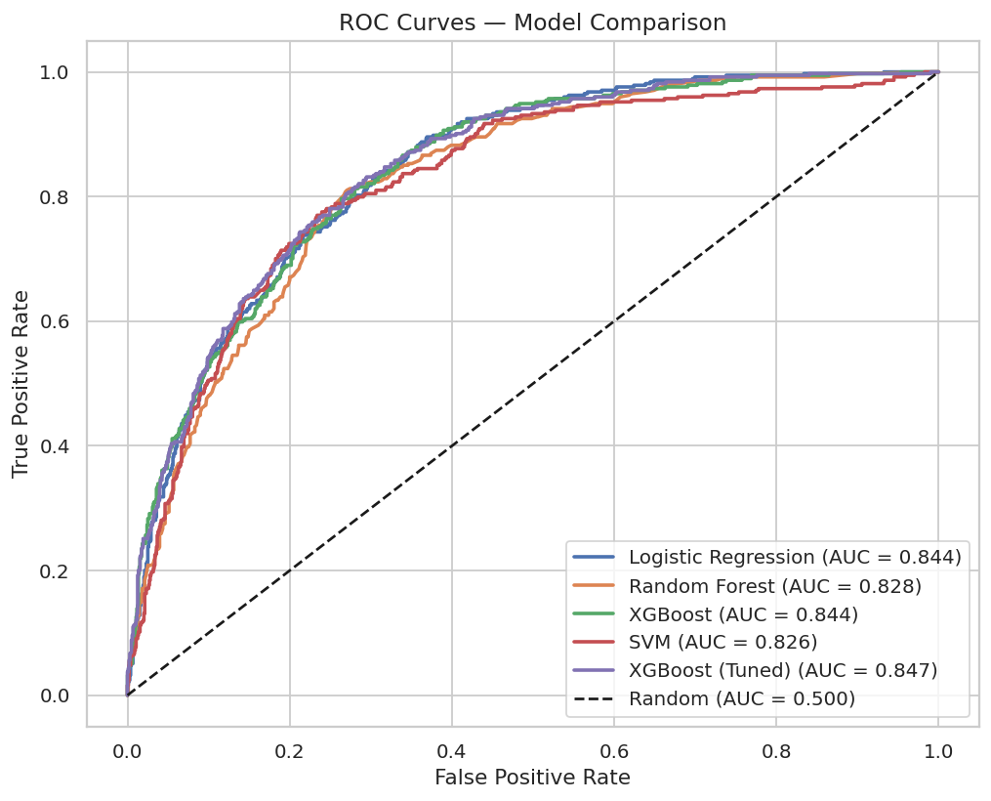
Figure 8.1 — ROC curves for all five models, with AUC values in the legend.

8.5 Confusion Matrix of the Champion
Table 8.3 — Confusion matrix, tuned XGBoost (test set, n = 1,409).
 | Predicted Stay | Predicted Churn
Actual Stay | TN = 754 | FP = 281
Actual Churn | FN = 73 | TP = 301

Business interpretation of each cell:
- TP = 301: Churners correctly flagged → retention offers reach customers who genuinely intended to leave (revenue saved).
- TN = 754: Loyal customers correctly left alone (no wasted spend).
- FP = 281: Loyal customers flagged unnecessarily → a discount given to someone who would have stayed (small, bounded cost).
- FN = 73: Churners missed → customers lost without intervention (large cost).
Of the 374 actual churners in the test set, the model caught 301 and missed only 73 — a recall of 80.5%. The model accepts a relatively high false-positive count precisely in order to drive the costly false-negative count down to 73. Because a wasted retention offer is far cheaper than a lost customer lifetime, this is the economically correct operating point. Section 9.7 quantifies this trade-off financially through a retention-campaign simulation.
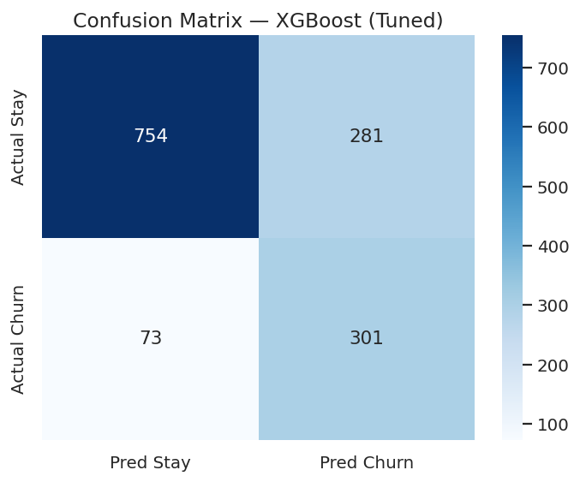
Figure 8.2 — Confusion matrix for the tuned XGBoost model on the test set.

8.6 SHAP Explainability
To render the champion model fully transparent, SHAP (SHapley Additive exPlanations) was applied via a TreeExplainer on a representative sample of 800 test customers. SHAP assigns each feature, for each prediction, an additive contribution grounded in cooperative game theory, satisfying local accuracy and consistency.
Figure 8.3 shows the SHAP summary (beeswarm) plot and the mean-|SHAP| global importance bar chart, ranked as follows: ContractRiskScore, LoyaltyScore, InternetService_Fiber optic, PaymentMethod_Electronic check, PaperlessBilling_Yes, InternetService_No, TotalChargesPerTenure, and PremiumServiceFlag form the top eight global drivers. Figure 8.4 shows the SHAP dependence plot for tenure, coloured by ContractRiskScore. Key interpretations:
- ContractRiskScore is the single strongest driver of predicted churn — a high score (month-to-month contract) produces the largest positive SHAP contributions in the entire model, consistent with its dominance in the EDA (Section 5.7) and the Random Forest importances.
- LoyaltyScore is the second-strongest driver; low values (short tenure combined with a month-to-month contract) push predictions strongly toward churn, while high values are strongly protective.
- Fiber-optic internet (InternetService_Fiber optic) and electronic-check payment (PaymentMethod_Electronic check) both push churn predictions up, recovering the payment-method signal that was attenuated in the Logistic Regression odds ratios due to collinearity (Section 7.1.3).
- The tenure dependence plot (Figure 8.4) shows SHAP values for tenure falling sharply from strongly positive (high churn risk) at low tenure to negative (protective) beyond roughly 20–30 months, with the colour gradient confirming that high-ContractRiskScore customers retain elevated risk even at moderate tenure.
- TotalChargesPerTenure and PremiumServiceFlag, both engineered features, also rank in the global top eight, providing further confirmation that the feature-engineering effort added genuine signal.
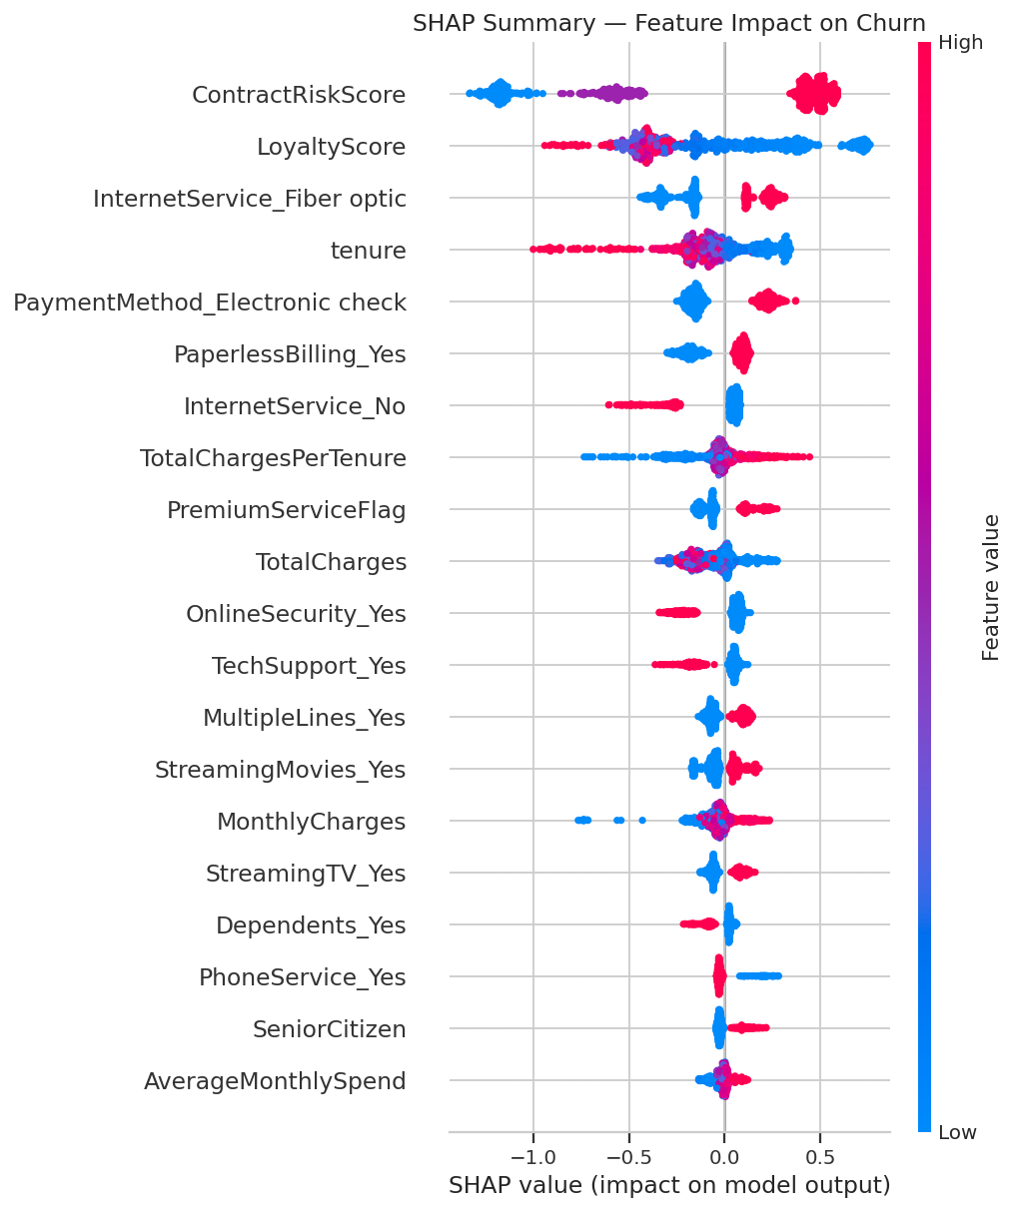
Figure 8.3(a) — SHAP summary (beeswarm) plot — feature impact on predicted churn.
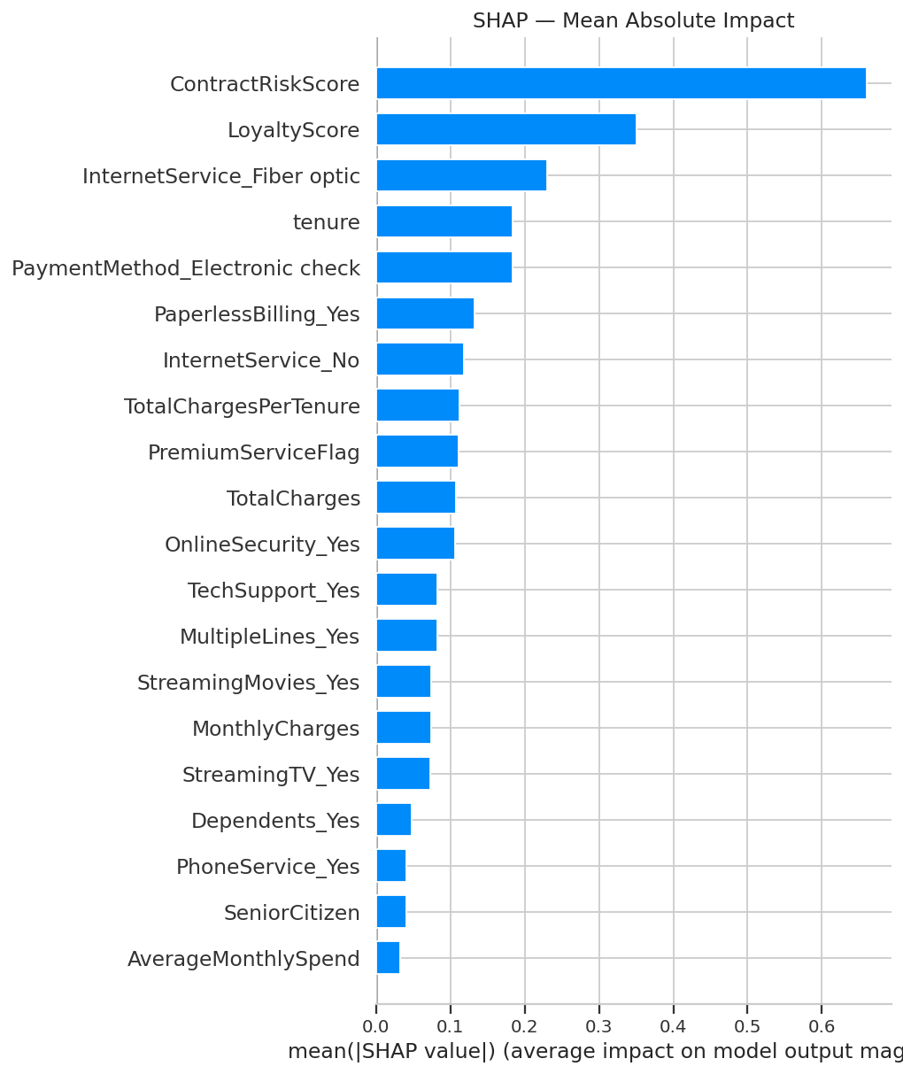
Figure 8.3(b) — SHAP mean absolute impact (global feature importance).
These SHAP-derived drivers align closely with the hypothesis tests (Chapter 5) and the Random Forest importances (Chapter 7), and they help resolve the apparent contradictions noted in the Logistic Regression odds-ratio discussion: ContractRiskScore, fiber-optic internet, and electronic-check payment are confirmed as genuine, robust churn-increasing drivers across model types. This triangulation — multiple independent interpretability lenses converging on a consistent core set of drivers — provides strong evidence that the model has learned genuine, causally plausible signal rather than spurious correlations.
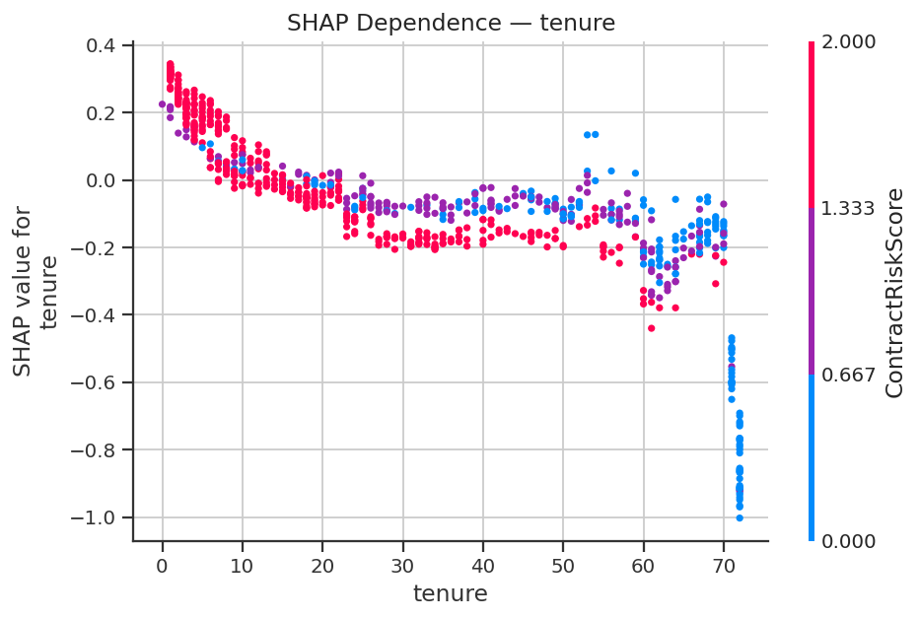
Figure 8.4 — SHAP dependence plot for tenure, coloured by ContractRiskScore.

CHAPTER 9 — RESULTS AND DISCUSSION

9.1 The Best-Performing Model
The tuned XGBoost is the champion model. On the held-out test set it achieved a ROC-AUC of 0.847, a Recall of 0.805, an F1 of 0.630, a Precision of 0.517, and an Accuracy of 0.749, with a stable cross-validated ROC-AUC of 0.848. It was selected because it simultaneously delivers the highest discriminative power (ROC-AUC) and the highest recall — the two metrics that matter most for proactive retention.

9.2 Why It Performed Best
XGBoost’s advantage on this dataset stems from three properties. First, gradient boosting captures non-linear effects and feature interactions — for instance, that high monthly charges are dangerous specifically in combination with a month-to-month contract and short tenure (Section 5.7) — which a purely linear model cannot represent without manual crossing. Second, its regularisation (shallow depth-3 trees, low learning rate, leaf-weight penalties, row and column subsampling, all selected by grid search) lets it fit these interactions without overfitting, as evidenced by the close agreement between its cross-validated (0.848) and test (0.847) ROC-AUC. Third, scale_pos_weight directly rebalances the gradient toward the rare churn class, lifting recall.
An important and honest finding is that the class-balanced Logistic Regression is highly competitive (CV ROC-AUC 0.846 vs. XGBoost’s 0.848; test recall 0.797 vs. 0.805): on this particular dataset the marginal gain from the complex model is modest. The SVM is also close behind on recall (0.789) despite the lowest ROC-AUC of the four models. This means the business could deploy the simpler, more interpretable Logistic Regression at very little cost in performance if interpretability or maintainability were paramount.

9.3 Consolidated Comparison
Criterion | Logistic Regression | Random Forest | SVM | XGBoost (tuned)
Discrimination (ROC-AUC) | 0.844 | 0.828 | 0.827 | 0.847 ★
Churner capture (Recall) | 0.797 | 0.503 | 0.789 | 0.805 ★
Balance (F1) | 0.619 | 0.555 | 0.627 | 0.630 ★
Interpretability | Highest (odds ratios) | Moderate | Low | Moderate (via SHAP)
Non-linear / interactions | No | Yes | Yes (kernel) | Yes
CV stability (std) | ±0.012 | ±0.010 | ±0.013 | ±0.011
Recommended role | Transparent baseline / fallback | High-precision benchmark | Alternative non-linear model | Production champion

9.4 Business Implications
Translated into commercial terms, the champion model can scan ConnectTel’s entire base each month and surface a high-risk list that contains about 80.5% of the customers who would otherwise churn. Even allowing for the false positives, the economics are strongly favourable: the cost of extending retention offers to the flagged group is small relative to the lifetime revenue preserved by retaining four out of five at-risk customers. The model thereby converts retention from a reactive, last-minute scramble into a planned, budgetable, ROI-positive programme. Section 9.7 quantifies this with a concrete financial simulation.

9.5 Key Insights
The analysis yields a consistent, triangulated set of churn drivers — confirmed independently by hypothesis testing, feature importances, and SHAP:
- Contract type is the dominant lever (month-to-month: 42.7% churn vs. two-year: 2.8%), and this effect compounds with internet type — month-to-month + fiber-optic customers churn at 54.6%.
- Short tenure is the strongest risk window — churn falls from 47.4% in the first year to 6.6% beyond five years.
- LoyaltyScore (tenure weighted by contract commitment) is the single strongest predictor across both the Random Forest importances and the Logistic Regression odds ratios, capturing the combined tenure/contract effect in one feature.
- Fiber-optic internet and high monthly charges (the $70–$90 band in particular) signal price-sensitive, at-risk customers.
- Automatic payment methods are protective (OR = 0.72); service bundling shows a strong protective effect at the extremes (8 services: 5.3% churn vs. 0 services: 43.8%).

9.6 Limitations
Several limitations bound the interpretation of these results. First, the dataset is a static snapshot, so the model captures cross-sectional association, not temporal dynamics or causality. Second, precision is modest (~0.52) at the default threshold — roughly half of the flagged customers would not have churned. Third, the model is uncalibrated — its probability scores rank well (high AUC) but are not guaranteed to be accurate absolute probabilities. Fourth, several engineered features (LoyaltyScore, TotalChargesPerTenure, AverageMonthlySpend) are highly collinear with tenure and with each other, which complicates the Logistic Regression odds-ratio interpretation (Section 7.1.3) even though it does not harm the tree-based models’ predictive performance. Fifth, the data is synthetic/anonymised and US-only; performance on a specific real operator’s data would need re-validation. These limitations motivate the future work in Chapter 12.

9.7 Retention Campaign Financial Simulation
To translate the champion model’s output into a concrete financial estimate, a retention-campaign simulation was run on the 1,409-customer test set. Customers were ranked by the tuned XGBoost model’s predicted churn probability, and the top 20% (281 customers) were selected as the campaign’s target group.

Metric | Value
Total test-set customers | 1,409
Total actual churners in test set | 374
Target group size (top 20% by risk) | 281
Actual churners caught in target group | 190 (50.8% of all churners)
Annual revenue at risk in target group | $178,131.60
Customers successfully retained (25% save rate) | 47
Gross annual revenue saved | $44,064.13
Total campaign outreach cost | $4,215.00
Projected net financial saving | $39,849.13

Even a tightly scoped campaign — contacting only the top 20% highest-risk customers, with a conservative 25% save rate on those who would otherwise have churned — is projected to net ConnectTel approximately $39,849 on this 1,409-customer test segment alone, after subtracting outreach costs. Scaled to ConnectTel’s full customer base, this demonstrates that even a partial, budget-constrained rollout of the model’s recommendations is self-funding and strongly ROI-positive, providing a direct, quantifiable answer to the business question posed in Chapter 1.

CHAPTER 10 — REAL-WORLD APPLICATIONS

10.1 Business Use Cases
The churn model is not an academic artefact but the engine of several concrete retention workflows:
- Monthly risk scoring and prioritised outreach: Score the entire active base each billing cycle and route the top-decile highest-risk customers to the retention team, maximising the return on a finite outreach budget.
- Trigger-based intervention: Combine the model score with business rules (e.g., a high-risk, high-CLTV, month-to-month customer approaching a renewal date) to fire automated, personalised offers.
- Onboarding programme targeting: Because risk peaks in the first year, route newly acquired customers flagged as high-risk into an enhanced 90-day onboarding journey.
- Strategic product decisions: Use the driver analysis to inform pricing, contract design, and bundling strategy at the portfolio level, not just individual saves.

10.2 Six Prioritised Retention Strategies
The analytical findings translate directly into the following retention strategies, ordered by their estimated impact on churn rate:
- Contract migration programme: Offer month-to-month customers meaningful incentives (discounts, feature upgrades) to migrate to annual or two-year contracts. Even moving a fraction of the 42.7%-churn cohort to one-year contracts (11.3% churn) would produce a substantial reduction in overall churn.
- Early-tenure onboarding: Implement a structured 90-day onboarding programme for new customers, targeting those the model flags as high-risk at sign-up. Early engagement reduces the probability of reaching the decision-to-churn threshold.
- Fiber-value reassurance: Contact fiber-optic customers proactively with communications that reinforce service quality and value. Consider offering service credits or feature enhancements to customers showing early churn signals.
- Automatic-payment incentives: Actively promote automatic payment methods (bank transfer, credit card) with a modest bill discount or loyalty point. The 30-percentage-point difference in churn rate between electronic-check and automatic-payment customers makes this one of the highest-ROI interventions available.
- Service-bundling strategy: Use the ServiceCount and BundleScore features to identify low-bundle customers and offer them targeted add-on trials. Customers with zero services churn at 43.8% versus just 5.3% for customers with all eight services (Section 5.6), and a free trial converts switching cost into retention.
- Risk-targeted retention spend: Rank at-risk customers by the model’s probability score and direct the retention budget — which is finite — to the highest-risk, highest-value segment first. This alone converts a generic, low-ROI retention spend into a targeted, measurable programme.

10.3 Enterprise Deployment Architecture
A typical production realisation serialises the fitted scaler and model (e.g., with joblib), wraps them behind a scoring service, and persists scores to a table the CRM consumes. The same preprocessing code used in training must be reused at inference to guarantee train-serve consistency.

10.4 Scalability
The approach scales comfortably. Tree-ensemble inference is extremely fast (sub-millisecond per customer), so scoring a base of millions is a matter of minutes in batch. For very large bases, the same logic ports directly to distributed frameworks (Spark MLlib, Dask) or GPU-accelerated XGBoost. Because scoring is embarrassingly parallel across customers, horizontal scaling is straightforward.

CHAPTER 11 — CONCLUSION

This internship project delivered a complete, reproducible, and explainable machine learning solution to the problem of telecommunications customer churn, framed around the realistic business needs of the ConnectTel case study. Beginning from a raw 7,043-customer dataset, the work proceeded through rigorous data inspection and cleaning — including the principled handling of eleven tenure-zero TotalCharges blanks and the removal of the non-predictive customerID identifier column — to comprehensive exploratory analysis (including tenure-bucket, monthly-charge-category, and service-count segmentation), formal statistical validation of six churn hypotheses, the engineering of ten domain-informed features, leakage-free encoding and scaling, and a stratified train-test split.
Four complementary models were trained under identical conditions and evaluated on metrics appropriate to an imbalanced, asymmetric-cost problem. The tuned XGBoost model was selected as champion, achieving a test-set ROC-AUC of 0.847, a Recall of 0.805, and an F1 of 0.630, with a stable cross-validated ROC-AUC of 0.848 and no evidence of overfitting. Critically, the project did not stop at prediction: through Logistic Regression odds ratios, Random Forest importances, and SHAP explanations — multiple independent lenses that converged on the same drivers — the model was rendered fully transparent, confirming that it had learned genuine, business-credible signal: short tenure, month-to-month contracts (especially combined with fiber-optic internet), a low LoyaltyScore, fiber-optic internet, and high monthly charges. A retention-campaign financial simulation further showed that even a budget-constrained, top-20%-of-risk campaign is projected to net ConnectTel approximately $39,849 on the test segment alone.
These findings were translated into six prioritised, actionable retention strategies and a credible deployment roadmap. The project thereby fulfils every objective set out in Chapter 1 and demonstrates not merely the ability to fit a model, but the more valuable competency of reasoning about a model within a commercial context — choosing the right metric for an asymmetric-cost problem, validating intuitions statistically, eliminating leakage for honest performance estimates, and converting analytical output into business action. The result is a workflow that is simultaneously defensible for academic evaluation and ready, with the engineering extensions described next, for industrial adoption.

CHAPTER 12 — FUTURE SCOPE

While the project achieves its stated objectives, several advanced extensions would increase its performance, robustness, and operational value:
- Class-imbalance refinements: Apply SMOTE or ADASYN oversampling, or undersampling/ensemble-of-balanced-subsets, and perform explicit decision-threshold tuning (rather than the default 0.5) to navigate the precision–recall trade-off according to the actual monetary cost of FP vs. FN.
- Probability calibration: Apply Platt scaling or isotonic regression so the model emits trustworthy absolute churn probabilities, enabling expected-value-based offer optimisation rather than mere rank-ordering.
- Additional and stacked models: Benchmark LightGBM and CatBoost (which handle categoricals natively), and explore stacked/blended ensembles that combine the linear, tree-based, and kernel models (including the SVM already developed in Chapter 7) for potential incremental gains.
- Deep learning: For richer data (sequences of monthly usage, call-centre transcripts, network-quality logs), explore recurrent/attention-based architectures and TabNet-style networks that learn from temporal and unstructured signals beyond the static snapshot.
- Explainable AI at scale: Operationalise per-customer SHAP explanations in the retention dashboard so that agents see why each customer is at risk and can tailor the offer accordingly.
- Uplift modelling: Move from “who will churn” to “who can be saved” using treatment-effect/uplift models, directing spend only where an offer changes the outcome.
- MLOps and deployment: Package the pipeline as a versioned, containerised batch- and real-time-scoring API; manage experiments and model registry (MLflow); automate retraining; and enforce train-serve consistency.
- Monitoring: Instrument data-drift and concept-drift detection, performance dashboards, and automated alerts, with periodic retraining triggered by drift or decay.
- Causal and experimental validation: Validate the recommendations through controlled A/B tests, replacing the assumed 25% save rate used in the Section 9.7 simulation with an empirically measured save rate, and quantifying realised retention ROI to close the loop between prediction and proven business value.

REFERENCES

[1] T. Chen and C. Guestrin, "XGBoost: A Scalable Tree Boosting System," in Proc. 22nd ACM SIGKDD Int. Conf. on Knowledge Discovery and Data Mining (KDD '16), San Francisco, CA, USA, 2016, pp. 785–794.
[2] L. Breiman, "Random Forests," Machine Learning, vol. 45, no. 1, pp. 5–32, 2001.
[3] S. M. Lundberg and S.-I. Lee, "A Unified Approach to Interpreting Model Predictions," in Advances in Neural Information Processing Systems (NeurIPS), vol. 30, 2017, pp. 4765–4774.
[4] F. Pedregosa et al., "Scikit-learn: Machine Learning in Python," Journal of Machine Learning Research, vol. 12, pp. 2825–2830, 2011.
[5] Kaggle, "Telco Customer Churn (WA_Fn-UseC_-Telco-Customer-Churn.csv)," IBM Sample Data Sets / Kaggle Datasets, 2018. [Online]. Available: https://www.kaggle.com/datasets/blastchar/telco-customer-churn
[6] W. McKinney, "Data Structures for Statistical Computing in Python," in Proc. 9th Python in Science Conf. (SciPy), 2010, pp. 56–61.
[7] C. R. Harris et al., "Array Programming with NumPy," Nature, vol. 585, pp. 357–362, 2020.
[8] J. D. Hunter, "Matplotlib: A 2D Graphics Environment," Computing in Science & Engineering, vol. 9, no. 3, pp. 90–95, 2007.
[9] M. L. Waskom, "seaborn: Statistical Data Visualization," Journal of Open Source Software, vol. 6, no. 60, p. 3021, 2021.
[10] P. Virtanen et al., "SciPy 1.0: Fundamental Algorithms for Scientific Computing in Python," Nature Methods, vol. 17, pp. 261–272, 2020.
[11] D. W. Hosmer, S. Lemeshow, and R. X. Sturdivant, Applied Logistic Regression, 3rd ed. Hoboken, NJ, USA: Wiley, 2013.
[12] J. H. Friedman, "Greedy Function Approximation: A Gradient Boosting Machine," Annals of Statistics, vol. 29, no. 5, pp. 1189–1232, 2001.
[13] N. V. Chawla, K. W. Bowyer, L. O. Hall, and W. P. Kegelmeyer, "SMOTE: Synthetic Minority Over-sampling Technique," Journal of Artificial Intelligence Research, vol. 16, pp. 321–357, 2002.
[14] T. Hastie, R. Tibshirani, and J. Friedman, The Elements of Statistical Learning: Data Mining, Inference, and Prediction, 2nd ed. New York, NY, USA: Springer, 2009.

APPENDIX

A. Key Code Snippets

A.1 Data Cleaning
df['TotalCharges'] = pd.to_numeric(df['TotalCharges'], errors='coerce').fillna(0)
# Drop the non-predictive unique identifier column
df = df.drop(columns=['customerID'])
# Rebuild the binary target from the textual label
df['ChurnValue'] = (df['Churn'].str.strip().str.lower() == 'yes').astype(int)
df = df.drop(columns=['Churn'])

A.2 Feature Engineering (excerpt)
safe_tenure = data['tenure'].replace(0, 1)
data['TotalChargesPerTenure'] = data['TotalCharges'] / safe_tenure
data['ServiceCount'] = (data[service_flags] == 'Yes').sum(axis=1)
data['LongTermCustomer'] = (data['tenure'] > 12).astype(int)
data['AutoPaymentFlag'] = data['PaymentMethod'].str.contains('automatic', case=False).astype(int)
data['ContractRiskScore'] = data['Contract'].map({'Month-to-month':2,'One year':1,'Two year':0})
data['LoyaltyScore'] = data['tenure'] * (3 - data['ContractRiskScore'])
data['PremiumCustomerFlag'] = ((data['MonthlyCharges'] > 80) & (data['ServiceCount'] >= 3)).astype(int)

A.3 Stratified Split + Leakage-Free Scaling
X_train, X_test, y_train, y_test = train_test_split(
X, y, test_size=0.20, random_state=42, stratify=y)
scaler = StandardScaler()
X_train_sc[scale_cols] = scaler.fit_transform(X_train[scale_cols])
X_test_sc[scale_cols] = scaler.transform(X_test[scale_cols])

A.4 XGBoost with GridSearchCV
spw = (y_train == 0).sum() / (y_train == 1).sum() # ≈ 2.77
param_grid = {'max_depth':[3,4,5], 'learning_rate':[0.03,0.05,0.1],
'n_estimators':[300,400], 'min_child_weight':[1,3],
'subsample':[0.8,1.0], 'colsample_bytree':[0.8,1.0]} # 144 candidates
grid = GridSearchCV(xgb_base, param_grid, scoring='roc_auc',
cv=StratifiedKFold(3, shuffle=True, random_state=42), n_jobs=-1)

A.5 Retention Campaign Simulation (excerpt)
risk_scores = best_xgb.predict_proba(X_test)[:, 1]
target_idx = np.argsort(risk_scores)[::-1][:int(0.20 * len(X_test))] # top 20%
caught = y_test.iloc[target_idx].sum()
retained = int(caught * 0.25) # assumed 25% save rate
net_savings = gross_revenue_saved - outreach_cost

B. Libraries Used
Library | Purpose | Version
pandas | Tabular data handling | —
NumPy | Numerical computing | —
scikit-learn | Splitting, preprocessing, LogReg, RF, SVC, metrics, CV, GridSearch | —
XGBoost | Gradient-boosting model | 3.2.0
SHAP | Model explainability | 0.52.0
Matplotlib | Base plotting | —
Seaborn | Statistical visualisation | —
SciPy | Statistical hypothesis tests | —

C. Environment and Reproducibility
- Platform: Google Colab (cloud) / local Python 3 environment.
- Reproducibility: global seed RANDOM_STATE = 42 fixed across split, models, and CV.
- Hardware: standard Colab CPU instance is sufficient; no GPU required.

D. Folder Structure
Internship/
├── Telco_Churn_Prediction.ipynb # the analysis notebook (runs top-to-bottom)
├── WA_Fn-UseC_-Telco-Customer-Churn.csv # Telco Customer Churn dataset (7043 × 21)
└── Telco_Churn_Internship_Report.docx # this report
— END OF REPORT —
Aaditiya Anjan | 24BCS13112 | BE-CSE Semester 5 | Chandigarh University

