***Virtual Environment***

A virtual environment is an isolated workspace that allows developers to manage dependencies and packages separately for each project. This is especially useful in programming languages like Python, where different projects may require different versions of libraries or tools.

### Advantages of Virtual Environments:

1. Isolation of Dependencies  
    Each project can maintain its own set of packages and versions, avoiding conflicts with other projects.
2. Improved Reproducibility  
    Developers can recreate the same environment using files like requirements.txt or environment.yml, ensuring consistency across machines and teams.
3. Cleaner System Environment  
    Virtual environments help keep the global system environment uncluttered by avoiding the installation of unnecessary or conflicting packages globally.
4. Safe Experimentation  
    Developers can test new libraries or update packages in an isolated setting without risking the stability of other projects.
5. Version Control Integration  
    Dependency files can be tracked in version control, enhancing collaboration and deployment processes.

### Disadvantages of Virtual Environments

1. Extra Setup Time  
    Initial configuration requires time to create and manage environments, which can slow down early development.
2. Increased Storage Usage  
    Each virtual environment maintains its own package versions, which may lead to redundant storage consumption.
3. Learning Curve for Beginners  
    New developers may find it confusing to create, activate, and manage multiple environments.
4. Lack of Global Availability  
    Packages installed in one virtual environment are not accessible in others or globally, requiring repeated installations.
5. Environment Activation Required  
    Developers must remember to activate the correct environment before executing project-specific code or commands.

Some of the tools used to create virtual env are:

1. Conda
2. venv
3. virtualenv

Demo using Conda:

1. Move to the directory where your file is:



1. Create conda env using:  
   conda create –n ‘env_name_of_your_choice’ python=’python_version’

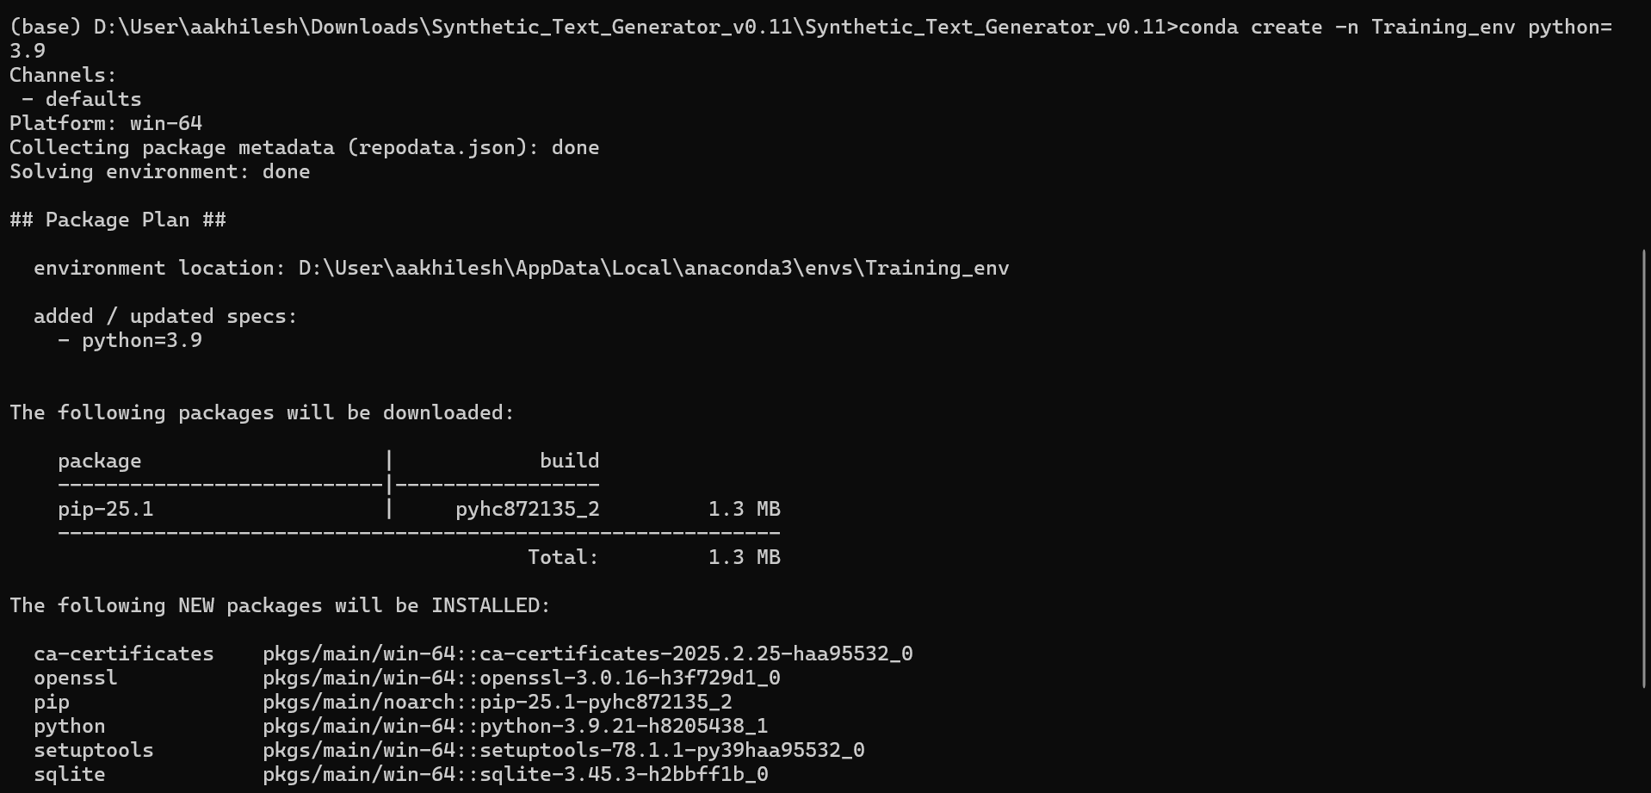

1. Use the environment by activating it:

conda activate “your_environment_name”

