Task 2:
Level 0:
Used ssh username@hostname -p 2220
SSH has a default port number of 22 unless changed. Here ssh is located on port number 2220, hence we target port number 2220 to establish a connection.
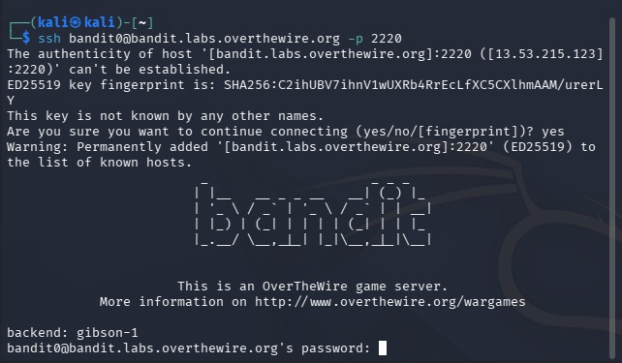
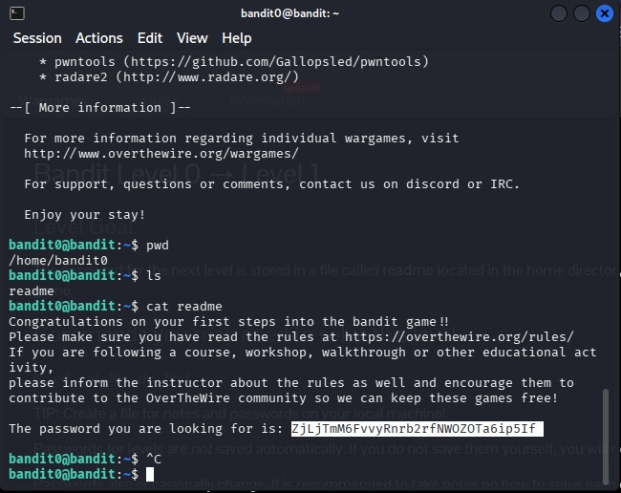
Was supposed to access password for level 1 stored in readme file . used Cat command to do so. First listed all the present files to ensure readme was present in the working directory.
Level 1-2:
Established connection using the password obtained form level 0, was supposed to access password stored in a file named (-). However, names starting with a (-) are mistaken for a flag. So, the system needs to explicitly know that it is a file in the current working directory, I had to give its absolute path. For this I used “./”. Thus I could access the password
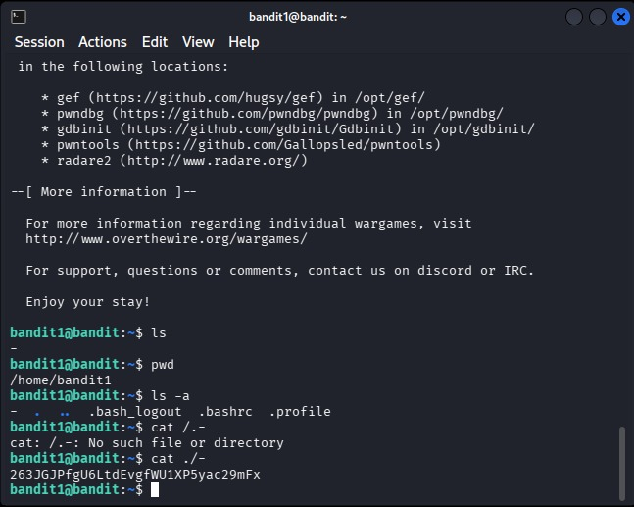
Level 2-3:
The password was in a file with spaces in its name. using direct cat <filename> would not work, so I tried to handle it using double quotes so that the system treats it as a single string and not separate elements. However, it still needed explicit mention that it is a file in the current working directory and give its absolute path. For this I used ./” --Filename with spaces--”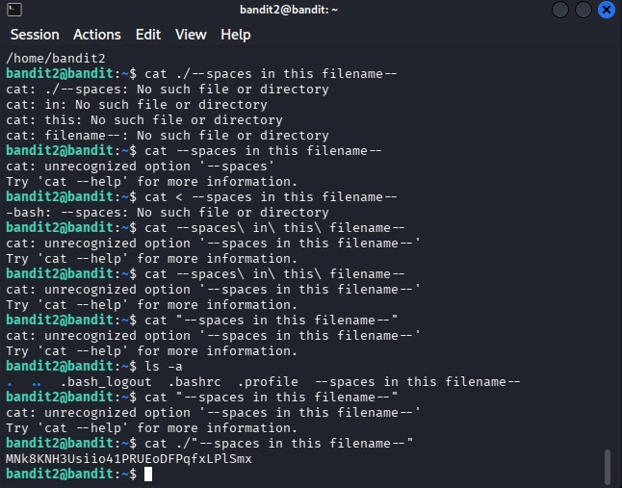
Level 3-4:
In level 3, the password was stored in a directory rather than a file, so I used cd to change the directory and then listed all the files, to find the correct ones.
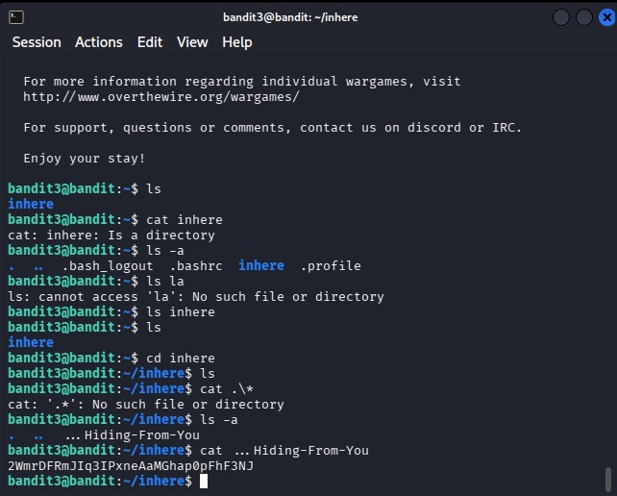
Level 4-5:
The only text readable file in the directory was -file07. Used brute-force to guess. Accessed it using the absolute path
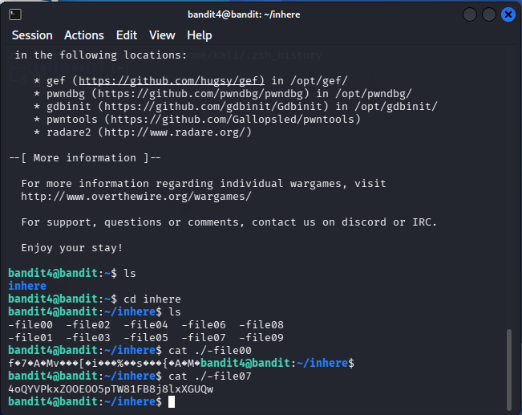
Level 5-6:
As specifications of the file type and search scope increased, I resorted to using the find command.
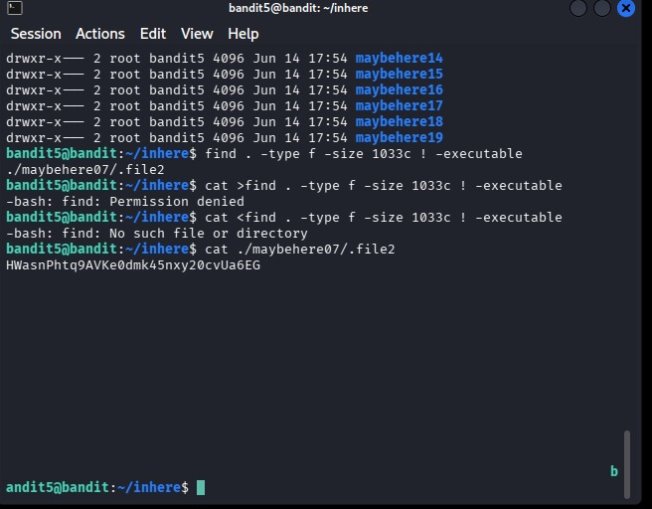

Level 6-7:
Used the find command to filter using the user and group criteria. To find it in the entire system used the / command. After this, errors started showing up, which made it difficult for me to access the correct file, so I decided to divert all the errors in the (2) that is the “stderr” file using the “2 > /dev/null”
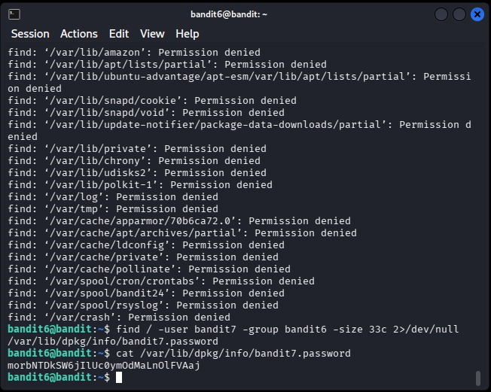
Level 7-8:
I initially resorted to the find command, however I realised it was applicable for files, so I used the grep command to find the word in the file data.txt.
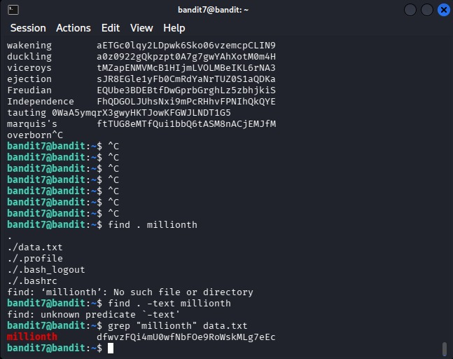

Level 8-9:
The file had repeated lines, and only a unique line mattered. I realized frequency matters, so I sorted data first to group duplicates, then filtered unique lines.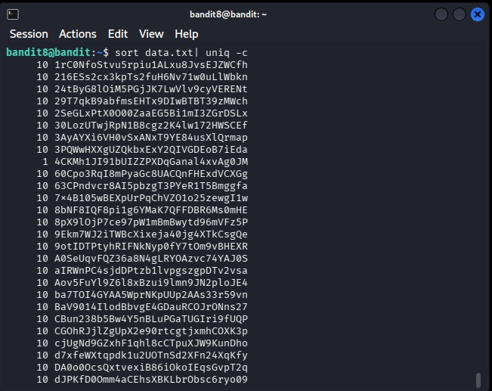

Level 9-10:
Binary data needed extraction first. I used strings to extract readable text, then filtered with patterns, for this I created a pipeline using the | operator.
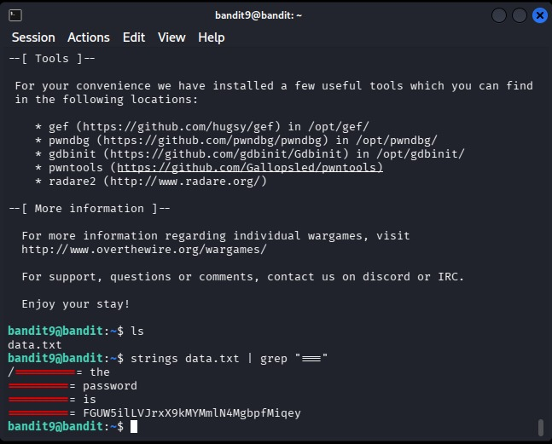
Level 10-11:
The file was base64 encoded. The format was encoded and not encrypted, so it was possible to decode it directly.
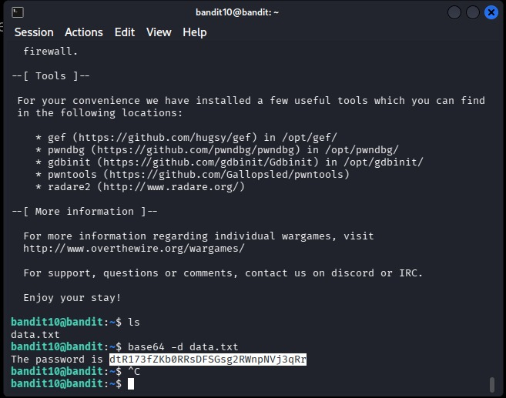
Level 11-12:
I checked the conditions and realised the data was encoded using a simple text rotation cypher ROT13,which shifts the text by 13 places. I used translate command to map every letter to its decoded letter. After decoding, the output revealed itself.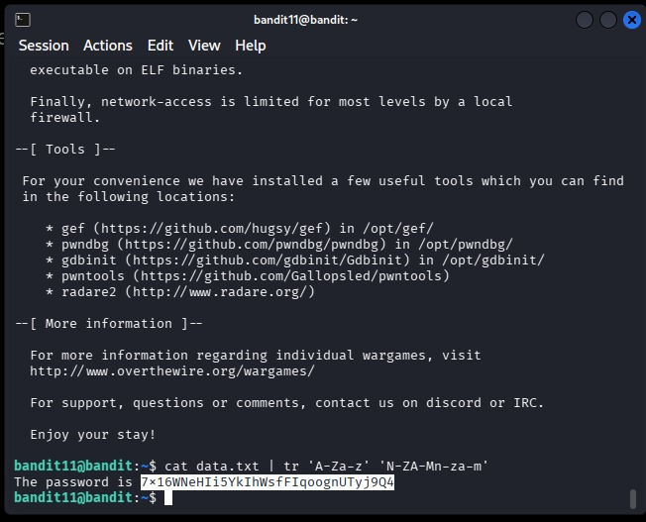

Level 12-13: Run a series of operations to get the answer.
My first idea was to recreate the original file from the hexdump using [xxd -r], and then check what type of file it actually became using file. From there, I realised this wasn’t a one-step solution, it was a chain of compressed files hidden inside each other. When I saw gzip and bzip which are compression formats, I decompressed it. When I saw tar, which is a container, I extracted it. For this, I searched up the required commands. I run a series of commands until I saw an ASCII file, that contained the password. To9 keep a continuous track on what is exactly happening, I used the [file *] command and [ls] commands frequently after each step. Once I found the extracted ASCII format of the copied file data.txt, I accessed the password using the cat command.
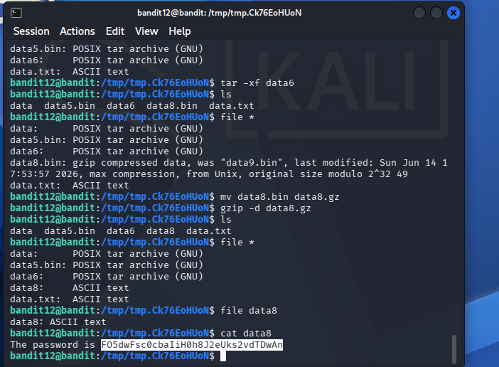
Level 13-14:
Gave a private SSH key in the home directory.
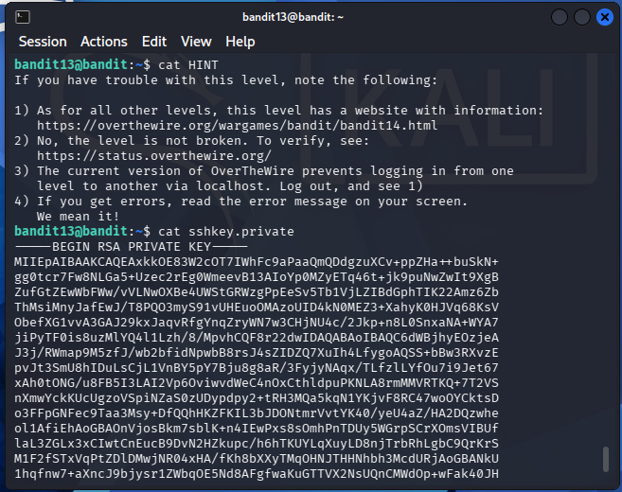

Level 14-15:
Saved the key in a file and used it to enter the bandit 14 . First I tried to paste the entire key, It required user elevation permissions. So I used “sudo” command, but then decided to instead save it in a file, so I can elevate the permissions myself, and it will be more readable and understandable. SO I created a file and elevated the permissions
