**iAgroPod**

**Abstract**

Food scarcity, quality of food, land degradation, fertilizers, and other chemicals are becoming major problems all over the world. In 2020, nearly one of every three people in the world did not have access to adequate food; that is an increase of almost 320 million people in just one year. Around 660 million people may still face hunger in 2030, and this may increase further.

The urbanization had led to a decrease in the availability of land for cultivation over the last 10 years, and to fulfil the need for food, the farmers had started using chemicals and fertilizers to meet the demand, but now we had come to a situation where the chemicals had made the land unfertile. In the next 10 years, we will have reached the point where there will be no land left for cultivation.

To solve the problem of the availability of land and food, we came up with the idea of "**iAgroPod"**, an intelligent method and model for cultivation which does not require any soil for plant growth. **The model is based on two aeroponic methods (high thature aeroponic and fogponic), which were not widely used in the past due to a lack of available technology and resources.** This method requires far less land and water than traditional farming methods. The nutrients are provided to plants in the form of a fog with an approximate size of 10–20 microns. Plants grow faster than in the traditional method due to the abundant availability of oxygen. This model works with both horizontal and vertical farming methods, allowing you to grow 10 hectares or more of crop in just 1 hectare. The plants grown on this model does not require any chemicals for the growth leading to increase the need of this method and model for Cultivation.

**Advantages of iAgroPod**

* **Need of water**- The amount of water needed for the growth of plant is much less as compare water required in Traditional method for irrigation.
* **Quality of Plants**- Amount of oxygen available for the growth of plants is much more as compare to traditional methods with will lead to healthy and faster growth of plants.
* **Land**- The quantity of land required in this method is much less as compare to Traditional method for irrigation.
* **Time required for Plants growth**- The time required for the growth of plants is much less than the traditional methods for irrigation. It can grow plants in half of the time needed in the traditional methods
* **Varity of plants**- The verity of plants can differ with user to user. Depending on the requirement it can grow different type of plants at the same time.
* **Nutrients Absorption**- The absorption of nutrients is inversely proportional to the size of water droplet, so smaller the size of droplet greater the extent of absorption. Due to this reason the absorption of nutrients is much larger in our method.

**Model for iAgroPod and its Advantages-:**

* **Self- sustaining-** With help of IOT we have made our model self-sustaining. Now it can work independently without any human interaction. All the processed that are going on can be seen on its application. With help of IOT the precision of nutrients required for plants growth increases.
* **Green House Effect-** This is the important effect required for the healthy plant growth. With help of artificial greenhouse effect, the plant can have a better environmental condition which will lead to better growth of plants.
* **Temperature and Humidity regulation-** Temperature and humidity plays an important role in the plant growth. Its regulation is important as if the temperatures rise beyond its level, it can also lead to damage of plats so its regulation.
* **Ladder Model-** We have designed a different model for irrigation in which in 1 Hector of land now you can grow plants of 10 hector and more depending on the requirement.
* **Varity of Plants-** Growing different plants at same time is very difficult and this seems to be impossible with traditional methos of irrigation but with our model the amount of nutrients required for different plants can be supplied as per there need.
* **Application Controlled-** The whole process that are going in the growth of plants like nutrition level, surrounding condition, plants health and many more can be seen through its personalize application and can also perform different functions.

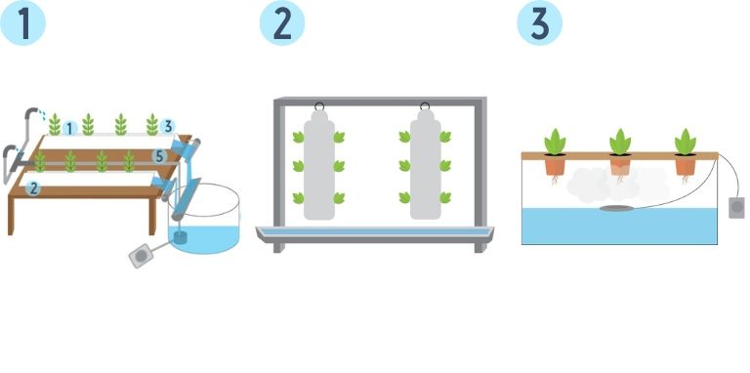

**Working**

Like an hydroponics system, plants are given with moisture, nutrients, oxigen. They do not have to actively seek for these like in the soil counterparts. iAgroPod works by hanging the plants in container/tray/foam in the presence of air. The plant roots are suspended, so they have plenty of oxygen access. Water is provided by plants via the foggers.

The process was also controlled by timer.

iAgroPod operates just like aeroponics. But instead using the water in the form of tiny droplets form spray bottles, the foggers are used.  
They produce and convert into very much fine droplets than in aeroponics, usually less than 10 microns in size (the size of general droplets in spray is larger than 20 microns).

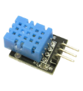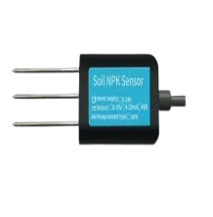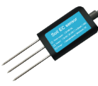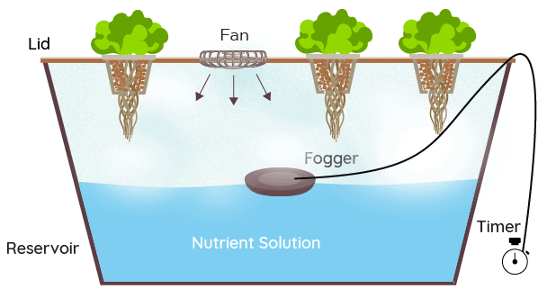

**Techstack**

**Software**- Mainly software is composite of an android application. Android application consists of three screens. Login credentials are provided to the each and every particular user. Through other screens you can control the nutrients proportion, salinity, water pump, air pump, light control factors and many more. All the above process is communicated through an IOT server.

**Hardware**- Our prototype is embedded with different types of sensors. It has sensors like NPK, EC, humidity, temperature sensors and many more. All these sensors are synchronised with the app and give us the live update about the particular plant.

**Layout of iAgroPod:**

* **A container:** Anything large enough that can hold water and at least one or two plant.
* **A lid:**This will cover your reservoir and keep the fog from escaping. You will also need to drill some holes to place the net pot with the plants in it.
* **A net pot:** Get the size you find fit in system. It will fill with the growing media (hydroton, perlite, vermiculite). It will place at the net pot on the reservoir. It must be held by the lid or closed-cell so that when plants are put into the net pot, their roots are hung above the water of the reservoir.
* **Nutrient:** Plants do need nutrients. The liquid form as it works best in the fogponics system. We can also use the powder form, and make it totally dissolved. Stay away from any organic nutrient form because it can clog our fogponic system. We prefer the 3-part General Hydroponics. After choosing the nutrients, Fill them in the reservoir.
* **Fogger and Sprayer set (Simillar to Blatic Freya 2.0):** This is the most important apparatus as it decides whether you call it aeroponics or fogponics. Put it in the reservoir. Turn it on, and let the fog come out.
* **A micro fan**: We can place it above or below the root. Aim the fan at the direction that helps regulate the fog around the roots.
* **pH measurement sensor:** Get a pH meter to first check the pH of the system, and occasionally recheck it later.
* **A pH control kit:** We prefer pH up and down. If the pH of our system is too low or too high, just add the appropriate pH control kit into it.
* **NPK sensor:** The soil NPK sensor is suitable for detecting the content of nitrogen, phosphorus, and potassium in the soil, and judging the fertility of the soil.

**PROS AND CONS iAgroPod:**

**Pros:**

* Tiny sized droplets.
* High Nutrient concentration.
* Easy to clean.

**Cons:**

* Heat from the atomizer.
* Built up salt.
* Susceptible to power outage.

**Flowchart:**

