Employee Management System - Features Documentation
Backend Feature Documentation
Version: 1.0
Technology Stack: Spring Boot, Spring Security, JWT

Project Overview
The Employee Management System is a secure backend application developed using Spring Boot and Spring Security.
The system provides authentication, employee management, role-based authorization, and multiple security mechanisms to protect user accounts and sensitive operations.
The application supports:
• JWT-based authentication
• Refresh token rotation
• OAuth2 login (Google & GitHub)
• Role-based access control
• Account security and blocking mechanisms
• Admin monitoring dashboard
The system is designed with multiple layers of security including token blacklisting, login attempt tracking, and centralized exception handling.

Core Features
The system provides the following capabilities:
• User Authentication and Authorization
• Employee Management (CRUD Operations)
• Secure JWT Authentication
• Refresh Token Rotation
• OAuth2 Login (Google & GitHub)
• Role Based Access Control (RBAC)
• Account Blocking and Security Mechanisms
• Admin Monitoring Dashboard
• Centralized Exception Handling
• Secure Logging System

Authentication Features
User Login
Endpoint
POST /api/login
Functionality:
• Authenticates user using username and password
• Generates JWT Access Token
• Generates Refresh Token
• Returns authentication response with expiry information
Example Response:
{
"token": "eyJhbGciOiJIUzI1NiJ9...",
"refreshToken": "rt_xxxxxxxxx",
"username": "admin",
"timeStamp": "2026-03-12T17:31:37",
"expiryTime": "2026-03-12T17:46:37"
}
Error Example:
{
"error": "Unauthorized The request is unauthenticated please pass the correct auth credentials."
}
Security Handling:
• Tracks failed login attempts
• Automatically blocks user after 5 failed attempts
• Prevents brute-force login attacks

OAuth2 Login
The system supports OAuth2 authentication, allowing users to sign in using external identity providers.
Supported Providers
• Google
• GitHub
OAuth2 authentication is implemented using Spring Security OAuth2 Client.
OAuth Flow
- User selects OAuth provider
- User is redirected to provider login page
- After successful authentication:
- User account is created (if not already existing)
- JWT tokens are generated
- User session continues using JWT authentication
http://localhost:8090/login/oauth2/authorization/google
http://localhost:8090/login/oauth2/authorization/github

Token Security

Logout System
Endpoint
POST /api/logout
Functionality:
- Extracts JWT token
- Adds token to blacklist
This prevents reuse of old tokens.
Response Example: Logged out successfully

Token Refresh
Endpoint
POST /api/refresh
Functionality:
- Validates refresh token
Example: {
"refreshToken": "rt_xxxxxxxxx”
}
OR Error Response Example:
{
"error": "Unauthorized The request is unauthenticated please pass the correct auth credentials."
}
- Rotates refresh token
- Generates new access token
Example: {
"token": "eyJhbGciOiJIUzI1NiJ9xxxxxxxx",
"refreshToken": "rt_xxxxxxxxxx",
"username": "xxxx",
"timeStamp": "2026-03-12T18:01:25.0657257",
"expiryTime": "2026-03-12T18:16:24"
}
This ensures secure session management without forcing user to login again.

Security Features

Temporary Account Blocking
If a user enters wrong password 5 times:
- Account is blocked
- Lock duration = 30 minutes
- This prevents brute force attacks.

Permanent Account Blocking (Admin)
Endpoint
POST /api/admin/block/{id}
Admin can permanently block any user account.
Effects:
- Account disabled
- User cannot login
- Only admin can unblock
Response Example:
User's account has been permanently blocked Only can be unblocked by you
OR( If Wrong )
error: Invalid JWT token
OR
{
"timestamp": "2026-03-13T12:25:49.4499723",
"status": 404,
"message": "User with id {id} not found",
"username": "/api/admin/block/{id}",
"reason": "Employee not found",
"expiryTime": "2026-03-13T12:40:49.4509817"
}

Self Account Block
Endpoint
POST /api/self-block
Users can permanently disable their own account for security reasons.
Response Example: Your account has been permanently blocked and can only be unblocked by admin

Unblock User (Admin)
Endpoint
POST /api/unblock/{id}
Admin can:
- Re-enable account
- Reset failed attempts
- Remove block status
Response Example :
User unblocked successfully by Admin
OR( If Wrong)
{
"timestamp": "2026-03-13T12:25:49.4499723",
"status": 404,
"message": "User with id {id} not found",
"username": "/api/admin/block/{id}",
"reason": "Employee not found",
"expiryTime": "2026-03-13T12:40:49.4509817"
}

Employee Management

Create Employee
Endpoint
POST /api
Access : ADMIN
Functionality
• Creates a new employee
• Creates associated user account
• Password is securely encrypted using BCrypt
Example Request :
{
"name": "Ram Sharma",
"email": "ram@gmail.com",
"department": "IT",
"username": "ram",
"password": "ram123"
}
Example Response :
{
"name": "Ram Sharma",
"email": "ram@gmail.com",
"department": "IT"
}

Username Already Exists Protection
Before creating a user, the system checks if the username already exists.
If the username already exists, the user creation process is rejected.
Error Example :
{
"timestamp": "2026-03-13T16:30:00",
"status": 409,
"message": "Username already exists: ram",
"path": "/api",
"reason": "Username already exists"
}

Get Employee By ID
Endpoint
GET /api/employee/{id}
Access: ADMIN
Returns employee details.
Response Example :
{
"department": "IT",
"email": "ram@gmail.com ",
"name": "Ram",
"password": null,
"username": null
}
Error Example :
{
"timestamp": "2026-03-13T12:25:49.4499723",
"status": 404,
"message": "User with id {id} not found",
"username": "/api/admin/block/{id}",
"reason": "Employee not found",
"expiryTime": "2026-03-13T12:40:49.4509817"
}

Update Employee
Endpoint
PUT /api/{id}
Access : ADMIN
Allows admin to update employee information.

Delete Employee
Endpoint
DELETE /api/{id}
Access : ADMIN
Deletes employee record.

User Management

Get All Employees
Endpoint
GET /api
Access : ADMIN
Returns list of all employees.

Get All Users
Endpoint
GET /api
Access : ADMIN
Returns list of all users.

Get Own Profile
Endpoint
GET /api/me
Access : Authenticated Users
Returns profile of the currently logged-in user.

Admin Dashboard
Endpoint
GET /api/dashboard
Access : ADMIN
Provides dashboard statistics such as:
total employees
blocked users
system statistics
Example :
{
"hrDepartmentCount": 1,
"itDepartmentCount": 1,
"totalEmployees": 3,
"totalUsers": 4
}

Blocked User Monitoring

Get Temporary Blocked Users
Endpoint
GET /api/temp-blocked
Access : ADMIN
Admin can see users temporarily blocked due to login failures.

Get Permanent Blocked Users
Endpoint
GET /api/permanent-blocked
Access : ADMIN
Admin can view permanently blocked accounts.

Role Based Access Control
The system supports RBAC (Role Based Access Control).
Roles: ADMIN
USER
Security enforced using:
@PreAuthorize
Example:
@PreAuthorize("hasRole('ADMIN')")

Error Handling & Exception Management
The system uses Global Exception Handling.
Implementation
@RestControllerAdvice
Handles exceptions such as
• EmployeeNotFoundException
• UsernameAlreadyExistsException
• BadCredentialsException
Example Error Response
{
"timestamp": "2026-03-13T16:30:00",
"status": 409,
"message": "Username already exists",
"path": "/api",
"reason": "Username already exists"
}

Logging and Monitoring
The system uses SLF4J logging.
Logs capture
• Login attempts
• Token generation
• Account blocking
• Admin actions
• Employee operations
This helps in monitoring and debugging the application.

Security Stack Used
Technologies implemented:
• Spring Boot
• Spring Security
• JWT Authentication
• OAuth2 Login (Google & GitHub)
• Refresh Token Rotation
• Token Blacklisting
• Role Based Authorization
• Account Lock Mechanism
• Global Exception Handling
• SLF4J Logging

Key Security Mechanisms
The system implements multiple security layers:
• JWT authentication
• Refresh token rotation
• OAuth2 login support
• Login attempt tracking
• Temporary account lock
• Permanent admin block
• Token blacklist for logout
• Role based authorization
• Centralized exception handling

API table format :

API | Method | Access | Description
/api/login | POST | Public | User login
/api/refresh | POST | Public | Refresh token
/api/logout | POST | Authenticated | Logout user
/api/self-block | POST | USER | Self block account
/api/admin/block/{id} | POST | ADMIN | Block user
/api/unblock/{id} | POST | ADMIN | Unblock user
/api | POST | ADMIN | Create employee
/api/{id} | PUT | ADMIN | Update employee
/api/{id} | DELETE | ADMIN | Delete employee
/api/dashboard | GET | ADMIN | Dashboard stats
/api/temp-blocked | GET | ADMIN | Temporary blocked users
/api/permanent-blocked | GET | ADMIN | Permanent blocked users
/api/employee/{id} | GET | ADMIN | Get employee
/api | GET | ADMIN | Get all employees
/api/users | GET | ADMIN | Get all users
/api/me | GET | Authenticated | Get own profile

System Architecture
The application follows a layered architecture pattern, which separates responsibilities into different layers.
Architecture Layers:
Client Layer
↓
Controller Layer
↓
Service Layer
↓
Repository Layer
↓
Database

Architecture Components
Client Layer
Handles user interaction.
Examples:
• Postman

Controller Layer
Responsible for handling HTTP requests.
Main responsibilities:
• Receive API requests
• Validate input
• Call service layer
• Return response
Example:
EmployeeController
AuthController

Service Layer
Contains business logic of the application.
Responsibilities:
• Process business operations
• Validate data
• Manage transactions
• Call repository layer
Example:
EmployeeService
RefreshTokenService
DashboardService

Repository Layer
Responsible for interacting with the database using Spring Data JPA.
Example:
UserRepository
EmployeeRepository
RefreshTokenRepository

Security Layer
The system includes a dedicated security layer.
Main components:
- Spring Security
- JWT Authentication Filter
- OAuth2 Login
- Token Blacklist Service
- Role-Based Authorization
Security Flow:
Request
↓
JWT Filter
↓
Authentication Manager
↓
Security Context
↓
Controller Access

Database Schema Documentation
The application uses MySQL database.
Main tables:
• users
• employees
• refresh_tokens

Users Table
Stores authentication and account-related information.
Column | Type | Description
- id | Long | Primary key
- username | String | Unique username
- password | String | Encrypted password
- role | String | User role (ADMIN / USER)
- email | String | User email
- department | String | Department name
- failedAttempts | int | Login failure counter
- blocked | boolean | Block status
- blockType | ENUM | TEMPORARY / PERMANENT
- enabled | boolean | Account enabled status
- lockoutTime | LocalDateTime | Lock expiration time

Stores employee-related information.
Column | Type | Description
id | Long | Primary key
name | String | Employee name
email | String | Employee email
department | String | Department
user_id | Long | Foreign key to users table
Relationship:
Employee
|
OneToOne
|
User
Meaning:Each employee is linked to one user account.

Refresh Tokens Table
Stores refresh tokens used for JWT token rotation.
Column | Type | Description
id | Long | Primary key
token | String | Refresh token
username | String | Associated user
expiryDate | LocalDateTime | Token expiration

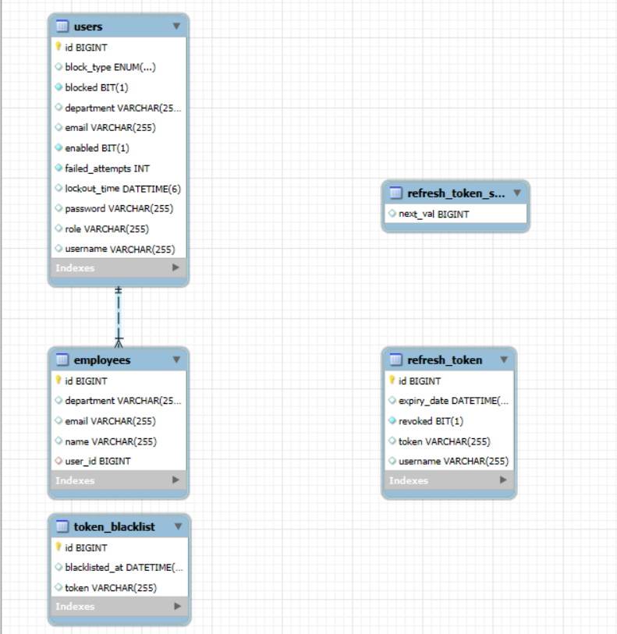

Security Flow Diagram
The authentication process follows the flow below:
User Login Request
↓
Authentication Manager
↓
JWT Token Generated
↓
JWT Stored on Client
↓
Client sends JWT in request header
↓
JWT Authentication Filter
↓
Token Validation
↓
Request Allowed to Controller

OAuth2 Authentication Flow

User Clicks OAuth Login
↓
Redirect to Provider (Google/GitHub)
↓
User Authentication
↓
Provider Redirects to Application
↓
OAuthSuccessHandler Executes
↓
User Created (if new)
↓
JWT Tokens Generated
↓
User Logged Into System

Exception Handling Architecture
The system uses Global Exception Handling.

Controller
↓
Service
↓
Exception Thrown
↓
GlobalExceptionHandler
↓
Structured Error Response

Example Error Response
{
"timestamp": "2026-03-13T17:20:00",
"status": 404,
"message": "Employee not found",
"path": "/api/employee/10",
"reason": "Employee not found"
}

