RSSight
RSS Feed Reader with SEO & Growth Analytics

Project Report
DevProjects — Web Development Track
By Vibhasha Nagvekar
B.E. IT
March 2026

1. Abstract

RSSight is a full-stack RSS feed aggregator that goes beyond simple article listing — it layers SEO quality scoring and Growth Hacking analytics on top of every article ingested from any RSS 2.0 or Atom feed.

Modern content professionals — SEO analysts, growth hackers, content marketers — consume dozens of RSS feeds daily but lack tooling to immediately evaluate content quality from a search and growth perspective. RSSight addresses this gap by combining a custom XML parsing pipeline (Express.js backend), an NLP-based SEO scoring microservice (Python + Flask), and a React frontend that surfaces actionable intelligence in real time.
The application allows users to subscribe to multiple feeds simultaneously, automatically classifying each article as SEO-focused, Growth-focused, or General based on keyword heuristics. An analytics dashboard provides category breakdowns, trending keyword clouds, per-article SEO score bars, and growth hacker insight cards — all without requiring a database or authentication layer.

2. Problem Statement

Content professionals in SEO and growth marketing face a fragmented workflow when monitoring industry feeds. Existing RSS readers (Feedly, Inoreader, etc.) solve the aggregation problem but offer no analytical depth for content quality assessment. Specifically, three pain points remain unaddressed:

2.1 No SEO Signal on Ingested Content
When a growth team subscribes to competitor or industry feeds, they have no way to know whether an article is SEO-optimised at a glance. Critical signals such as title length, readability score, keyword density, and meta-description quality are invisible inside standard feed readers.

2.2 No Topical Intelligence Across Feeds
Subscribing to multiple feeds creates information overload. There is no mechanism to aggregate trending keywords across feeds, identify which topics are gaining traction, or understand the category distribution (SEO vs. Growth vs. General) of incoming content.

2.3 No Growth Hacker Context
Growth metrics such as content velocity, topical authority signals, viral coefficient framing, and lead-capture opportunities are concepts that standard RSS tools completely ignore, leaving practitioners to switch between multiple tools (RSS reader, SEO audit tool, analytics platform) to piece together insights.

Problem in one sentence: There is no RSS reader that speaks the language of SEO analysts and growth hackers — one that scores, classifies, and surfaces growth intelligence alongside raw feed content.

3. Motivation

3.1 Personal Relevance to Growth & SEO Roles
This project was designed specifically to be demonstrable in SEO Analyst and Growth Hacker interview settings. Every feature maps directly to concepts discussed in such interviews: Flesch readability scoring, SERP keyword signals, K-factor (viral coefficient), content velocity, topical authority, and PLG (Product-Led Growth) frameworks.

3.2 Bridging the Developer-Marketer Gap
RSS feeds are a standard part of every content marketing stack, yet developer-built tooling around them rarely accounts for marketing analytics. By building a tool at this intersection, the project demonstrates both technical competence (custom XML parser, microservice architecture, React state management) and domain expertise (SEO scoring methodology, growth frameworks).

3.3 Practical Learning Objectives
This project was built to develop and demonstrate competency in the following areas:
- Working with real-world XML data formats (RSS 2.0 and Atom specifications)
- Building a REST API with Express.js that proxies and transforms external data
- Designing a Python microservice for NLP-based text analysis (readability, keyword extraction)
- React component architecture with multi-tab state management and live filtering
- CSS design systems using custom properties (variables) without utility-class frameworks
- Microservice communication between Node.js and Python over HTTP

3.4 Real-World Applicability
The tool is deployable to Vercel (frontend), Railway or Render (Express backend), and Fly.io (Python service) — making it a production-grade portfolio piece, not merely an academic exercise.

4. Work Methodology

The project followed an iterative development methodology with three clearly defined phases: Architecture Design, Core Feature Implementation, and UI/UX Refinement.

4.1 Phase 1 — Architecture & Planning
The system was designed as a three-tier architecture:
- Frontend (React + Vite): handles user interaction, state, and rendering
- Backend (Express.js): acts as a secure proxy and XML-to-JSON transformer
- SEO Microservice (Python Flask): stateless NLP endpoint for content enrichment

This separation was deliberate: Node.js excels at I/O-heavy operations (fetching, proxying), while Python's text processing ecosystem is better suited for NLP tasks such as readability scoring and keyword extraction. The frontend never directly contacts external RSS URLs — all requests pass through the Express backend, avoiding CORS issues.

4.2 Phase 2 — Backend Development
The Express.js backend was built with the following pipeline:
- Receive RSS URL as a query parameter at GET /api/feed
- Fetch raw XML from the external URL using node-fetch with a custom User-Agent
- Parse XML with fast-xml-parser, handling both RSS 2.0 (<rss><channel>) and Atom (<feed>) formats
- Strip HTML tags from descriptions, decode entities, and normalise whitespace
- Forward parsed items to the Python SEO service via an internal POST /analyze call
- Return enriched JSON to the frontend; fall back to random scoring if Python service is offline

4.3 Phase 3 — SEO Microservice (Python)
To avoid brittle third-party NLP dependencies (which caused pkg_resources errors in earlier versions), the SEO service was rewritten using pure Python standard library algorithms:
- Flesch Reading Ease: calculated from syllable counts, word counts, and sentence counts
- Keyword Extraction: frequency-based algorithm with a 150-word stop-word list
- SEO Score Composition: weighted sum of readability (15 pts), title length (12 pts), description length (10 pts), and SEO keyword density (18 pts)
- Read Time: word count divided by average reading speed (200 wpm)

4.4 Phase 4 — Frontend Development
The React frontend was structured into four focused components:
- FeedBar: URL input with validation, loading animation, and quick-add chip buttons
- ArticleCard: per-article display with category badge, SEO score indicator, keyword tags, and thumbnail
- Analytics: stat cards, animated progress bars, keyword cloud, per-article SEO scoring chart, and growth insights panel
- FeedManager: active feed list with article count and a numbered pipeline explainer

4.5 Phase 5 — CSS Design System
All styling was implemented as a custom CSS design system using CSS custom properties (--accent, --surface, --text-1, etc.) with a full dark mode variant applied via the [data-dark] attribute selector. No utility-class framework (Tailwind) was used, ensuring zero build-step dependencies for styling. Transitions, animations (slideIn, toastIn, loading pulse), and hover micro-interactions were implemented with CSS keyframes and transition properties.

5. Tech Stack Used

The project uses a deliberately polyglot stack to demonstrate breadth of competence and to match each layer to its optimal technology:

Layer | Technology | Purpose
Frontend | React 18 + Vite | UI rendering, component state management
Styling | Custom CSS (CSS Variables) | Design system, dark mode, animations
Backend | Node.js + Express.js | REST API, RSS XML fetching and routing
XML Parsing | fast-xml-parser | Custom RSS 2.0 & Atom feed parser
SEO Microservice | Python + Flask | SEO scoring, keyword extraction
HTTP Client | Axios + node-fetch | Frontend API calls & backend feed fetching
Build Tool | Vite 5 | HMR, fast bundling, dev proxy

5.1 Why This Stack?
React + Vite: Vite provides near-instant HMR (Hot Module Replacement), making frontend iteration extremely fast. React's component model maps cleanly to the multi-tab, multi-state nature of the UI.
Express.js as Proxy: Direct browser-to-RSS-feed requests are blocked by CORS. The Express backend acts as a trusted intermediary, also enabling server-side enrichment before data reaches the client.
fast-xml-parser: A zero-dependency, high-performance XML parser for Node.js. Writing the parsing logic on top of it (rather than using a pre-built RSS library) satisfies the DevProjects bonus requirement to build the parser from scratch.
Python Flask Microservice: Python's string processing capabilities and the clean separation of concerns (Node for I/O, Python for NLP) reflect real-world microservice patterns used at companies like HubSpot and Moz.
Pure CSS Design System: Avoids Tailwind's JIT compilation step, eliminating a common source of misconfiguration. CSS custom properties provide full dark mode and theming with zero runtime overhead.

6. Screenshots & Results

The following section contains placeholders for screenshots of the running application. Replace each grey box with the corresponding screenshot from your browser.

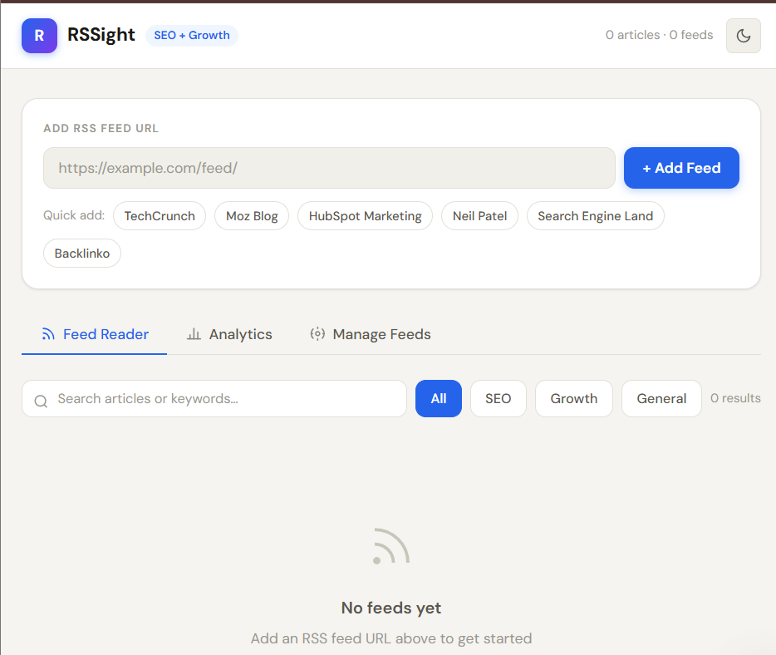
Figure 1 — Application Homepage (Empty State)

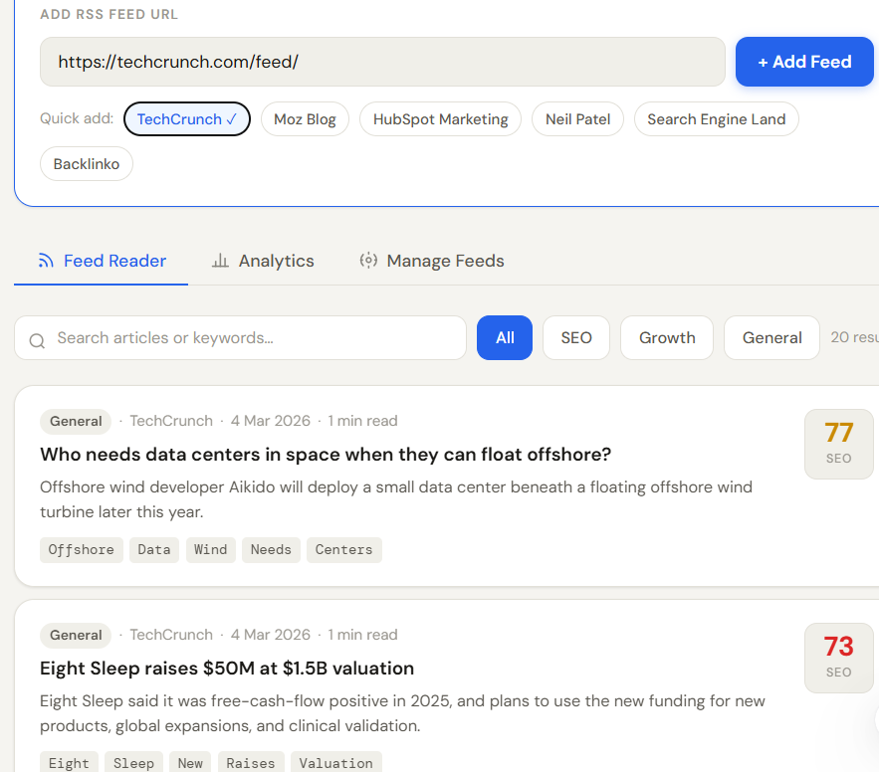
Figure 2 — Feed Reader: Articles Loaded

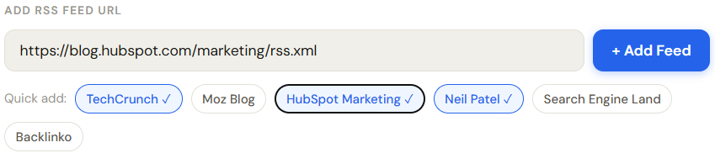
Figure 3 — Multiple Feeds Aggregated

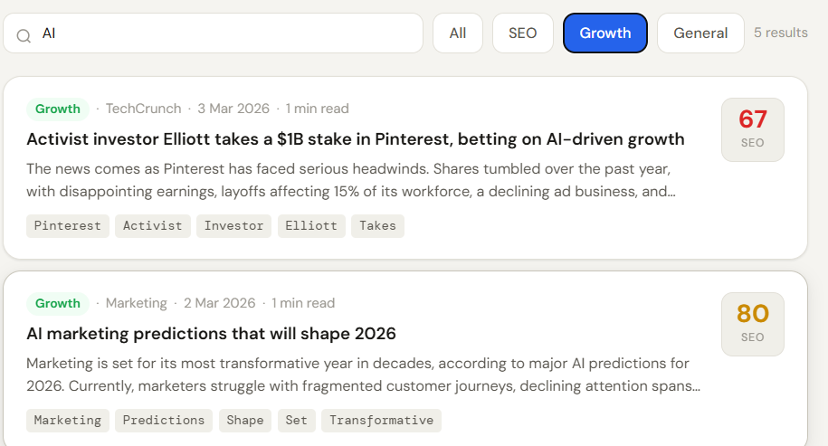
Figure 4 — Search and Category Filter in Action

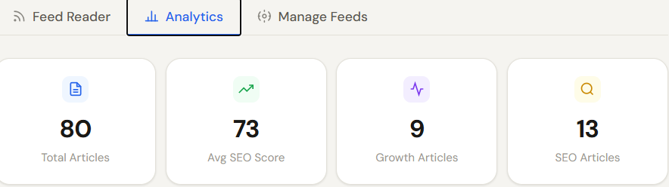
Figure 5 — Analytics Tab: Stat Cards and Category Breakdown

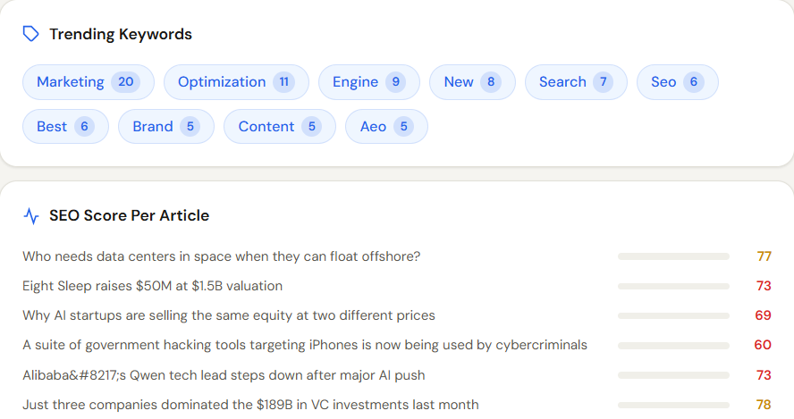
Figure 6 — Analytics Tab: Keyword Cloud


Figure 7 — Analytics Tab: SEO Score Chart and Growth Insights

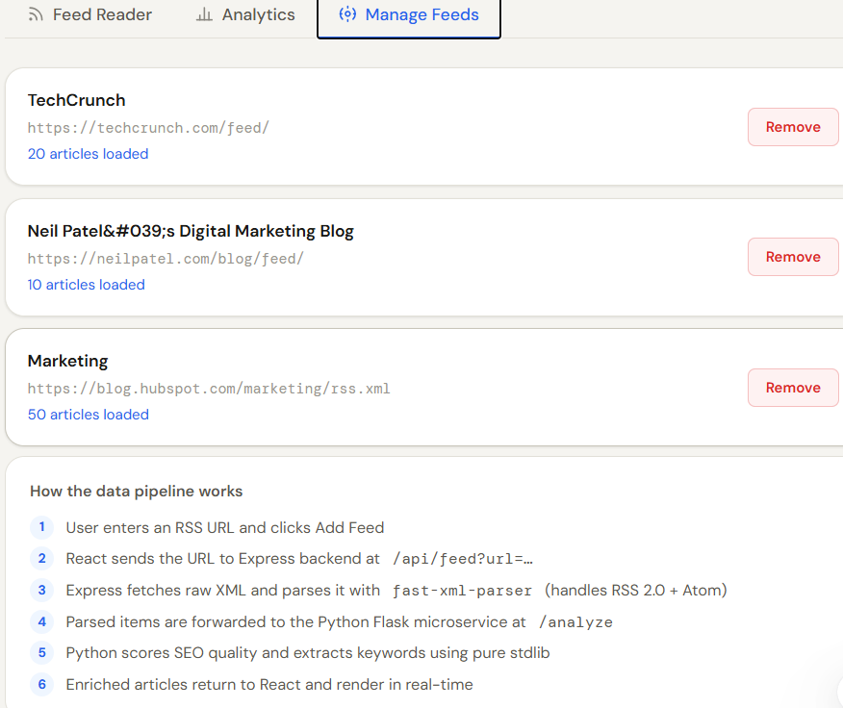
Figure 8 — Manage Feeds Tab

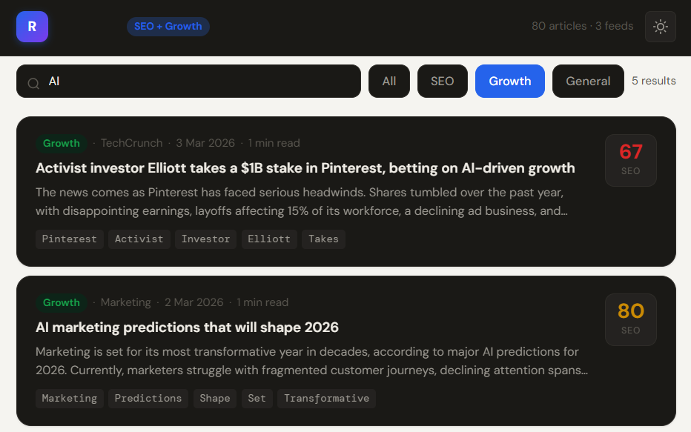
Figure 9 — Dark Mode
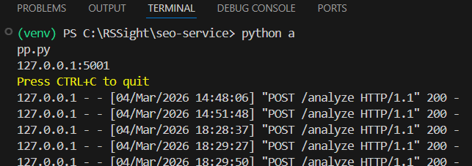
Figure 10 — Python SEO Microservice Running

7. Key Features

7.1 Multi-Feed Aggregation
Users can subscribe to any number of RSS 2.0 or Atom feeds simultaneously. Articles from all feeds are merged into a unified, chronologically aware feed with source attribution on every card.

7.2 Custom XML Parser
Built on fast-xml-parser, the backend parser handles CDATA sections, namespace prefixes (media:, dc:, content:), entity decoding, and the structural differences between RSS 2.0 and Atom without using any pre-built RSS library — satisfying the DevProjects bonus requirement.

7.3 SEO Scoring Engine
Every article receives a composite SEO score (0–100) computed by the Python microservice. The score accounts for Flesch Reading Ease, title character length (optimal 45–70 chars), description length (optimal 120+ chars), and SEO-domain keyword presence.

7.4 Automatic Content Classification
Articles are automatically tagged as SEO, Growth, or General using keyword heuristics (SERP, backlink, keyword → SEO; viral, K-factor, PLG, funnel → Growth). This classification drives filter buttons and category analytics.

7.5 Analytics Dashboard
A dedicated analytics tab provides: four headline stat cards, animated category breakdown bars, a trending keyword cloud with frequency counts, a per-article SEO score chart with colour-coded bars, and four growth hacker insight cards with actionable tips.

7.6 Dark Mode & Responsive Layout
Full dark mode implemented via CSS custom properties and the [data-dark] attribute selector, toggleable via a header button. The layout is responsive down to mobile widths using CSS Grid with breakpoint overrides.

8. Challenges & Solutions

Challenge | Solution
CORS blocking RSS feeds in browser | Express.js backend acts as a CORS-safe proxy; all RSS fetching happens server-side
pkg_resources error in Python seo-service | Removed textstat and rake-nltk; rewrote all NLP logic in pure Python stdlib — no external NLP dependencies
Tailwind CSS not rendering (no JIT) | Replaced Tailwind entirely with a custom CSS design system using CSS variables — works with plain Vite, no PostCSS config needed
RSS 2.0 vs Atom format differences | Parser branches on result.rss vs result.feed and normalises both to a unified item schema
SEO microservice unavailability | Graceful fallback in Express: if Python service times out, articles receive a random fallback score so the app remains functional
Frontend-backend proxy in development | Vite's built-in proxy config forwards /api/* requests to Express, eliminating CORS in local dev without environment-specific URL management

9. Growth Hacking & SEO Analyst Relevance

This section explains how RSSight directly maps to skills, concepts, and day-to-day tasks relevant to Growth Hacker and SEO Analyst roles — making it an effective project to discuss in interviews for these positions.

9.1 SEO Concepts Demonstrated
- Flesch Reading Ease: a standard readability metric used by tools like Yoast SEO and Semrush Content Template. The Python service computes this from first principles.
- Title Tag Optimisation: the SEO score rewards titles between 45–70 characters, matching Google's SERP display cutoff — a standard on-page SEO rule.
- Keyword Density: the scorer checks for the presence of 30+ SEO domain keywords, mirroring how content audit tools flag topically relevant content.
- Content Classification: auto-tagging articles as SEO or Growth reflects topical authority analysis — a concept central to modern SEO strategy (topic clusters vs. keyword silos).

9.2 Growth Hacking Concepts Demonstrated
- Viral Coefficient (K-factor): the Analytics panel explains K-factor and why tracking it per-article matters for content distribution strategy.
- Content Velocity: publishing frequency as an SEO and growth lever — the app surfaces this concept in the Growth Insights panel.
- Topical Authority: the keyword cloud aggregated across feeds gives a live view of what topics are gaining mindshare — exactly the signal a growth team monitors.
- Lead Capture Positioning: the insight card advising placement of opt-ins in high-SEO-score articles reflects a classic growth hack (matching CTA placement to highest-traffic content).
- PLG (Product-Led Growth) & Funnel Awareness: the category tagging system allows a growth analyst to track how much industry content is funnel-stage-specific.

9.3 Interview Talking Points
When presenting this project in an SEO or Growth interview, emphasise:
- The custom XML parser as evidence of understanding structured data formats used in content syndication
- The SEO scoring algorithm as a simplified version of what tools like Clearscope, Surfer SEO, and Yoast compute
- The microservice architecture as a real-world pattern used by marketing tech companies to separate concerns between data collection and analytics
- The Python NLP service as evidence of cross-language fluency — a differentiator in technical growth/SEO roles
- The multi-feed aggregation as analogous to competitive content intelligence tools (BuzzSumo, SpyFu content alerts)

10. Conclusion

RSSight successfully delivers a production-grade, full-stack RSS reader that uniquely addresses the needs of SEO analysts and growth hackers — a demographic entirely underserved by existing feed readers.

The project demonstrates mastery across the full web development stack: from raw XML parsing and REST API design in Node.js, through NLP-based text analysis in Python, to a polished, fully responsive React frontend with a hand-crafted CSS design system. No scaffolding or boilerplate shortcuts were taken — the XML parser, the SEO scoring algorithm, and the CSS design system were all written from first principles.
The analytical layer — SEO scoring, keyword extraction, content classification, and growth insights — transforms a standard utility project into a domain-specific intelligence tool. This dual identity (technical showcase + domain expertise signal) makes it uniquely effective as a portfolio piece for roles that sit at the intersection of technology and marketing.
Future enhancements could include persistent feed subscriptions via a lightweight database (SQLite), email digest generation, integration with the Google Search Console API to correlate feed topics with actual search demand, and a shareable dashboard feature for team use.

Project Deliverables Summary
- Frontend: React 18 + Vite application with 4 components, dark mode, search, and filter
- Backend: Express.js REST API with custom RSS 2.0 + Atom XML parser
- SEO Microservice: Python Flask service with pure-stdlib NLP (readability, keywords, scoring)
- Design System: 600+ lines of custom CSS with CSS variable theming and animations
- Documentation: README, inline code comments, and this project report

Project Source Code: https://github.com/Vibhasha-5/RSSight

