SECRETSCAN
Secret & API Key Detector
A Production-Grade DevSecOps Toolkit

By
Vibhasha Nagvekar
B.E. IT
March 2026

Category: Cybersecurity / DevSecOps
Stack: Python · Flask · Regex · Shannon Entropy Analysis

1. Abstract
SecretScan is a production-grade DevSecOps tool for detecting hardcoded API keys, tokens, passwords, and high-entropy strings across source code repositories. It combines two complementary detection engines: curated regex pattern matching for 30+ known secret types, and Shannon entropy analysis to surface unknown or obfuscated credentials.
The tool is delivered as a full-stack web application (Flask + HTML/CSS/JS), a command-line interface (CLI), and a CI/CD-ready pipeline integration. It produces both human-readable terminal output and machine-readable JSON reports, making it suitable for direct developer use and automated pipeline gates.

2. Problem Statement
Hardcoded credentials in source code are one of the most common and highest-impact security vulnerabilities in software development. A single exposed AWS key, Stripe secret, or database password can lead to data breaches, financial loss, and full system compromise.

2.1 The Scale of the Problem
Studies consistently show that thousands of secrets are committed to public repositories every day. The challenge is three-fold:
- Secrets are often added accidentally during development and not caught before pushing
- Standard code review processes do not reliably detect non-obvious secret patterns
- Entropy-based secrets (randomly generated tokens) are invisible to human reviewers

2.2 No Automated Gate in Most Pipelines
Most development teams lack an automated secret scanning step in their CI/CD pipeline. Without a programmatic gate that fails the build on detected secrets, credentials can reach production code undetected.

2.3 No Unified Tool for Multiple Secret Types
Existing free tools often cover only a subset of secret types and lack Shannon entropy analysis. SecretScan addresses this by combining pattern matching and entropy analysis in a single, extensible tool with a web interface, CLI, and JSON output.

3. Motivation

3.1 Cybersecurity Placement Relevance
SecretScan was designed to be demonstrable in campus placement interviews for security engineering, DevSecOps, and backend developer roles. Every technical decision — the modular detector architecture, Shannon entropy math, CI/CD exit code integration, and JSON report format — was made to generate interview talking points.

3.2 Practical Learning Objectives
The project was built to develop and demonstrate competency in the following areas:
- Regex Engineering: multi-pattern detection across 30+ secret types with false positive suppression
- Information Theory: Shannon entropy formula H = -Σ p(x) log₂(p(x)) applied to string analysis
- Python Architecture: SOLID principles, abstract base classes, single-responsibility detectors
- Flask Web Development: REST API design, file upload handling, JSON serialisation
- DevSecOps: CI/CD pipeline integration, exit codes as quality gates, JSON reporting for SIEM tools
- Frontend Engineering: responsive SPA with cinematic landing page, floating UI components

3.3 Real-World Applicability
SecretScan is deployed as a working web application accessible via a browser. It correctly detects real-world secret formats used by AWS, GitHub, Stripe, OpenAI, Slack, Google, Twilio, Discord, SendGrid, and more — making it immediately useful to any development team.

4. Work Methodology

4.1 Phase 1 — Architecture & Planning
The system was designed as a three-layer architecture:
- Detection Engine (src/): pattern detectors + entropy checker, all extending a shared BaseDetector
- Reporting Layer (src/report/): text formatter and JSON reporter for dual output formats
- Presentation Layer: Flask web app with full landing page UI + CLI entry point
This separation ensures the detection logic is fully decoupled from how results are presented — any new output format (Slack webhook, SIEM integration) can be added without touching the detectors.

4.2 Phase 2 — Detector Development
Three single-responsibility detector classes were built, each extending BaseDetector:
- APIKeyDetector: AWS Access/Secret keys, Google API keys, Stripe live/test keys, SendGrid, Mailgun, OpenAI, Azure Storage, Heroku, HubSpot, PayPal/Braintree, Discord, Twilio SID
- TokenDetector: GitHub PATs (fine-grained and classic), GitLab tokens, Slack bot/user tokens, Slack webhooks, JWTs, Telegram bot tokens, NPM access tokens, DigitalOcean tokens
- SecretDetector: RSA/EC/OpenSSH private keys, MongoDB/PostgreSQL/MySQL/Redis URIs, hardcoded passwords, hardcoded secrets, HTTP Basic Auth headers, Bearer token headers, FTP credentials

4.3 Phase 3 — Entropy Analysis
Shannon entropy H = -Σ p(x) log₂(p(x)) is computed for every candidate string in each scanned file. Strings meeting all three criteria are flagged:
- Character set: base64 (A-Za-z0-9+/=) or hexadecimal (0-9a-fA-F)
- Length: between 20 and 200 characters
- Entropy score: above configurable threshold (default 4.5 bits)
Known placeholder values (your_api_key_here, changeme, etc.) and low-variance strings are automatically suppressed to reduce false positives.

4.4 Phase 4 — Web UI & CLI
The web interface is a single-page application built with vanilla HTML, CSS, and JavaScript served by Flask. It features:
- Full cinematic landing page with scrolling hero, marquee strip, and animated code panel
- Scanner section with code-snippet paste and file-upload tabs
- CI/CD Setup section with platform-specific workflow templates (GitHub Actions, GitLab, Jenkins, Bitbucket)
- SecretBot AI assistant powered by a built-in FAQ engine with optional OpenAI API key integration
- Floating sticky note panel with 5 colour themes for security summaries after each scan
- Responsive design with hamburger menu for mobile screens

5. Technology Stack

5.1 Full Stack Overview

Layer | Technology | Purpose
Backend Framework | Python / Flask 3.0 | REST API, file upload handling, template rendering
Detection Engine | Python — re (regex) | 30+ curated patterns across 3 detector classes
Entropy Analysis | Python — math module | Shannon entropy scoring for unknown secrets
Configuration | YAML / Python dataclasses | Pattern definitions separated from detection logic
CLI | Python argparse | Full-featured terminal tool with severity filtering
Web Frontend | HTML5 / CSS3 / Vanilla JS | Responsive SPA — no framework dependency
Typography | Syne + Inter + JetBrains Mono | Via Google Fonts CDN
Output Formats | Plain text + JSON | Human-readable and machine-readable reports
AI Chatbot | Built-in FAQ + OpenAI API | DevSecOps assistant with GPT-3.5 optional mode
Testing | pytest | Unit tests for detectors, entropy, and scanner

5.2 Architecture Decisions

BaseDetector Abstract Class
All three detector classes extend a shared BaseDetector abstract base class that handles regex compilation, line-number resolution, secret masking, and placeholder suppression. Adding a new detector requires only implementing _load_patterns() — following the Open/Closed Principle.

Entropy as a Second Engine
Regex patterns can only detect secrets whose format is known in advance. Shannon entropy analysis catches any high-randomness string regardless of format — covering custom API key formats, internal tokens, and obfuscated credentials that no pattern library can anticipate.

Exit Code as a CI Gate
The CLI returns exit code 1 if any CRITICAL or HIGH finding is detected, and exit code 0 otherwise. This is the standard UNIX convention, making SecretScan a drop-in quality gate for any CI/CD platform without custom scripting.

Dual Output Formats
The text formatter produces colour-coded terminal output with severity icons. The JSON reporter produces a structured report with metadata, summary counts, and full finding details — suitable for SIEM tools, Grafana dashboards, and Slack notification pipelines.

6. Screenshots & Results
The following screenshots demonstrate the key interfaces and detection outputs of SecretScan.

6.1 Landing Page — Hero Section
The hero section features large editorial typography with the red "Secrets." accent word, an animated scrolling code panel on the right showing live CRITICAL/HIGH/CLEAN findings, and a single "Run a Scan" CTA. All icons are CSS-only — no emojis.
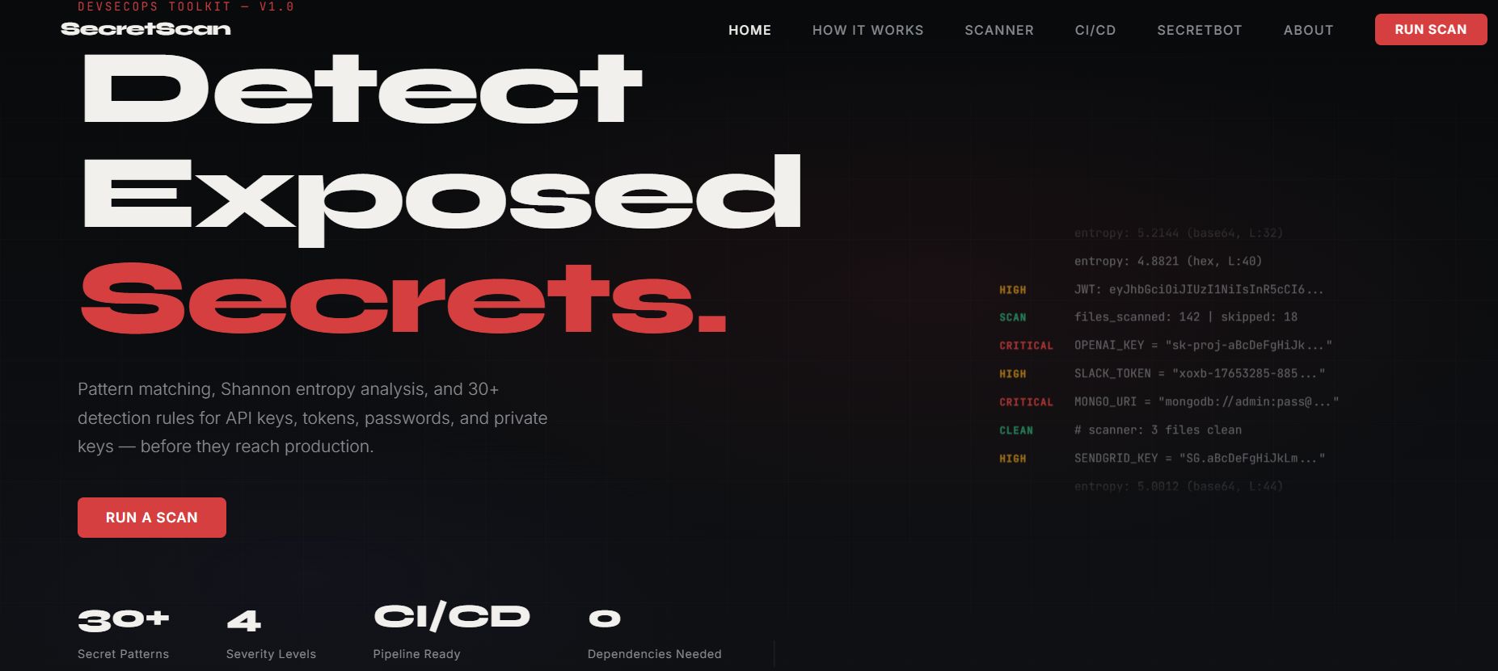

6.2 Scanner — Code Snippet Input & Results
The scanner section shows the code snippet paste area (left) and the live results panel (right). The results panel shows severity count boxes (Critical, High, Medium, Low), individual finding cards with type, masked value, line number, and context.
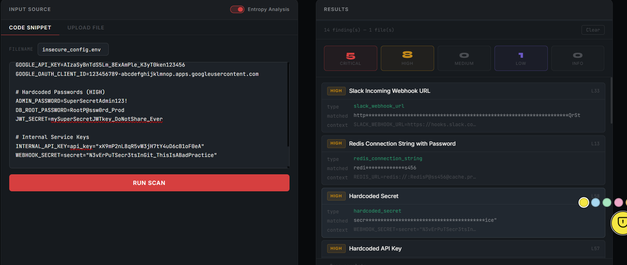

6.3 Sticky Note Security Summary
After a scan, a floating FAB button appears in the bottom-right corner with an animated pulsing ring. Clicking it opens the sticky note panel showing all CRITICAL and HIGH findings with red danger circles, line numbers, masked values, and remediation instructions. 5 colour themes available (yellow, blue, green, pink, orange).
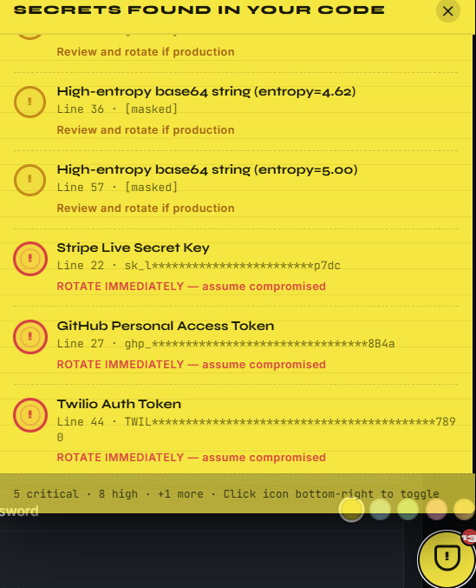

6.4 CI/CD Setup Section
The CI/CD section provides a 5-step illustrated setup guide and platform-specific YAML workflow templates for GitHub Actions, GitLab CI, Jenkins, and Bitbucket Pipelines. A live config tester lets users scan a pasted .env file directly on the page.
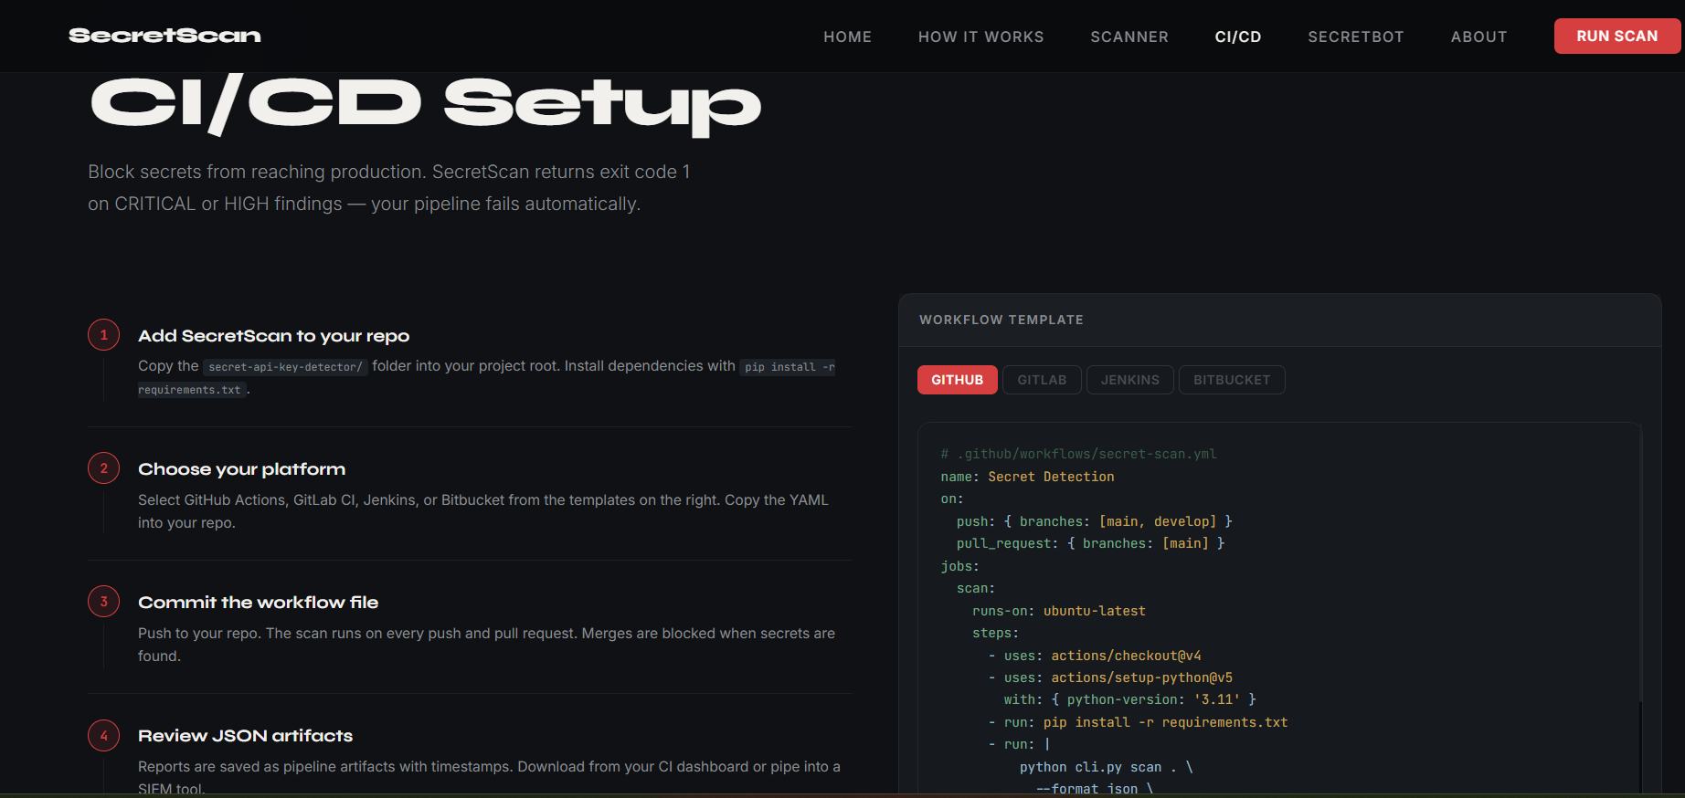

6.5 SecretBot AI Assistant
SecretBot answers DevSecOps questions from a built-in FAQ engine covering entropy analysis, CI/CD integration, severity levels, secret remediation, and false positive reduction. Adding an OpenAI API key upgrades to full GPT-3.5 powered answers with conversation history.
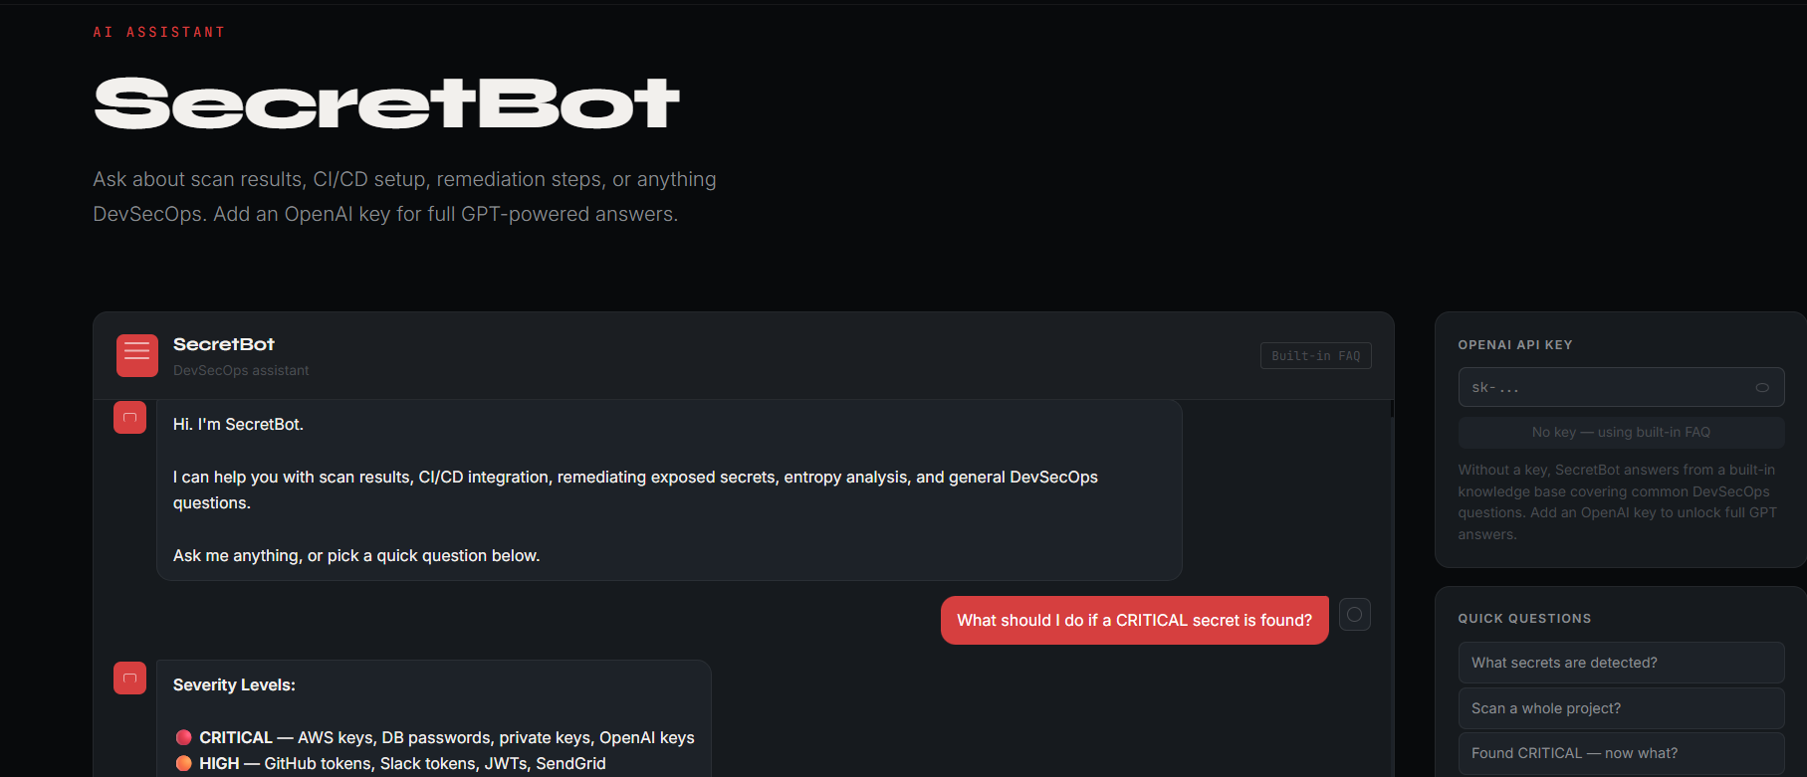

6.6 CLI Scan Output
The CLI provides a title output of the created application that can be used in both Windows and Linux Operating Systems. Users can use the tool to simulate the same.
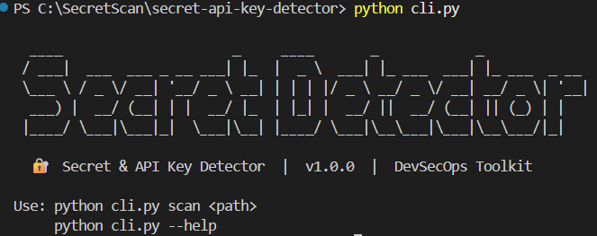

6.7 About & Patterns Section
The About section shows the full project architecture tree, 3 feature cards (Shannon Entropy, Modular Detectors, Exit Code Gate), and a complete table of all 30+ supported secret types with their detection patterns and severity levels.
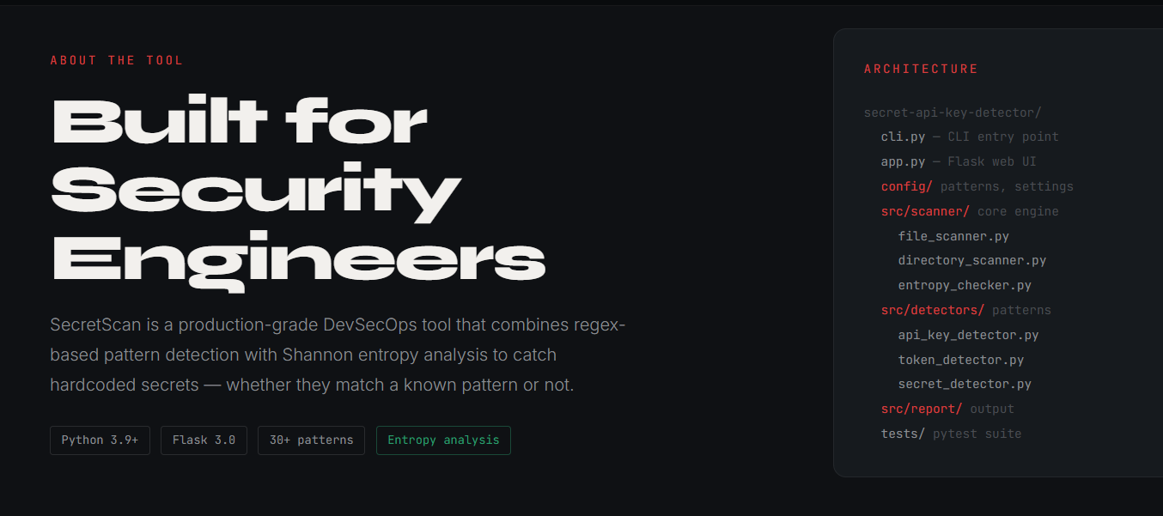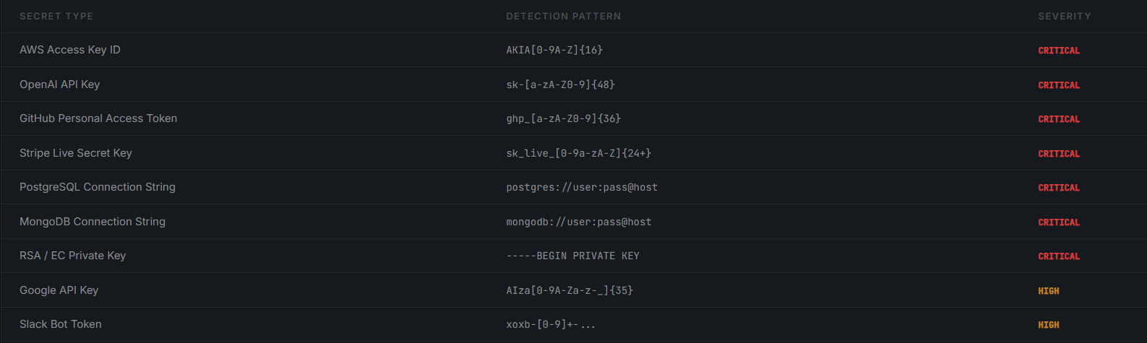

7. Key Features

7.1 Shannon Entropy Detection
Implements H = -Σ p(x) log₂(p(x)) to score every string in a scanned file. Strings in base64 or hex character sets with entropy ≥ 4.5 bits and length 20-200 chars are flagged as high-entropy candidates. Random API keys typically score 4.5-5.5 bits versus plain English text at 2.5-3.5 bits.

7.2 30+ Pattern Detectors
Curated regex patterns covering:
- Cloud providers: AWS Access Key IDs, AWS Secret Access Keys, Azure Storage connection strings
- Source control: GitHub PATs (classic and fine-grained), GitLab tokens, NPM tokens
- Payment: Stripe live and test secret keys, Stripe publishable keys, PayPal/Braintree tokens
- Communication: Slack bot/user tokens, Slack webhooks, Discord bot tokens, Telegram bot tokens, Twilio SID/auth
- AI/Email: OpenAI API keys, SendGrid API keys, Mailgun API keys, HubSpot API keys
- Database: MongoDB, PostgreSQL, MySQL, Redis connection strings with embedded credentials
- Authentication: JWTs, RSA/EC/OpenSSH private keys, HTTP Basic Auth headers, hardcoded passwords

7.3 Modular Single-Responsibility Detectors
The SOLID architecture means each detector class has exactly one responsibility. Adding a new cloud provider requires creating one file with one method. The BaseDetector handles all cross-cutting concerns: regex compilation, line number resolution, secret masking, and placeholder suppression.

7.4 Floating Sticky Note Summary
A floating action button with an animated pulsing ring appears after each scan containing CRITICAL or HIGH findings. It opens a sticky note panel with red danger circles, masked secret values, line numbers, and plain-English remediation instructions. Available in 5 colour themes.

7.5 CI/CD Pipeline Integration
Out-of-the-box YAML templates for GitHub Actions, GitLab CI, Jenkins, and Bitbucket Pipelines. Exit code 1 on CRITICAL/HIGH findings ensures the build fails automatically. Workflow templates are available directly in the web UI.

7.6 SecretBot AI Assistant
A built-in FAQ chatbot answers common DevSecOps questions without requiring an API key. Topics: entropy analysis, severity levels, CI/CD integration, AWS key remediation, false positive reduction, and JSON report export. OpenAI API key support upgrades to full GPT-3.5 responses.

8. Challenges & Solutions

Challenge | Solution
False positives from entropy analysis on base64-encoded non-secrets | Max length cap of 200 chars eliminates large blobs. Known placeholder dictionary suppresses common test values. Minimum 20-char length eliminates short common words.
Regex patterns with catastrophic backtracking risk | All patterns use non-backtracking character classes and anchored length quantifiers. Patterns tested against pathological inputs before inclusion.
File encoding errors on binary files | All file reads use errors="ignore" with UTF-8 encoding. Binary-only extensions (.png, .jpg, .class, .pyc) excluded from scan targets.
Result cards rendering as blurred colored bars in browser | Root cause: animation-fill-mode:both + staggered animation-delay caused cards to sit in opacity:0. Fixed by removing stagger delays and using CSS transitions instead.
Sticky note panel elongating the input card layout | Moved sticky note to a fixed-position floating overlay completely outside the document flow. Results card given explicit height with flex overflow scroll.
CI/CD integration across 4 different platforms | Platform-specific YAML templates embedded in the web UI. Exit code convention (1=failure) is universal across all platforms without custom scripting.

9. Learning Outcomes & Interview Value

9.1 Security Engineering Concepts
- Secrets management: why hardcoded credentials are a critical vulnerability class
- Detection methodology: pattern-based vs entropy-based detection trade-offs
- Severity classification: blast-radius scoring for different credential types
- Incident response: rotation, revocation, and audit log review after credential exposure
- Defence in depth: pre-commit hooks + CI/CD gates + runtime scanning as layered controls

9.2 Software Engineering Concepts
- SOLID principles: Open/Closed via BaseDetector, Single Responsibility via detector classes
- Abstract base classes in Python: enforcing interface contracts with @abstractmethod
- Information theory: Shannon entropy applied to practical string analysis
- Regular expression engineering: non-greedy quantifiers, anchoring, character class optimisation
- CLI design: exit codes as machine-readable status signals, argparse subcommands

9.3 Interview Talking Points
- "I implemented Shannon entropy scoring to detect secrets that no regex pattern can catch — any string with H ≥ 4.5 bits in a base64 character set is flagged"
- "The tool follows the Open/Closed Principle — adding a new secret type requires only implementing one method in one new file"
- "It returns exit code 1 on CRITICAL/HIGH findings, making it a drop-in CI/CD gate that fails the build automatically"
- "The JSON reporter produces SIEM-compatible output that can feed directly into Splunk or Elastic for real-time alerting"

10. Conclusion
SecretScan successfully delivers a production-grade secret detection toolkit that operates across three interfaces: a browser-based web application, a command-line tool, and a CI/CD pipeline integration. The combination of regex pattern matching and Shannon entropy analysis provides comprehensive coverage of both known and unknown credential formats.
The modular architecture demonstrates real software engineering discipline: SOLID principles, abstract base classes, separation of concerns between detection and reporting, and dual output format design. These are the exact qualities that security engineering and DevSecOps hiring teams look for in portfolio projects.
The project is immediately deployable to production environments, integrates with all major CI/CD platforms, and is designed to be extended with new detector patterns without modifying existing code.

Project Deliverables Summary

Deliverable | Description | Status
Detection Engine | APIKeyDetector + TokenDetector + SecretDetector + BaseDetector | Complete
Entropy Checker | Shannon entropy scoring for base64 and hex strings | Complete
Flask Web App | Full-stack web UI with landing page and scanner | Complete
CLI Tool | python cli.py scan with severity filtering and JSON output | Complete
30+ Regex Patterns | AWS, GitHub, Stripe, OpenAI, Slack, Google, Twilio, Discord | Complete
JSON Reporter | Machine-readable output for SIEM/dashboard integration | Complete
CI/CD Templates | GitHub Actions, GitLab CI, Jenkins, Bitbucket Pipelines YAML | Complete
SecretBot | Built-in FAQ chatbot + optional OpenAI GPT-3.5 integration | Complete
Sample Files | 3 intentionally insecure files for demonstration | Complete
Test Suite | pytest tests for detector, entropy, and scanner modules | Complete
Responsive UI | Mobile-first SPA with hamburger menu and scroll animations | Complete

SecretScan v1.0.0 — Built by Vibhasha Nagvekar | B.E. IT | March 2026

Project Source Code: https://github.com/Vibhasha-5/SecretScan
Live Demo: https://secret-scan-nine.vercel.app/

