MAHARAJA AGRASEN INSTITUTE OF TECHNOLOGY
Computer Science and Technology Department
MINOR PROJECT SYNOPSIS, 7TH SEMESTER

Citizen Rights and Government Scheme Navigator
A Retrieval-Augmented System for Scheme Discovery and Eligibility Awareness

Submitted by
Name: ____________________________ Roll No.: __________
Name: ____________________________ Roll No.: __________
Name: ____________________________ Roll No.: __________

Under the guidance of
Project Guide: ____________________________

Batch 2023-2027

1. Problem Statement
India offers thousands of government welfare schemes across domains such as education, healthcare, agriculture, and employment. However, many eligible citizens remain unaware of these benefits due to fragmented information sources, complex eligibility rules, and formal administrative language.
While citizens search using natural, everyday language, official documents rely heavily on bureaucratic terminology. Traditional keyword search engines fail to bridge this gap, leaving users unable to locate relevant schemes. This project proposes a Retrieval-Augmented Generation (RAG) platform that allows users to search for government schemes in plain natural language, delivering source-grounded summaries and automated eligibility guidance.

2. Why This Topic Was Chosen
Government scheme discovery is a genuine, large-scale information retrieval problem rather than a purely academic exercise: the underlying corpus is large, heterogeneous, and written in inconsistent administrative language, which makes naive keyword search insufficient and gives hybrid retrieval and grounded generation an actual reason to exist.
This topic was also chosen to build directly on prior hands-on experience with hybrid retrieval-augmented generation systems, including database-backed dense and lexical search, reranking, and retrieval evaluation. Applying that experience to a civic-tech problem extends it from a private data domain to a public-interest one, while keeping the same core technical challenges: fusing keyword and semantic search, keeping generation strictly grounded in source text, and measuring answer quality in a way that goes beyond “it looks right.”
Finally, the domain has a clear and measurable social benefit, reducing the gap between citizens who are entitled to a benefit and citizens who are aware of it, which makes it a suitable subject for a project that is expected to demonstrate both technical depth and real-world relevance.

3. Objectives and Scope

3.1 Objectives
- Hybrid Retrieval: Implement a hybrid search pipeline using PostgreSQL Full-Text Search (FTS) for keyword matching and pgvector for semantic vector search.
- Verified Generation: Generate accurate, fact-grounded explanations using an LLM paired with retrieved source contexts.
- Evaluation: Measure system performance and response quality using an evaluation approach similar to RAGAS, focused on Faithfulness and Answer Relevancy.
- Usability: Provide a simple web interface where a citizen with no domain knowledge can describe their situation in plain language and receive a relevant, cited answer.

3.2 Scope
The project will cover a curated subset of central and/or state government welfare schemes (education, healthcare, agriculture, and employment categories) sourced from official public portals such as myscheme.gov.in. It will support English language natural language queries and will surface eligibility criteria, benefits, and application information with citations to the source document.
The scope explicitly excludes online application submission, authentication against government ID systems, and legal certification of eligibility. The system is an information and awareness layer, not a transaction or adjudication system. Multilingual support and coverage of the full national scheme catalogue are noted as future extensions rather than deliverables of this synopsis.

4. Methodology
The system follows a standard hybrid RAG pipeline, adapted for the scheme-discovery domain, as shown below.
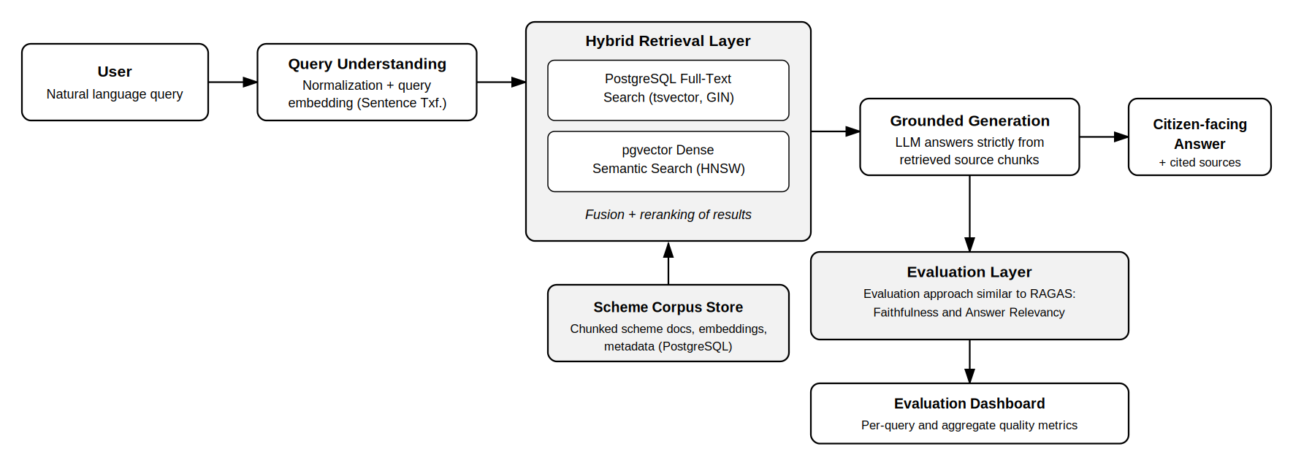
Fig. 1: High-level data and control flow of the retrieval-augmented pipeline

4.1 Data Collection and Ingestion
Scheme documents (notifications, eligibility guidelines, FAQs) are collected from official government portals, cleaned, and split into semantically coherent chunks. Each chunk is embedded using a Sentence Transformer model and stored in PostgreSQL alongside a tsvector column for full-text search, so a single database backs both retrieval arms.

4.2 Hybrid Retrieval
A user query is normalized and embedded. Two retrieval arms run in parallel: a PostgreSQL Full-Text Search query over the tsvector index for exact and lexical matches, and a pgvector nearest-neighbour search over chunk embeddings for semantic matches. Results from both arms are fused (for example, via reciprocal rank fusion or a weighted score) and optionally reranked before being passed to generation.

4.3 Grounded Generation
The top-ranked chunks are passed to an LLM along with the user's query, with an explicit instruction to answer only from the provided context and to cite the source scheme for every claim. This constrains the model to avoid inventing eligibility rules that are not present in the retrieved text.

4.4 Evaluation
Response quality will be measured using an evaluation approach similar to RAGAS, focused on two metrics: Faithfulness and Answer Relevancy. These are computed through a set of direct LLM-as-judge prompts, giving interpretable, per-query scores that can be tracked as the retrieval and prompting design changes during development.
Metric | What it measures | How it is computed
Faithfulness | Whether every claim in the generated answer is actually supported by the retrieved context. | The answer is decomposed into individual claims by an LLM prompt; each claim is checked against the retrieved chunks by a second LLM judge call; score = supported claims / total claims.
Answer Relevancy | Whether the generated answer actually addresses the question asked, rather than drifting off-topic. | An LLM reverse-generates candidate questions from the answer; embedding similarity between these and the original query is averaged into a relevancy score.
Table 1: Evaluation metrics (RAGAS-style)
Each metric is logged per query and aggregated across a held-out evaluation set of representative citizen questions, giving a quantitative basis for comparing retrieval and prompting changes during development rather than relying on manual spot-checking alone.

5. Hardware, Software, and Technology Stack
Component | Technologies
Core Languages | Python, SQL, JavaScript
Backend Framework | FastAPI, LangChain / LangGraph
Frontend Interface | React.js
Database & Storage | PostgreSQL (Full-Text Search & pgvector)
AI & Search Engine | Sentence Transformers, Hybrid Search (PostgreSQL FTS + Dense Retrieval via pgvector), Large Language Models (LLMs)
Evaluation & Tracing | Evaluation approach similar to RAGAS (Faithfulness, Answer Relevancy), Arize Phoenix for tracing
Deployment | Docker, Git
Table 2: Technology stack

6. Contribution to Society
The project applies computer science techniques to public service delivery, spanning information retrieval and natural language processing, data engineering and database systems, and civic technology more broadly.
By making government welfare schemes searchable in plain language and grounding every answer in an official source, the platform directly supports Sustainable Development Goal (SDG) 16: Peace, Justice and Strong Institutions. It enhances civic awareness, promotes more equal access to public welfare benefits regardless of a citizen's familiarity with bureaucratic language, and reduces the information asymmetry between citizens and the institutions meant to serve them.
Title of Project | SDGs | Justification
Citizen Rights and Government Scheme Navigator | SDG 16: Peace, Justice and Strong Institutions | Improves transparent, source-grounded access to public welfare information and reduces information asymmetry between citizens and government institutions.
Table 3: SDG mapping

7. Project Schedule
The project is planned over an eight-week cycle, moving from domain research and data collection through pipeline construction, evaluation, and final integration, as shown in the Gantt chart below.
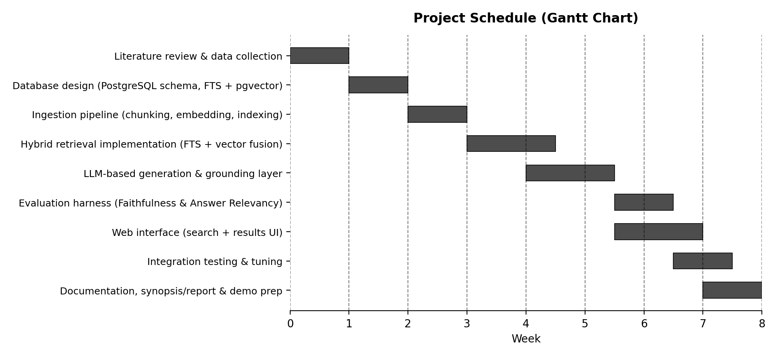
Fig. 2: Project schedule (Gantt chart)

8. Expected Outcomes
- Search Interface: A functional web interface where citizens can search for schemes using intuitive natural language.
- Unified Database Architecture: A unified, indexed database infrastructure in PostgreSQL handling both text tokens and dense vector representations.
- Fact-Grounded Responses: A reliable, hybrid RAG pipeline that gives answers tied strictly to official source texts.
- Performance Insights: An evaluation dashboard, built in the style of RAGAS, tracking Faithfulness, Answer Relevancy, and processing latency across queries.

9. References
[1] S. Es, J. James, L. Espinosa-Anke, and S. Schockaert, “RAGAS: Automated Evaluation of Retrieval Augmented Generation,” arXiv:2309.15217, 2023.
[2] PostgreSQL Global Development Group, “Full Text Search,” PostgreSQL Documentation. [Online]. Available: https://www.postgresql.org/docs/current/textsearch.html
[3] pgvector, “Open-source vector similarity search for Postgres,” GitHub repository. [Online]. Available: https://github.com/pgvector/pgvector
[4] MyScheme, Government of India, National Government Services Portal. [Online]. Available: https://www.myscheme.gov.in/
[5] N. Reimers and I. Gurevych, “Sentence-BERT: Sentence Embeddings using Siamese BERT-Networks,” in Proc. EMNLP, 2019

