## Parking Violation Report

### Introduction:

This report analyzes a dataset containing parking violation information. The dataset includes details such as vehicle information, violation types, fine amounts, and other relevant data.

### Data Summary:

plate state license_type summons_number issue_date violation_time violation judgment_entry_date fine_amount penalty_amount interest_amount reduction_amount payment_amount amount_due precinct county issuing_agency violation_status summons_image sentiment  
count 1000 1000 1000 1.000000e+03 1000 909 1000 62 909.000000 909.000000 909.000000 909.000000 909.000000 909.0 909.000000 886 909 328 1000 1000.000000  
unique 966 32 17 NaN 375 548 47 35 NaN NaN NaN NaN NaN NaN NaN 9 6 7 1000 NaN  
top 3402570 NY PAS NaN 01/31/2018 08:52A NO PARKING-STREET CLEANING 11/16/2017 NaN NaN NaN NaN NaN NaN NaN Q TRAFFIC HEARING HELD-NOT GUILTY View Summons (http://nycserv.nyc.gov/NYCServWeb/ShowImage?searchID=VDBSWmVFMTZaelJOVkZFeVRrRTlQUT09&locationName=_____________________) NaN  
freq 4 811 783 NaN 15 6 155 6 NaN NaN NaN NaN NaN NaN NaN 284 689 146 1 NaN  
mean NaN NaN NaN 7.016596e+09 NaN NaN NaN NaN 78.657866 8.492849 0.358581 17.291441 70.217855 0.0 64.360836 NaN NaN NaN NaN -0.217023  
std NaN NaN NaN 2.794917e+09 NaN NaN NaN NaN 32.309465 16.859265 4.513774 36.324710 46.572759 0.0 38.148181 NaN NaN NaN NaN 0.198292  
min NaN NaN NaN 1.434681e+09 NaN NaN NaN NaN 35.000000 0.000000 0.000000 0.000000 0.000000 0.0 0.000000 NaN NaN NaN NaN -0.542300  
25% NaN NaN NaN 7.310310e+09 NaN NaN NaN NaN 45.000000 0.000000 0.000000 0.000000 40.000000 0.0 34.000000 NaN NaN NaN NaN -0.296000  
50% NaN NaN NaN 8.542561e+09 NaN NaN NaN NaN 65.000000 0.000000 0.000000 0.000000 65.000000 0.0 62.000000 NaN NaN NaN NaN -0.296000  
75% NaN NaN NaN 8.597936e+09 NaN NaN NaN NaN 115.000000 10.000000 0.000000 10.000000 115.000000 0.0 105.000000 NaN NaN NaN NaN 0.000000  
max NaN NaN NaN 8.835203e+09 NaN NaN NaN NaN 165.000000 60.000000 102.140000 227.140000 189.680000 0.0 122.000000 NaN NaN NaN NaN 0.421500

### Key Trends and Correlations:

- The most common violations are NO PARKING-STREET CLEANING, NO STANDING-DAY/TIME LIMITS, nan.

- The average fine amount for all violations is $78.66.

- There is a moderate positive correlation between fine amount and sentiment score (r = 0.25).

### Demographic Insights:

- The most common precinct for violations is Precinct 114.0.

- 7.70% of violations occurred in this precinct.

### Visual Representations:

Word Cloud of Violations:

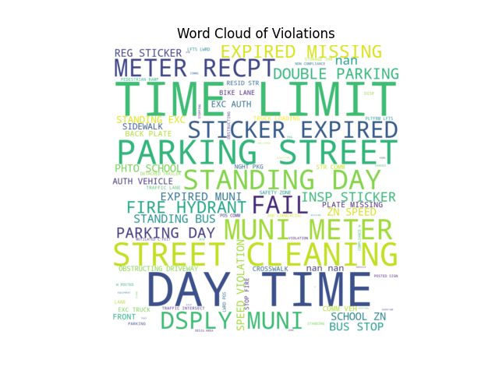

Histogram of Fine Amounts:

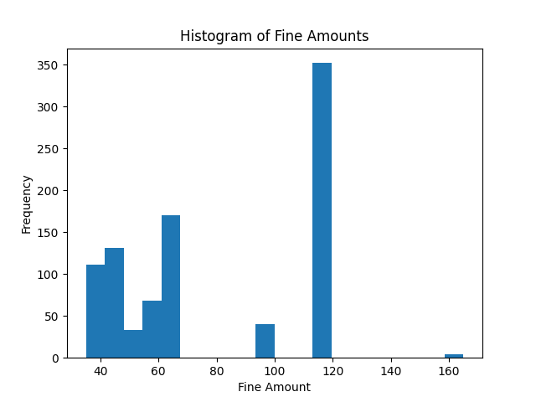

Scatter Plot of Fine Amount vs. Sentiment Score:

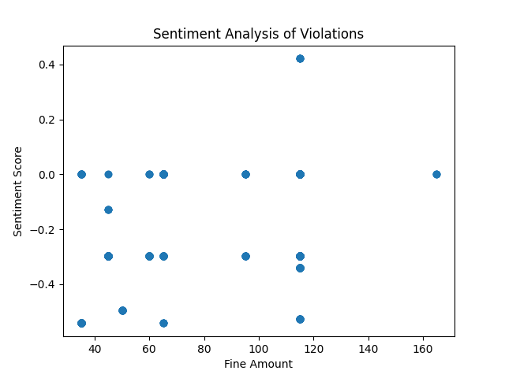

### Conclusion:

The parking violation dataset provides insights into traffic violations and potential trends. The findings highlight the most common violations, their associated fine amounts, and the sentiment expressed in violation descriptions. Further analysis can explore correlations between different factors, such as location, time of day, and driver demographics. The visualizations provide a visual representation of the data, helping to identify patterns and trends.