
DEPARTMENT OF COMPUTER ENGINEERING & APPLICATIONS
Institute of Engineering & Technology

Lab Manual

Subject Name & Code: Digital Image Processing Lab (BCSE0131)
Course: B. Tech.(CS)
Name : Vibhu Dixit
University roll no. : 2215001940
Section: B
Roll no.: 77
Year: III Semester: VI

Submitted To: Jharna Agrawal Mam

EXPERIMENT NO: 0
Objective: The objective of this lab session is to understand the DIP and MATLAB.
DIP
Imagine you have a drawing or a photo. Digital Image Processing (DIP) is like using a magic computer tool to change, improve, or understand that image. Here’s how it works in simple words:
- Turning Pictures into Numbers 🧮
  - A computer sees an image as tiny dots (pixels) with numbers for colors.
- Fixing and Improving Pictures 🎨
  - Just like adding filters in a phone camera, DIP can make images brighter, clearer, or even change colors!
- Finding Hidden Things 🔍
  - Computers can find faces, objects, or even letters in an image, just like how we recognize our friends in a crowd.
- Making Fun Changes ✨
  - You can remove red eyes, make funny face swaps, or even turn a picture into a cartoon!
- Helping the World 🌍
  - DIP is used in medical scans, space pictures, and even in robots to see things better.
So, Digital Image Processing is like teaching computers to see and edit pictures in a smart way! 🎥💻
PIXEL
A pixel (short for picture element) is the smallest dot in a digital image. Think of it like tiny LEGO blocks that come together to form a picture.
- Many Pixels = One Picture 🖼️
  - A photo on your phone or computer is made of millions of tiny pixels.
- Each Pixel Has a Color 🎨
  - Every pixel has a color, and together they make the full image.
- More Pixels = Clearer Image 🔍
  - A high-pixel image looks sharp, while a low-pixel image looks blurry.
MATLAB
MATLAB (short for MATrix LABoratory) is a computer software used for solving math problems, making graphs, and working with data.
Simple Explanation:
- Solves Math Problems ➗ – It can quickly do big calculations, like a super-smart calculator.
- Works with Images & Signals 🎨🔊 – Used in image processing, sound editing, and more.
- Creates Graphs & Plots 📊 – Turns numbers into colorful charts and diagrams.
- Uses Simple Coding 💻 – It has its own programming language to automate tasks.
- Used in Science & Engineering ⚙️ – Scientists, engineers, and students use it for research and projects.
It's like a powerful toolbox for solving problems and making smart visualizations! 🚀
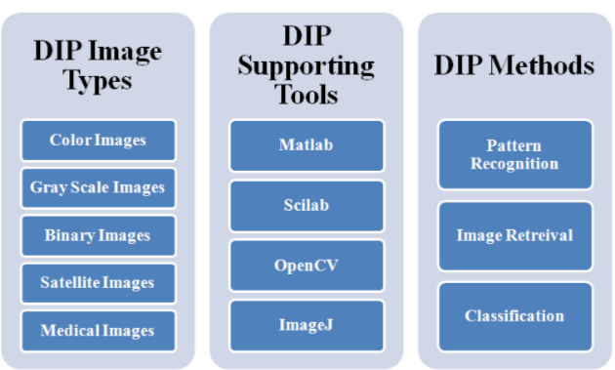
EXPERIMENT NO: 1
Objective: The objective of this lab session is to understand the image Arithmetic Operations & image Logical Operation and implement the following tasks in MATLAB.
Mathematical Operations:
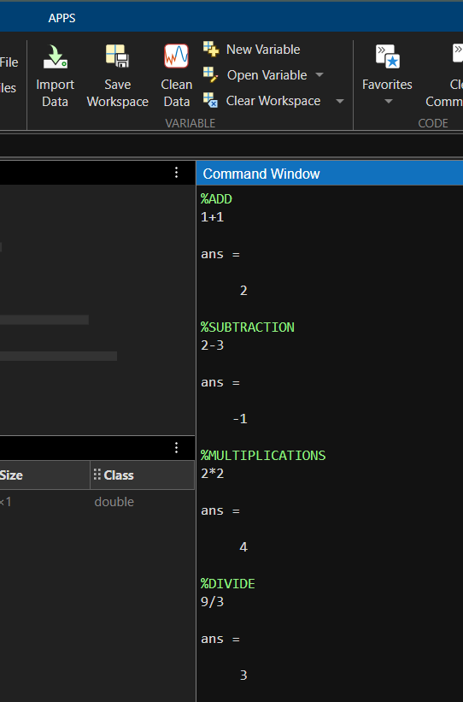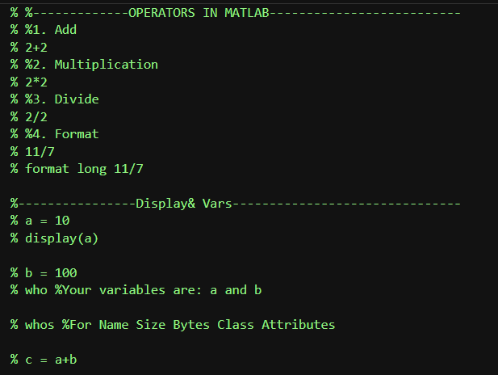
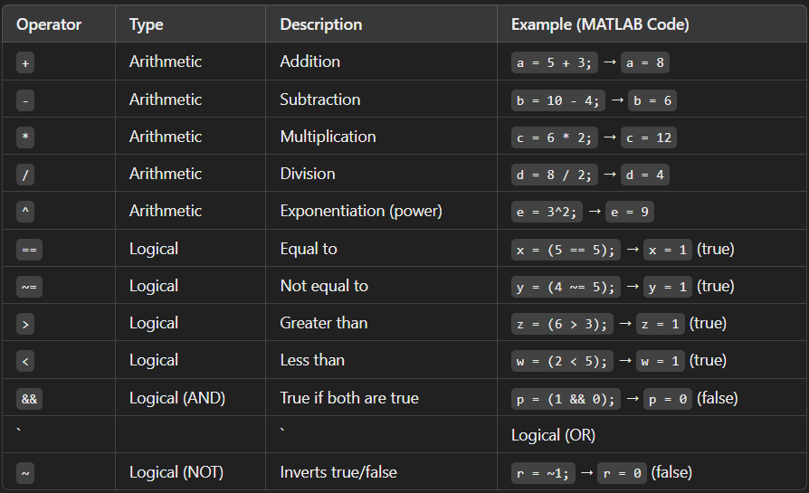
Command | Description | Example (MATLAB Code) | Output
disp | Displays text or variable values. | disp('Hello, MATLAB!') | Hello, MATLAB!
who | Lists all variable names in the workspace. | a = 5; b = 10; who | Your variables are: a b
whos | Lists variables with details like size, type, and bytes used. | a = 5; b = 10; whos | Name, Size, Bytes, Class details of a and b

Basic Array Operations:
Category | Operation | MATLAB Code | Description
Basic Operations | Row-wise concatenation | C = [A; B] | Combines matrices A and B row-wise.
 | Column-wise concatenation | D = [A, B] | Combines matrices A and B column-wise.
Array Operations | Inverse of a matrix | inv(A) | Finds the inverse of matrix A.
 | Determinant of a matrix | det(A) | Computes the determinant of A.
 | Rank of a matrix | rank(A) | Returns the rank of matrix A.
 | Transpose of a matrix | transpose(A) or A' | Swaps rows and columns of A.
 | Matrix multiplication | C = A * B | Multiplies matrices A and B.
 | General matrix operation | Z = D * C | Multiplies matrices D and C.
 | Display result | display(Z) | Prints the result of Z.
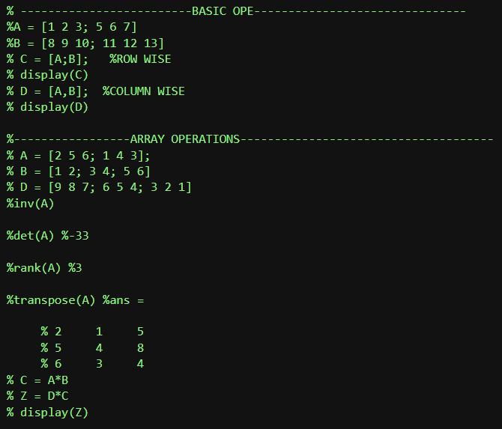
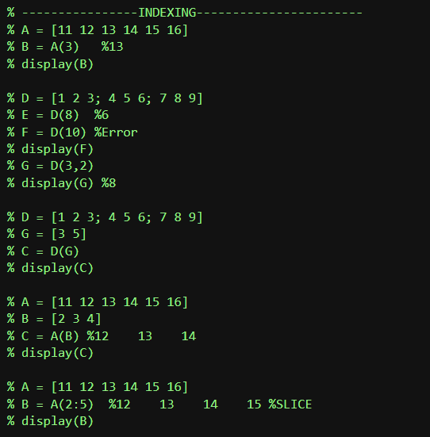
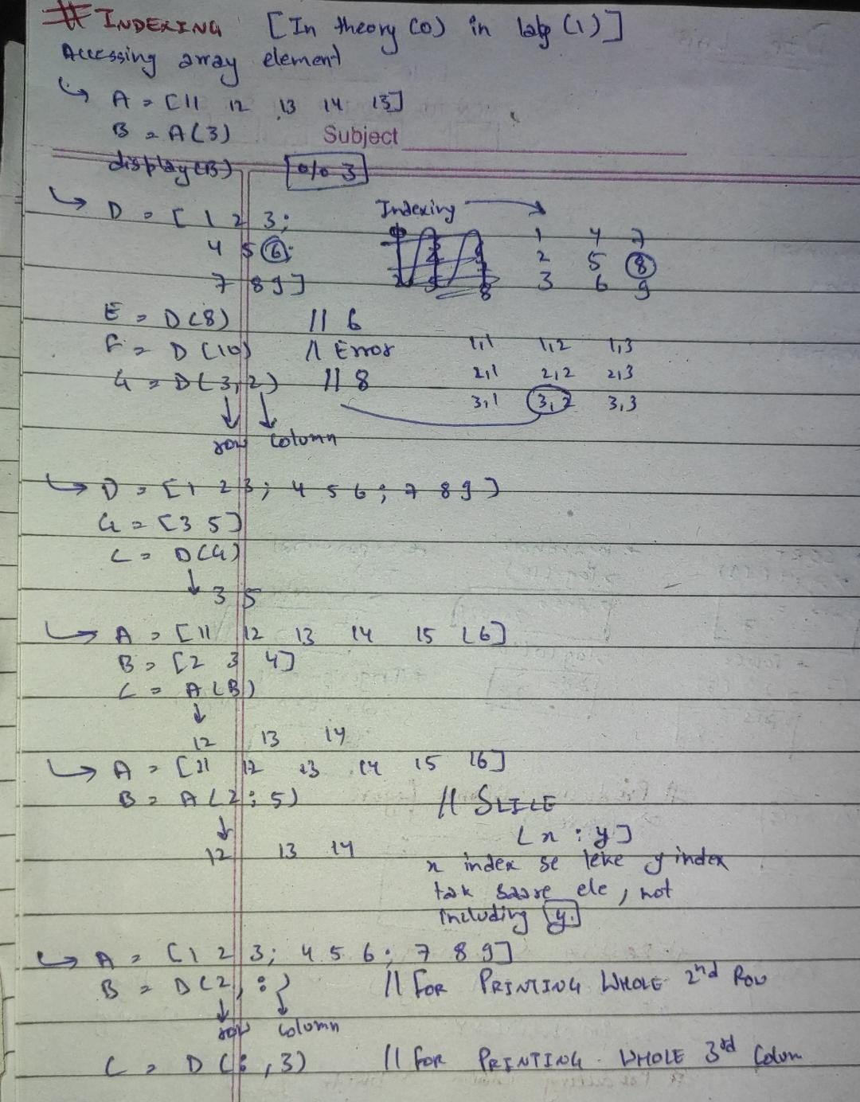
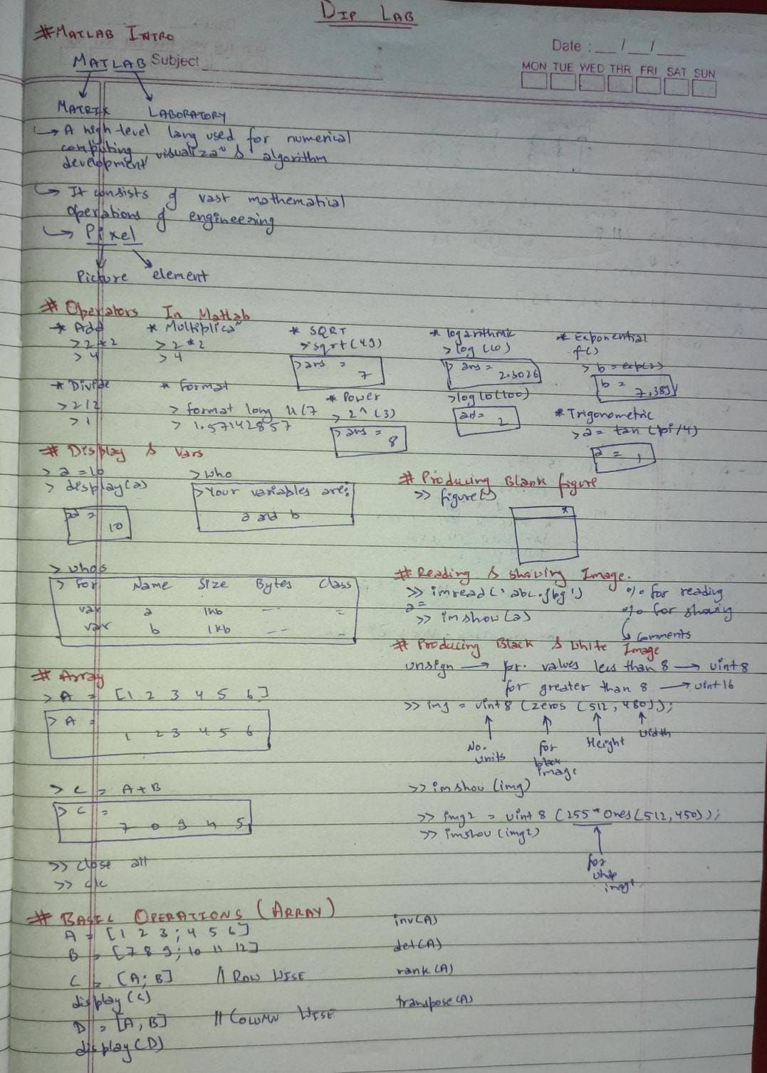
#The zeros() function in MATLAB creates a matrix filled with zeros.
Syntax | Description | Example | Output
zeros(n) | Creates an n × n square matrix of zeros. | A = zeros(3) | 3×3 matrix of zeros
zeros(m, n) | Creates an m × n matrix of zeros. | B = zeros(2, 4) | 2×4 matrix of zeros
zeros(size(A)) | Creates a zero matrix of the same size as A. | C = zeros(size(A)) | Zero matrix with same size as A
zeros(1, n) | Creates a 1 × n row vector of zeros. | D = zeros(1, 5) | [0 0 0 0 0]
zeros(m, n, p) | Creates a m × n × p 3D array of zeros. | E = zeros(2, 3, 2) | 3D matrix filled with zeros
Syntax & Examples:
#Row Concatenation (Horizontal Concatenation):
- This joins arrays side by side, meaning the resulting array will have the same number of rows but the columns of the arrays are added together.
Example:
% Create two arrays
A = [1, 2, 3];
B = [4, 5, 6];
% Horizontal concatenation (row-wise)
C = [A, B]; % or C = horzcat(A, B);
% Display the result
disp(C);
Output:
C = [1 2 3 4 5 6]
2. Column Concatenation (Vertical Concatenation):
- This joins arrays on top of each other, meaning the resulting array will have the same number of columns, but the rows of the arrays are stacked.
Example:
% Create two arrays
A = [1, 2, 3];
B = [4, 5, 6];
% Vertical concatenation (column-wise)
C = [A; B]; % or C = vertcat(A, B);
% Display the result
disp(C);
Output:
C= 1 2 3
4 5 6
Important Considerations:
- Horizontal Concatenation: Ensure the arrays have the same number of rows. For example, if A is of size 1x3, B must also be 1x3 for horizontal concatenation.
- Vertical Concatenation: Ensure the arrays have the same number of columns. For example, if A is 1x3, B must also be 1x3 for vertical concatenation.
You can use the following functions to explicitly concatenate:
- horzcat(A, B) for horizontal concatenation.
- vertcat(A, B) for vertical concatenation.
# Randomization in DIP (MATLAB):
- rand(): Generates random numbers between 0 and 1 (uniform distribution).
- randn(): Generates random numbers with a standard normal distribution (mean = 0, variance = 1).
- randi(): Generates random integers within a specified range.
Example:
Function | Description | Example Output
rand() | Uniform random numbers [0, 1] | [0.5, 0.3]
randn() | Normally distributed random numbers | [0.2, -1.5]
randi() | Random integers in a range | [3, 7]
MATLAB Code Example:
A = rand(1, 2); % Random numbers between 0 and 1
B = randn(1, 2); % Normally distributed random numbers
C = randi([1, 10], 1, 2); % Random integers between 1 and 10
# sort() in MATLAB:
Function | Description | Example Output
sort() | Sorts elements in ascending order | [1, 2, 3, 5, 8]
sort('descend') | Sorts elements in descending order | [8, 5, 3, 2, 1]
A = [5, 2, 8, 1, 3]; % Original array
% Ascending order
sorted_asc = sort(A);
% Descending order
sorted_desc = sort(A, 'descend');
disp(sorted_asc); % Output: [1 2 3 5 8]
disp(sorted_desc); % Output: [8 5 3 2 1]
MATLAB Functions for Shifting, Reshaping, and Flipping:
Function | Description | Example Output
reshape() | Reshapes an array into a new size | [1 2 3; 4 5 6]
rot90() | Rotates an array 90 degrees counterclockwise | [3 6; 2 5; 1 4]
fliplr() | Flips an array left to right | [3 2 1; 6 5 4]
flipud() | Flips an array upside down | [4 5 6; 1 2 3]
circshift() | Circularly shifts the elements of an array | [5 1 2 3 4]



EXPERIMENT NO: 2
Objective: The objective of this lab session is to understand the image handling in MATLAB.

imread() | Reads an image file into MATLAB as an array. | img = imread('peppers.png');

Function | Description | Example Code Snippet
imshow() | Displays an image stored in an array. | imshow(img);

imresize() | Resizes an image to specified dimensions or scale factor. | resizedImg = imresize(img, 0.5); % Resize to 50% of original size

figure() | Creates a new figure window for displaying graphics or images. | figure;

title() | Adds a title to the current axes (or image display). | title('My Image');



