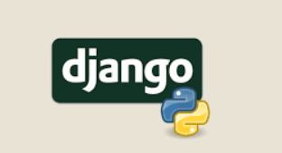

**#INTRO**

1.Backend 🡪 koi bhi essi technology jo front mai dikh nahi rahi hai but back mai koi functionality provide kara rahi hai.

2.Django 🡪 it’s a python framework

3.Python-based web framework Django allows you to create efficient web applications quickly.

4.  It is also calledbatteries include web framework Django because It provides built-in features for everything including Django Admin Interface, default database – SQLlite3, etc.

5.  Django Python gives you ready-made components to use for rapid development.

6.Framework 🡪 kissi language mai design ek set jo kisi work ke liye banaya gaya ho.

7. In computer systems, a framework is often a layered structure indicating what kind of programs can or should be built and how they would interrelate.

**#INSTALLATION**

1.Django works perfectly on python version 3.10…

2.Then install Django using cmd

3.Type: “python -m pip install django”

4.

5.

**#MVT STRUCTURE**

1.M 🡪 Models

2.V 🡪 Views

3.T 🡪 Templates

4.HTML’s anchor tag <a> work is only to redirect to new page or make changes in urls.

5.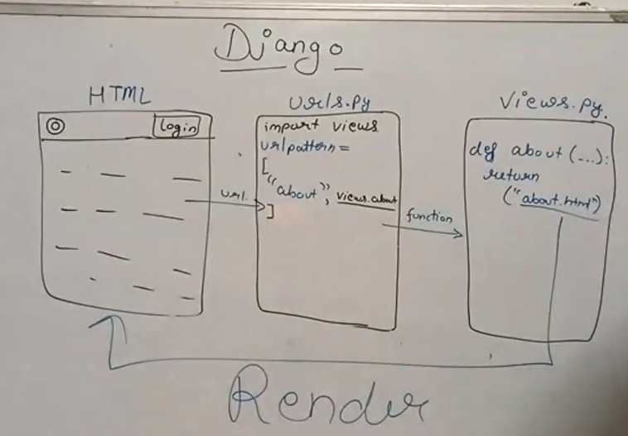

6.The structure or the pattern which Django follows is known as MVT structure.

7.

**#SETTING UP A PROJECT BASIC REQ.**

1.Make a new folder and then open cmd in that folder. 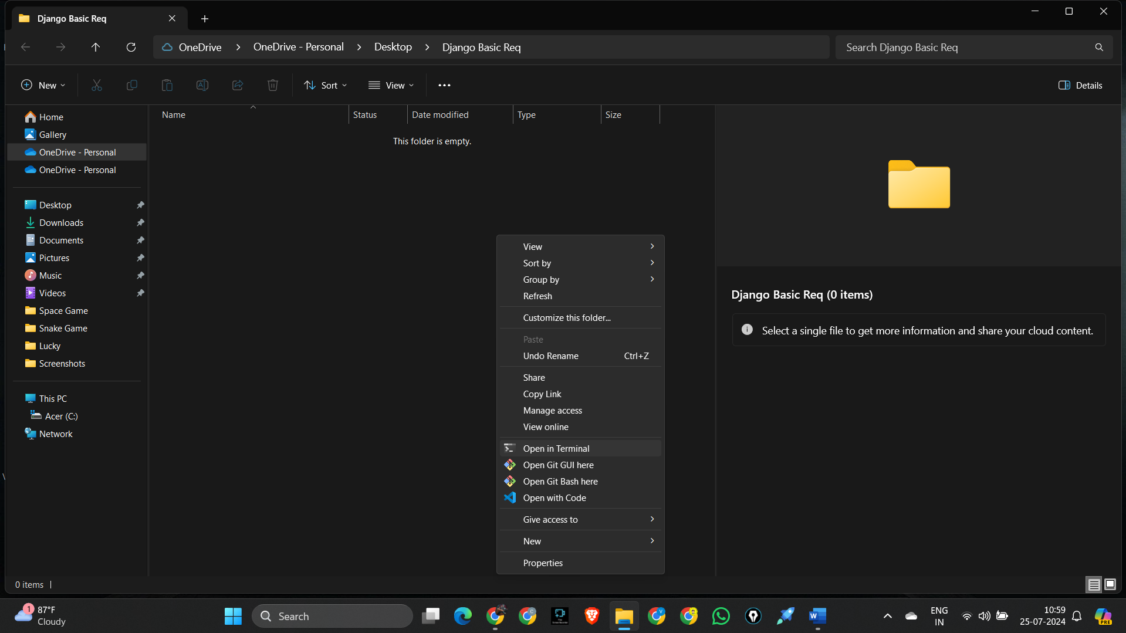

2.Now for initiating a project we have many commands. “django-admin”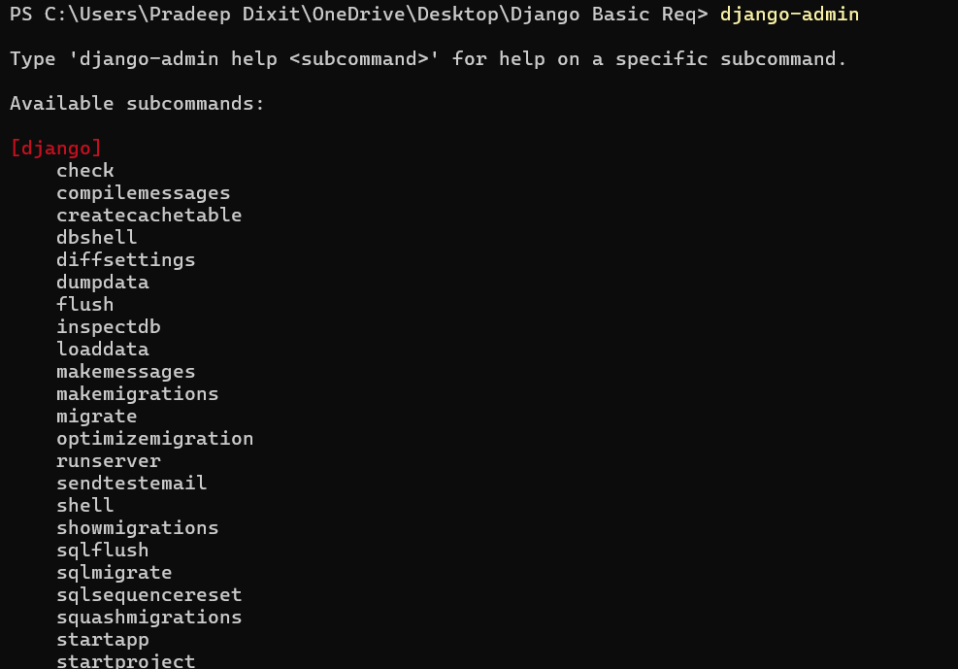

3.Now for starting a project we have some basics need of files which have to import “django-admin startproject project_name”

4.A folder is created automatically 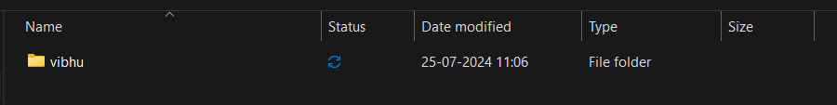

5. 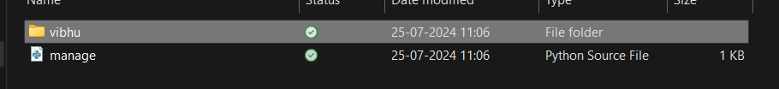

6. 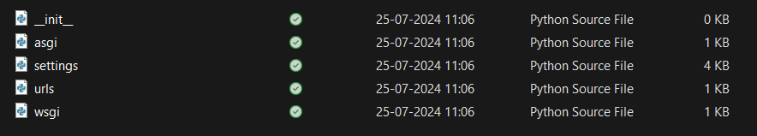

7.Now open vs code in folder where manage.py is held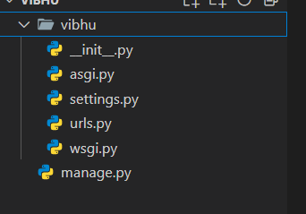

8.Now for checking successfully basic req. acces go to urls.py and open terminal and run “python manage.py runserver”

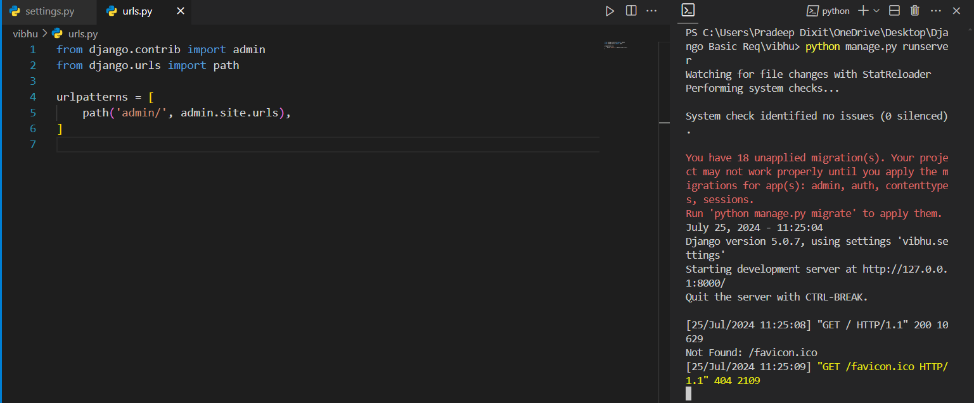

9. 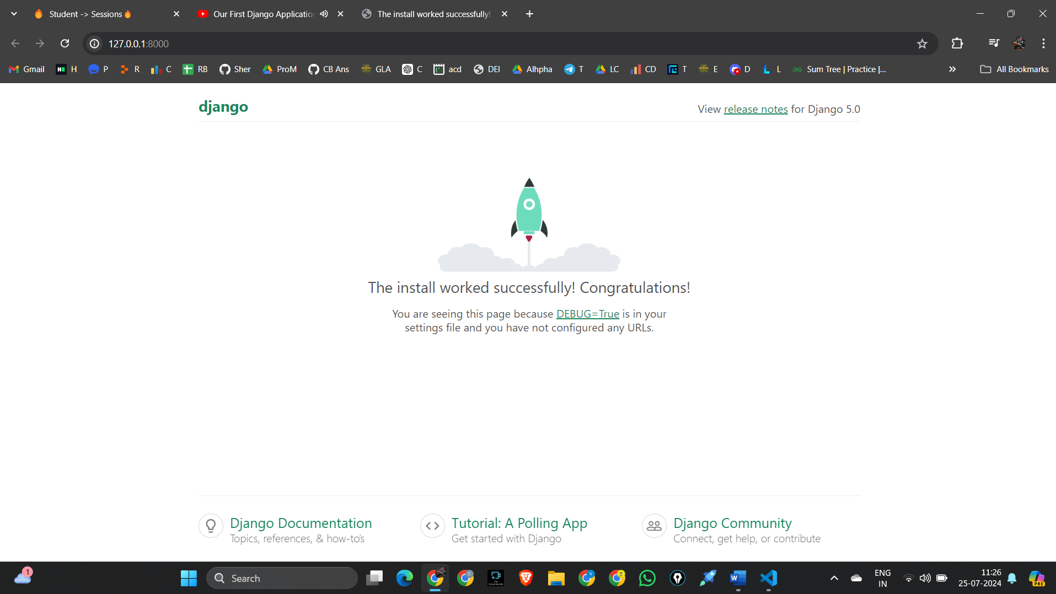

10.Now it means that our basic requirement is done.

**#RRC**

1.Request Response Cycle

2. 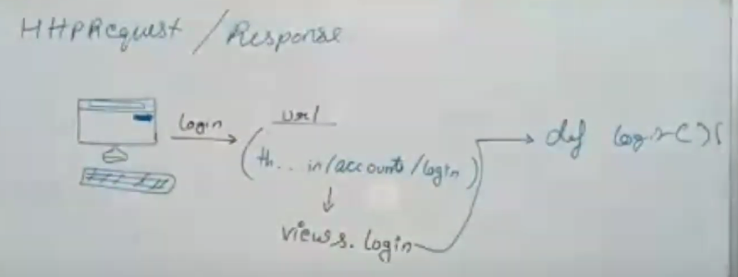

3.Our server start at urls.py it checks for link http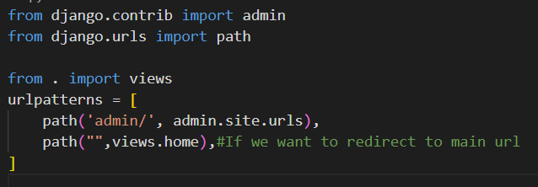

4.Here goes to check in views if that link exist or not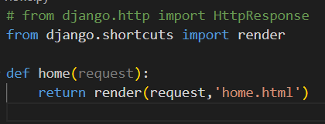

5.Then is link in views.py that f() exists then it will does it works and finsinsh.

**#urls.py**

1.The first two lines are just default for admin and path.

2.We know that in urls.py we check the urls…if exists or not if exists then go to that specific f() which is available in views.py.

3.Thus for going from urls.py to views.py we have to first import views. “from . import views”

Means from current working directory import the views file.



**#views.py**

1.Its main aim is to just go to that f( ) which is call from urls.py and do the work which f( ) initialize.

2.To display on main screen we have two methods “HttpResponse” & “render”

3. HttpResponse 🡪 just to to display the passed text or some short html tags. It first should import “from django.http import HttpResponse”. We can’t render .html files through HttpResponse.

4.render 🡪 it comes to render .html files. It takes two arguments i.e. request & .html file 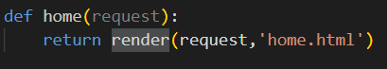

It first should import “from django.shortcuts import render”

5. 

6. 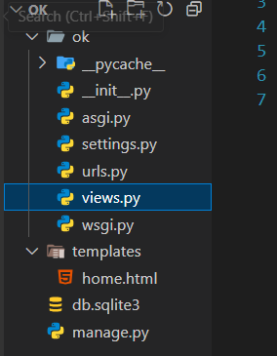The folder structure contains the templates which we added to add our .html files which django doesn’t know thus if we now run withou telling django that we have added template folder then it give an error. 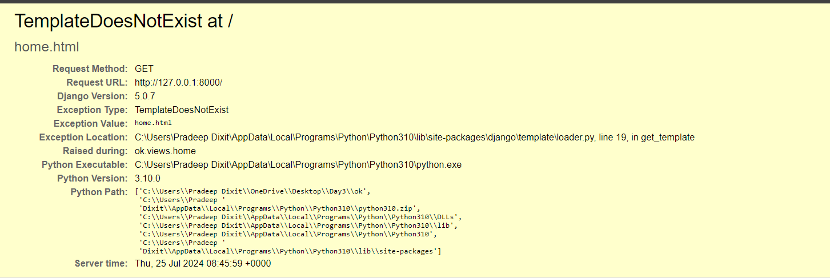

**#urls.py**

1.

**#urls.py**

1.

**#urls.py**

1.

**#urls.py**

1.

**#**

1.

**#**

1.

**#**

1.

**#**

1.

**#**

1.

**#**

1.

**#**

1.