M365 Tenant Advisor
Technical Architecture Proposal
Prepared for Meridian Solutions
Date: June 03, 2026

1. High-Level System Architecture
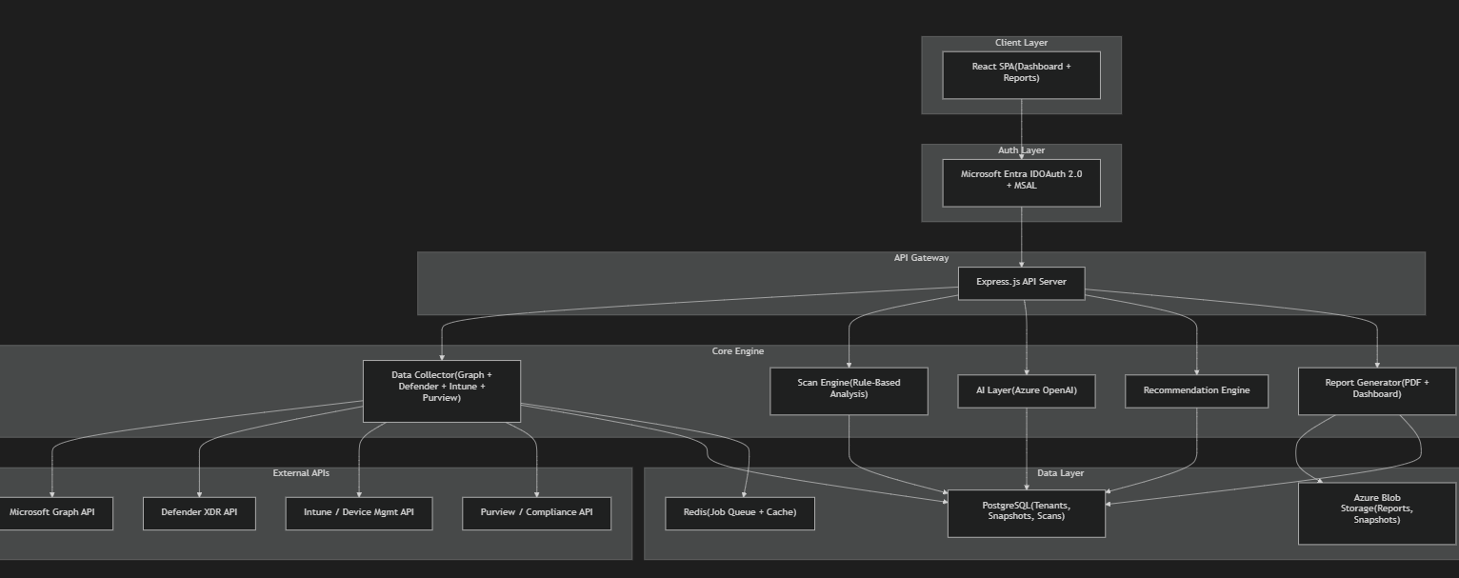

2. Architecture Pattern: Event-Driven Scan Pipeline
I'm choosing a pipeline architecture over a simple request-response model. Here's why:
Scanning a tenant takes time — you're hitting 15+ Microsoft API endpoints, processing thousands of users, devices, and policies. This cannot be synchronous.

The Flow
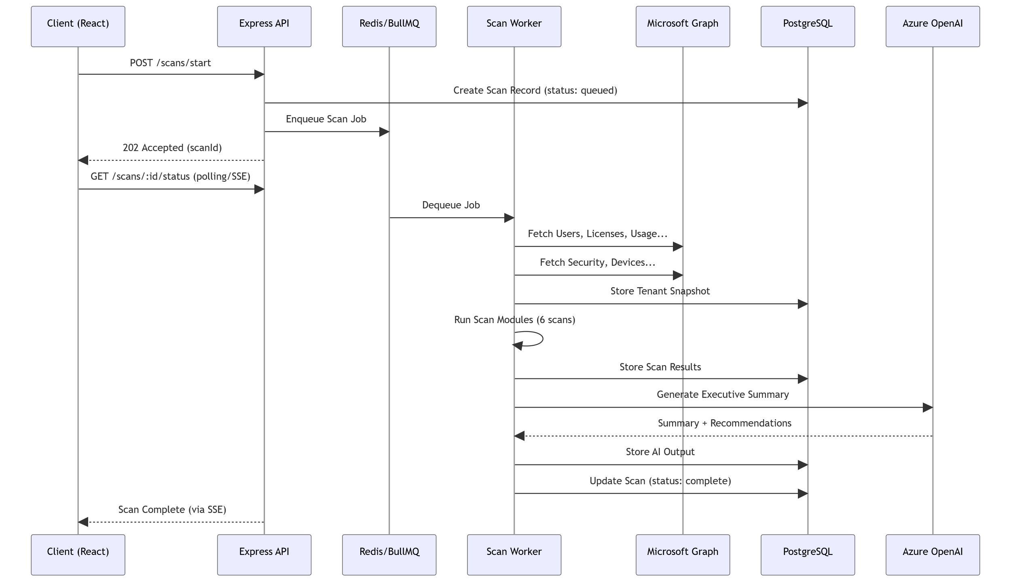
IMPORTANT:
Why this matters: A single tenant scan could take 30-120 seconds depending on size. Using a job queue (BullMQ + Redis) lets us handle multiple tenants concurrently, retry failed API calls, and give real-time progress updates via Server-Sent Events (SSE).

3. Tech Stack — My Choices & Rationale
Layer | Technology | Why
Frontend | React 18 + Vite | Fast dev experience, ecosystem maturity
Styling | Tailwind CSS v4 | Rapid UI development, utility-first for dashboards
Charts | Recharts / Chart.js | Lightweight, React-native charting
Backend | Node.js + Express | You're comfortable with it; Graph SDK is JS-native
Job Queue | BullMQ + Redis | Reliable async scan processing with retries
Database | PostgreSQL | Relational data (tenants, users, licenses), JSONB for flexible scan results
Cache | Redis | API response caching + session store
Auth | MSAL.js + Entra ID | Microsoft's official OAuth library
AI | Azure OpenAI (GPT-4o) | Stays in Azure ecosystem, enterprise compliance
PDF Reports | Puppeteer / @react-pdf/renderer | Generate professional PDF reports
File Storage | Azure Blob Storage | Store generated reports, large snapshots
Deployment | Azure App Service + Azure Container Apps | Natural fit for M365 ecosystem
CI/CD | GitHub Actions | Automated testing + deployment

4. Module Architecture (Backend)
src/
├── config/ # Environment, DB, Redis, Azure configs
│ ├── database.js
│ ├── redis.js
│ ├── azure.js
│ └── microsoft-graph.js
│
├── auth/ # Microsoft Entra ID OAuth
│ ├── msal-config.js
│ ├── auth.middleware.js
│ └── auth.routes.js
│
├── tenants/ # Tenant onboarding & management
│ ├── tenant.model.js
│ ├── tenant.service.js
│ └── tenant.routes.js
│
├── collector/ # Data Collection Engine
│ ├── graph/
│ │ ├── users.collector.js
│ │ ├── licenses.collector.js
│ │ ├── usage.collector.js
│ │ ├── security.collector.js
│ │ └── groups.collector.js
│ ├── intune/
│ │ ├── devices.collector.js
│ │ ├── compliance.collector.js
│ │ └── enrollment.collector.js
│ ├── defender/
│ │ ├── incidents.collector.js
│ │ ├── secureScore.collector.js
│ │ └── vulnerabilities.collector.js
│ ├── purview/
│ │ ├── dlp.collector.js
│ │ ├── retention.collector.js
│ │ └── sensitivityLabels.collector.js
│ └── collector.orchestrator.js # Runs all collectors in parallel
│
├── scanner/ # Scan Engine (6 scan modules)
│ ├── license-optimization.scan.js
│ ├── security-gap.scan.js
│ ├── compliance-readiness.scan.js
│ ├── cost-leakage.scan.js
│ ├── identity-risk.scan.js
│ ├── device-endpoint.scan.js
│ ├── scan.orchestrator.js # Runs all scans, aggregates results
│ └── rules/ # Rule definitions per scan
│ ├── license.rules.json
│ ├── security.rules.json
│ └── compliance.rules.json
│
├── intelligence/ # AI + Scoring Layer
│ ├── ai-summary.service.js
│ ├── health-score.service.js
│ ├── benchmark.service.js
│ └── prompts/
│ ├── executive-summary.prompt.js
│ └── recommendation.prompt.js
│
├── recommendation/ # Recommendation Engine
│ ├── license.recommender.js
│ ├── security.recommender.js
│ ├── compliance.recommender.js
│ └── roadmap.generator.js
│
├── reports/ # Report Generation
│ ├── pdf.generator.js
│ ├── templates/
│ │ ├── executive-report.hbs
│ │ └── technical-report.hbs
│ └── report.routes.js
│
├── jobs/ # Background Job Processing
│ ├── scan.worker.js
│ ├── monthly-report.worker.js
│ └── queue.config.js
│
├── sku-database/ # Own SKU + Pricing Master Data
│ ├── skus.json # All M365 SKU definitions
│ ├── features-matrix.json # SKU → Feature mapping
│ ├── pricing.json # SKU → Price mapping
│ └── sku.service.js
│
└── shared/
├── logger.js
├── errors.js
└── graph-client.js # Reusable Graph API client
TIP:
The sku-database/ module is your own maintained database of Microsoft SKUs, features, and pricing. Microsoft doesn't offer a public pricing API, so you'll curate this from Microsoft's licensing reference and update it periodically.

5. Database Schema (PostgreSQL)
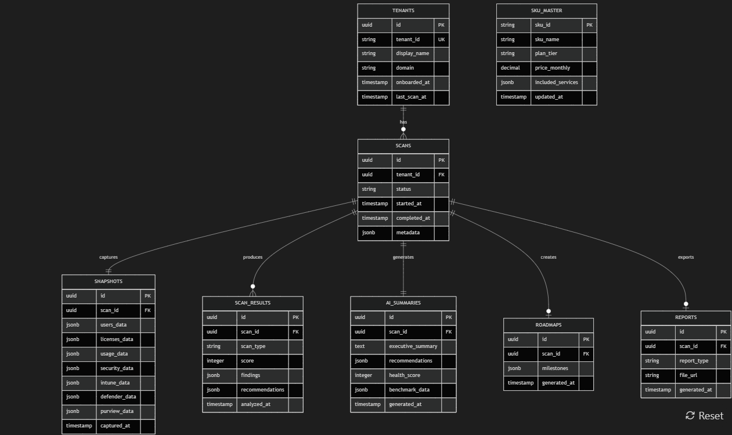
NOTE:
Why JSONB columns? Microsoft API responses are deeply nested and vary by tenant size. Storing raw snapshots as JSONB gives us flexibility to evolve the schema without migrations, while still supporting fast PostgreSQL JSON queries.

6. Microsoft API Integration Strategy

Permission Scopes Required (Application Permissions)
Microsoft Graph:
├── User.Read.All
├── Directory.Read.All
├── Organization.Read.All
├── Reports.Read.All
├── AuditLog.Read.All
├── Policy.Read.All
├── DeviceManagementManagedDevices.Read.All
├── DeviceManagementConfiguration.Read.All
├── SecurityEvents.Read.All
├── SecurityIncident.Read.All
└── InformationProtectionPolicy.Read.All
Defender:
├── Incident.Read.All
├── Alert.Read.All
└── SecurityRecommendation.Read.All

API Call Strategy
Phase 1: Identity & Licensing (parallel)
├── GET /users?$select=id,displayName,assignedLicenses,signInActivity
├── GET /subscribedSkus
├── GET /organization
└── GET /groups?$filter=groupTypes/any(...)
Phase 2: Usage Reports (parallel)
├── GET /reports/getEmailActivityUserDetail
├── GET /reports/getTeamsUserActivityUserDetail
├── GET /reports/getOneDriveUsageAccountDetail
├── GET /reports/getSharePointSiteUsageDetail
└── GET /reports/getOffice365ActiveUserDetail
Phase 3: Security & Compliance (parallel)
├── GET /security/secureScores?$top=1
├── GET /security/incidents
├── GET /identity/conditionalAccess/policies
├── GET /policies/authenticationMethodsPolicy
└── GET /deviceManagement/managedDevices
Phase 4: Intune & Purview (parallel)
├── GET /deviceManagement/deviceCompliancePolicies
├── GET /deviceManagement/deviceConfigurations
└── GET /informationProtection/sensitivityLabels
WARNING:
Rate Limiting: Microsoft Graph has throttling limits (~10,000 requests per 10 minutes per app). The collector must implement exponential backoff, request batching ($batch), and delta queries for large tenants (1000+ users).

7. Scan Engine — Rule-Based Architecture
Each scan module follows the same pattern:
// Example: license-optimization.scan.js
class LicenseOptimizationScan {
constructor(snapshot, skuDatabase) {
this.snapshot = snapshot;
this.skuDb = skuDatabase;
}
analyze() {
return {
scanType: 'license-optimization',
score: this.calculateScore(),
findings: [
...this.detectUnusedLicenses(),
...this.detectOverLicensing(),
...this.detectUnderLicensing(),
...this.detectDisabledUsersWithLicenses(),
...this.detectSharedMailboxLicenses(),
],
recommendations: this.generateRecommendations(),
savings: this.calculateSavings(),
};
}
detectUnusedLicenses() {
// Users with E5 but only using Exchange + Teams
// → Recommend E3 or Business Standard
}
detectOverLicensing() {
// Users < 300 with E5 but no Purview/Defender usage
// → Recommend Business Premium
}
}

Rule Definition Format
{
"ruleId": "LIC-001",
"name": "Unused E5 License Detection",
"severity": "high",
"condition": {
"license": "SPE_E5",
"unusedServices": ["THREAT_INTELLIGENCE", "INFORMATION_BARRIERS", "LOCKBOX_ENTERPRISE"],
"minUnusedPercent": 60
},
"recommendation": {
"action": "downgrade",
"targetSku": "SPE_E3",
"reason": "User is utilizing less than 40% of E5-exclusive features"
}
}

8. AI Layer Architecture
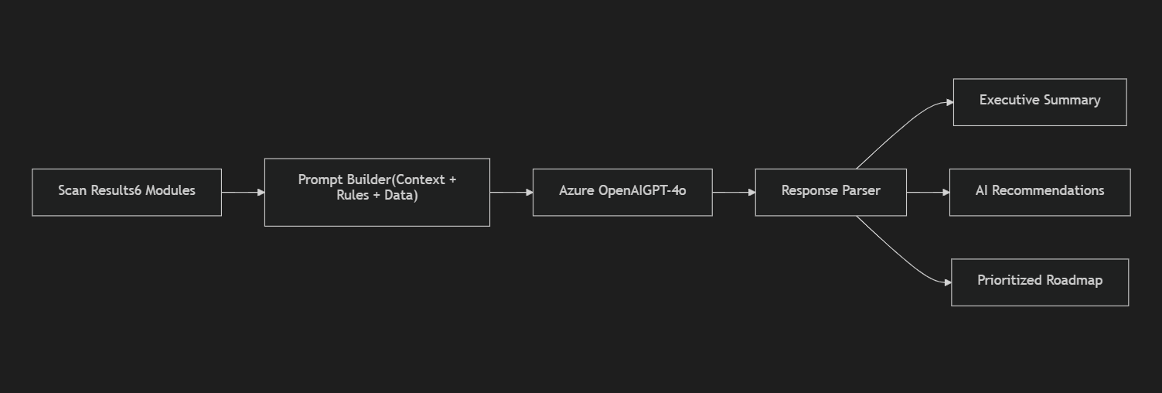

Prompt Engineering Strategy
Rather than dumping raw data into GPT, I'd structure it as:
SYSTEM: You are an M365 licensing and security advisor for MSPs.
CONTEXT:
- Tenant: {name}, {userCount} users, {deviceCount} devices
- Current Licenses: {licenseBreakdown}
- Health Score: {score}/100
SCAN FINDINGS:
{structuredFindings}
INSTRUCTIONS:
1. Write a 3-paragraph executive summary for a CTO
2. List top 5 prioritized recommendations
3. Estimate potential annual savings
4. Flag any critical security risks
FORMAT: Respond in JSON with keys: summary, recommendations[], savings, criticalRisks[]
TIP:
Keep AI costs low — only call GPT for the executive summary and natural-language recommendations. All scoring, rule matching, and cost calculations should be deterministic (rule-based engine), not AI-driven. AI is the polish layer, not the core logic.

9. Frontend Architecture
frontend/
├── src/
│ ├── pages/
│ │ ├── Dashboard/ # Overview with health score
│ │ ├── LicenseOptimization/ # License scan results
│ │ ├── SecurityAnalysis/ # Security gap findings
│ │ ├── ComplianceReadiness/ # Compliance scan
│ │ ├── CostLeakage/ # Cost waste detection
│ │ ├── IdentityRisk/ # Identity scan
│ │ ├── DeviceEndpoint/ # Device scan
│ │ ├── Recommendations/ # All recommendations
│ │ ├── Roadmap/ # Generated roadmap
│ │ ├── Reports/ # PDF report history
│ │ └── Settings/ # Tenant settings
│ │
│ ├── components/
│ │ ├── ScoreGauge/ # Circular health score
│ │ ├── ScanCard/ # Individual scan summary
│ │ ├── FindingsTable/ # Detailed findings list
│ │ ├── SavingsCalculator/ # Interactive cost widget
│ │ ├── RoadmapTimeline/ # Visual roadmap
│ │ └── ReportPreview/ # PDF preview
│ │
│ ├── hooks/
│ │ ├── useAuth.js
│ │ ├── useScan.js
│ │ └── useTenant.js
│ │
│ └── services/
│ ├── api.js
│ └── auth.js

10. MVP Scope (Phase 1)
Based on your plan, here's what I'd build first:
Module | MVP | Post-MVP
Tenant Onboarding | ✅
Data Collector (Graph) | ✅
License Optimization Scan | ✅
Security Gap Analysis | ✅
Cost Leakage Detection | ✅
AI Executive Summary | ✅
Tenant Health Score | ✅
Dashboard UI | ✅
PDF Report | ✅
Compliance Readiness |  | ✅
Identity Risk Scan |  | ✅
Device & Endpoint Scan |  | ✅
Roadmap Generator |  | ✅
Industry Benchmarking |  | ✅
Monthly Auto-Reports |  | ✅
Multi-Tenant Management |  | ✅

11. Deployment Architecture
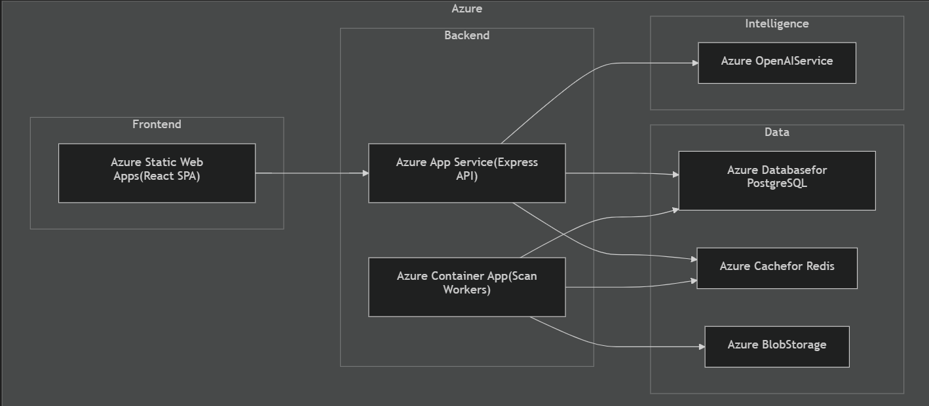
IMPORTANT:
Why all-Azure? Since this product integrates deeply with Microsoft 365, deploying on Azure gives you:
• Native Entra ID integration
• Compliance certifications your enterprise clients need
• Low-latency access to Graph API endpoints
• Azure OpenAI (data stays in Azure, no external calls)

12. Key Architectural Decisions Summary
Decision | Choice | Rationale
Sync vs Async Scans | Async (Job Queue) | Scans take 30-120s; can't block HTTP requests
AI for everything vs Rule-based | Rule-based core + AI polish | Deterministic results, low cost, AI only for summaries
SQL vs NoSQL | PostgreSQL with JSONB | Best of both — relational structure + flexible JSON storage
Own SKU DB vs API | Own curated database | Microsoft has no public pricing API
Monolith vs Microservices | Modular Monolith (MVP) | Ship fast, split later if needed
Real-time vs Polling | SSE for scan progress | Lightweight, no WebSocket overhead
Multi-tenant data isolation | Shared DB, tenant_id column | Simple for MVP, can shard later

Open Questions
IMPORTANT:
Before we start building, I need clarity on these:
1. Target audience — Are you building this for internal use at Meridian Solutions (scan client tenants), or as a public SaaS product anyone can sign up for?
2. Microsoft Partner Center access — Do you have access to Partner Center / delegated admin permissions (GDAP) for client tenants? This changes the auth flow significantly.
3. Demo mode — Should we build a demo mode with mock data so you can showcase the product without needing a real tenant?
4. Pricing data — Do you already have a Microsoft SKU/pricing spreadsheet, or should I curate one from Microsoft's public docs?
5. MVP timeline — What's your target timeline? This affects whether we go full React SPA or start with a simpler server-rendered approach.

