️Java Script️
#Intro
1. JavaScript is a lightweight, cross-platform, single-threaded, and interpreted compiled programming language.
2. It is also known as the scripting language for webpages.
3. JavaScript is a weakly typed language (dynamically typed).
4. JavaScript can be used for Client-side developments as well as Server-side developments.
JavaScript contains a standard library of objects, like Array, Date, and Math, and a core set of language elements like operators, control structures,
5. JS Engine is needed to run JS program
6. Made in only 10 days by (Brender Eiche)Netscape in 1995 named Mocha
7.JS code ko line by line check karta hai using interpreter.
8.Check karta hai ek ek karke ki wo word usme exist karta hai ya nai.
9. 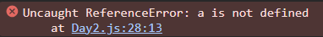
10.Thus in it a is not exist.
11.All the errors are shown in console.
12. The shortest code in js is empty file without single character in it.
13.Note that programming language does’t interact with browser. In PL you can make ur own logic.
14.Javascript is the only programming language understood by our browser.
15.Programming language – Any language that can be used to create logics.
16.Browser – where we can send request to server and get the response. Eg. – chrome, firefox, etc
17.Primitive – smallest possible division, which cannot be further broken down. (Building block of your program)
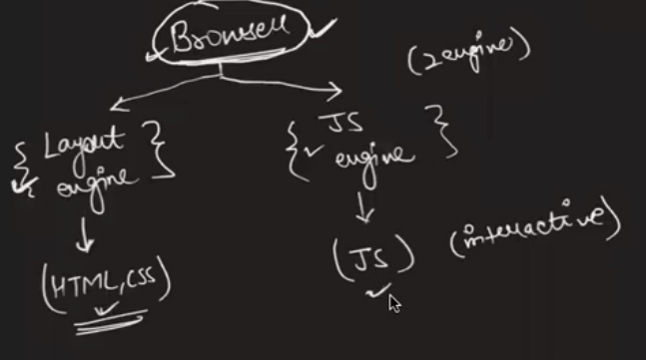

#Note:- ctrl + shift + j open console in browser

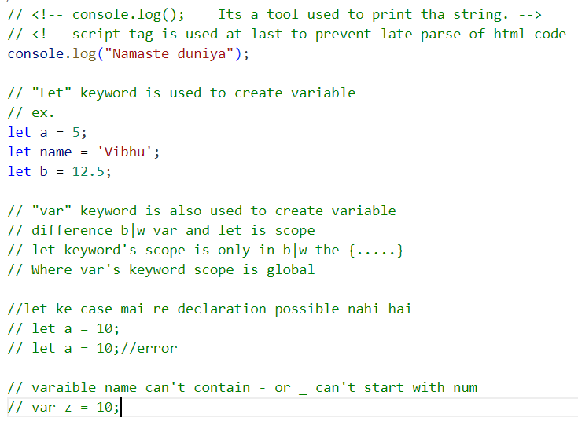
#Translators
1.Compiler task ko Dheere perform karta hai
But run fast ho jata hai
Ex. C,Java
2.Interpretter task ko tej perform karta hai
But run slow hota hai
Ex. Js
3.Jit Compiler Mixer hai compiler and interpreter ka
Mtlb fast task execute hoga and run bhi
Ex. Google
#Window
- Collections of tools that browse offers
- Ex. Console.alert, prompt,document

#About Console
1.console is not in js but it is in web context API.
2.console alert prompt are browse part with the help of Js we can use them.
3.console.log(“”) for printing plane message

4.console.warn(“”) its for warning
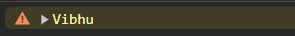
5.console.error(“”) it give message in error
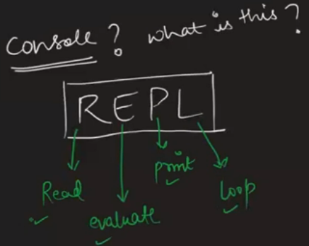
#Note:-
1.Computer English nahi samajhta , 0 & 1 nahi samjhata ……only current flow and current bypass is known to computer.
2.alert(“”) pop-up message
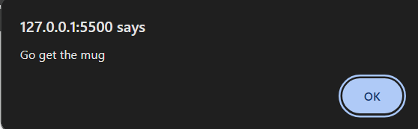
3.prompt(“”) alert ka bhai hai
It when pop-up ask something
Written part will be sended to prompt itself
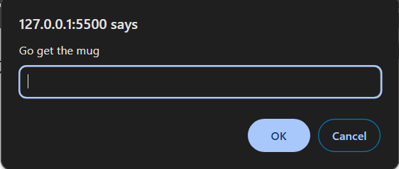
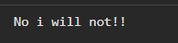
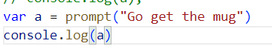
JS -> interpreted, weakly typed, dynamically typed, sungle threaded.
• Interpreted – line by line
• Weakly typed – where the data type(primitive) of the variable is not fixed. Eg. – let umar = 17; umar = “17 baras”;
• Dynamically typed – at run-time, data type(primitive) is defined. Eg. – let sam = 100; sam = “abcd”; sam = true; sam = undefined; • Single threaded – Ek time par ek kaam hoga , i.e, multiple tasks cannot be performed at the same time.
#Variables
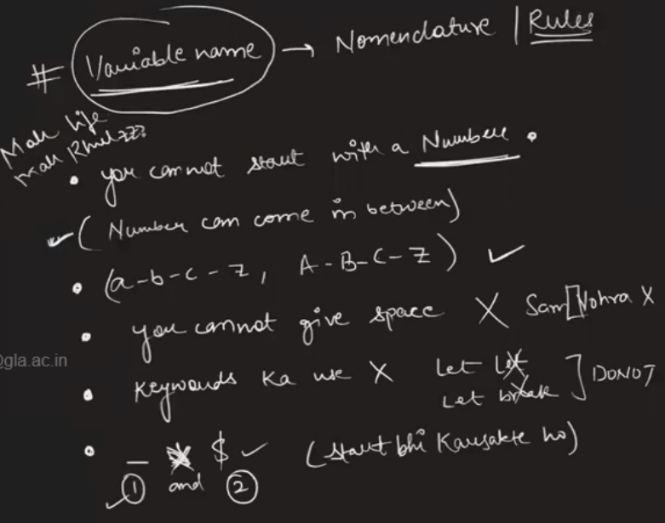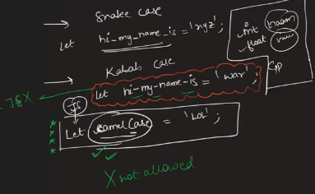
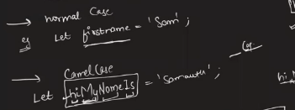

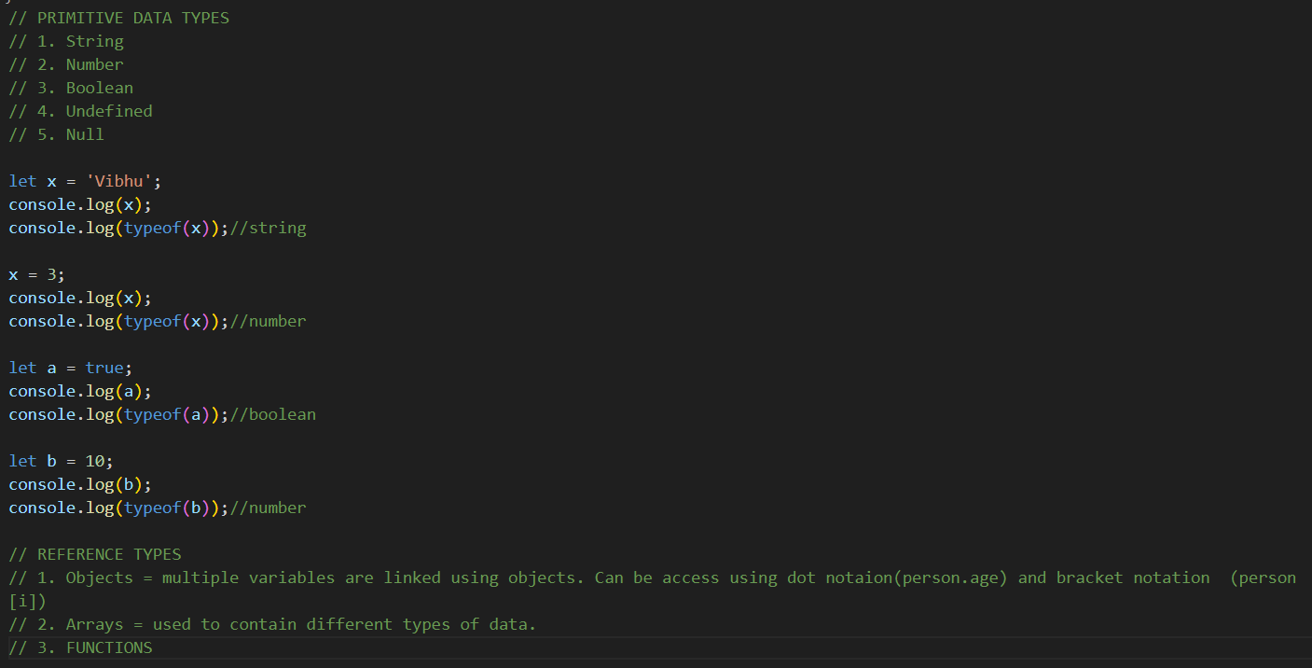
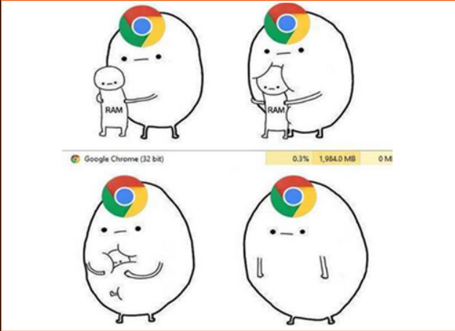

#Nomenclature
Way of declaring the variables… (Variables ko kon kon se naam de sakte ho)
▪ can contain (a-z), (A – Z), (0,1, 2,… 9)
▪ can contain _ , $
▪ must not start with a number.
▪ must not have predefined words.
▪ can be start with _ , $
Eg. – let mann = 10; let marziya = 20; let mann let 2mann let man_made let man$made let _ let $ let break
#BackTicks
1.let name1 = 'This is\n my \' "first" message';
console.log(name1);
let x = 'I love you \t Vibhu';
console.log(x);
2.let m = `This line
is written in
several line
using backticks`;
console.log(m);

let ok = `Hello ${m}`;
console.log(ok);

#Extras
1.let date = new Date();
Sat Nov 11 2023 18:13:50 GMT+0530 (India Standard Time)
2.let date2 = new Date('June 20');
let date3 = new Date(2003, 8, 19, 8);
date3.setFullYear(1947);
date3.setMonth(12);
date3.setDate(29);
3.date3.getFullYear;
console.log(date3);

#Escape Characters
Way of defining the variables
Normal case Eg. – let venugopaliyer = “goa”;
Camel case Eg. – let venuGopalIyer = “Readability”; •Most preferred case.
Snake case Eg. – let venu_gopal_iyer = “Saanp”; Kabab case
Eg – let venu-gopal-iyer = “Bhaukaal”;
• We cannot use kabab case in javascript because of the hyphen.
1. 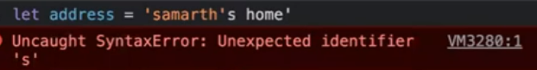
2.Jaha use karna ho use pahale \ ye laga do bss.
3. 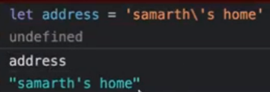
4.But it is not like html to use like \n \t directly 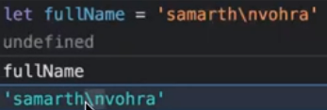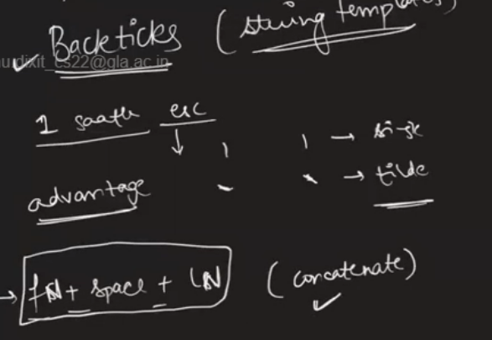
6.Jis cheez ko aapko string mai inclosed karna hai toh ${} ke andar likna hoga var ka name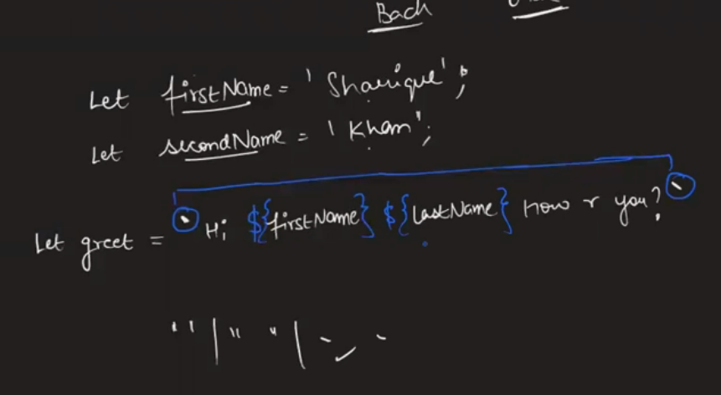
7.For multiplication use ‘**’ 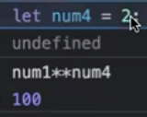
8. 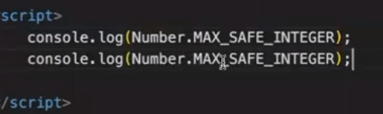
9. 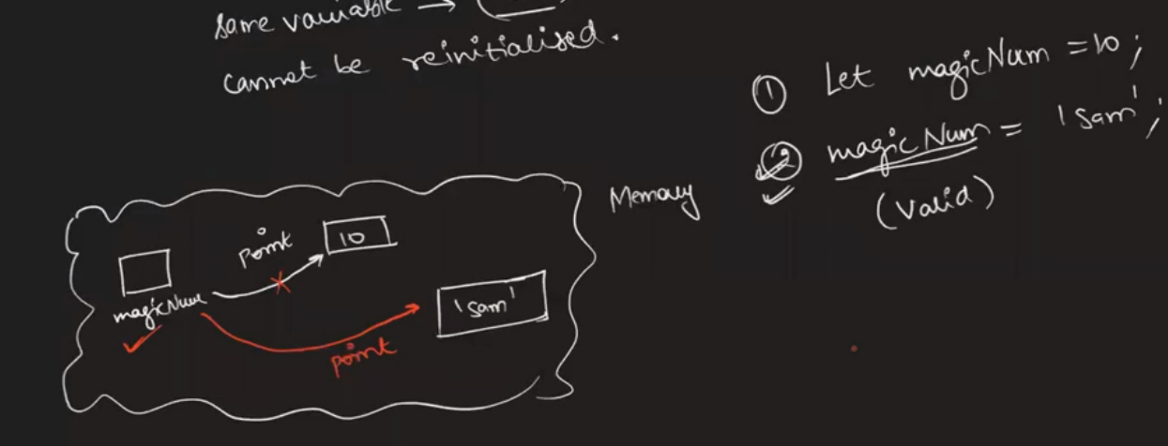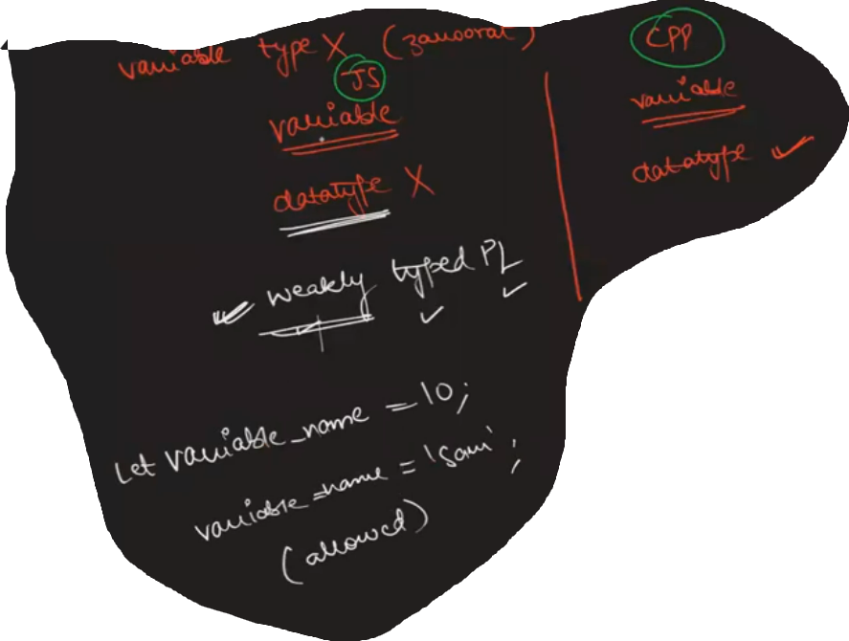
10.Esse languages jiske variable ka type eaxctly runtime par pata chale usse Dynamic PLanguage kahte hai,

11. 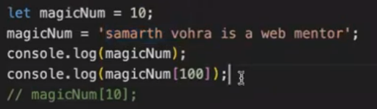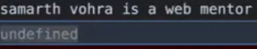
12. 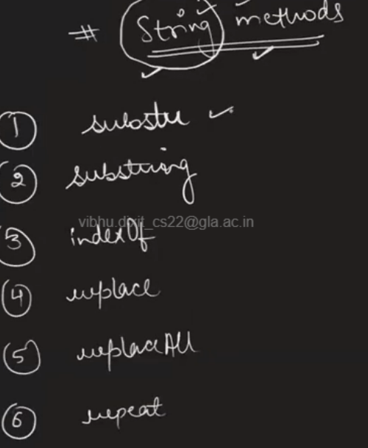
#Note
1.Dynamicaly Typed Language
let x = 1;
x = 'a';
console.log(x);//no error successfully run and value printed
function sum(a,b){
return a+b;
}
console.log(sum(1,2));//3
console.log(sum(1));//NaN --> not a no. as 1 is added with undefined no.
console.log(sum(1,2,3,4,5,6));//3
x
#Scope Of Variables
- 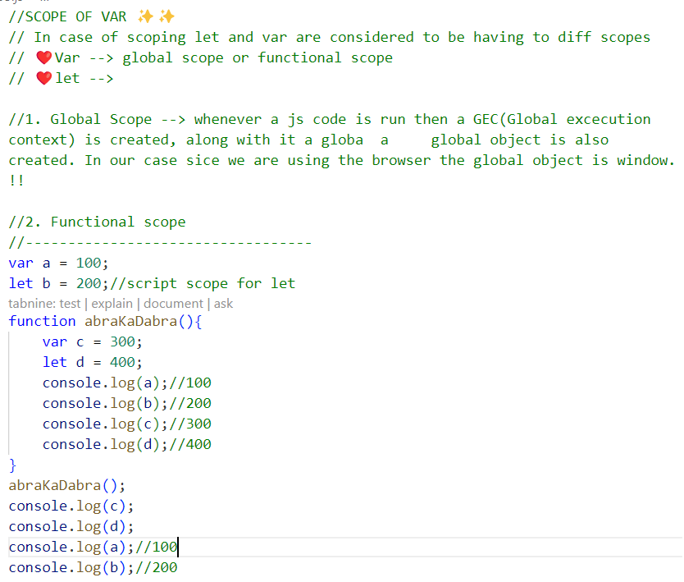
- 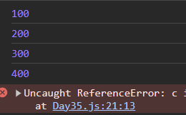
#Types Of Data
1.data type mtlb data ka roop
2.Data types are of two types:-
a.Reference Data Type [ ], { }, ( )
b.Primitive Data Type String, Integer, float, char,
Boolean
Ex. let a = {value:10};
let b = a;
//In Reference type data type copied data is pointed only by that variable
//Here a object is madee inn memory were value:10 is stored and a & b both points that
//Where in primitive type new object is made

#Operators
1. Assignment
2. Arithmetic
3. Comparison
4. Bitwise
5. Logical
6. Ternary operator
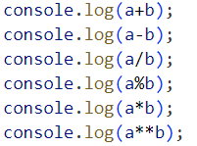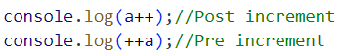
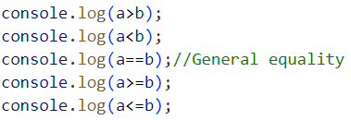
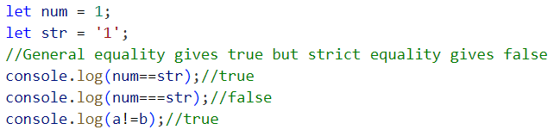
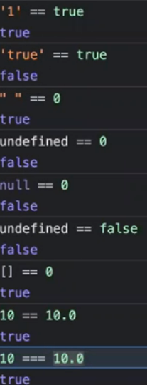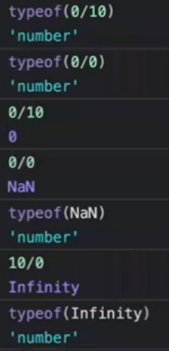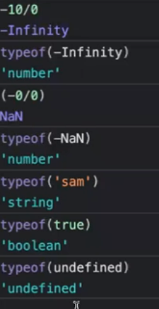
# LOGICAL OPERATOR
1. AND && (all condition should be true)
2. OR || (any condition is true) shortcircuiting happens in this
3. NOT ! (ans is swapped)
4.BITWISE OPERATOR(works on bits)
1. AND & (dono ka one hona impo. hai)
2. OR | (ek bhi 1 ho jaye )
OPERATOR PRECEDENCE
PEMDAS
5.MATH INPUILT FUNCTIONS
console.log(Math.round(1.8));
console.log(Math.max(1,8));
console.log(Math.abs(-2));
console.log(Math.pow(2,2));

# Conditionals
1.if-else, else-if, ternary operator, switch
2.if me hamesha true ya false value aata hai
3.Truthy & falsy values har value ko true ya false banaya ja sakta hai depend karta hai value ka kya type hai
4. False values false,null,NAN,0,’’,””,document,all,und
5.Truth values baaki sab true hai
Ex. 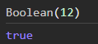 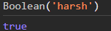 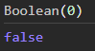 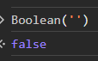
6. 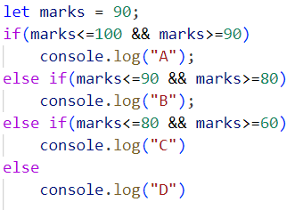7. 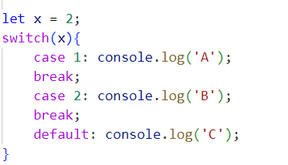
8.GENERAL COMPARISON:- Typecast is possible
let ans = s == 1;
STRICT COMPARISON:- Typecast is not possible
let ans = s === 1;
9. 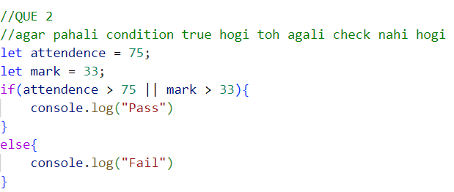10. 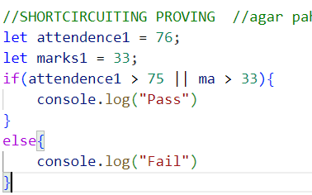
#Loops
1.for, while, do-while, for-each, for-in
2.for-in & for-each baaki kia tarah nahi hai jo start, end and change par depend ho
3.It only works on Arrays.
4. for-in are applied on non iterable items thus can be applied on objects only.
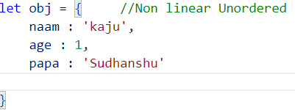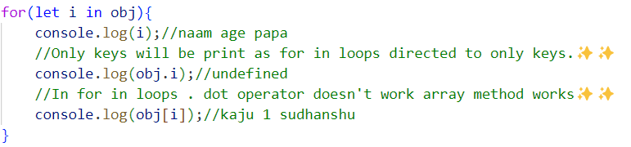
5. //Outside the for-in loops . dot operator works
console.log(obj.age);//1
//Outside the for-in loops arrays method doesn't work
console.log(obj[1]);//undefined
6. 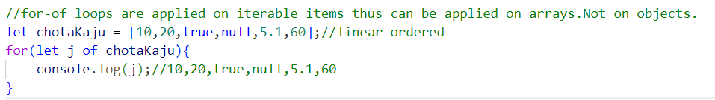
7. 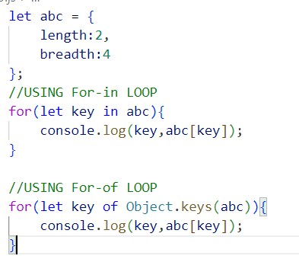
#Note:-
A.
1.let a = [ ];
Technically this value is reference data type but as ‘a’ is holding it thus ‘a’ is also reference.
2.var arr = [1,2,3,4]; O/P arr = [1,2,3]
var brr = arr; brr = [1,2,3]
brr.pop( );
3.This is due to as ‘arr’ is a reference data type , thus its value is not copied to ‘brr’ but only its address is copied.
4.Thus if we change the values of ‘brr’ then value of ‘arr’ will also be changed.
5.For actual data copying we can use spread operator.
Var a = [1,2,3,4]
Var b = […a]
6.Now if changes made on ‘b’ then ‘a’ does not affected.
7.CLONNING BY USING For-in LOOP
let src = {value:10};
let dest = {};
for(let key in src){
dest[key] = src[key];
}
console.log(dest);
8.CLONNING BY USING Assign
let src = {value:10};
let dest = Object.assign({},src);
console.log(dest);
9.CLONNING BY USING Spread
let src = {value:10};
let dst = {...src};
console.log(dest);
10. 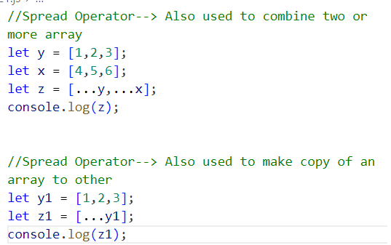
#Functions
1. A block of code that fullfill a specific task.
2. 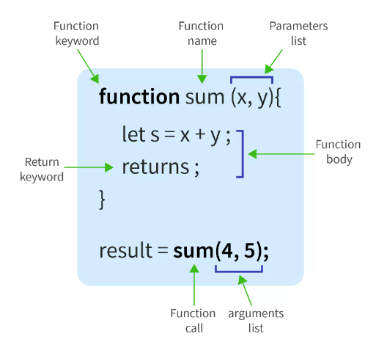
3.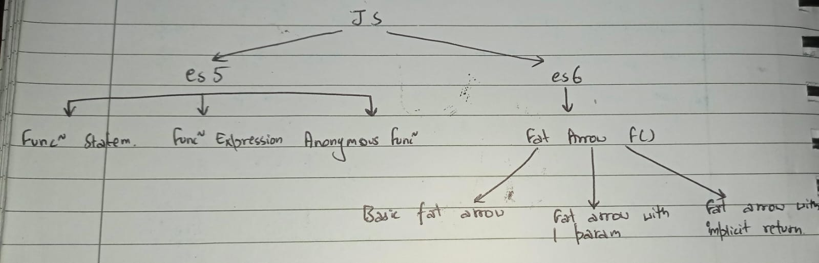
4. Wenever a JS code is run a gloabal execution context (GEC) is created inside that GEC we have 2 phases
1. MCP --> MEMORY CREATION PHASE
2. CEP --> CODE EXCECUTION PHASE
5. 1. MCP --> MEMORY CREATION PHASE
Before execution of a code all code is copied to M

CP(skimming out variable)--> a,hello{} doesn't go inside f()
Here every variable as well as function get temporary value as undefined!!
2. CEP --> CODE EXCECUTION PHASE
It starts when MCP ends.
Here now from top to bottom starts executing code one by one.
Also includes the change of value from unefined to actual value.
Whenever a f() is called a new execution context is created with the name of the f() which also has two phases ((same as above i.e. MCP & CEP))
6.Js mai f() ko first class f() ka darja diya gaya hai, jiska mtlb hai ki js mai f() ko value/variable ki tarah treat kar sakte hai.
7.In passing values/arguments u can send even f( ) also.
8.function abcd( ){
//FUNCTION STATEMENT
}
9. var abcd = function( ){
//FUNCTION EXPRESSION
}
//Function storing in variable
10.function( ){
//ANONYMOUS F( )
}
//Function without name
11.var a = ( )=>{ }; //BASIC FAT ARROW
12.var g = a =>{ }; //FAT ARROW WITH ONE PARAM
g(12);
One parameter pass hai toh aap fat( ) hata sakte ho.
13.var abcd = ( ) => “Vibhu”; //FAT ARROW WITH
Var go = abcd( ); // IMPLICIT RETURN
Isme ek value implicitly return hoti hai jaha calling hoti
hai uss variable mai.
14.Essa function jo kuch bhi return nahi karta wo undefined return karta hai.
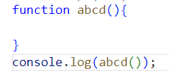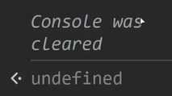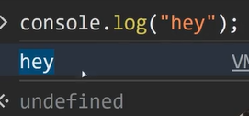

15.In parameters a variale is their to get value.
16. 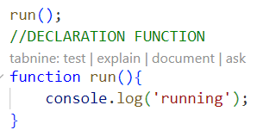 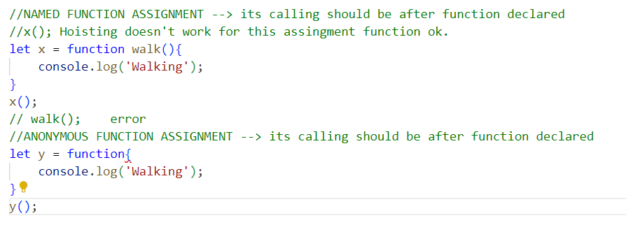 HOISTING --> Its is the process moving function declaration to the top of file --> doing automatically by JS Engine
17. CALLING FUNCTION --> it can also be done before the function declare
run();
19. //let, var & const can be hoist but in 2 diff. styles.
//var --> in this case we get undefined
//let, const --> in this case we get error
// Dead Temporal Zone(DTZ)

18.Arguments to accept more values:-
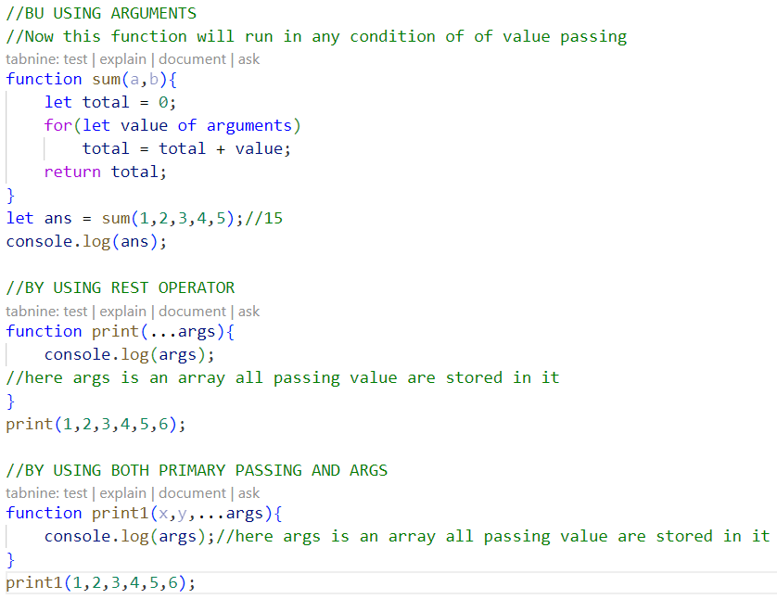
19.Default parameters in f( )
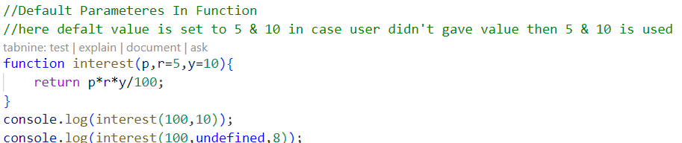
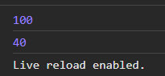
# Note
1.undefined is a value ye value tab di jaati hai jab variable ko koi value na di jaai hai , mtl ye ek garbage value ki tarah treat ki jaati hai, ya defaut value bhi de sakte ho.
2.not defined is an error variable/function/identity ko use karna without its declaration gives an error and that error is not defined error
3.null is also a value this is a value which resolve like, not found, it is received when something is not found.
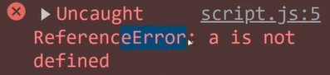
#Arrays
- 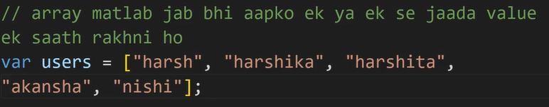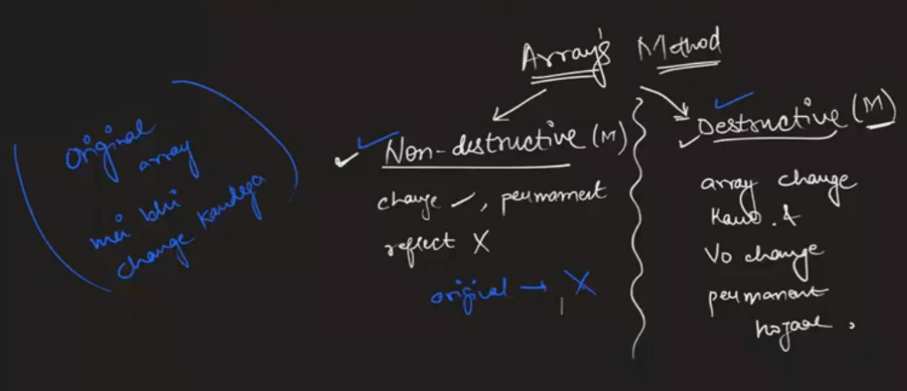
- In array counting starts from 0 called 0th index.
- 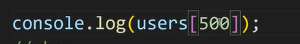
- Can put anything
- A lot of time the data is in the shape of more than member to contain them all we use array.
- 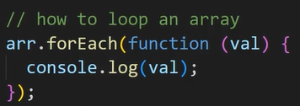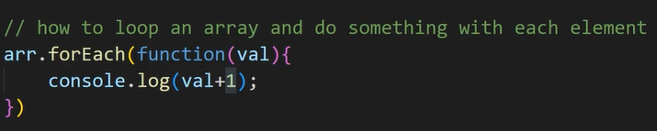
- 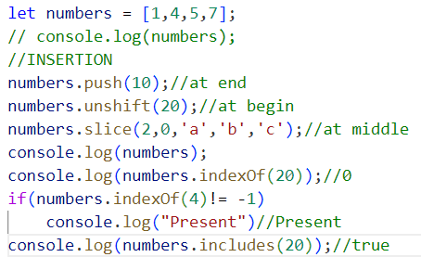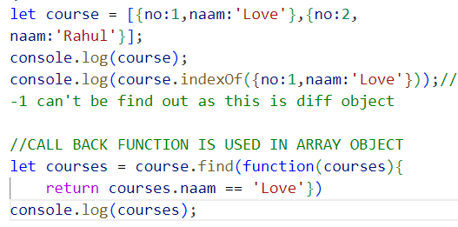
- 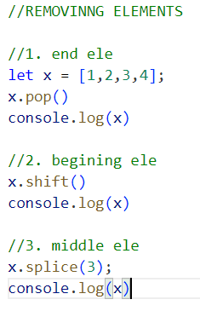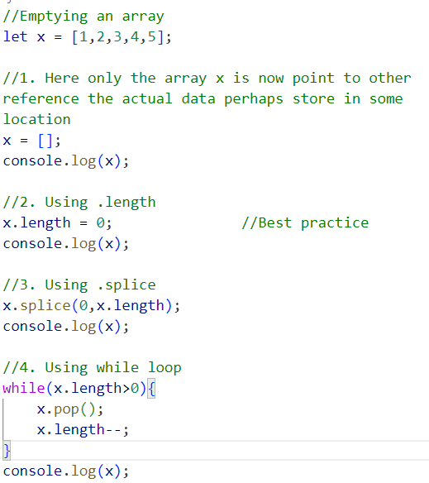
- 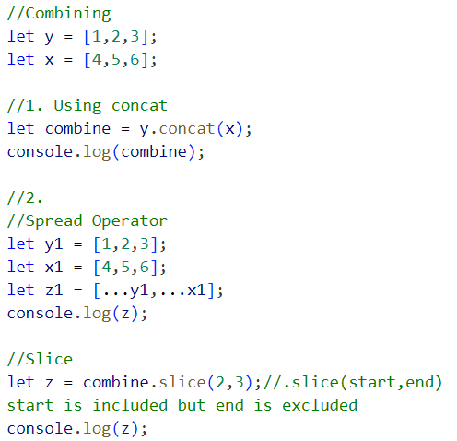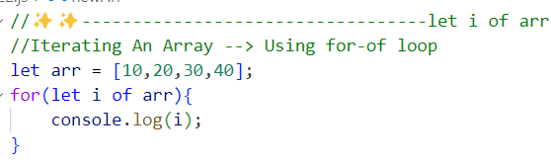
- 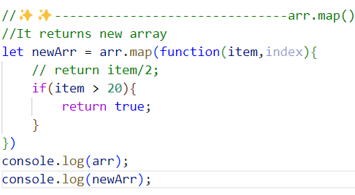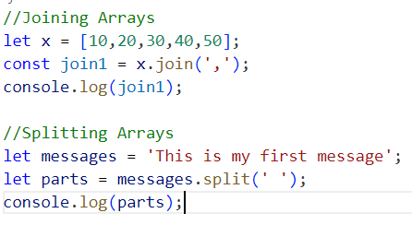
- 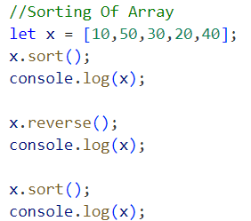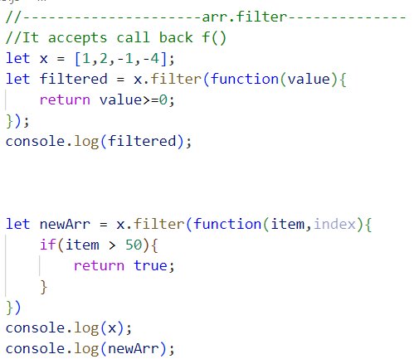
#String
1. Primitive String
let a = 'Vibhu';
2. Object String
let lastname = new String('Dixit');
console.log(typeof(lastname));
console.log(lastname.includes('Di'));
console.log(lastname.startsWith('Di'));
console.log(lastname.endsWith('t'));
console.log(lastname.indexOf('D'));
console.log(lastname.toUpperCase());
console.log(lastname.toLowerCase());
console.log(lastname.trim());
console.log(lastname.replace('Di','ti'));
console.log(lastname.slice());
console.log(lastname.split('Di'));
3.let message = 'This is my first message';
console.log(message.split(' '));
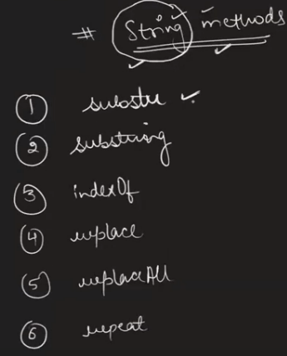
#Objects
1.Ek tareeka hai jisse hum ek identity ki details ko ek saath rakhte hai.
2.Kai saare logo ka data Array [ ]
3.Ek log ka saara data Objects { }
4.can be make like var obj = { };
var obj1 = new obj1{ };
5. var obj = {
name : ‘Vibhu’,
age : 19,
sex : ‘Male’
} console.log(obj.name);
#Synchronous & Asynchronous js
1.Synchronous mai code humesha line by line chalta hai
2.Async mai code line by line nahi chala-ta, saara asyn code ek saath shuru kar diya jaata hai and jo pahle complete hojaye uska answer dediya jata hai.
3.All synchronous code goes to main stack directly ans async goes to side stack.
4.In side stack no code is excuted only processing is done in that.
#This
1.This keyword js mai one of the most suspenseful hai
2.Keyword ka mtlab hota hai jiska koi mtlb ho programming lang mai
3.This ki value baar baar badal sakti hai alag alag conditions mai
4.Global scope(wo code jo kissi bhi braces main a ho ya kisi f( ) main a ho ) mai this ki value window
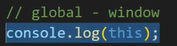
5.Function mai this ki value window
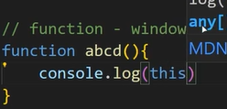
6.Method (object mai kisi field ki value agar f( ) ho) mai this ki value Object
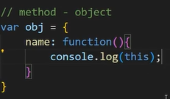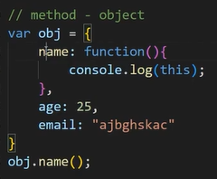
7.Function inside method(es5) mai this ki value window
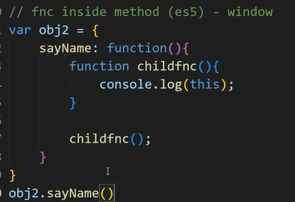
8. Function inside method(es5) mai this ki value Object
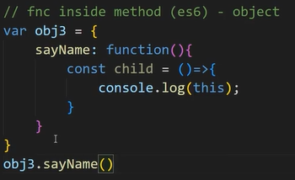
9.Constructor f() mai this ki value new blank object
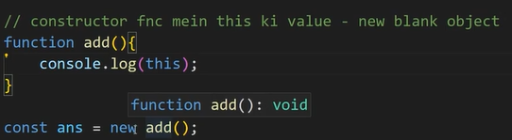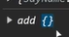
10.Event listener mai mai this ki value that element jisme this ho
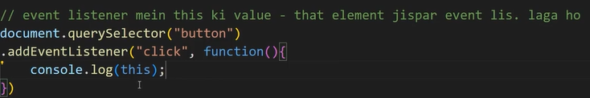

11. THIS depends on how it is being called upon.
#Call Apply Bind
1.Ye teen tareeke hai f( ) ko call karne ke kisi object ko this maan kar.
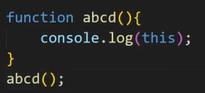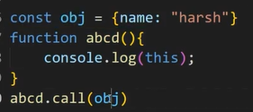
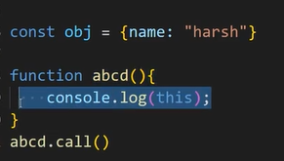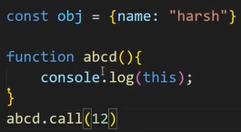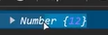
2..call( ) ki help se f( ) ki value kya rakhna hai ye set kar sakte hai.
3. 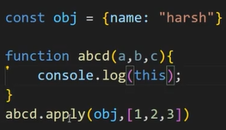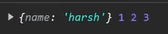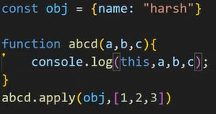
4..apply( ) and .call( ) mai bss itna fark hai ki .call( ) mai saare arguments ek-ek karke bhej sakte hai whereas .apply( ) mai pahale arg. ke baad aapko baaki argument array mai bhejne hoga.
5..bind( ) bilul call ki tarah hai bss iska ans aapko console par turant nahi milta, ye f( ) ko chalata nahi hai , ye aapko baad mai chalan eke lye ek function deta hai.
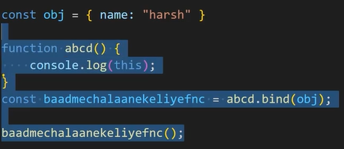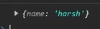
#Prototypal Inheritance
- 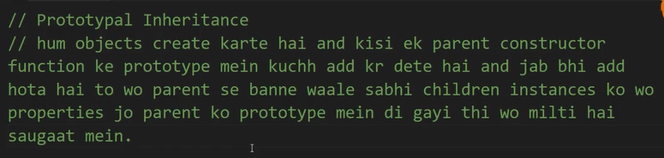
- 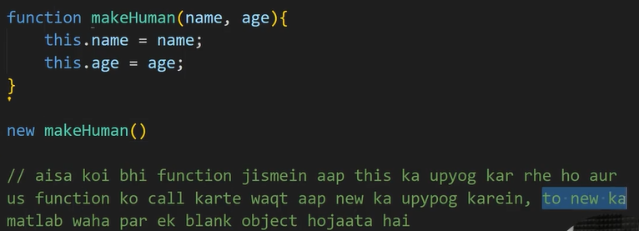
- 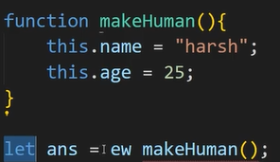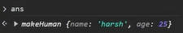
- Ek f( ) jo ki this ka use kar raha ho and new ke dwara naye naye object de raha ho esse f ( ) ko constructor f( ) kahate hai.
- 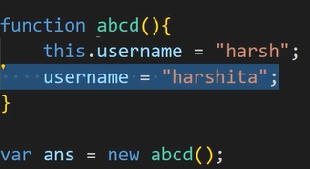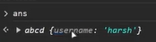
- 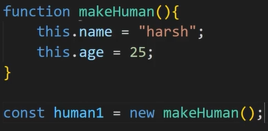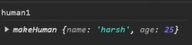
- But there is a problem if you storing this.something in one var using new than it is ok,…..buut for two variable storing at same time then data will be same stored.
- 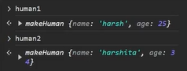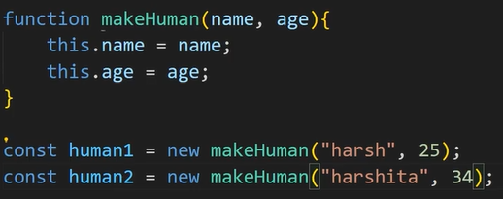
- 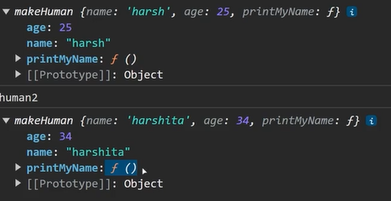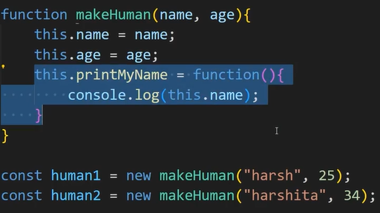
10.Here we can see that as both f( ) .printMyName has same value but taking space in both f( ).
11.So we can save that memory using prototype of inheritance.
12.By making storing . printMyName in other place and allow access to everyone.
13.We can store everything in f( ) using .prototype.
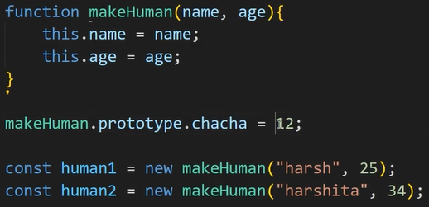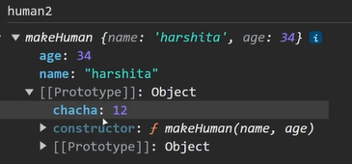
14.Now that is available in a sharaed way. 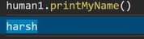
#Closures
1. CLOSURE:- Whenever you return a function that function will never returned alone it always takes along the lexical environment with it so that if in future we ever want to run that returned function, then it should not throw an error.
2. //✨✨--USE OF CLOSURE-------
//Before the class syntax was introduced we had no way to privatise our variables or functions.
//So in that case we use closures so that we can privatise the variables.
3.Aisa koi bhi f( ) jo kisi or f( ) ko return kar de to use closure kahate hai.
4. 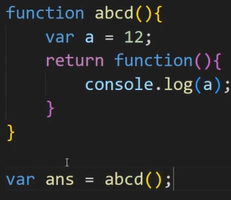
5. 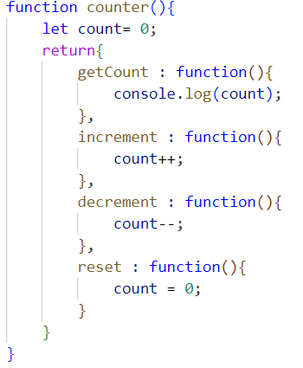 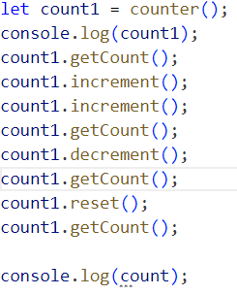 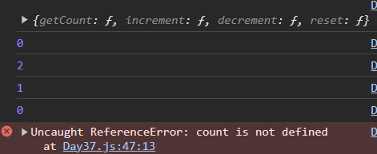
6. 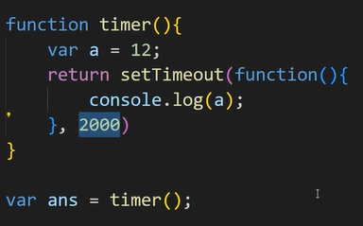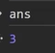

#Lexical Scoping
1. It is defined as local memory(MCP) + parents lexical scope(which means parents local memory and its parents LS and so onnnn...)
2. 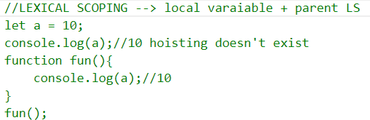
3. 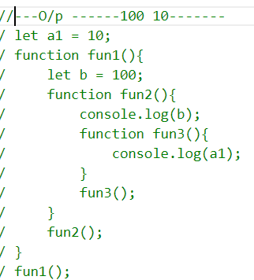 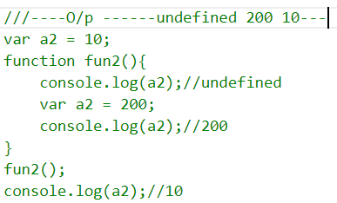
4. 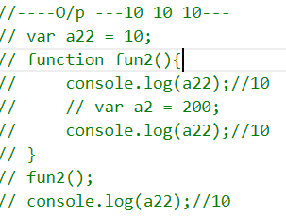 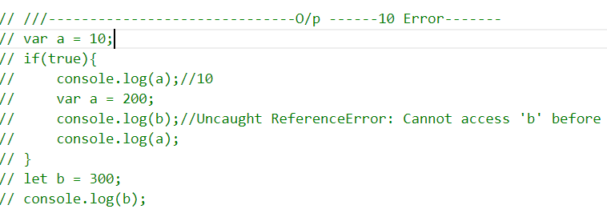 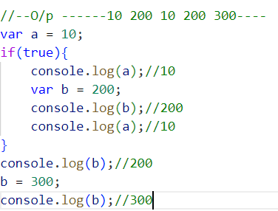
#Event Deligation
1.Jab aap ek event listener se kai saare diff elements se events ko handle kar sake.
2.Event listener ko parent par lagao and unko id, class ya fir tag ke basis par differentiate karke diff. karao.
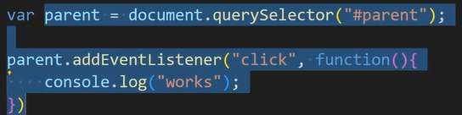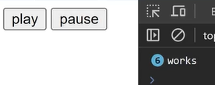
3.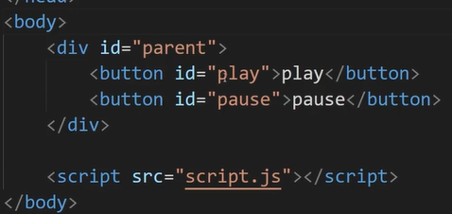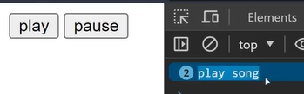
4.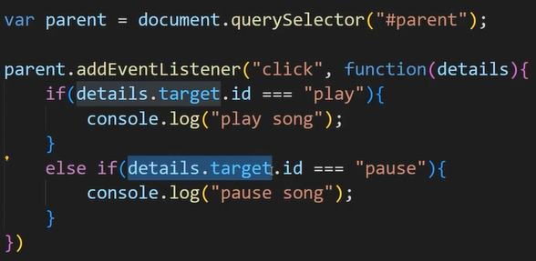
#Higher Order Functions
1.Aisa koi f( ) jo ki ek f( ) ko parameter mai accept karle and ek f( ) ko return karde.
2. 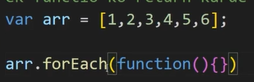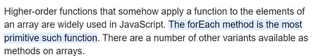
#Try- Catch
1.Apne poore code ko try{ } mai daal do and catch( ) mai error accept hoga.
2.To handle error you can use throw Error(“ “) and can print that in console using catch.
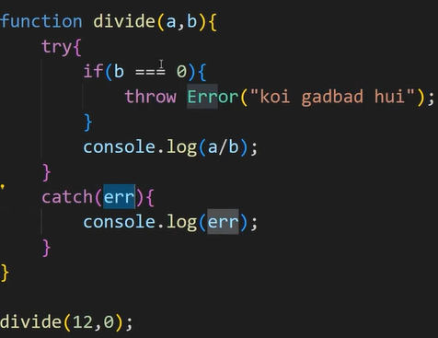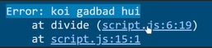
#Custom Events
1.We know events like click, dbclick, mouseover, input ,et
2.We can also make our own events like chacha.
3. 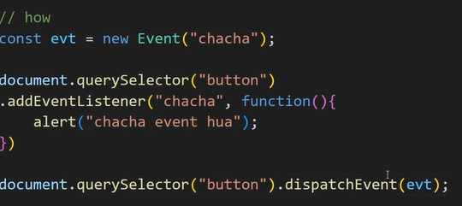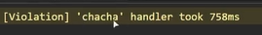
4. 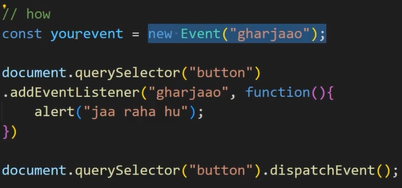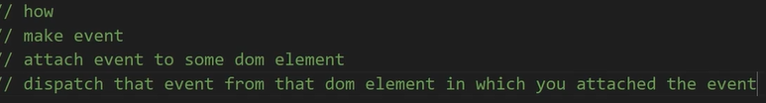

Introduction To DOM

#Intro To Manipulation
1.Document Object Model jo bhi ham web par dekhte hai wo sab kuch body tag ke andar bnta hai!!, ab jo body mai banta hai wahi web par dikhta hai!!
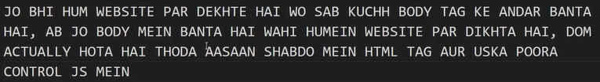
2.Html mai koi essa feature nahi hai jo click ko handle kar sake
3.Aisi js jo aapke webpage par chejo ko badal sake, us js ko ham perform kar sakte hai DOM ke saath.
4.
5.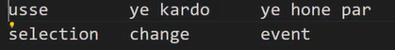
#Accessing Elements
1.Ek webpage banao – usme kuch ele banao
2.DOM mai sabse pahale select karna hai ele jisko changes karna hai.
3.You can get ele in many ways:-
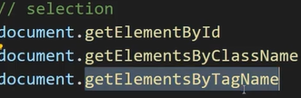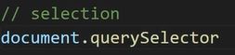
4.To insert in .querySelector use single quote ‘ ‘.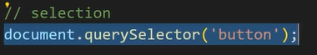
5.And we have to select and save.
6.You can select ele in many ways:-
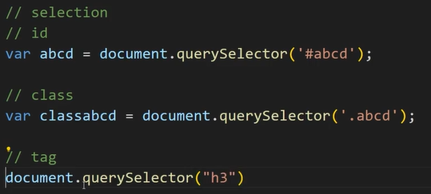
7.Agar aapke pass bohot saare h3 hai and aap select karte ho h3 to sirf pahala h3 select hoga.For selectiong rest all h3 than use:-
8.All selections should be at the top for easy code structure.
#Modifying Ele
1.Kisi ko bhi change karne se pahala step hota hai usse select karna
2.Change content:-
3.Ex. 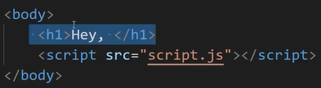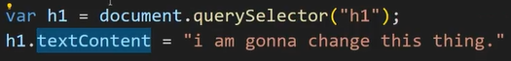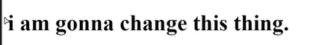
4.For concat:- 
5.For changing the tag;- 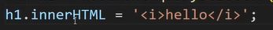
# Manipulating CSS
1.Sabse pahale select karo kis ele par css change karni hai and save karo usse ek var mai.
2.Than .style.<property> use kar lo:-
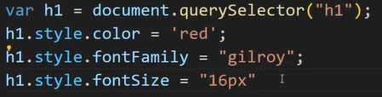
3.For adding direct class css 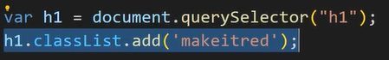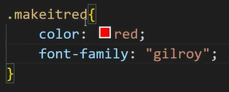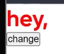
4.For removing classList 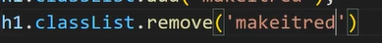
#Creating And Deleting Elements
1.Here we will learn how to create html elements in .js file and link it to.html file.
2. 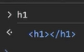
3. 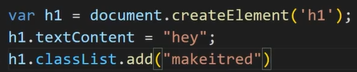 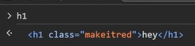
4.Now we have to link or select the area where we have to put that ele.
5.We can link that ele in .html using .appendChild( ).
6. 
7.Ex. 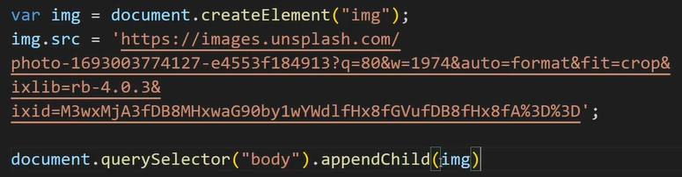
8.
9.

#Event Handling
1.Jab bhi aap kisi ele par kissibhi prakaar ka reaction karte ho to wha par inbuilt , by default auttomatically raise hota hai.
2.Ab agar aapne koi event listener nahi banaya hai to wo event ignore kar dia jata hai par agar aapne listener baaya hai to wo event ignore nahi kiya jayega balki uska listener chalega.
3.Callback is a f( ){}
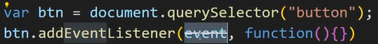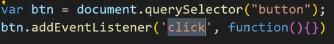
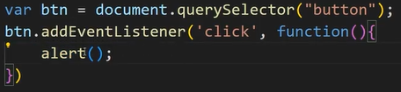
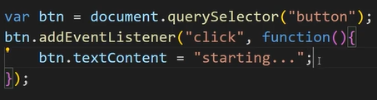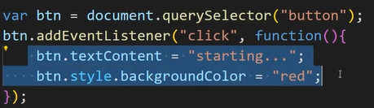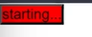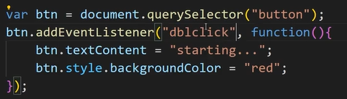
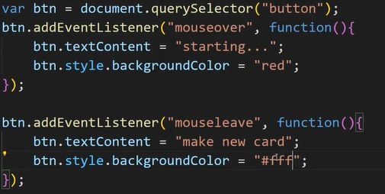
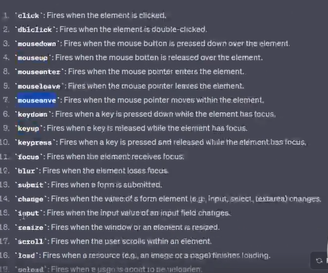
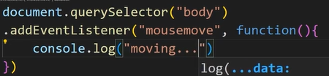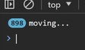
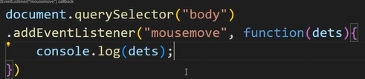
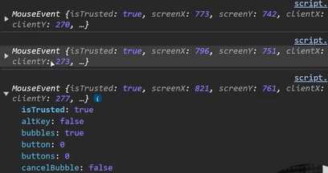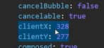
#QUESTION 1
1.
2. 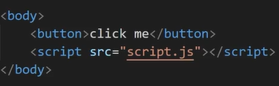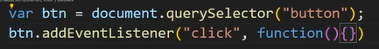
3. 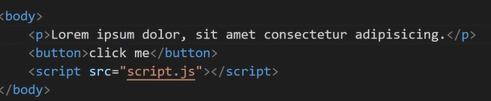
4. 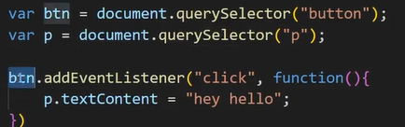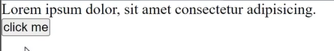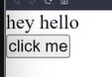

# QUESTION 2
1.
2.
3. 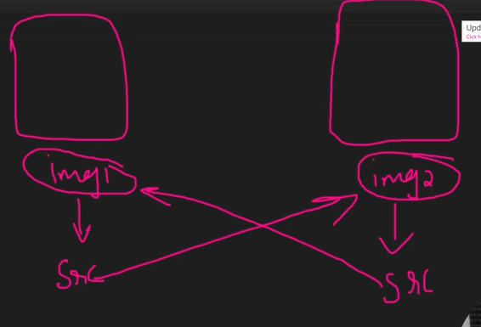
4. 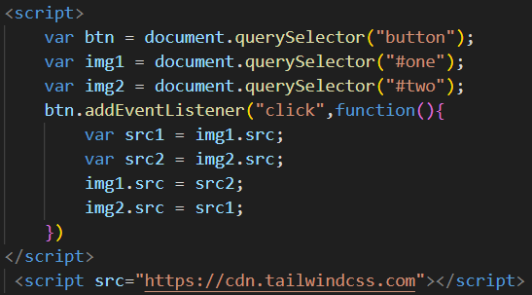
5. 
# QUESTION 3
1.
2.Jab bhi forms ke sath deals karo yaad rakho submit hone par forms page ko reload kar dete hai, tumhe khayal rakhna hai ki page reload na ho agar page reload hua toh js nahi chalegi.
3.Kyunki js chale usse pahale hi page reload ho chuka hoga.
4.Form ko submit karne par reload se rokne ke liye use .preventDefault( );
5. 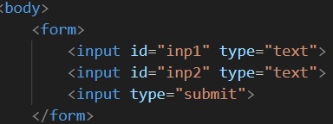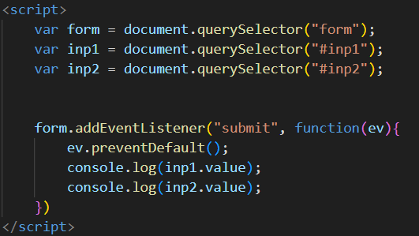
6. 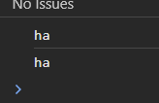
7.For checking input is blank or not:- 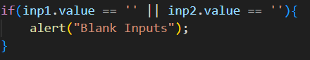
8. 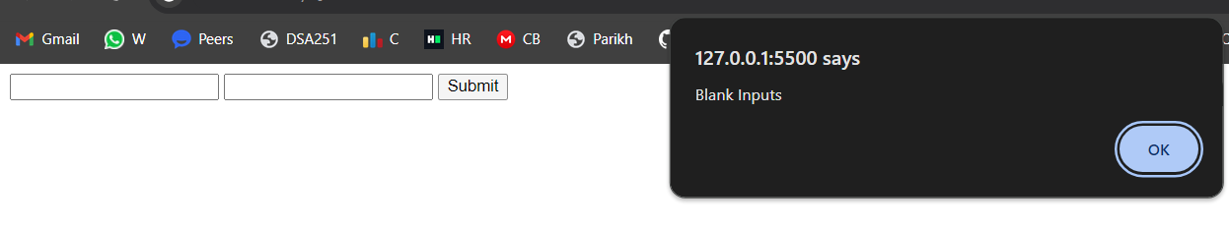
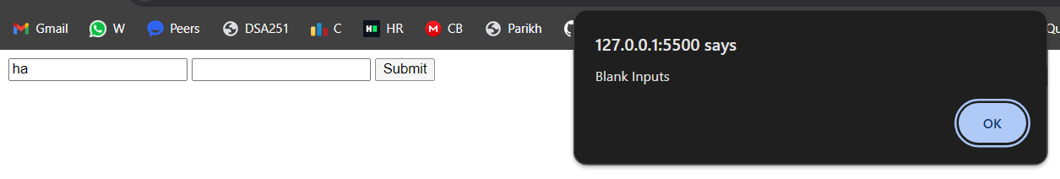
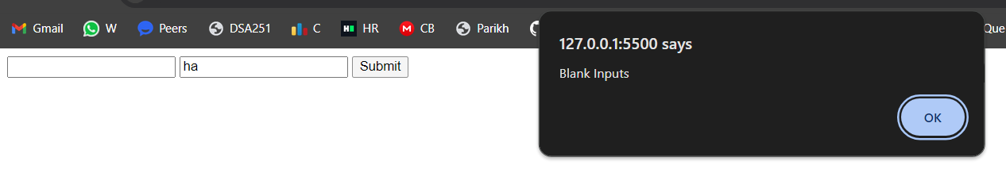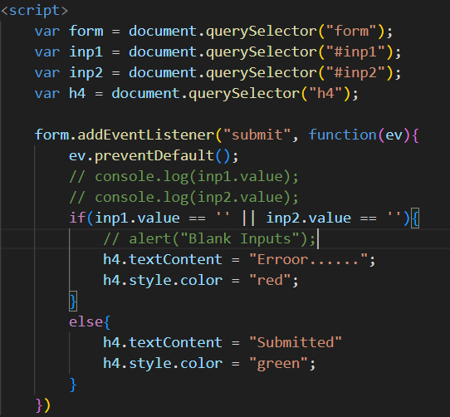
9. 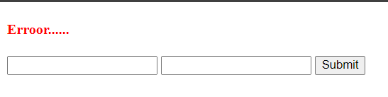 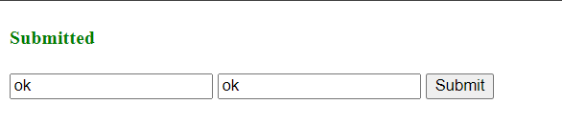
10. In place of writteing so many document.query.. we can create its array 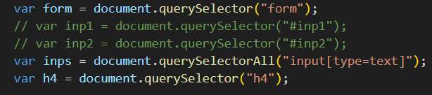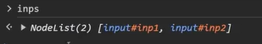
11. 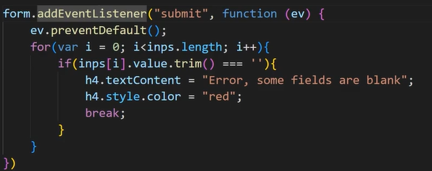

#QUESTION 4
1.
2. 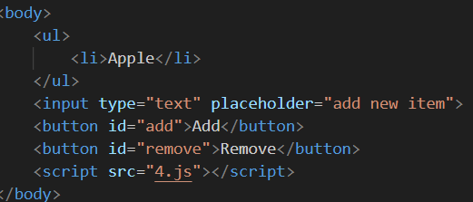
3. 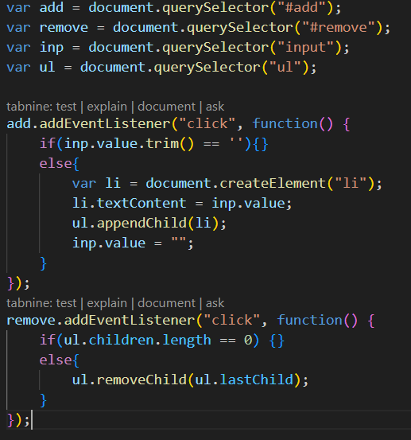
4. 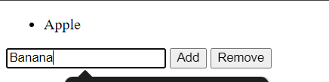
5. 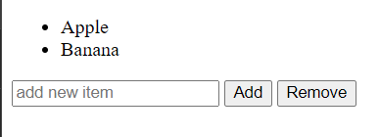
#QUESTION 5
1.Timer
2. 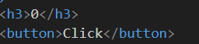
3. 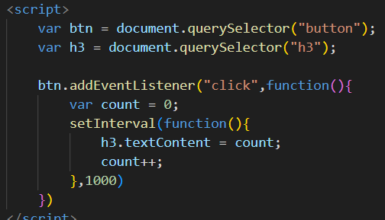
4. 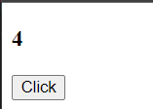Constantly running…..
5.For stopping the counter we have to clear that interval which is constantly running.
6.For that we have to store that in a var.
7. 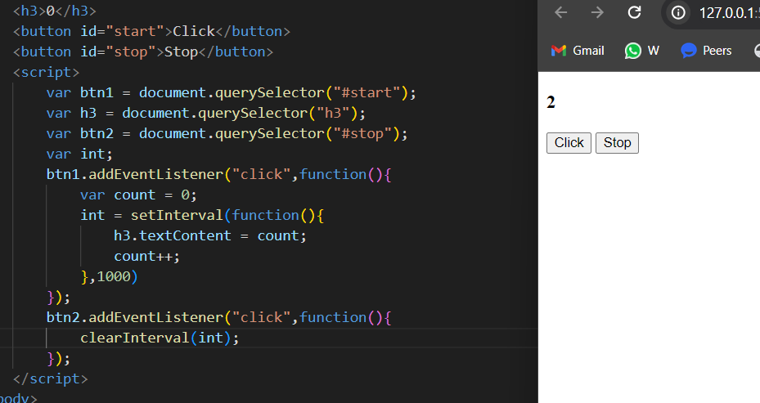
#QUESTION 6
1.Create a tabbed interface where clicking on tabs displays diff content sections without reload.
2. 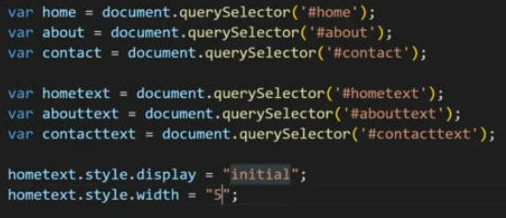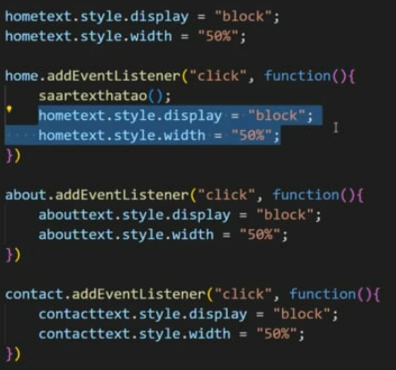
3. 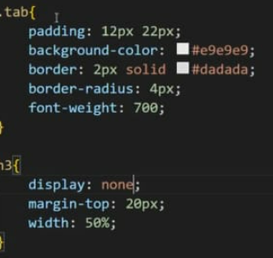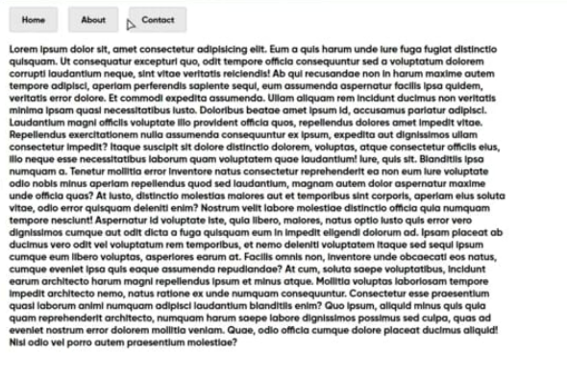
4. 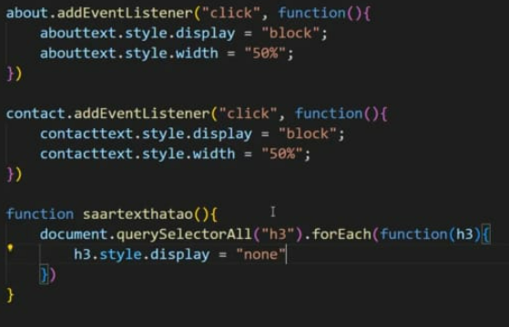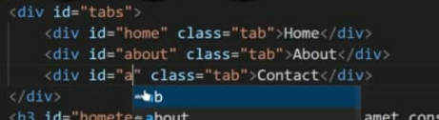
6. 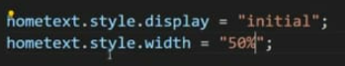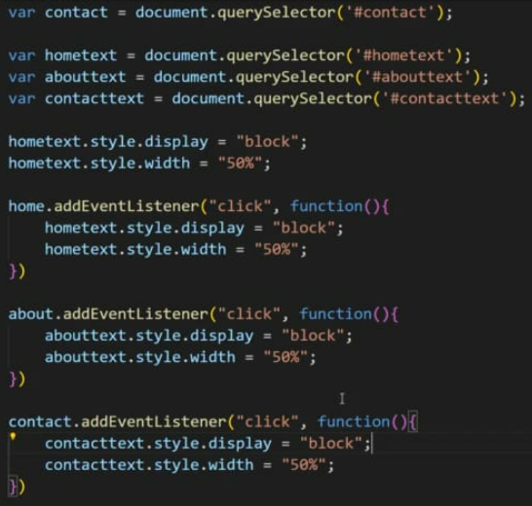
7. 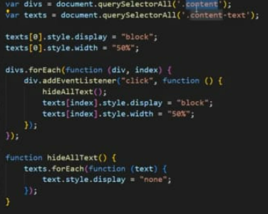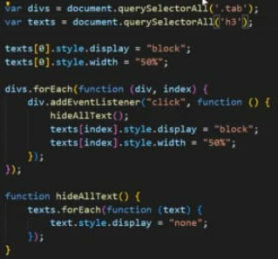
# QUESTION 7
1.
2. 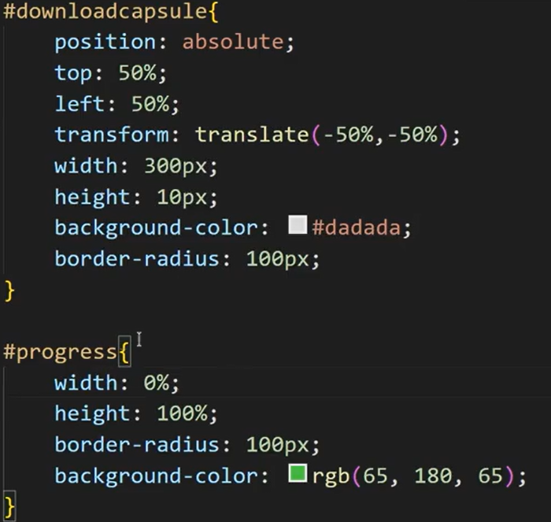 We have to basically change the value of that width to change the percentage of download done.
3.  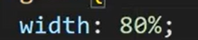
4. 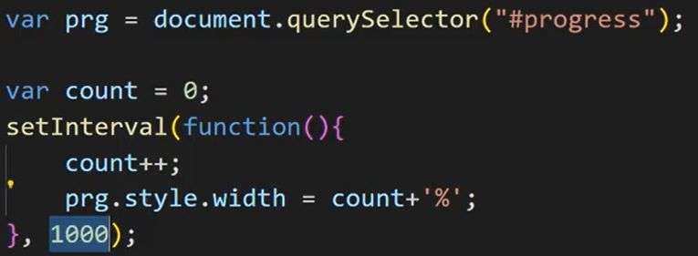 
5.Here we can see that it kept on increasing as we doesn’’t say it where to stop. 
6. 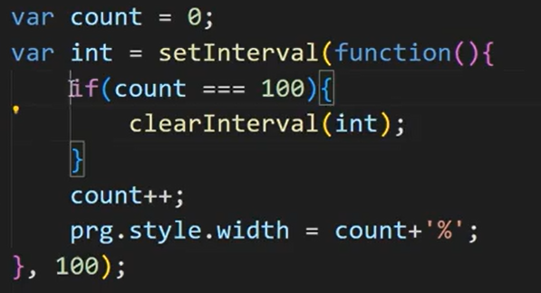
7.For smooth behaviour we can use
8.For when it complete we can write “Download complete” for that we can make changes in its css. 
10. 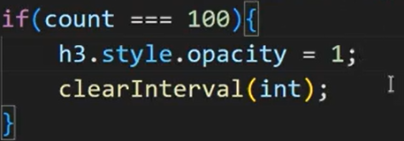

️GSAP️
#What Is GSAP?
1.GREENSTOCK ANIMATION PLATFORM is an easy-to-use js library for web animations.
2.It lets you animate just about anything that can be accessed with js including SVG, generic objects,canvases and more.
3.For starting with GSAP we have to first link it with our html file in script tag before app.js link tag.
4.Search on google GSAP cdn link and copy that link
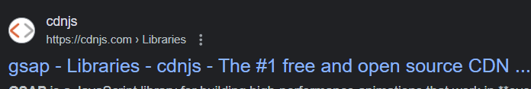
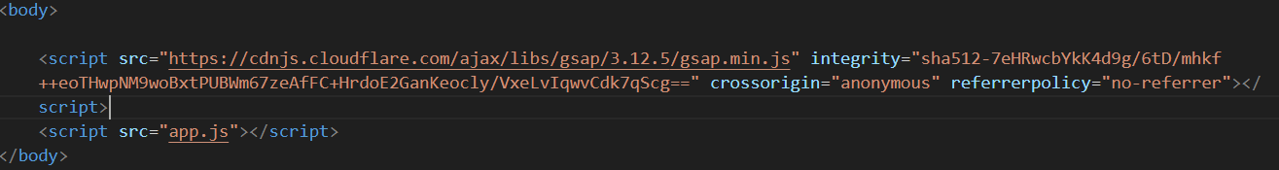
5.Animation is nothing but moving element from initial to final pos. or vice versa.
6.For initial to final movement we have 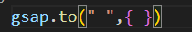
It takes two argum i.e. querry selector id and an object.
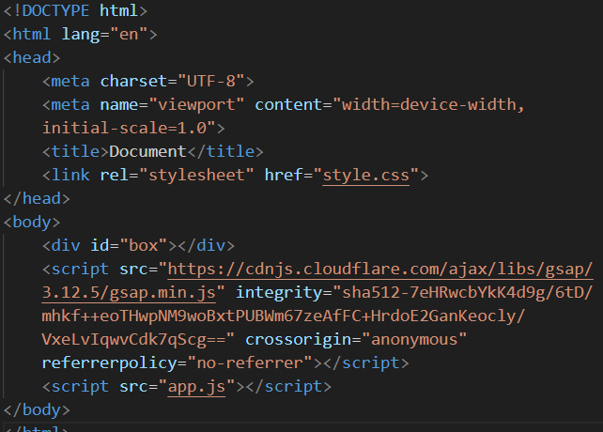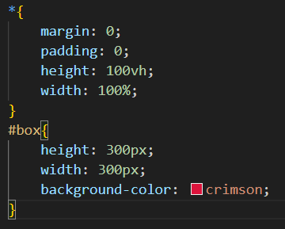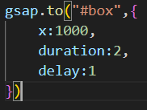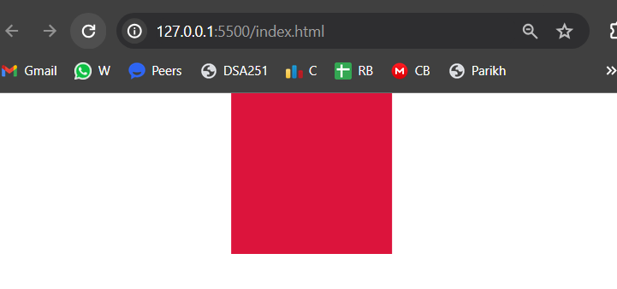
x,y,z it is the direction in which the ele will move
delay kitni der baad shuru hoga
duration kitni der tak chalega
rotate rotate hoga given degree value par move ke sath
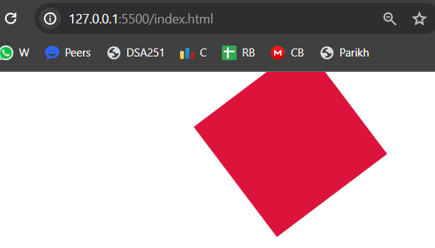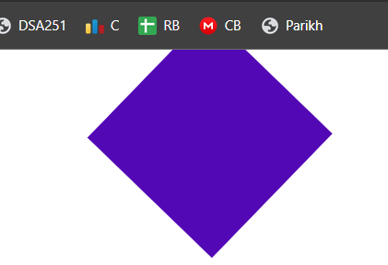
backgroundColor for changing color while moving
scale it will decrease or incre size of ele while moving
7.For moving from final pos to initial we have “gsap.from( )” 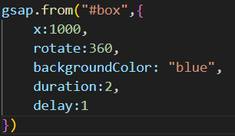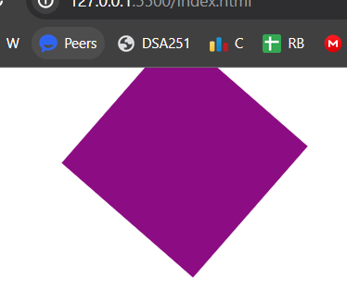
#GSAP Timeline
1.It is a powerful sequencing tool that acts as a container for tweens and other timelines, making it simple to control them as a whole and precisely manage their timing.
2.For example we have three boxes and for all three boxes we have to define delay for all three boxes
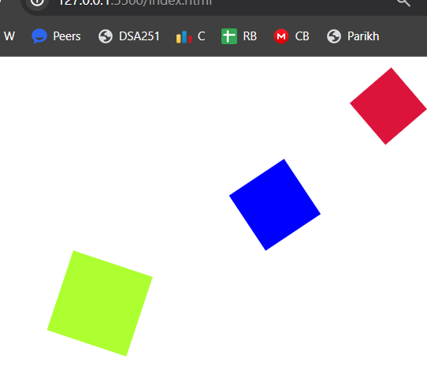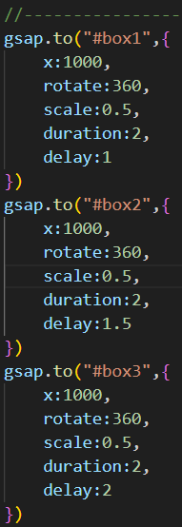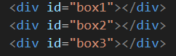
3.Used for only delay means kitni der baad chalega
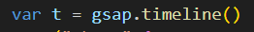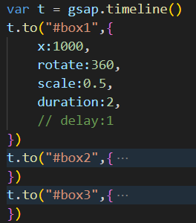
4.At default when 1 box reach final pos then the other goes if timeline( ) tag is empty 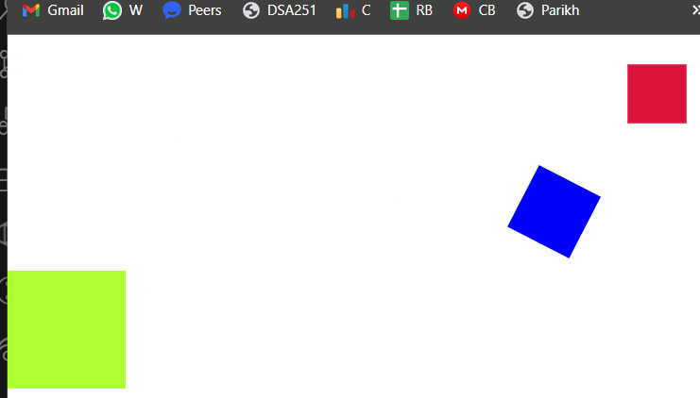
#
1.

