**IP Addressing (IPv4):**

**Structure**: 32-bit address divided into 4 octets (e.g., 192.168.1.1).

**Binary Representation**: 11000000.10101000.00000001.00000001.

**Classes & Ranges**:

|  |  |  |  |  |
| --- | --- | --- | --- | --- |
| **Class** | **Range** | **Default Subnet Mask** | **CIDR Notation** | **Purpose** |
| A | 1.0.0.0 to 126.255.255.255 | 255.0.0.0 | /8 | Large Networks (16M Hosts) |
| B | 128.0.0.0 to 191.255.255.255 | 255.255.0.0 | /16 | Medium Networks (65K Hosts) |
| C | 192.0.0.0 to 223.255.255.255 | 255.255.255.0 | /24 | Small Networks (256 Hosts) |
| D | 224.0.0.0 to 239.255.255.255 | - | - | Multicasting |
| E | 240.0.0.0 to 255.255.255.255 | - | - | Experimental |

**CIDR Notation (Classless Inter-Domain Routing):**

**Format:** <IP Address>/<Prefix Length> — Example: 192.168.1.0/24.

**Prefix Length (/24):** Represents the number of bits used for the **Network ID**.

/24 → First 24 bits are **Network**; last 8 bits are **Hosts**.

**Subnet Mask Equivalent:** 255.255.255.0.

**CIDR** Flexible subnetting (no strict class boundaries), More efficient IP address allocation.

Example Calculation:

192.168.10.0/28:

Network Bits: 28

Host Bits: 4 → 24−2==14 usable addresses.

Subnet Mask: 255.255.255.240.

**Subnetting:**

**Purpose:** Divides a large network into smaller subnetworks for better traffic management.

**Formulas:** **Number of Subnets:** 2n, where n = number of subnet bits.

**Hosts per Subnet:** 2h−2, where h = number of host bits.

**Example:**

IP Address: 192.168.20.0/26

**Subnet Mask:** 255.255.255.192

**Subnets:** 4 subnets

**Hosts per Subnet:** 62 (64 - 2 for Network & Broadcast)

**VLSM**

**Purpose:** VLSM allows subnetting a network into **variable-sized** subnets to **avoid IP wastage** based on actual host needs.

You’re given a **network: 192.168.1.0/24**, You need to subnet it for:

Dept A: 100 hosts, Dept B: 50 hosts, Dept C: 25 hosts, Dept D: 10 hosts

|  |  |
| --- | --- |
| **Subnet creation using VLSM** | |
| 1. Dept A – Needs 100 hosts: Closest power of 2: 128 → 7 host bits Subnet: 192.168.1.0/25 Range: 192.168.1.0 – 192.168.1.127 | 3. Dept C – Needs 25 hosts: Closest power of 2: 32 → 5 host bits Subnet: 192.168.1.192/27 Range: 192.168.1.192 – 192.168.1.223 |
| 2. Dept B – Needs 50 hosts: Closest power of 2: 64 → 6 host bits Subnet: 192.168.1.128/26 Range: 192.168.1.128 – 192.168.1.191 | 4. Dept D – Needs 10 hosts: Closest power of 2: 16 → 4 host bits Subnet: 192.168.1.224/28 Range: 192.168.1.224 – 192.168.1.239 |

**First & Broadcast Address**

**Network Address**: The first IP in the subnet (all host bits = 0)

**First Usable Address**: Network Address + 1

**Broadcast Address**: The last IP in the subnet (all host bits = 1)

**Last Usable Address**: Broadcast Address – 1

**Super netting:**

**Purpose:** Combines multiple subnets into a larger address space to reduce routing entries.

**Example:** Networks: 192.168.1.0/24, 192.168.2.0/24 → Super net: 192.168.0.0/23.

**Usage:** Commonly used by ISPs to simplify routing.

**Routing –** Routing is the process of **selecting a path** for traffic in a network to reach its destination.

**Static Routing:**

Manually Configured:

**Command**: ip route <destination> <subnet mask> <next hop>

**Example**: ip route 192.168.1.0 255.255.255.0 192.168.2.1.

**Pros**: Simple, secure, no overhead.

**Cons**: Not scalable, requires manual updates.

**Dynamic Routing:**

Automatically Configures Routes:

**Protocols**: OSPF, RIP, EIGRP.

Learns routes and adjusts based on network changes.

**Distance Vector vs. Link State**

|  |  |  |
| --- | --- | --- |
| **Feature** | **Distance Vector (e.g., RIP, RIPv2)** | **Link State (e.g., OSPF, IS-IS)** |
| Routing Method | Hop Count | Cost (Bandwidth-based) |
| Update Mechanism | Periodic (every 30s), to neighbours only | Triggered (when changes occur), to all |
| Convergence Time | Slow | Fast |
| Algorithm Used | Bellman-Ford | Dijkstra’s Shortest Path First |
| Loop Prevention | Split Horizon, Poison Reverse | Sequence Numbers, LSA Synchronization |
| Bandwidth Usage | High (regular updates) | Efficient (only topology changes) |
| Usage Scenario | Small networks | Large, scalable enterprise networks |

**IP (Internet Protocol)**

|  |  |  |
| --- | --- | --- |
| **Field and its Description IP V 4** | | |
| Version – IP version (always 4 for IPv4) | | Time to Live (TTL) – Limits packet lifespan (max hops) |
| Header Length – Header size in 32-bit words | | Protocol – Indicates next layer protocol (e.g., TCP) |
| Type of Service – Defines priority & QoS | | Header Checksum – Ensures header integrity |
| Total Length – Size of entire packet | | Source Address – Sender’s IP address |
| Identification – ID for fragment reassembly | | Destination Address – Receiver’s IP address |
| Flags – Control flags for fragmentation | | Options – Optional control info |
| Fragment Offset – Fragment’s position in original data | | Padding – Fills to 32-bit alignment |
| **Field and its Description IP V 6** | | |
| Version – IP version (always 6 for IPv6) | Next Header – Identifies type of next header (e.g., TCP, UDP, extension) | |
| Traffic Class – Packet priority & QoS (like IPv4 ToS) | Hop Limit – Max hops before packet is discarded (like TTL in IPv4) | |
| Flow Label – Marks packet flows for special handling | Source Address – 128-bit sender’s IP address | |
| Payload Length – Size of payload after the header | Destination Address – 128-bit receiver’s IP address | |

**IPv4**: 32-bit, fragmented at routers.

**IPv6**: 128-bit, fragmentation handled by the sender.

**Example of IPv6:** 2001:0db8:85a3::8a2e: 0370:7334.

**ICMP (Internet Control Message Protocol):**

**Purpose:** Error reporting and diagnostics.

**Usage:** ping, traceroute

**Common Messages:**

|  |  |  |
| --- | --- | --- |
| **Type** | **Message** | **Description** |
| 0 | Echo Reply | Response to ping request |
| 3 | Destination Unreachable | Network/Host unreachable |
| 8 | Echo Request | Ping to test reachability |
| 11 | Time Exceeded | TTL expired in transit |

**ARP (Address Resolution Protocol):**

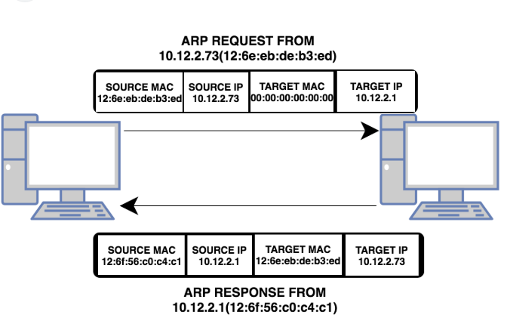

**Function:** Resolves IP addresses to MAC addresses.

**Process:** Broadcasts a request → Receives a unicast response.

**OSPF (Open Shortest Path First):**

**Type:** Link-State Protocol.

**Metric:** Cost based on bandwidth.

**Area-based Design:** Divides large networks into smaller areas (e.g., Area 0 - Backbone).

**Usage Scenarios:** Large enterprise networks, Fast convergence and loop-free topology

**RIPv2 (Routing Information Protocol v2):Type:** Distance Vector Protocol.

**Max Hop Count:** 15 (16 = Unreachable).

**Updates:** Sent every 30 seconds to neighbours.

**Usage:** Small networks with simple routing, Easy configuration but poor scalability.