

FALL SEMESTER 2020-21

MAT3004

APPLIED LINEAR ALGEBRA

**DIGITAL ASSIGNMENT-2**

**NAME: VIBHU KUMAR SINGH**

**REG NO: 19BCE0215**

**TEACHER: PADMA R.**

**II)**

**Q1) Find bases and dimensions for the Row space, Column space, Null space of the matrix:**

**1 -2 5 0 3**

**-2 5 7 0 -6**

**A= -2 3 -2 1 -3**

**-3 8 -9 1 -9**

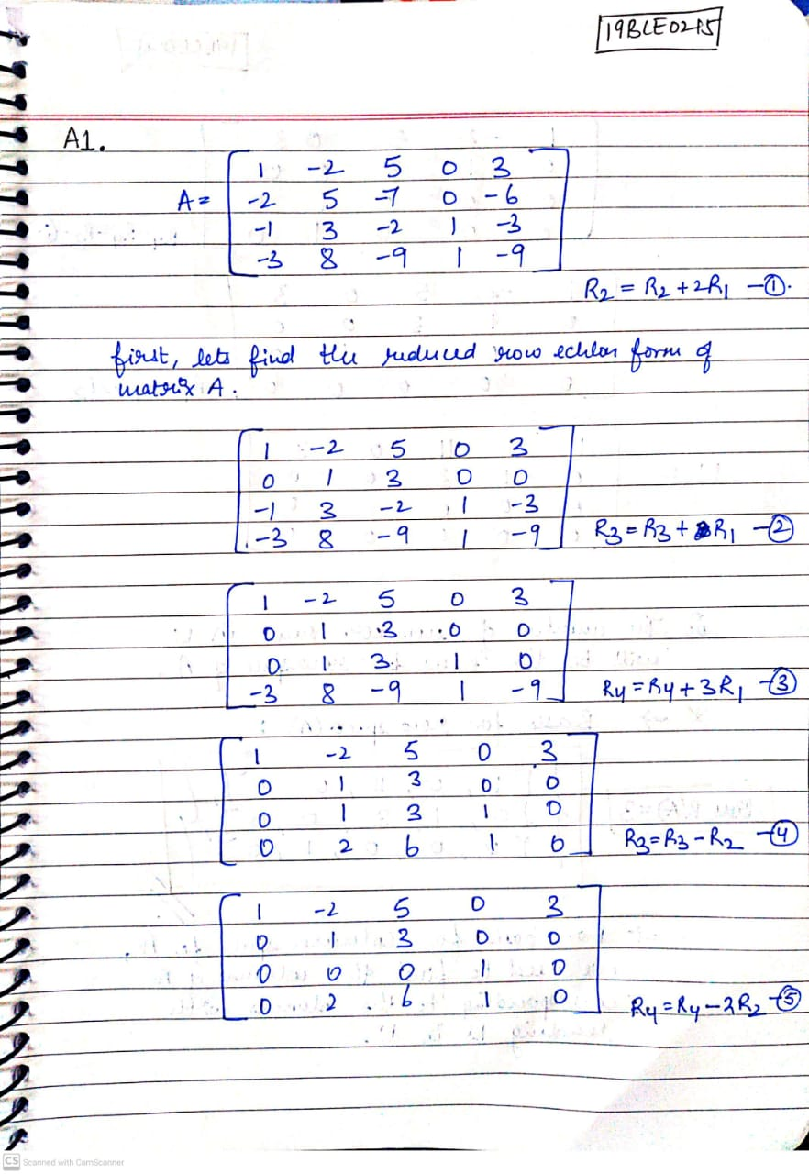

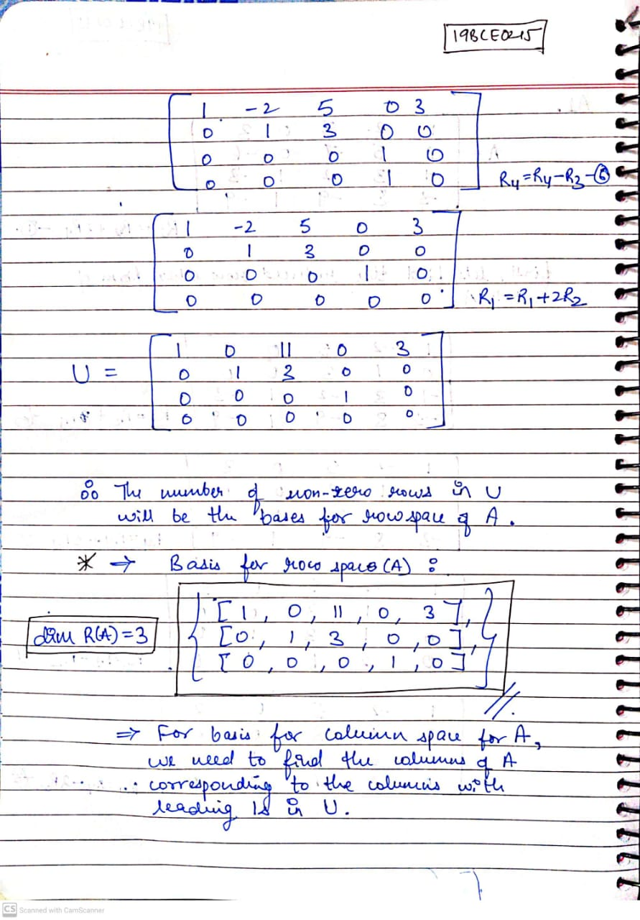

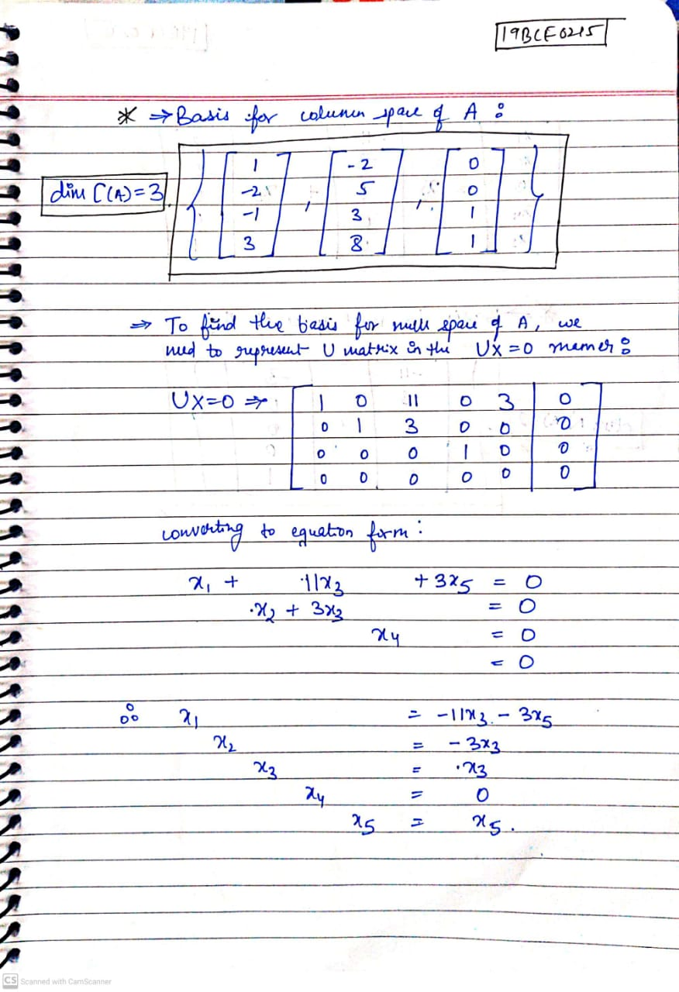

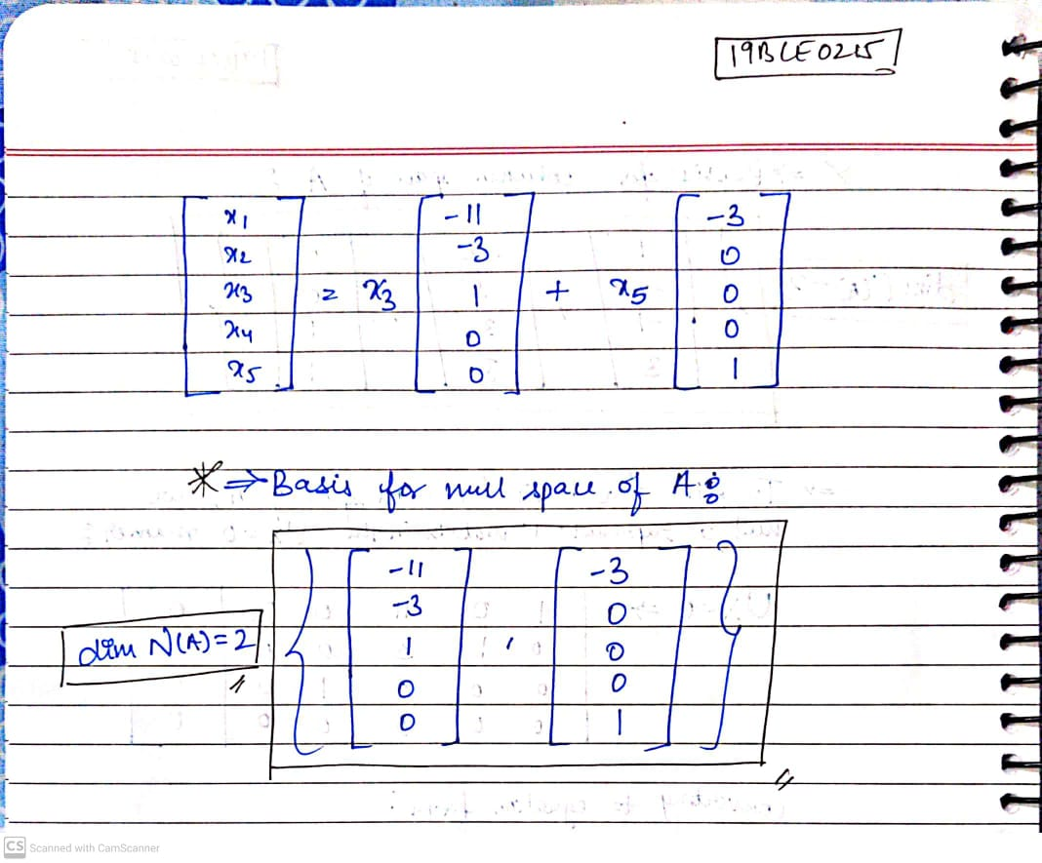

**Q2)Let T: M3 ^ M3 be the mapping given by T(x, y, z) = (2x + y + z, x + 2 y + z, x + y + 2 z).**

1. **Prove that T is linear**
2. **Find Ker(T)**
3. **Is T invertible? Find T-1 if T is invertible.**

