

CSE 1004

Network and Communication

Lab FAT

**NAME**: Vibhu Kumar Singh

**REG. NO**: 19BCE0215

**TEACHER**: Santhi H.

**Q2-a)** Develop a menu driven code to find the first address, last address and number of addresses of Class A, B and C IP address.  
**Ans1-a)**Handwritten (Algorithm and Source Code):

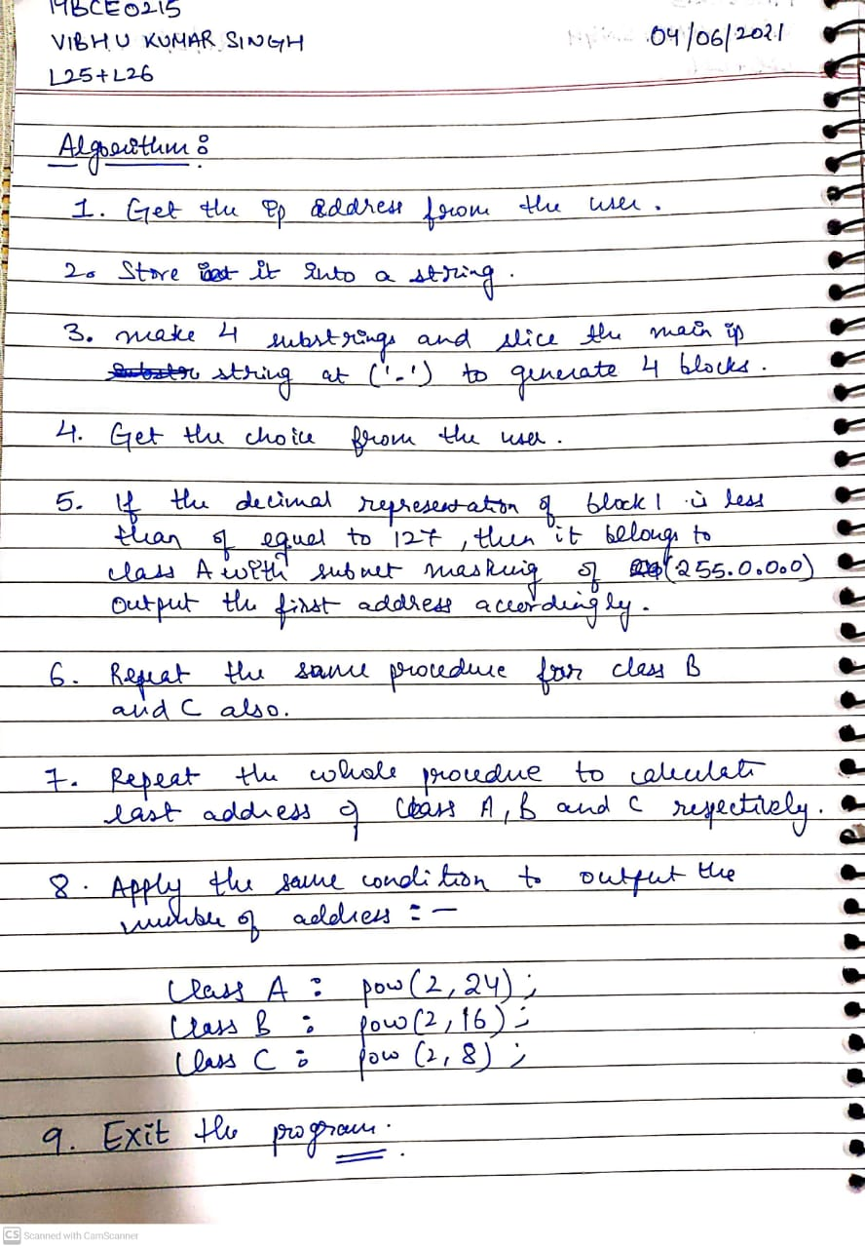

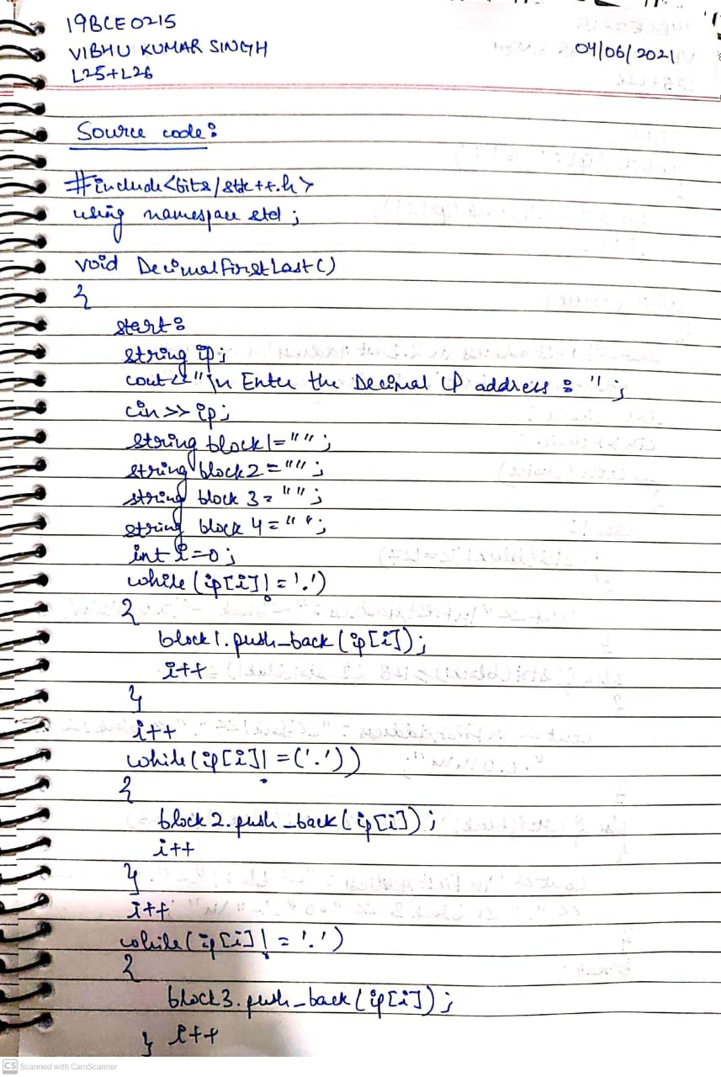

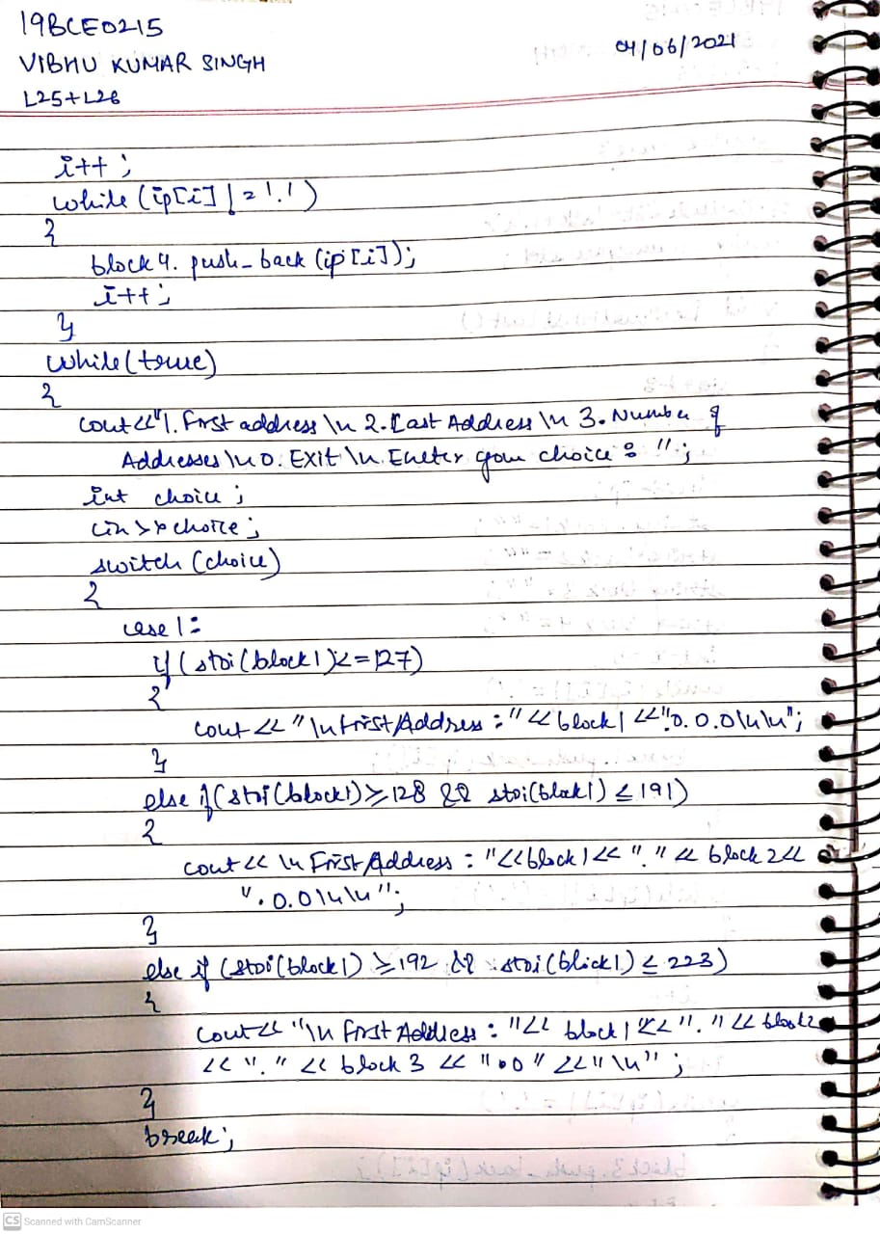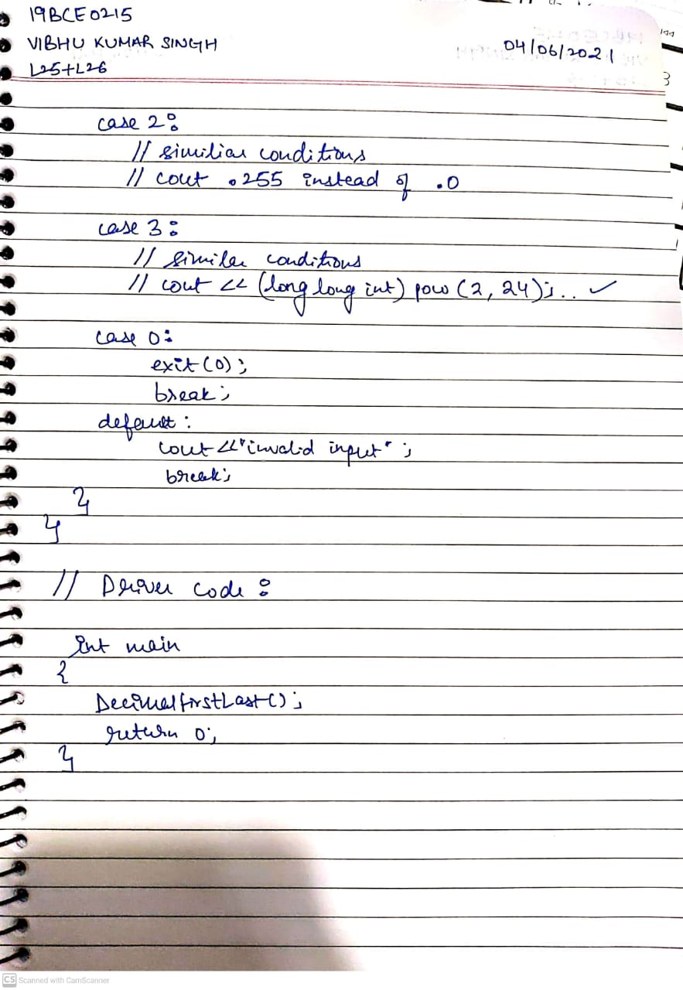

OUTPUT:

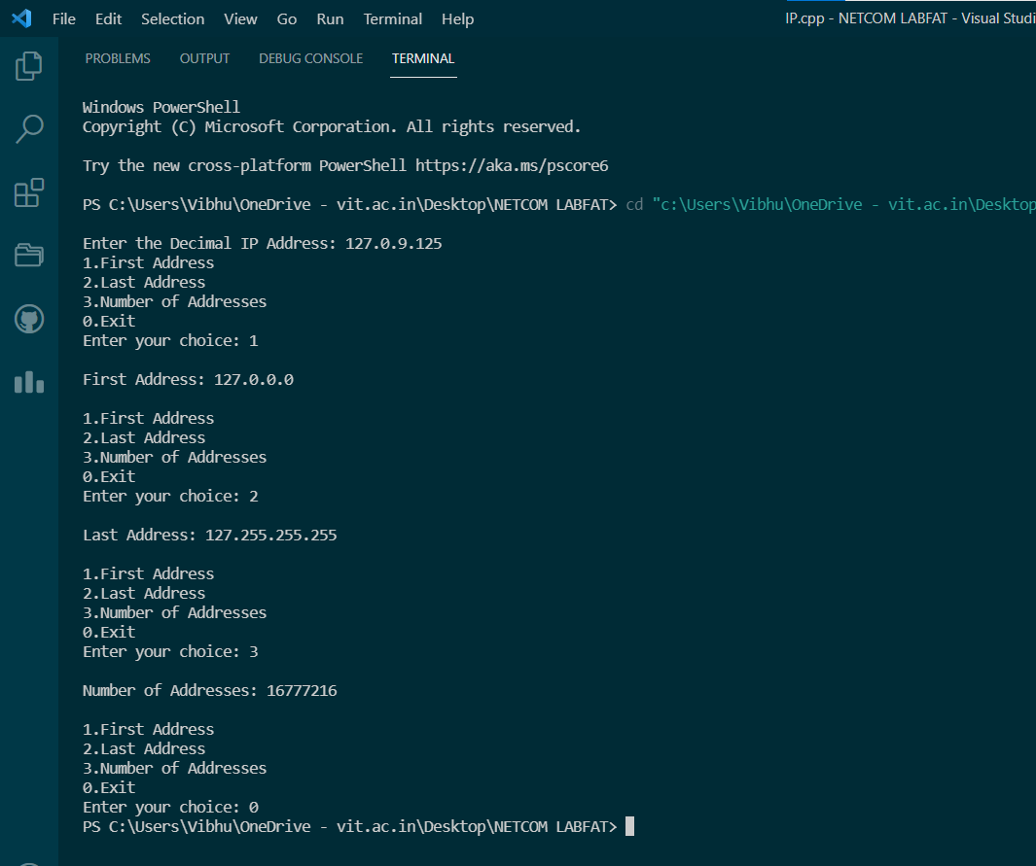

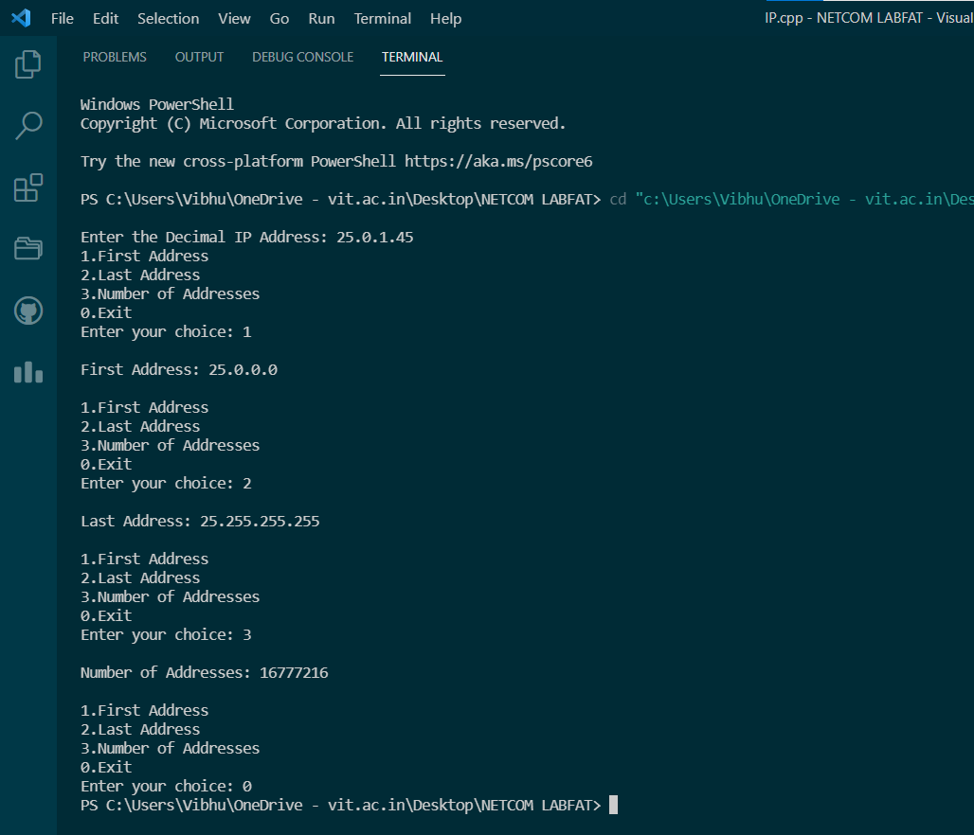

**Q2-b)** Develop a UDP client-server program to find the sum of any five digit number. The client program send any five digit integer number to the client and the server program reads and compute the sum of five digit received number and display the same at client side.

**Ans2-b)**

Handwritten (Algorithm and Source Code):

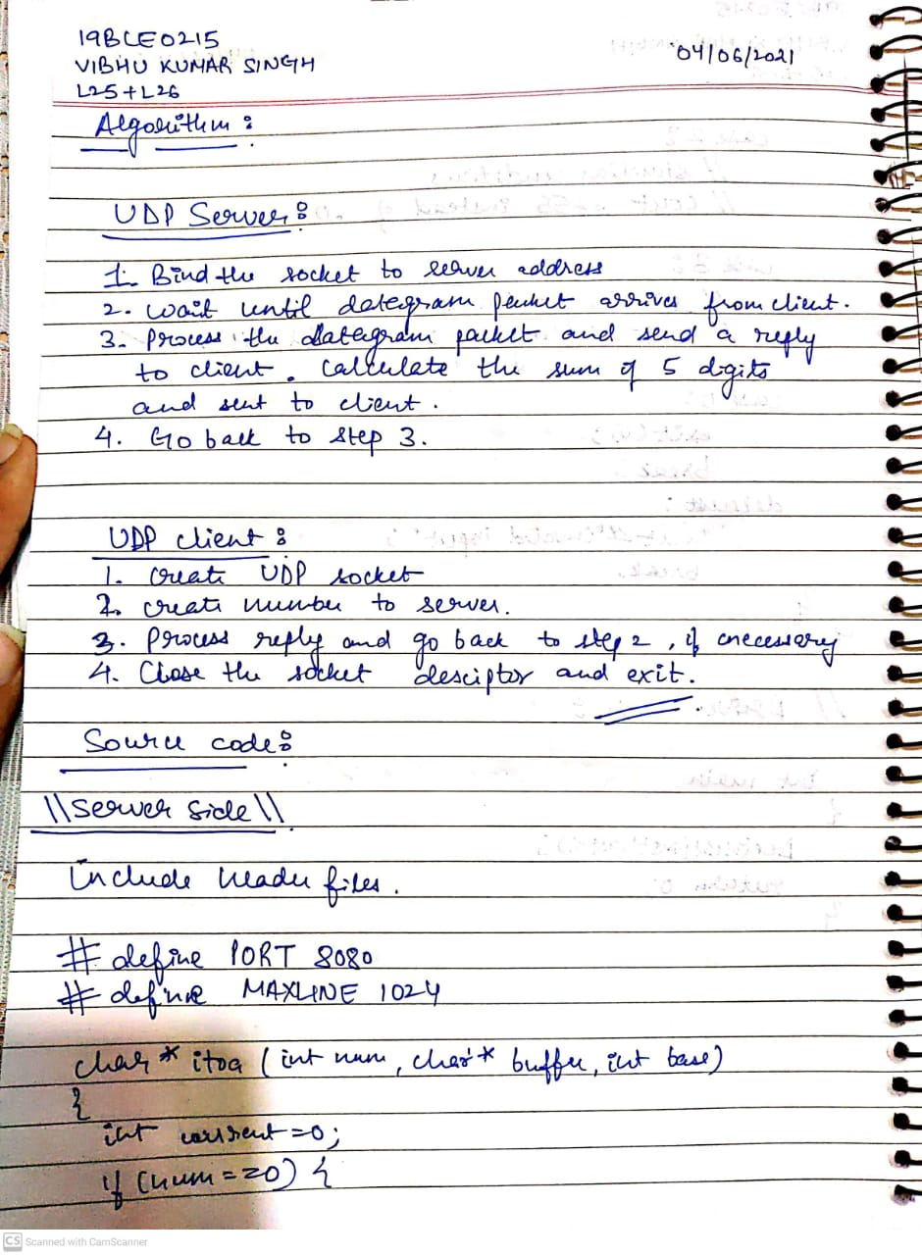

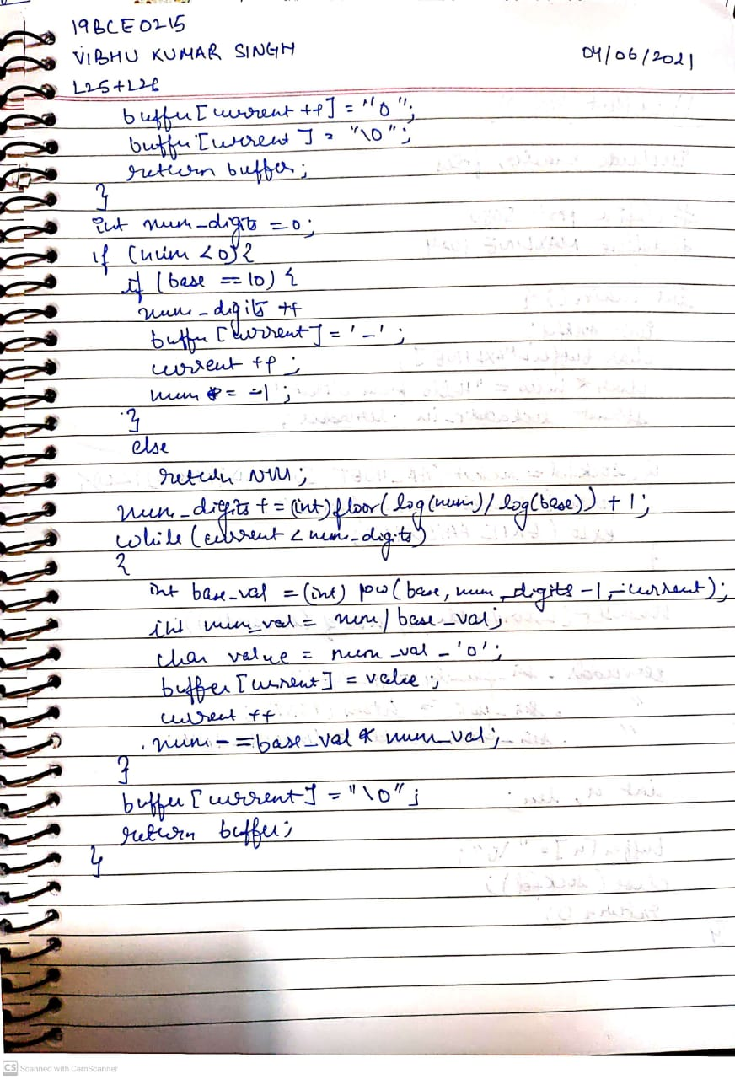

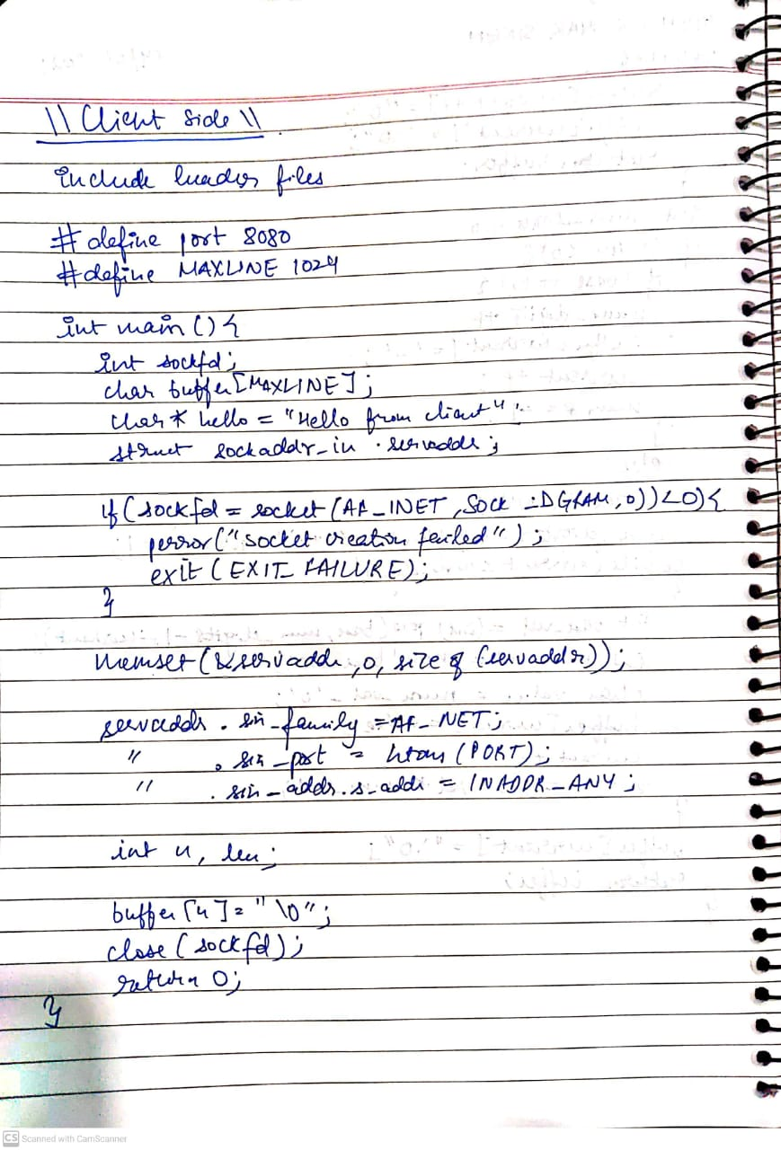

Screenshots:

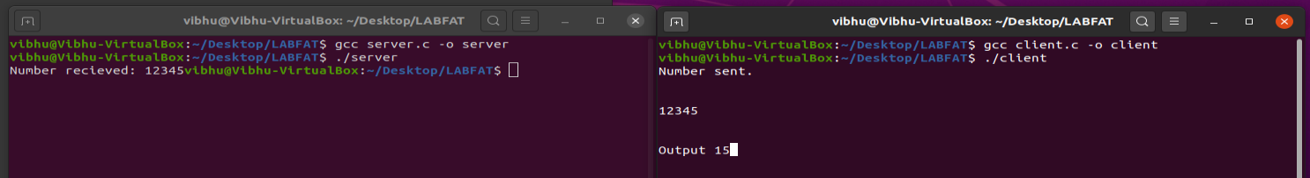

**Client Side:**

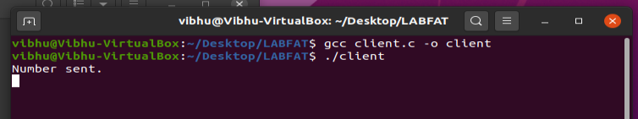

**Server Side:**

